Supplementary information
Mechanistic hazard differentiation of Cerium Oxide and Barium Sulfate Nanoparticles
using a Human-Relevant Lung Model
Isidora Loncarevic¹, Seyran Mutlu^{2,3}, Roman Mmanda Fortunatus¹, Nathalie Jung¹, Jorge Larios^{1,4}, Sandor Balog^{1,4}, Martina Dzepic^{2,3}, Alke Petri-Fink¹, Fabian Blank^{2,3}, Barbara Rothen-Rutishauser¹
¹Adolphe Merkle Institute, University of Fribourg, Chemin des Verdiers 4, 1700 Fribourg, Switzerland
² Lung Precision Medicine (LPM), Department for BioMedical Research (DBMR), University of Bern, Switzerland
³ Department for Pulmonary Medicine, Allergology and Clinical Immunology, Inselspital, Bern University Hospital, University of Bern, Bern, Switzerland
⁴National Center of Competence in Research Bio-Inspired Materials,
University of Fribourg, Chemin des Verdiers 4, 1700 Fribourg, Switzerland

Supplementary Table 1. Primer details: name, sequence, and efficiency
Primers |  | Sequence (5'->3') | Primer efficiency
IL1β | FWD | AGCTCGCCAGTGAAATGATGG | 1.94
IL1β | REV | GGTGGTCGGAGATTCGTAGC | 1.94
IL6 | FWD | CCACTCACCTCTTCAGAACG | 2.05
IL6 | REV | CATGTTACTCTTGTTACATGTCTCC | 2.05
IL8 | FWD | GAGAAGTTTTTGAAGAGGGCTGA | 2.04
IL8 | REV | GCTTGAAGTTTCACTGGCATCT | 2.04
TJP1 | FWD | CCAGCTGGTATGGGTTTCCG | 1.97
TJP1 | REV | ACCTGGAGCTGACAGGTAGG | 1.97
GAPDH | FWD | GTCGGAGTCAACGGATTTGG | 1.86
GAPDH | REV | GCCATGGGTGGAATCATATTGG | 1.86
YWHAZ -1 | FWD | GCTGGTGATGACAAGAAAGGGAT | 1.99
YWHAZ -1 | REV | GTTAAGGGCCAGACCCAGTC | 1.99
OCLD | FWD | GGTCTAGGACGCAGCAGATTG | 1.99
OCLD | REV | TGGACTTTCAAGAGGCCTGG | 1.99
HMOX1 | FWD | AGTTCAAGCAGCTCTACCGC | 1.9
HMOX1 | REV | GCAACTCCTCAAAGAGCTGGAT | 1.9
SOD2 | FWD | AGGCATGTTGGAGACTTGGG | 1.94
SOD2 | REV | TGCTTTTTCATGGACCACCAG | 1.94
TGFβ | FWD | CCCTACATTTGGAGCCTGGACACG | 2
TGFβ | REV | CGGGTTATGCTGGTTGTACAGGGC | 2
TNFα | FWD | TGCACTTTGGAGTGATCGG | 1.88
TNFα | REV | CGAGAAGATGATCTGACTGCC | 1.88

Supplementary Table 2. Composition and functional annotation of the qPCR panel.
Gene symbol | Full name | Status
Target genes — DNA damage/repair
ATM | ATM serine/threonine kinase | Retained
BAX | BCL2-associated X, apoptosis regulator | Retained
CDKN1A | Cyclin-dependent kinase inhibitor 1A (p21) | Retained
GADD45A | Growth arrest and DNA-damage-inducible alpha | Retained
Target genes — Oxidative stress
GCLC | Glutamate–cysteine ligase, catalytic subunit | Retained
GSR | Glutathione–disulfide reductase | Retained
NQO1 | NAD(P)H quinone dehydrogenase 1 | Retained
TXNRD1 | Thioredoxin reductase 1 | Retained
HSPA1A | Heat shock protein family A (Hsp70) member 1A | Retained
HSP90AA1 | Heat shock protein 90 alpha, class A, member 1 | Retained
Target genes — Inflammatory
RELA | RELA proto-oncogene, NF-κB subunit (p65) | Retained
AHR | Aryl hydrocarbon receptor | Retained
Target genes — Growth/signaling
EGFR | Epidermal growth factor receptor | Retained
Target genes — excluded (mean Ct > 30)
BCL2 | BCL2 apoptosis regulator | Excluded
LPO | Lactoperoxidase | Excluded
NOX1 | NADPH oxidase 1 | Excluded
CYBB | Cytochrome b-245 beta chain (NOX2/gp91phox) | Excluded
CYP1A1 | Cytochrome P450 1A1 | Excluded
Reference genes
GAPDH | Glyceraldehyde-3-phosphate dehydrogenase | Normalization
RPLP0 | Ribosomal protein lateral stalk subunit P0 | Normalization
YWHAZ | Tyrosine 3-monooxygenase/tryptophan 5-monooxygenase activation protein zeta | Normalization
Assay controls
HGDC | Human Genomic DNA Control | gDNA contamination check
QIC | RNA Quality Internal Control | RT / spike-in check
PPC | Positive PCR Control | PCR performance check
Custom QuantiNova LNA PCR Flexible Panel (Qiagen, Hilden, Germany; custom panel SBFA89194). Eighteen target genes were profiled; five with a mean Ct > 30 across all conditions were excluded, yielding a final panel of 13 genes used for statistical analysis and visualization. Gene symbols follow HGNC nomenclature. Functional categories correspond to the groupings shown in Figure 6 (heat-shock genes grouped under oxidative stress; apoptosis regulator BAX grouped under DNA damage/repair).

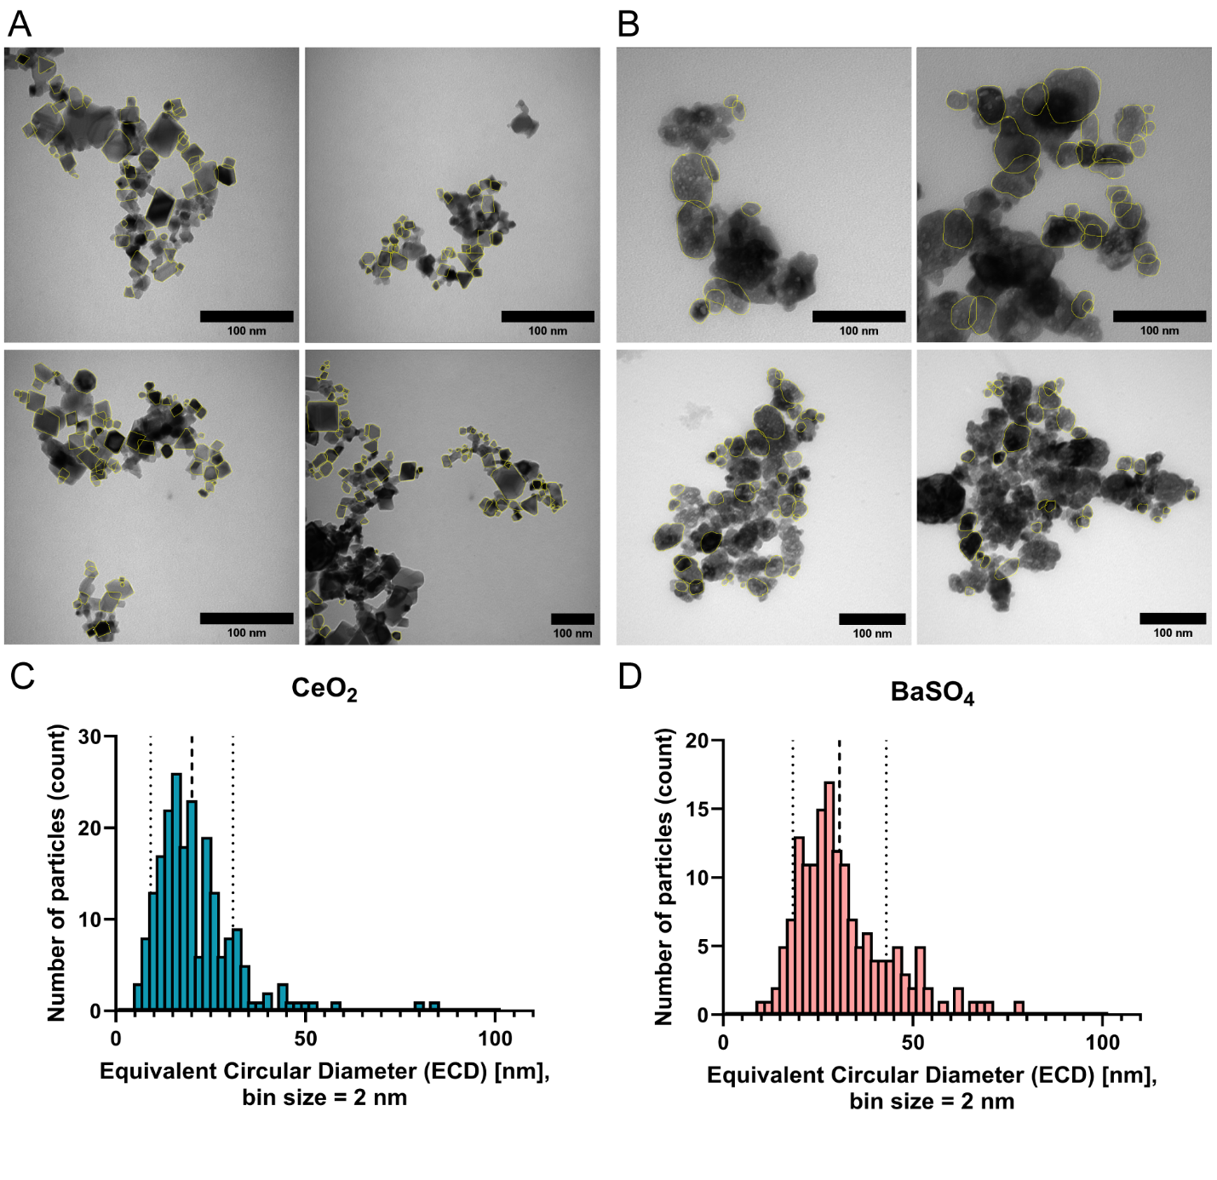
Supplementary Figure 1. Equivalent circular diameter (ECD) analysis of CeO₂ and BaSO₄ nanoparticles. Representative TEM images with highlighted regions of interest (ROIs) used for particle size measurements of (A) CeO₂ and (B) BaSO₄ nanoparticles. Scale bar 100 nm. Corresponding ECD size-distribution histograms showing the number of particles per 2 nm bin for (C) CeO₂ (n = 210) and (D) BaSO₄ (n = 160).

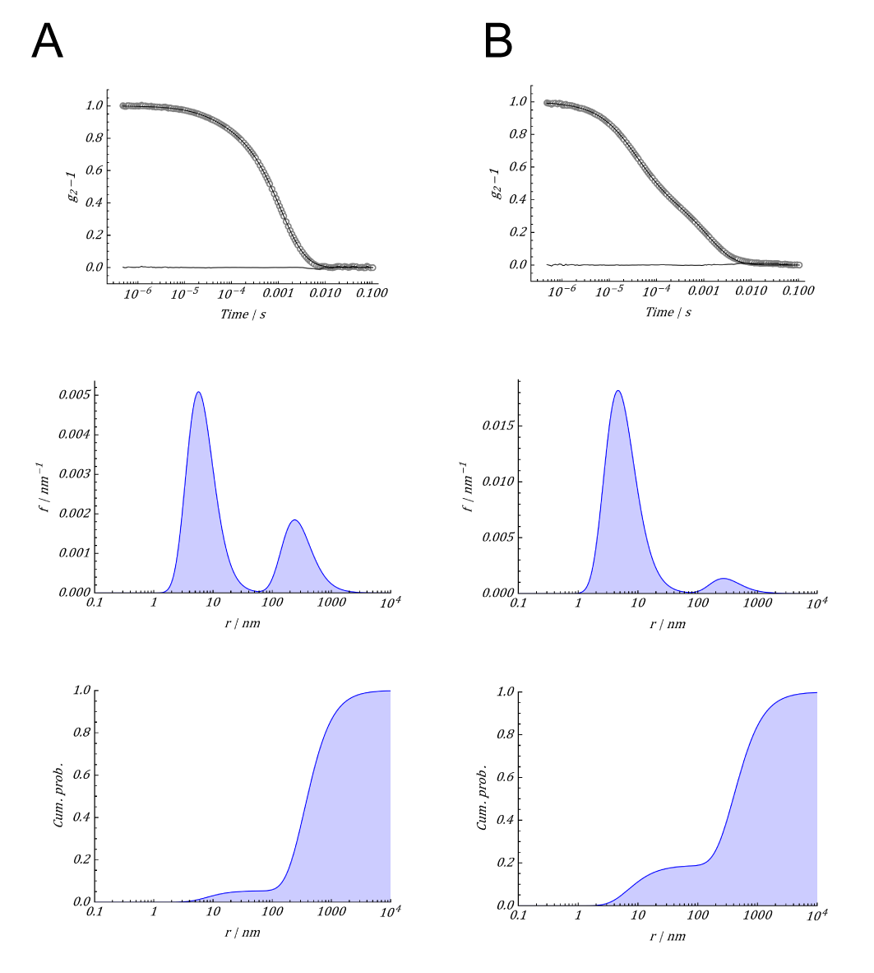
Supplementary Figure 2. DLS measurements of CeO₂ (A) and BaSO₄ (B) nanoparticles after 1h incubation in cell culture media (CCM). Before measurements, particles were washed 2 times with Milli-Q®. The autocorrelation functions were regressed via a bimodal linear combination of gamma (AKA Shultz-Zimm) distributions, as describe in detail elsewhere [Dynamic Depolarized Light Scattering of Small Round Plasmonic Nanoparticles: When Imperfection is Only Perfect | The Journal of Physical Chemistry C] Panels show (top) the autocorrelation function, the model regression, and the residuals, (middle) the probability density function and (bottom) cumulative distribution function of the intensity-weighted hydrodynamic radius.

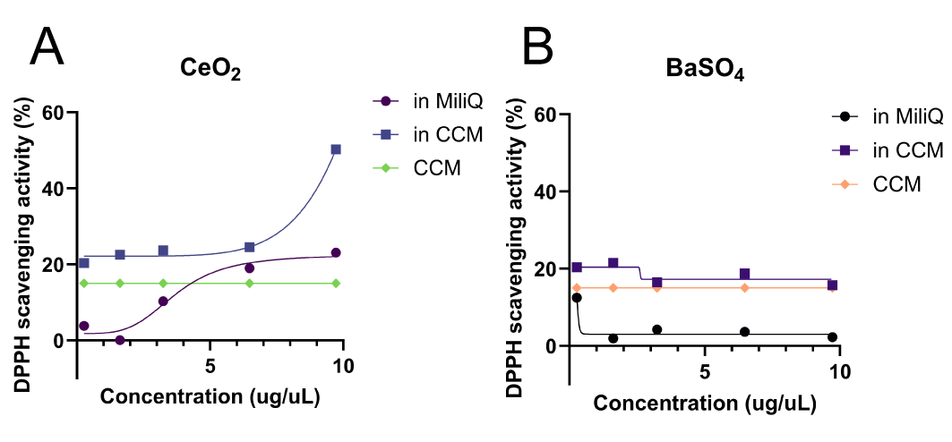
Supplementary Figure 3 DPPH radical scavenging activity of CeO₂ and BaSO₄ nanoparticles in water and cell culture media. Data are presented as DPPH radical scavenging activity (%) versus concentration of particles in the solution (μg/mL). CCM - cell culture media. Values are the average of 5 measurements and represented as a mean.
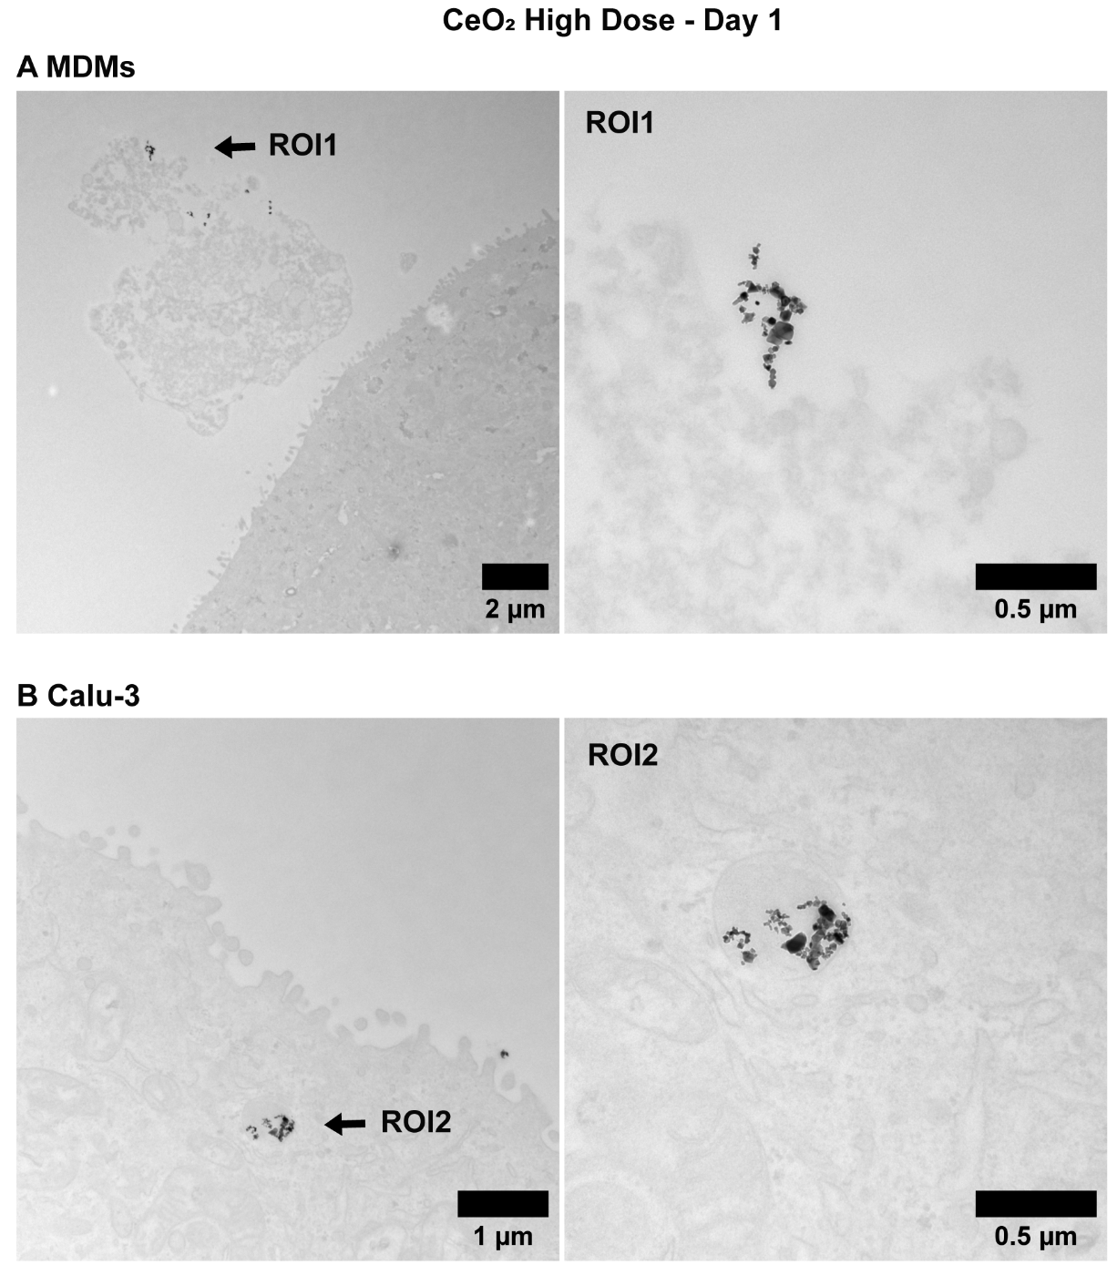
Supplementary Figure 4. Comparative CeO₂ particle uptake by MDMs and Calu-3 cells at high dose, day 1. Representative TEM micrographs showing CeO₂ uptake in (A) MDMs and (B) Calu-3 cells at the highest dose (324 µg/cm²). MDMs display small particle clusters in intracellular compartments (ROI1), while Calu-3 cells show markedly lower uptake with particles confined to single small vesicles (ROI2). Scale bars as indicated.
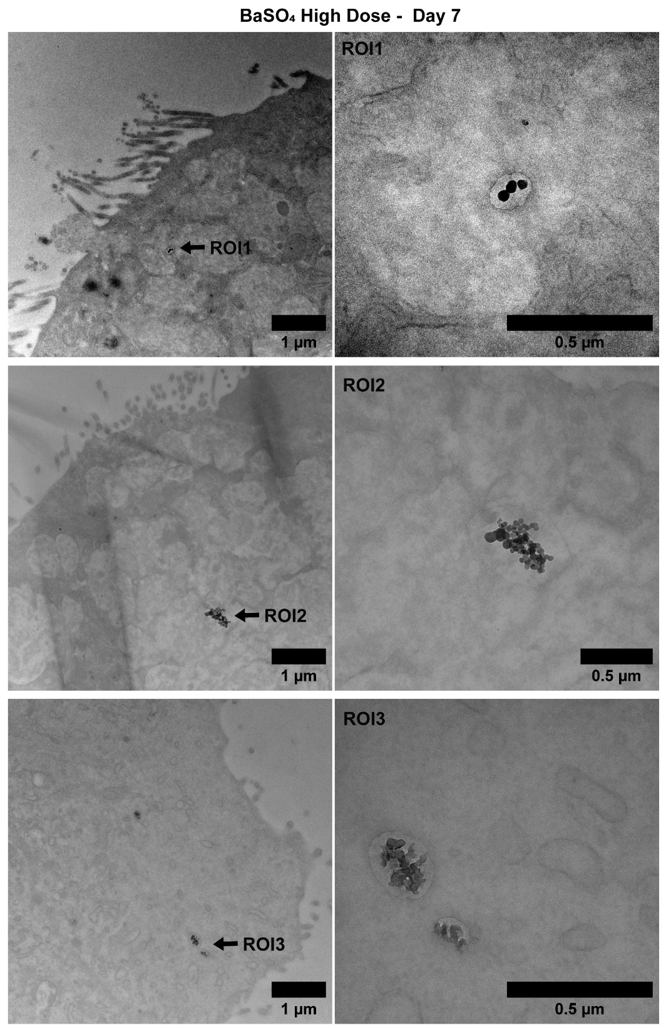
Supplementary Figure 5. Intracellular uptake of BaSO₄ nanoparticles in Calu-3 cells at high dose, day 7. Representative TEM micrographs showing sparse intracellular BaSO₄ particles at the highest dose (324 µg/cm²). Overview images (left) show regions of interest (ROI) indicated by arrows. Magnified ROI panels (right) confirm the presence of small particle clusters within vesicular compartments. Scale bars as indicated.

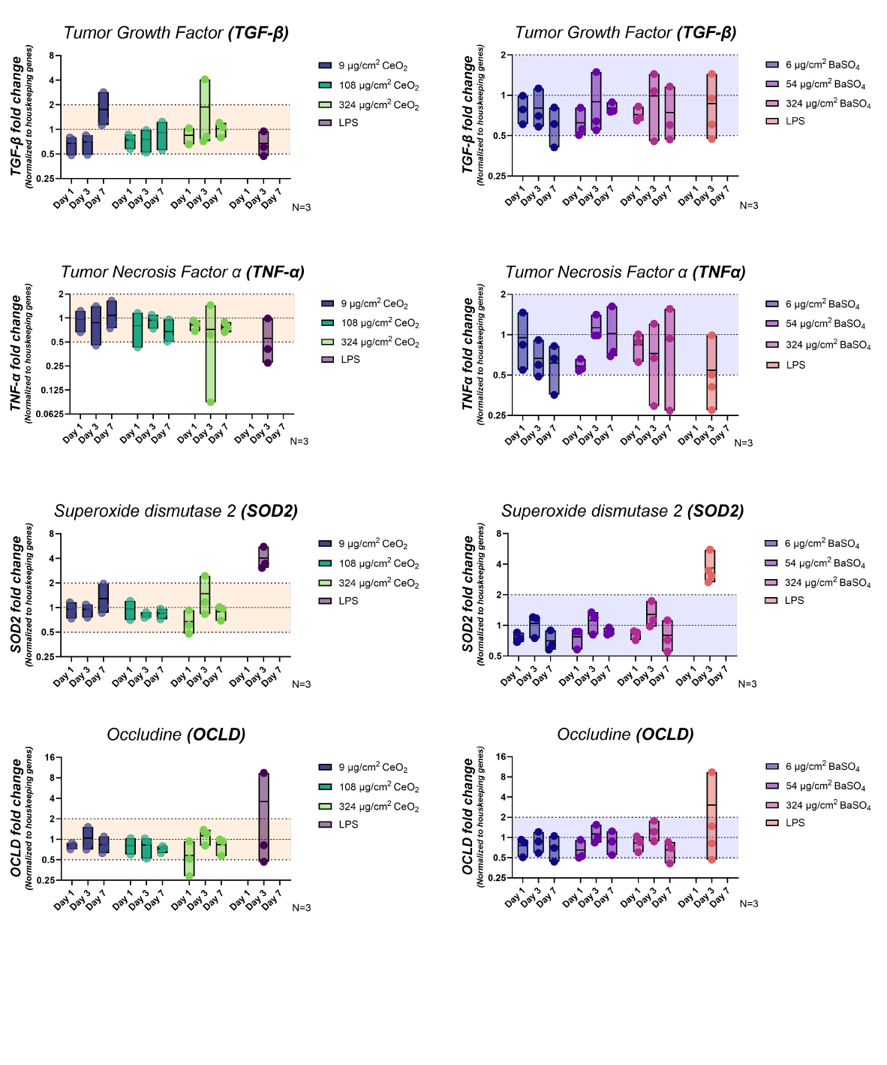
Supplementary Figure 6. Gene expression of the tight junction marker OCLN-1. qPCR analysis of OCLN-1 expression in Calu-3/MDM co-cultures exposed to low, middle, and high doses of CeO₂ and BaSO₄ over 7 days. Values are normalized to two housekeeping genes (GAPDH, YWHAZ) and represented as fold change relative to untreated controls.
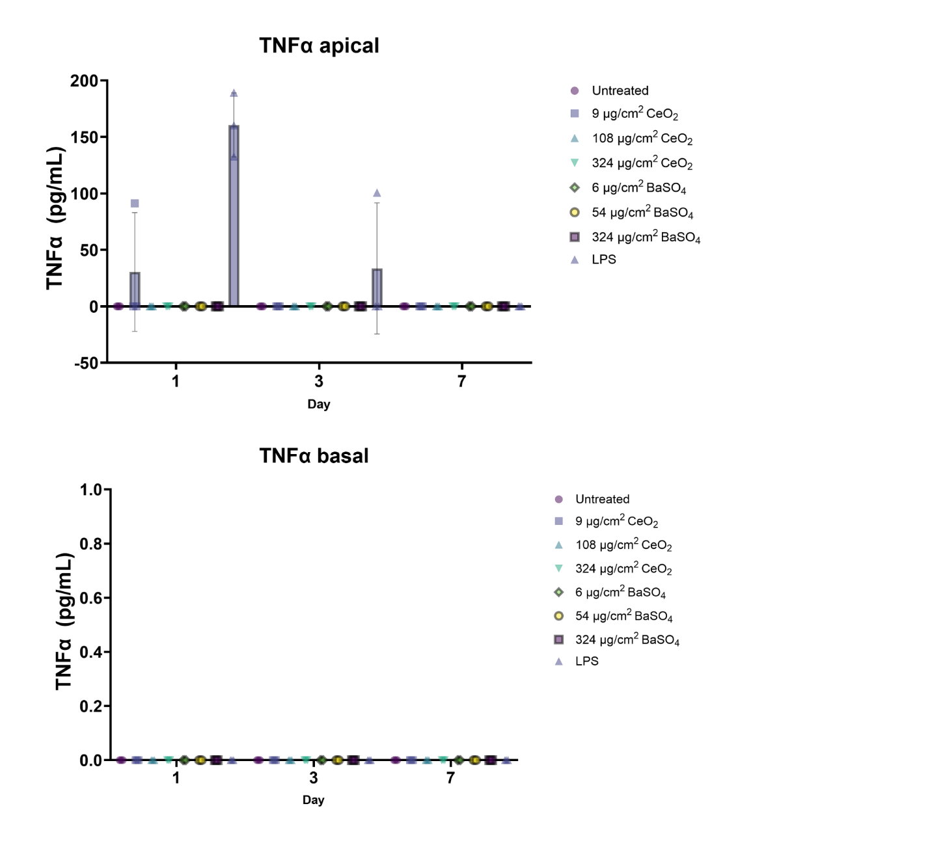
Supplementary Figure 7. TNF-α secretion in Calu-3/MDM co-cultures exposed to CeO₂ and BaSO₄ nanoparticles.
TNF-α release was measured from the basolateral (A) and apical (B) sides following exposure to different doses of CeO₂ and BaSO₄ at all time points. Data are presented as mean ± standard deviation (n = 3 biological replicates). No detectable TNF-α secretion was observed under any condition, while LPS (175 µg/mL) served as the positive control.
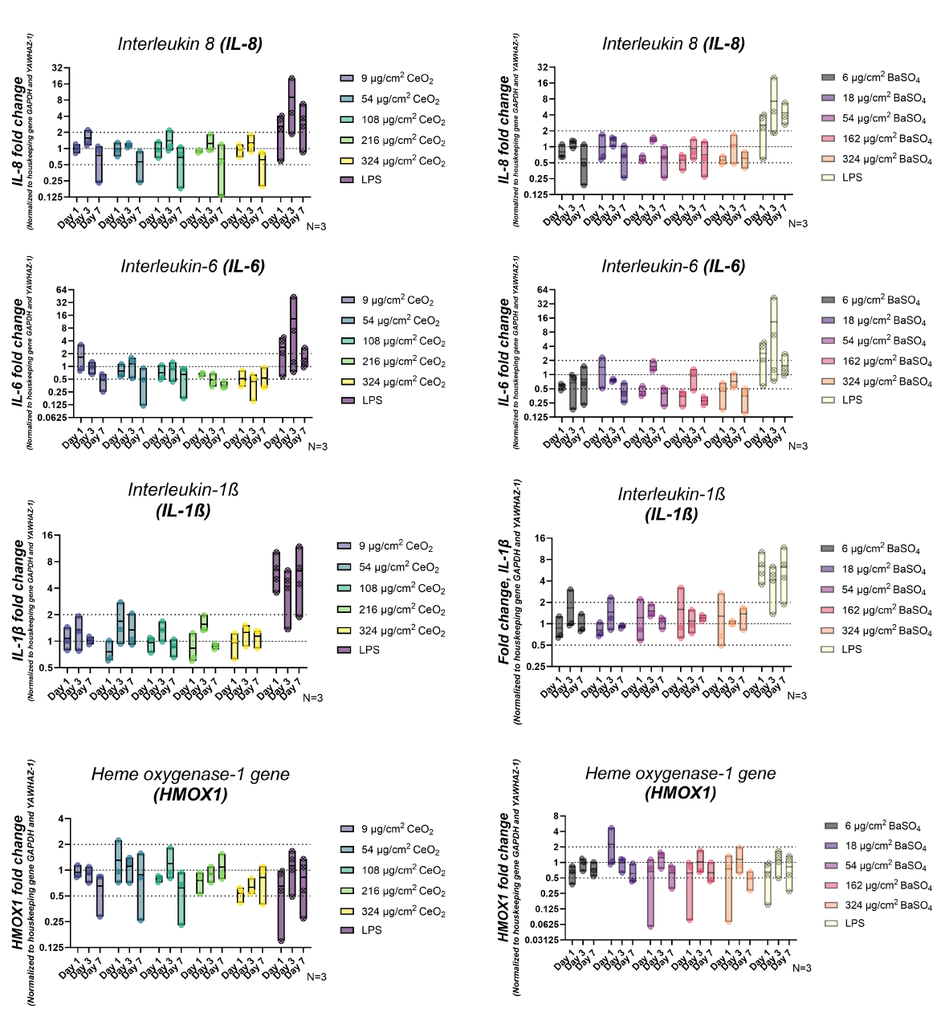Supplementary Figure 8A. Gene expression of additional markers related to oxidative stress, inflammation, and epithelial barrier integrity.
qPCR analysis of oxidative stress genes (HMOX1), inflammatory genes (IL-1β, IL-6, IL-8) in Calu-3/MDM co-cultures over 7 days. Values are normalized to two housekeeping genes (GAPDH, YWHAZ) and expressed as fold changes relative to untreated controls.

Supplementary Figure 8B. Gene expression of additional markers related to oxidative stress, inflammation, and epithelial barrier integrity.
qPCR analysis of oxidative stress genes (SOD2) and inflammatory genes (TGF-β, TNF-α) in Calu-3/MDM co-cultures over 7 days. Values are normalized to two housekeeping genes (GAPDH, YWHAZ) and expressed as fold changes relative to untreated controls.

