SUPPLEMENTARY MATERIAL
Andean wetlands: seasonal variability and their interactions with the cryosphere
Joshua Castro¹, Catriona L. Fyffe², Thomas E. Shaw², Evan S. Miles^{1,3,4}, Emily Potter⁵, Martin Hoelzle¹, Vinisha Varghese⁶, Francesca Pellicciotti²
1 Department of Geosciences, University of Fribourg, Fribourg, Switzerland
2 Institute of Science and Technology Austria, Austria
3 Swiss Federal Institute for Forest, Snow and Landscape Research WSL, Birmensdorf, Switzerland
4 Glaciology and Geomorphodynamics Group, Department of Geography, University of Zürich, Zürich, Switzerland
5 School of Geography and Planning, University of Sheffield, Sheffield, UK
6 Integrated Planning and Industrial Building, Institute of Building and Industrial Construction, Faculty of Civil and Environmental Engineering, TU Wien, Vienna, Austria

A. METHODOLOGY

A.1. Image pre-processing
Between 2013 and 2022, 764 satellite images were selected from the Landsat 7 and 8 Collections, Level-2 images, corresponding to the 33 seasons retained after quality control. To manage the computation load, we analysed only the most relevant bands: Blue, Green, Red, Near Infrared, Shortwave Infrared 1, Shortwave Infrared 2, Surface Temperature, and Pixel Quality Attribute (QA_pixel). Figure S1 shows the distribution of the used images by their day of the year (DOY) and cloud-cover information. Of the 764 selected images, 223 covered zone 1, 563 covered zone 2, and 658 covered zone 3, with overlap among zones. A full list of these images is provided in the Data Availability section. We applied a cloud-mask function that identifies and removes cloud and shadow pixels using QA_Pixel band information (Foga et al., 2017) and then calculated the median values of the remaining image collection to produce a reference multi-date mosaic image for each season.
Before defining the final dataset, a first visual inspection showed that a fixed 20% threshold for filtering images reduced the number of available images and seasons. A closer look showed that, even when the reported cloudiness was high, clouds did not always cover the entire image or were located outside the VUB boundaries. In other cases, most cloudy areas were in zone 1, in the northwest of the basin, where extensive forest cover is present. These details forced us to rely on manual intervention to produce high-quality mosaics. To ensure a robust dataset without losing image quality, we manually determined a cloud cover threshold per season (Table S1), ranging from 8% to 100%. The cloud-masking function was manually disabled in specific image collections where glacier surfaces were frequently misclassified as clouds. Despite these adjustments, we excluded 7 out of 40 seasons due to concerns with cloud cover and image quality: JFM of 2013, 2015, 2017, 2018, 2019, 2021, and OND of 2013, corresponding to months of high precipitation.
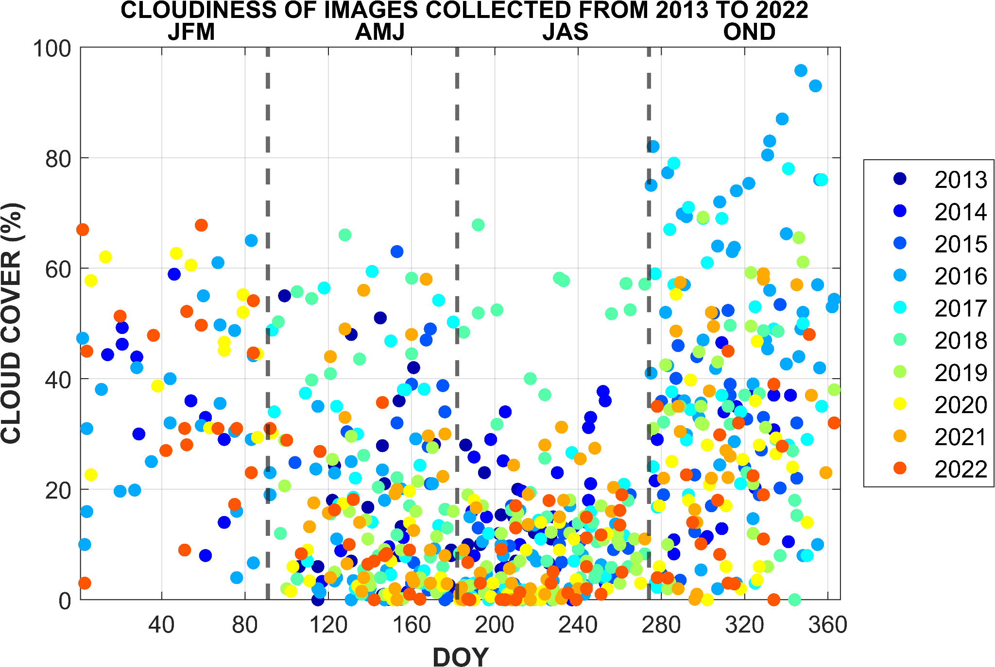
Fig. S1. Distribution of satellite images per cloud cover percentage. 764 satellite images were used between Landsat 7 (363 images) and Landsat 8 (401 images) Collection 2 Level-2 datasets across the VUB area.
Table S1. Cloud cover (CC) thresholds and masking settings used for seasonal land cover classification (2013 - 2022).
Year | Season | Landsat 7 CC | Landsat 8 CC | Landsat 7 Cloudmask | Landsat 8 Cloudmask
2013 | JFM | 70 | 90 | On | On
2013 | AMJ | 60 | 30 | On | On
2013 | JAS | 30 | 20 | On | Off
2013 | OND | 60 | 40 | Off | On
2014 | JFM | 40 | 60 | Off | On
2014 | AMJ | 0 | 20 | On | Off
2014 | JAS | 40 | 40 | On | On
2014 | OND | 40 | 50 | On | Off
2015 | JFM | - | - | - | -
2015 | AMJ | 70 | 40 | On | On
2015 | JAS | 20 | 20 | On | Off
2015 | OND | 50 | 55 | On | On
2016 | JFM | 70 | 50 | Off | Off
2016 | AMJ | 40 | 30 | On | Off
2016 | JAS | 20 | 20 | On | Off
2016 | OND | 100 | 100 | On | On
2017 | JFM | - | - | - | -
2017 | AMJ | 40 | 60 | On | On
2017 | JAS | 20 | 30 | On | Off
2017 | OND | 80 | 40 | On | On
2018 | JFM | - | - | - | -
2018 | AMJ | 20 | 70 | On | On
2018 | JAS | 20 | 70 | On | On
2018 | OND | 40 | 60 | On | On
2019 | JFM | - | - | - | -
2019 | AMJ | 20 | 30 | On | On
2019 | JAS | 20 | 20 | On | Off
2019 | OND | 40 | 70 | On | On
2020 | JFM | 0 | 70 | On | Off
2020 | AMJ | 10 | 35 | On | Off
2020 | JAS | 20 | 8 | On | Off
2020 | OND | 40 | 60 | On | On
2021 | JFM | - | - | - | -
2021 | AMJ | 60 | 30 | On | On
2021 | JAS | 30 | 35 | On | Off
2021 | OND | 60 | 60 | On | On
2022 | JFM | 50 | 70 | On | On
2022 | JAS | 40 | 40 | On | Off
2022 | JAS | 20 | 20 | On | Off
2022 | OND | 50 | 30 | On | On

A.2. Land cover classification method
The land cover classification methodology involves two approaches: a Random Forest classification (Hribljan et al., 2017; Tsai et al., 2018) to map the major land covers of Vilcanota-Urubamba Basin (VUB), and the Albedo Retrieval approach (Liang, 2001; Naegeli et al., 2019) (section A.6) to improve the difference between Snow and Ice. This methodology is detailed in Fig. 2 of the main paper and conducted on the Google Earth Engine platform.
We selected the Random Forest model, an algorithm that enhances classification accuracy and robustness by building a “forest” of Decision Trees, where each tree is a predictive model trained on random sets of data (Breiman, 2001; Rodriguez-Galiano et al., 2012; Shelestov et al., 2017). Compared to other classification models like Support Vector Machine algorithms, which struggle with large variable sets, or Decision Trees that are often prone to overfitting, Random Forest effectively handles these challenges, making it a more suitable option for large-scale land cover classification (Gislason et al., 2006; Vega Isuhuaylas et al., 2018).
Table S2. Land cover class definitions. Classes were grouped based on the National Ecosystem Map of Peru within the VUB (MINAM, 2018).
LAND COVER CLASS | DEFINITION
Snow/Ice | Glacial zones and the seasonal snow cover within and outside glacier boundaries
Water | Natural or artificial water bodies, including lakes ponds and reservoirs.
Wetland | Vegetated areas that are permanently or partially inundated, including high-elevation wetlands or bofedales. (Maldonado Fonkén, 2014).
Agriculture | Temporary or permanent cropped areas
Pasture | Grassland areas, including areas used for grazing.
Barren | Areas with little to no vegetation, including exposed soil, rocky surfaces, sand and gravel pits, removed cropland, and urban areas.
Shrub | Vegetated areas dominated by shrubs or growing trees.
Forest | Areas covered by tall trees.
Prior to initiating the classification process, we grouped main land cover classes based on the National Ecosystem Map within VUB (MINAM, 2018). Definitions for these classes are provided in Table S2. We then incorporated six spectral indices (Table S3) to assist in their classification (Lee et al., 2018; Tsai et al., 2018), using their maximum, median, and minimum values for each seasonal collection. In total, the random forest model considered 29 predictor variables (Table S3), including the spectral indices, filtered Landsat bands, and topographic indices. To train the model and assess maps accuracy, we used two independent datasets. The training points (see section A.3.) were used exclusively to build the Random Forest model and were not partitioned for accuracy assessment. One Random Forest model was trained for each seasonal image collection using the same fixed training dataset. Validation points (see section A.5.) were generated independently from the training dataset and by a second operator.
Table S3. Predictor variables applied in the Random Forest land cover classification.
GROUP | VARIABLE | FORMULA OR SOURCE | JUSTIFICATION
Spectral Indices: Seasonal minimum, median, and maximum values per index.  (18 variables) | NDSI - Normalised Difference Snow Index | $$\frac{Green-SWIR1}{Green+SWIR1}$$  Dozier (1989) | Snow and ice discrimination
 | NDWI - Normalised Difference Water Index | $$\frac{Green-NIR}{Green+NIR}$$  McFeeters (1996) | Water discrimination
 | NDVI - Normalised Difference Vegetation Index | $$\frac{NIR-Red}{NIR+Red}$$  Rouse (1973) | Vegetation discrimination
 | NDII - Normalised Difference Infrared Index | $$\frac{NIR-SWIR1}{NIR+SWIR1}$$  Hardisky et al. (1984) | Wetland and surface moisture
 | SAVI - Soil Adjusted Vegetation Index | $$1+L*\frac{NIR-Red}{\left(NIR+Red+L\right)}$$  Huete (1988) | Sparce cover vegetation
 | EVI2 - Enhanced Vegetation Index 2 | $$2.5*\frac{NIR-Red}{\left(NIR+2.4*Red+1\right)}$$  Jiang et al. (2008) | Vegetation greenness
Topographic Indices. (3 variables) | Elevation, Slope, Aspect | SRTM V3 DEM, Farr et al. (2007) | Elevation gradients and terrain controls
Landsat Bands: Seasonal median values.  (8 variables) | Blue, Green, Red, NIR, SWIR1, SWIR2, Surface Temperature, Pixel Quality | Landsat 7/8 Collection2 Level 2 | Spectral, and atmospheric information complementary to the spectral indices
Finally, to run the Random Forest classifier, we set the number of decision trees to 30 to balance classification performance and computational efficiency. This is consistent with evidence that Random Forest errors tend to stabilise with increasing tree numbers and that 30 trees can be adequate when Random Forest metrics are relatively insensitive to parameter settings (Rodriguez-Galiano et al., 2012; Sales et al., 2022). To assess the sensitivity of the classification to this setting, we performed a test for JAS 2020 using 30, 100, 200, and 500 trees. Increasing the number of trees produced moderate differences in accuracy metrics, with overall accuracy ranging from 0.725 to 0.775 and Kappa from 0.686 to 0.743 (Table S4). The improvement on the accuracy was not linear, and visual inspection showed that higher tree numbers did not consistently improve the spatial representation of the classified maps. We therefore retained 30 trees to reduce computational efficiency while keeping good performance and consistency across seasonal classifications.
Table S4. Performance comparison with different number of trees for Random Forest, based on 2020-JAS information.
n_Trees | Overall Accuracy | Kappa
30 | 0.725 | 0.686
100 | 0.763 | 0.729
200 | 0.750 | 0.714
500 | 0.775 | 0.743

A.3. Training Points
To incorporate the training information, we established 10 fixed training points per class over time, based on the National Ecosystem Map (MINAM, 2018) which offers baseline information for land cover classes. We first created a mask that included only pixels with valid information (Fig. S2a), applied it to the map to exclude areas without data, and then incorporated a random point distribution. In order to ensure an appropriate number of training points, three training point datasets were tested, including 7 (TP7), 10 (TP10), and 15 (TP15) points per land cover class. Although overall classification accuracy often increases with larger training datasets (e.g. Ramezan et al., 2021), increasing sample size does not necessarily improve the accuracy of every land cover class. Phinzi et al. (2023) found that some classes achieved high accuracies with smaller samples and that producer’s accuracy did not improve consistently with increasing sample size. Because a single fixed training dataset was used across all seasons, we prioritised equal representation of the land cover classes and temporally representation rather than maximizing sample size alone. Training points were selected within homogeneous areas and away from land cover boundaries to reduce mixed pixels and transition effects, and we contrasted their location with different Landsat true-colour composites across different seasons to verify class consistency. For comparison, we used the AMJ-2020 classification results, which produced a clear, detailed mosaic image with minimal pixel loss.
We assessed the three datasets by comparing the spectral responses of each class with its average profile (Fig. S3) and with the responses of individual classes (Fig. S4), and by looking at the resulting maps for each dataset. A first look into the spectral signatures of snow/ice, water, wetland, barren, and agriculture showed consistency with previous studies (Amani et al., 2018; Andreatta et al., 2022; Dozier, 1989; INAIGEM, 2023a), supporting their overall separability. The overlapping spectral signatures profiles explained misclassification among vegetated classes with TP7, while TP15 reduced these errors but showed strong overlap between snow/ice and water. TP10 provided clearer class separation and was therefore selected for Random Forest classification (Fig. S2b). Following the initial results, agriculture and pasture were merged into a single “agriculture/pasture” class due to their similar spectral responses (Fig. S3b, S4d-e). Finally, a majority filter using a weighted 3x3 Kernel function was applied to reduce isolated or single-pixel errors (Singh et al., 2022). In total 80 points (10 per class) were used for the classification across models. The final training points dataset and cloud-mask information are provided in the Data Availability section.
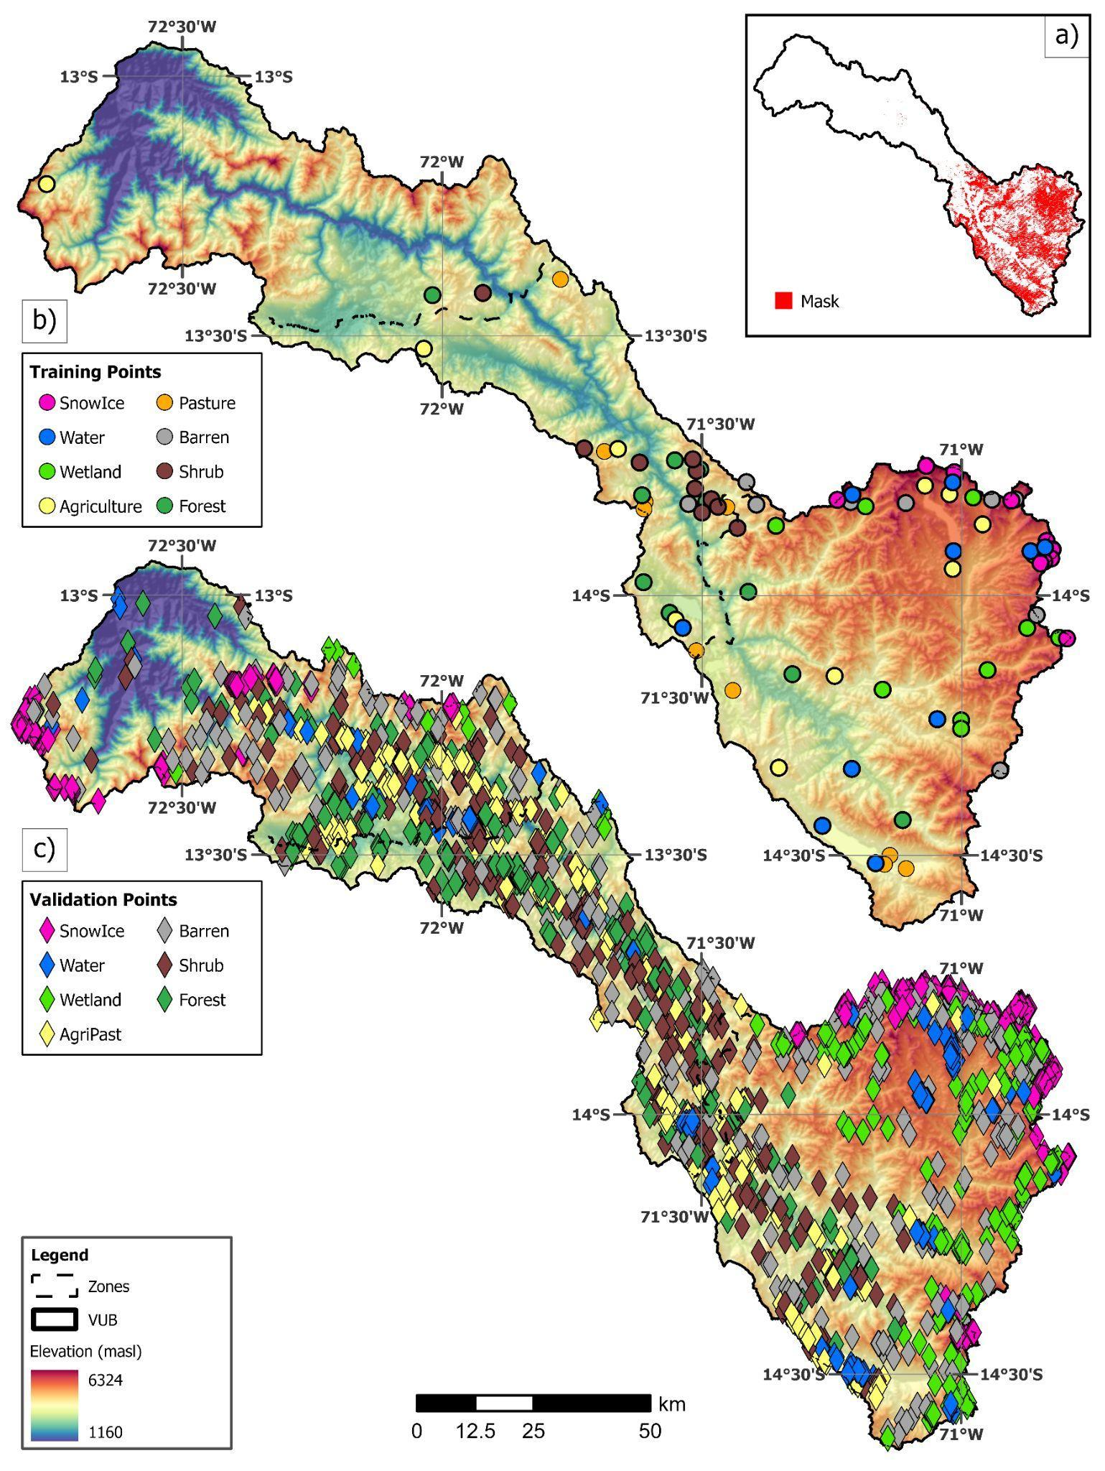Fig. S2. Training and Validation Points of the VUB. (a) Cloud-masked was generated by identifying pixels containing information across all seasons during the 10-year analysis, after applying the cloud-mask function to remove cloud and shadow pixels. (b) 10 training points per class, selected through random points stratification within the cloud-masked area. (c) Validation points for different land cover types.
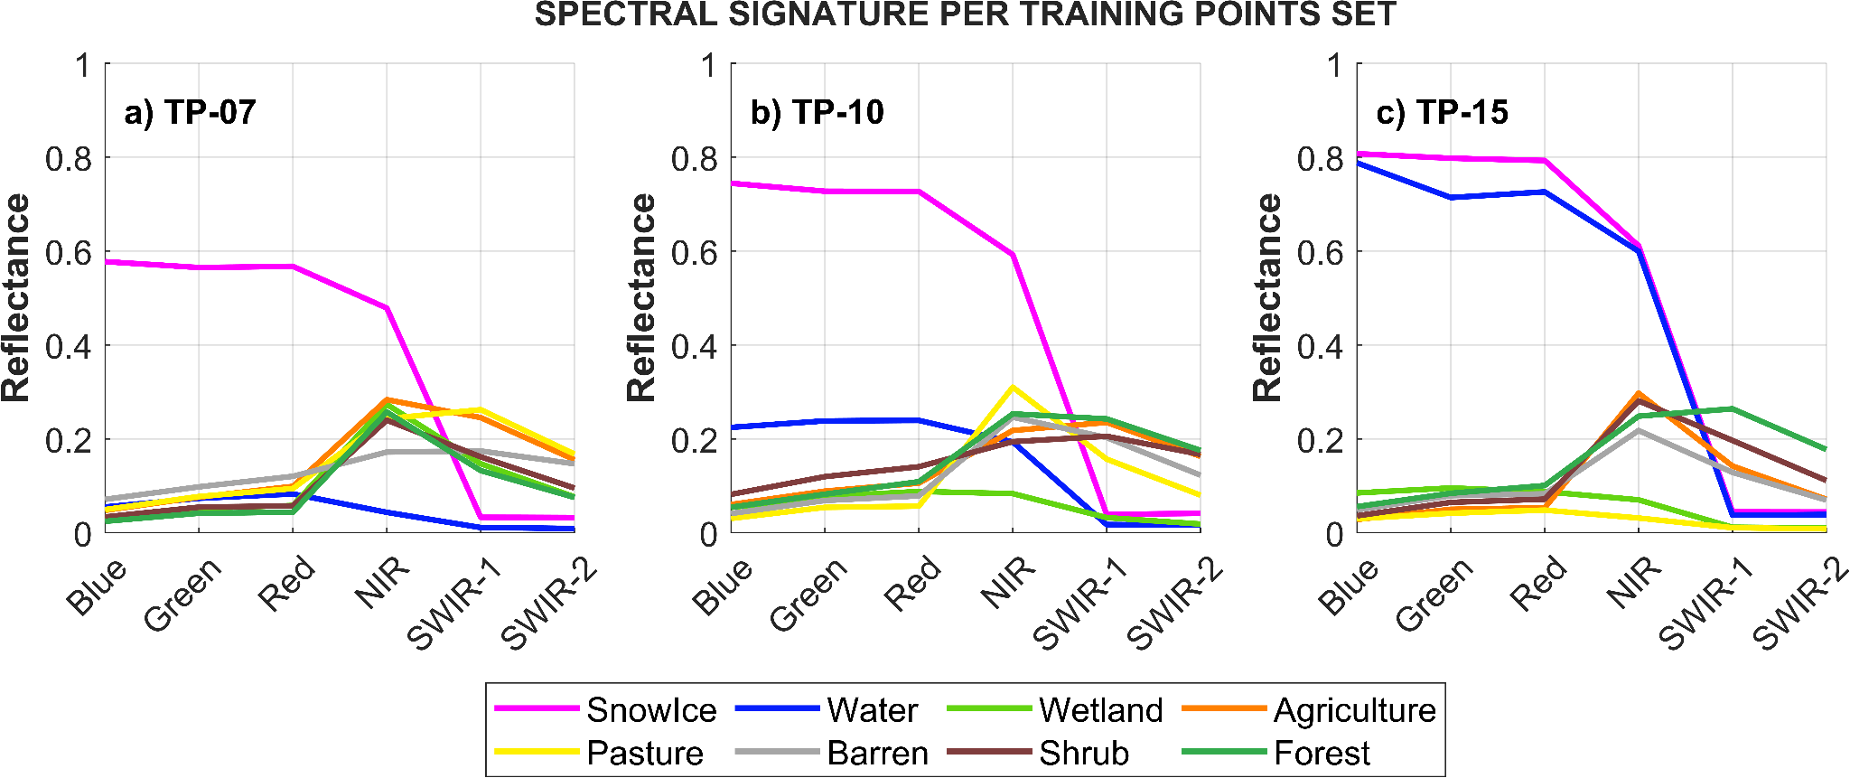
Fig. S3. Average spectral signatures comparison from the three different training point sets of 7 (a), 10 (b), and 15 (c) points per class.
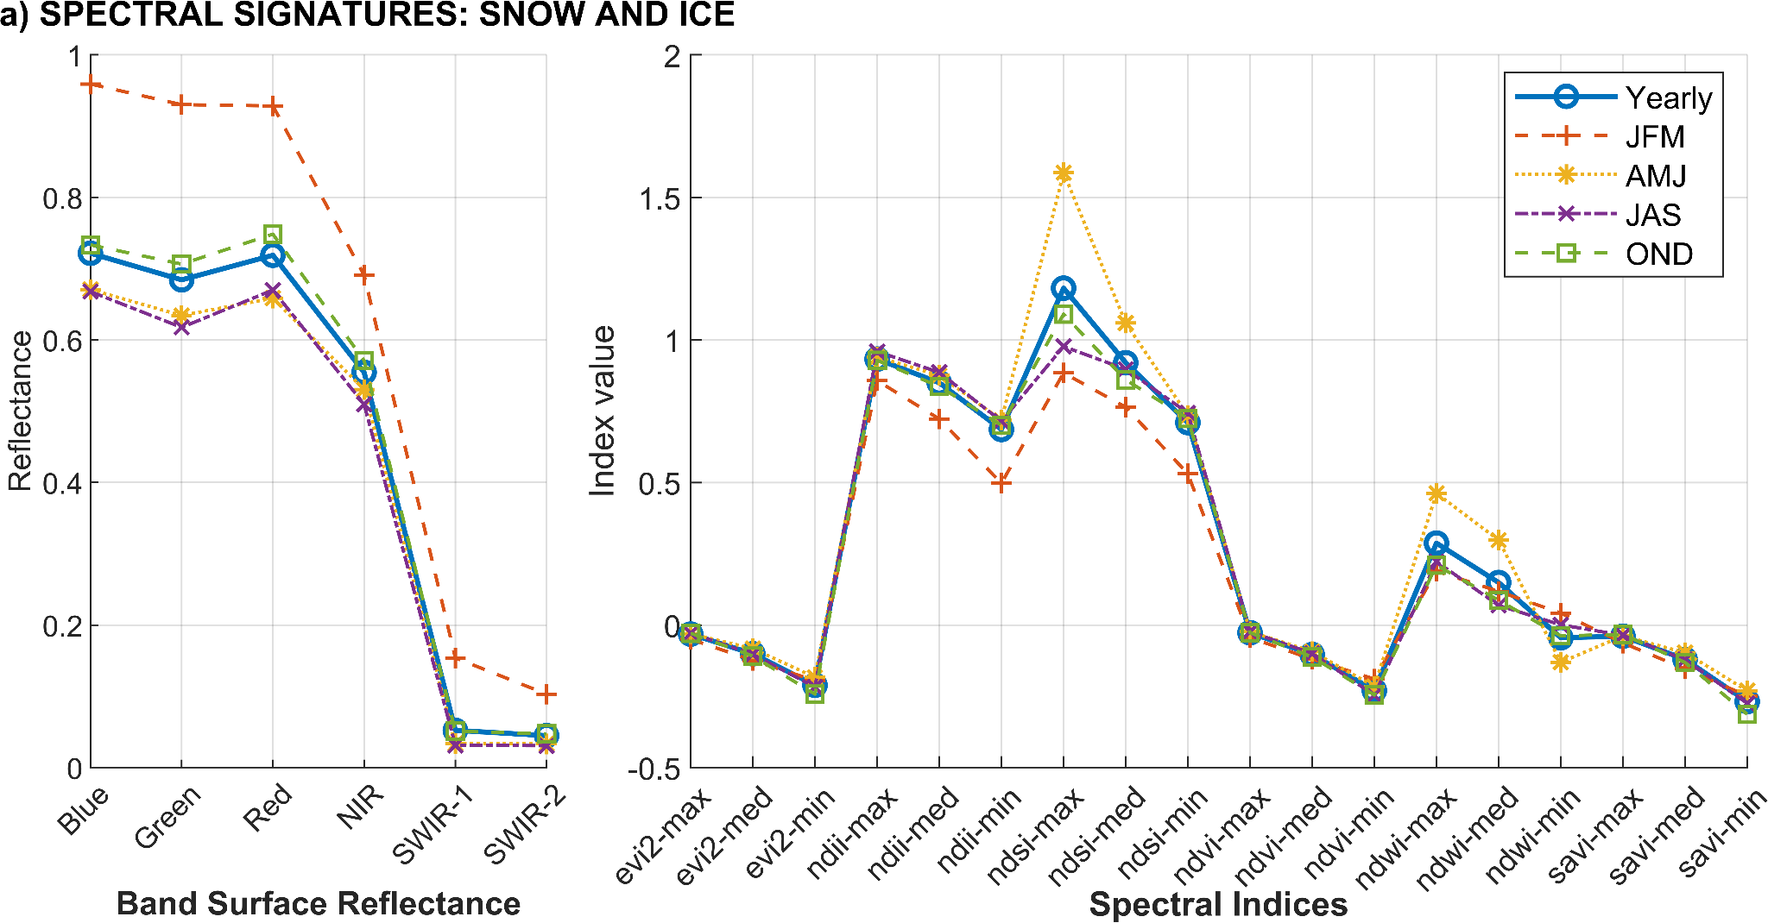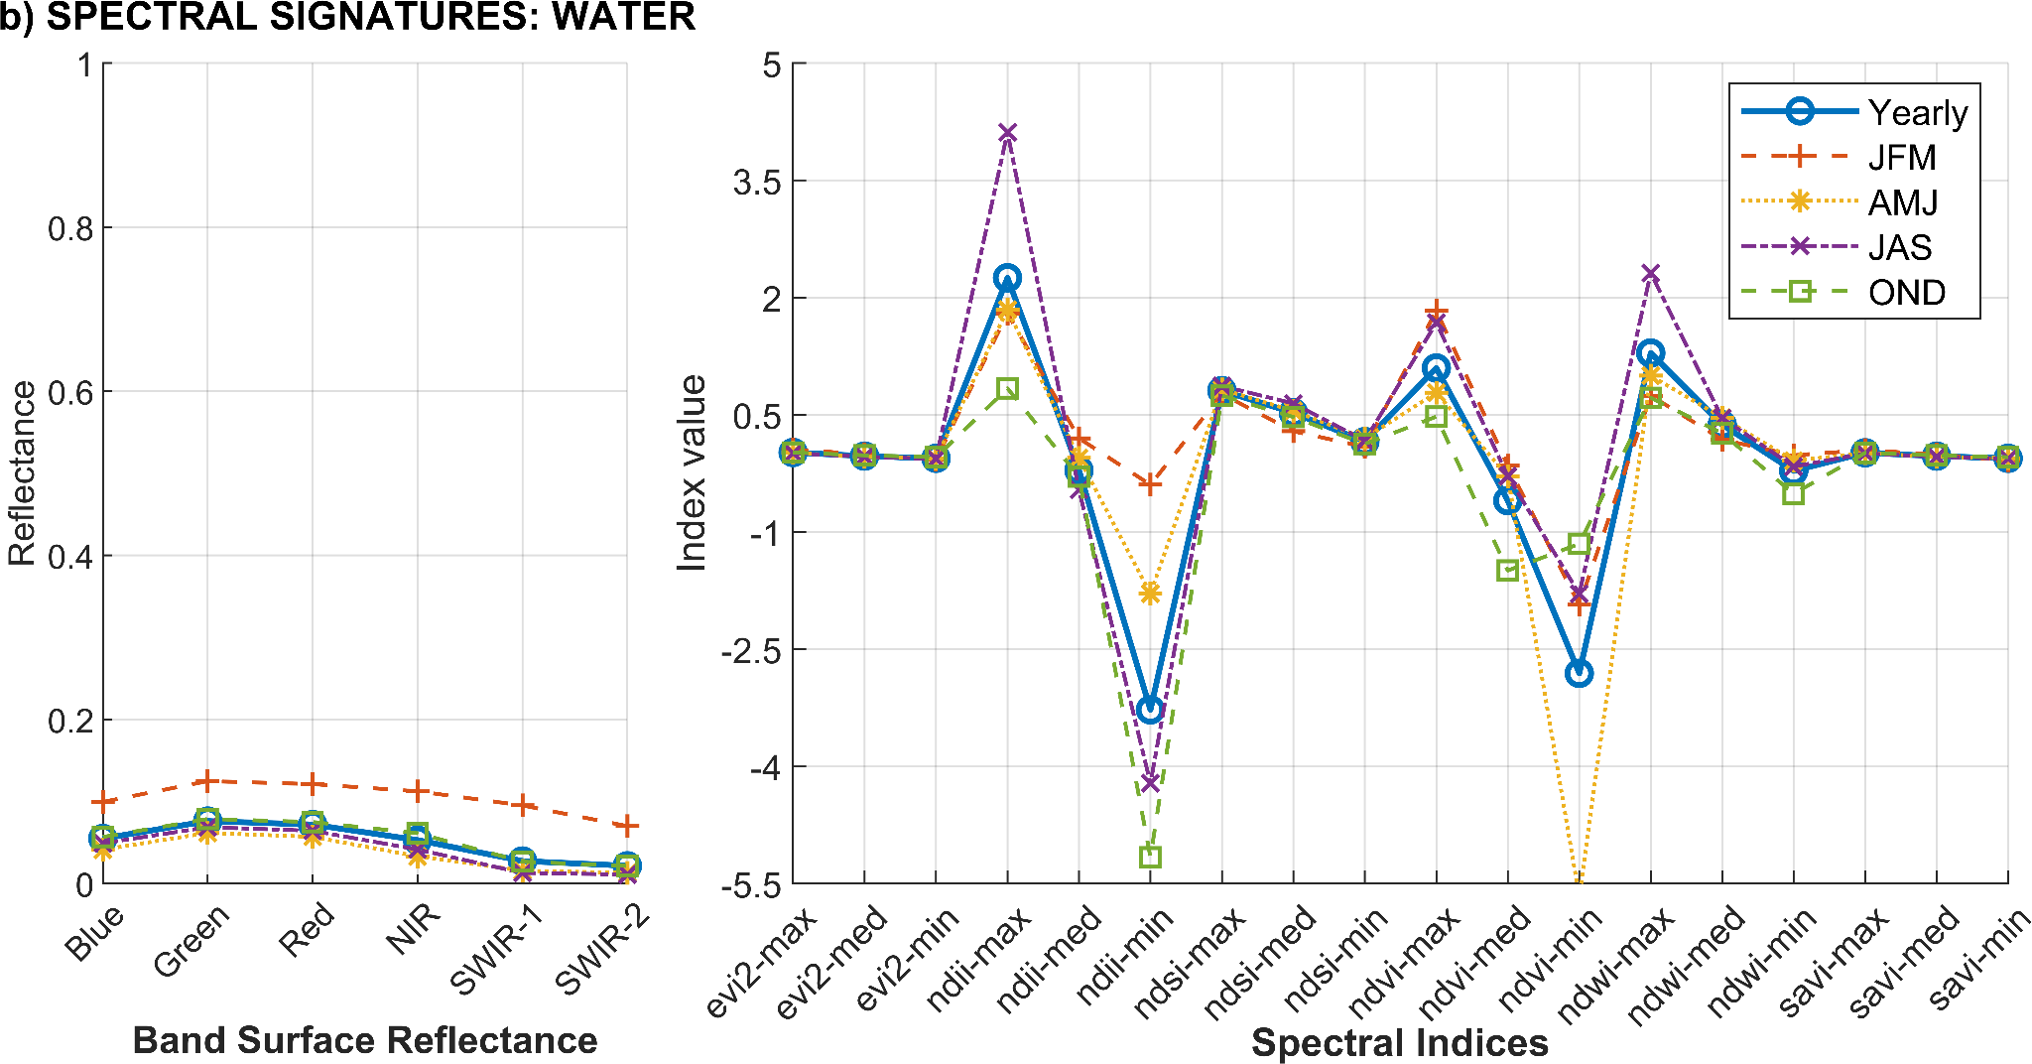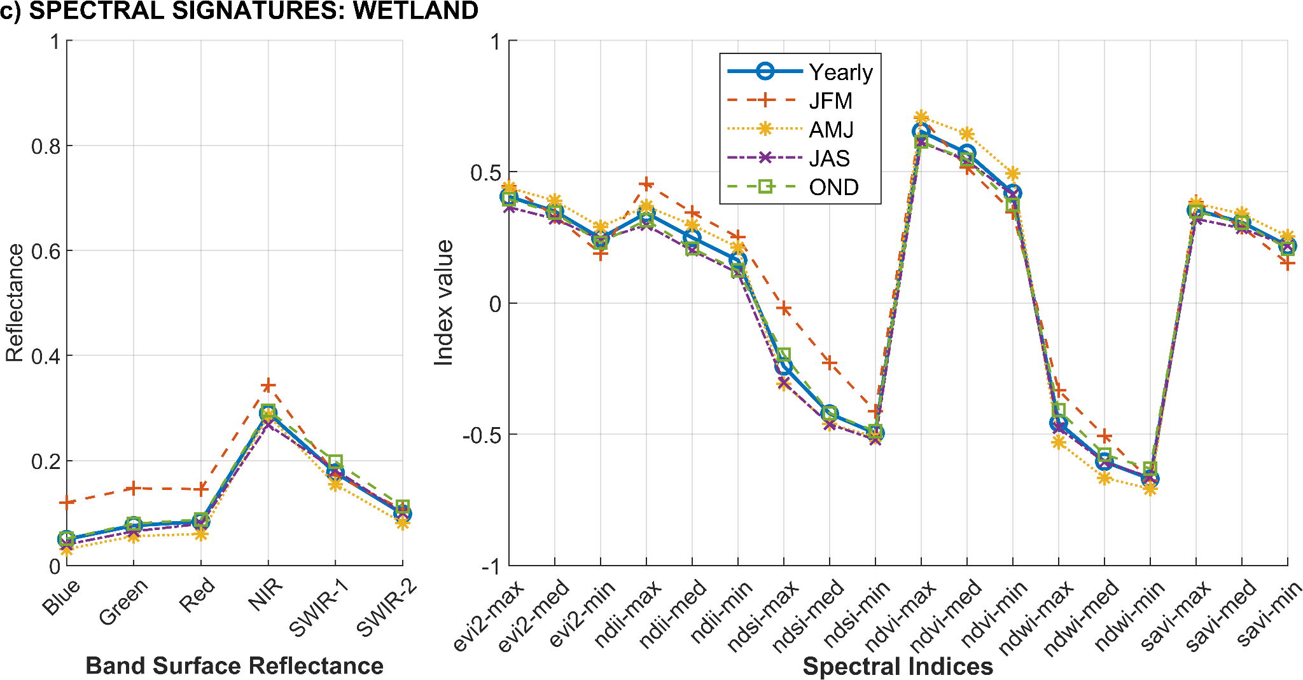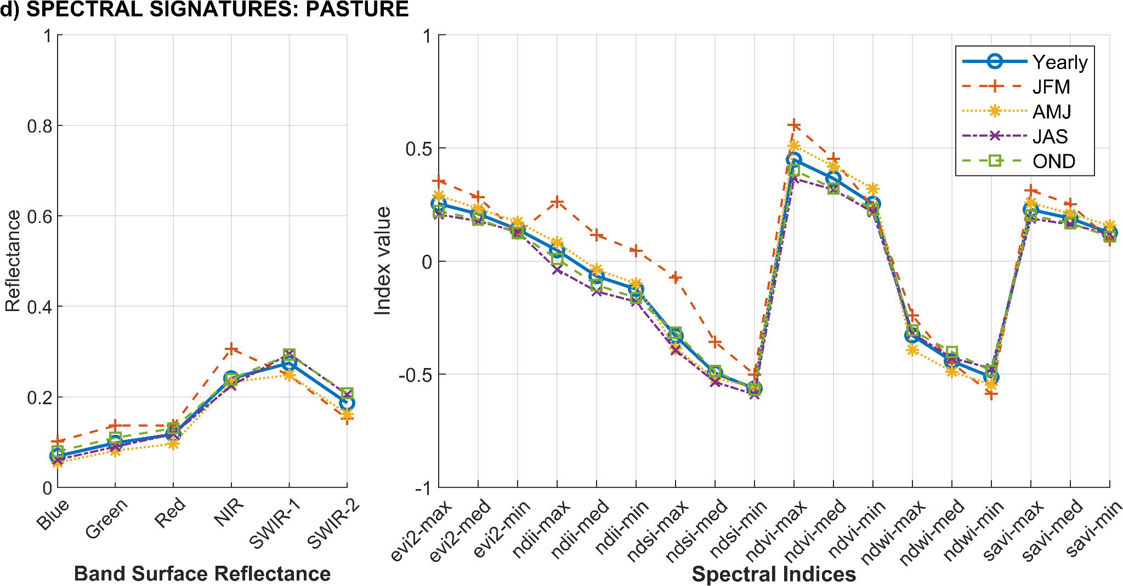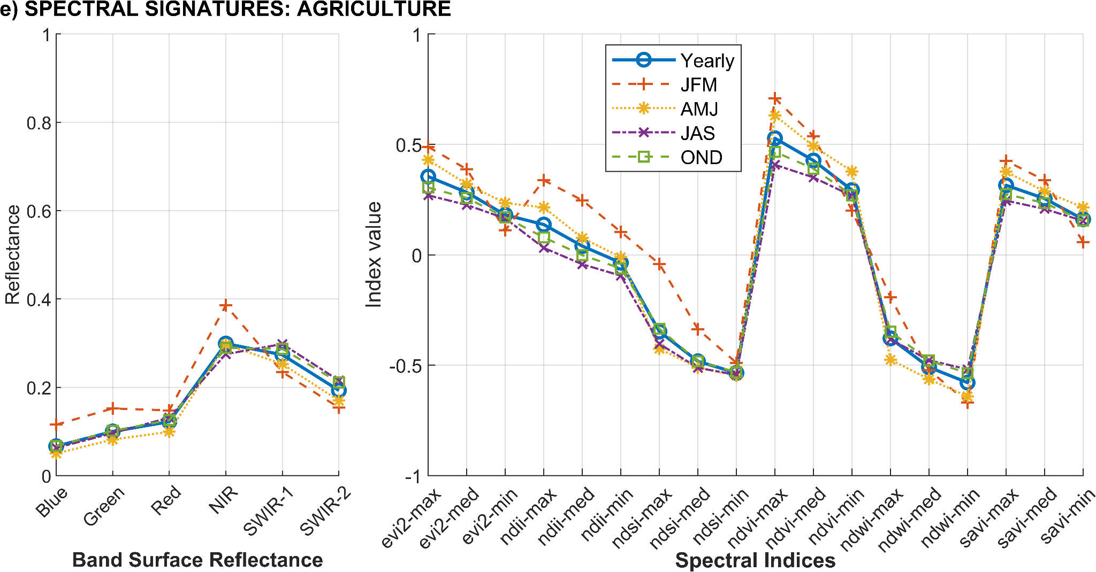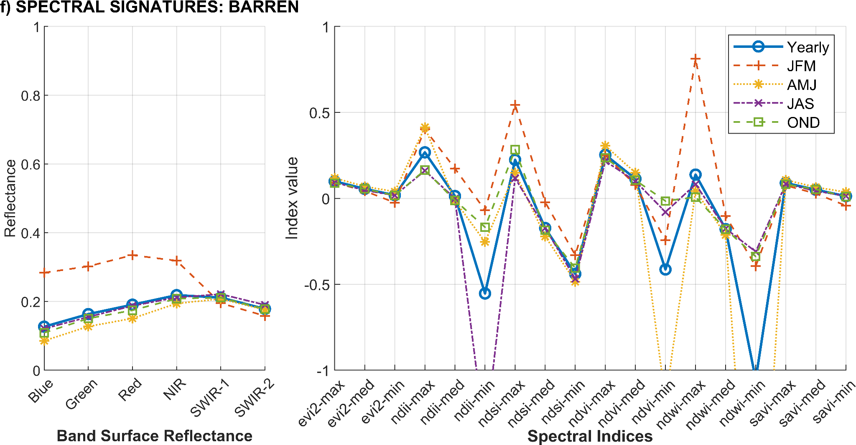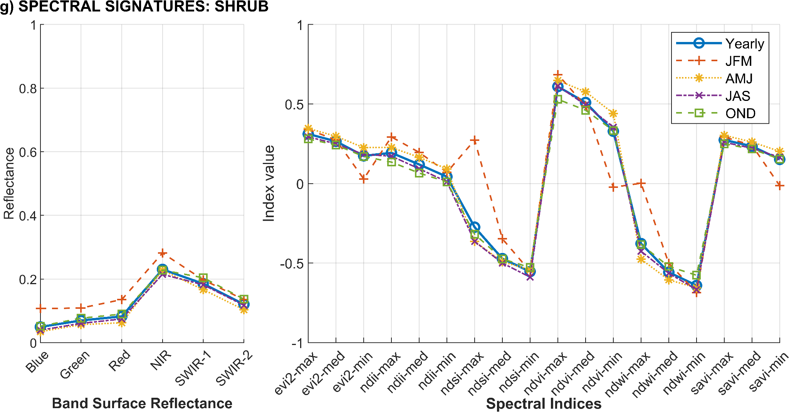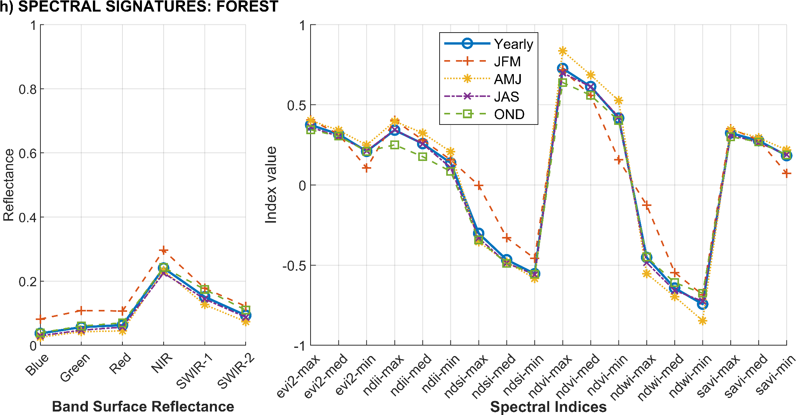
Fig. S4. Spectral signatures for band surface reflectance and spectral indices per land cover class at different time scales. Panels a to h present the average spectral signatures and spectral indices information at different time scales for snow/ice, water, wetland, pasture, agriculture, barren, shrub and forest, respectively. To enhance visualisation and facilitate comparison, the x-axis scales of plots have been adjusted.

A.4. Variable importance and predictor redundancy
Feature importance has been used in vegetation classification studies to identify which variables contribute most to class separation within a model (e.g. Marín Del Valle & Jiang, 2022). Here, variable importance was extracted from each seasonal Random Forest model using the “.explain()” function in Google Earth Engine. The values were normalised from 0-100% within each model, so each predictor represents its relative contribution to that seasonal classification. Fig. S5 presents the importance of variables across seasons, ranked by mean value. Slope, elevation, NDII-Min and NDII-Max presented the highest mean contributions (between 4.2% and 5.4%) (Fig. S5b). The importance of the 29 variables varied across seasons and years (Fig. S5a), suggesting that predictor contributions were not stable over time. Vegetation, water, and snow/ice classification indices maintained moderate yet consistent importance over time, supporting their application in seasonal land cover discrimination. The difference between the highest and lowest mean importance values was 3.6%, reflecting a relatively balanced contribution among predictors.
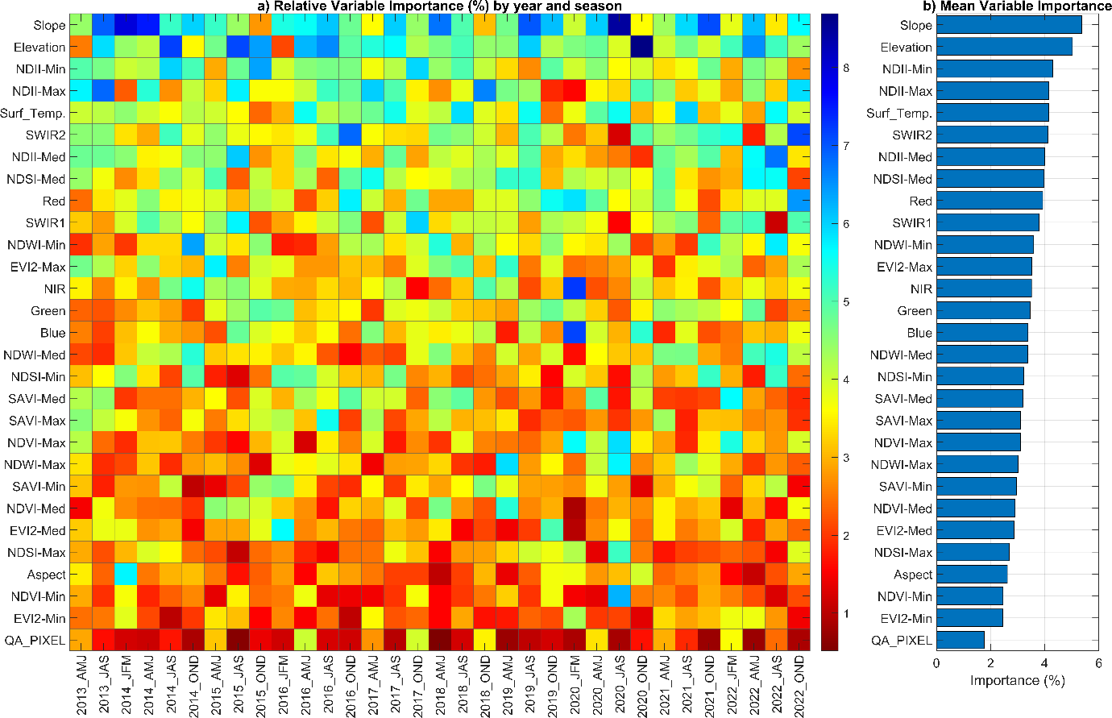
Fig. S5. Random Forest Variable Importance (%) results. (a) shows the results across seasons and years. (b) is the mean variable importance value. Values were obtained from each season using “.explain()” function in Google Earth Engine and normalised from 0-100% for comparison between seasons.
To assess potential redundancy among predictor variables, we calculated pairwise Spearman correlations (r) among the 29 predictors (see Table S3) used in the Random Forest classification. Correlations were computed using predictor values extracted at all training point locations across the 33 seasonal image collections. Predictor pairs with |r| > 0.8 and p < 0.05 were considered highly collinear. Highly collinear predictors sorted by the number of pairs and mean Importance representation in the classification model in 33 seasons are presented in Table S5. This analysis showed that 23 of the 29 predictors were involved in at least one highly collinear pair (|r|>0.8, p<0.05). Of these, 12 predictors were involved in only 1 to 3 highly correlated pairs. The remaining 11 predictors were involved in 10 to 11 pairs, including mainly vegetation and water indices derived from NDVI, NDWI, SAVI, and EVI2.
Table S5. Highly correlated predictors, number of pairs (based on |r|>0.8 and p<0.05).
Predictor | Collinear Pairs | Mean Variable Importance (%) | Rank Mean Variable Importance
NDWI-Min | 11 | 3.6 | 11
EVI2-Max | 11 | 3.5 | 12
NDWI-Max | 11 | 3.0 | 21
NDVI-Med | 11 | 2.9 | 23
NDWI-Med | 10 | 3.4 | 16
SAVI-Med | 10 | 3.2 | 18
SAVI-Max | 10 | 3.1 | 19
SAVI-Min | 10 | 3.0 | 22
EVI2-Med | 10 | 2.9 | 24
NDVI-Min | 10 | 2.5 | 27
EVI2-Min | 10 | 2.4 | 28
NDVI-Max | 3 | 3.1 | 20
NDII-Max | 2 | 4.2 | 4
SWIR2 | 2 | 4.1 | 6
NDII-Med | 2 | 4.0 | 7
NDSI-Med | 2 | 4.0 | 8
Red | 2 | 3.9 | 9
Green | 2 | 3.5 | 14
Blue | 2 | 3.4 | 15
NDSI-Max | 2 | 2.7 | 25
NDII-Min | 1 | 4.3 | 3
SWIR1 | 1 | 3.8 | 10
NDSI-Min | 1 | 3.2 | 17
However, we did not remove these predictors from the classification models justified by their role in separating different land covers. Although some predictors are statistically redundant, they still contribute useful spectral information for specific classes or seasonal conditions. This is supported by the Random Forest variable importance analysis (Fig. S5). Mean relative importance of these predictors ranged from 2.4% to 4.3%, and with some of these ranked predictors within the highest mean variable importance. Therefore, we retained the full predictor set to preserve information relevant to seasonal land cover discrimination.

A.5. Accuracy assessment and map comparisons
Due to the lack of a ground control point database for validating the results, we conducted the accuracy assessments using a validation points dataset independent of the training points information (Fig. S2c). This dataset consists of 10 validation points per class, identified individually for each season using true-colour satellite imagery (e.g., Landsat, Sentinel 2, Google Earth) with spatial resolution below 30 m. In total, 2,293 validation points were generated by an operator independent of the classification process, and this dataset is provided in the Data Availability section.
To provide a general evaluation of the classifications, we assessed the Overall Accuracy and Cohen’s Kappa coefficient, and for the analysis per land cover class we calculated a confusion matrix, precision, recall, and F1-score (Alem & Kumar, 2022). Fig. S6. presents the results of the Overall Accuracy and Kappa calculated for the full VUB and for each zone to evaluate temporal and spatial variability in classification performance. For the VUB, mean Overall Accuracy and Kappa were 0.74 and 0.70, respectively. Performance varied spatially, with higher values in zone 3 (Overall Accuracy = 0.85; Kappa = 0.82; n = 1104 validation points) and lower values in zone 1 (Overall Accuracy = 0.65; Kappa = 0.58; n = 629) and zone 2 (Overall Accuracy = 0.62; Kappa = 0.51; n = 560). These lower values reflect poorer image quality due to higher cloud presence in the northwestern and middle regions of the VUB. Seasonal differences were also observed (Fig. S6c), with lower accuracy during JFM and OND, when cloud presence was higher, and higher accuracy during the drier AMJ and JAS seasons.
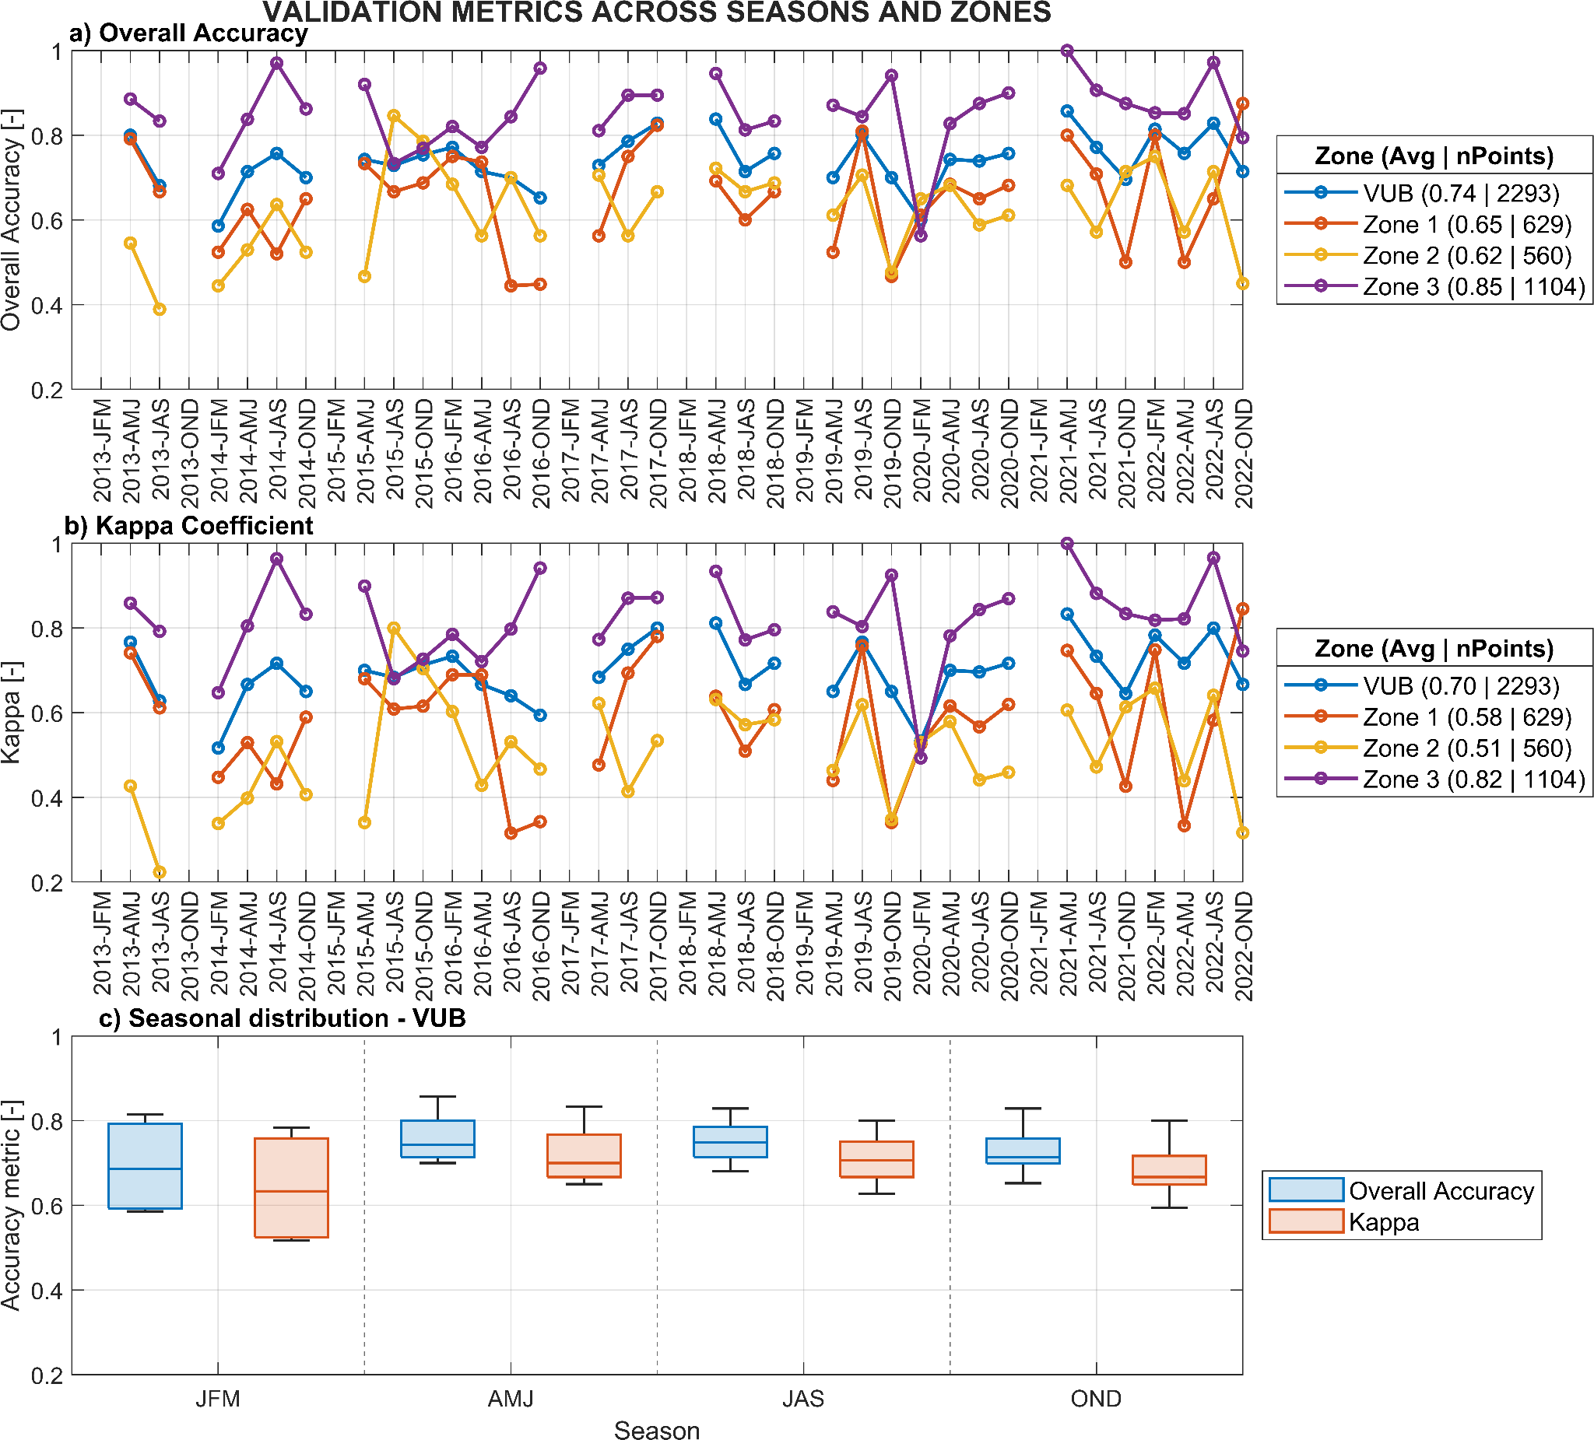
Fig. S6. Overall Accuracy and Cohen’s Kappa coefficient across seasons and zones. Panels (a) and (b) show the temporal variability of Overall Accuracy and Kappa coefficient for the VUB and its three zones across the 33 seasons. Panel (c) grouped metrics by season for the VUB.
Confusion matrix results are presented in Table S6, and summary of precision, recall, and F1-score results are presented in Table S7. Snow/Ice and water showed the highest performance, with F1-scores of 1.00 and 0.96, respectively. Wetlands also showed high recall (0.92) but lower precision (0.69), indicating that most observed wetlands were detected, although some other classes were also classified as wetlands. Agriculture/pasture and shrub presented the lowest F1-scores, 0.58 and 0.23, respectively, reflecting spectral overlap among vegetated classes. Additionally, we calculated the out-of-bag error to provide an internal assessment of model performance. The OOB error was used only as an internal model diagnostic, while the main accuracy assessment was based on the independent validation dataset. The average out-of-bag error across all seasons was 0.32, indicating that 32% of the samples excluded from training were misclassified.
Table S6. Confusion matrix for land cover classes using the complete validation dataset across 33 seasons.
 |  | PREDICTED
 |  | Snow/Ice | Water | Wetland | Agr/Past | Barren | Shrub | Forest
OBSERVED | Snow/Ice | 330 | 0 | 0 | 0 | 0 | 0 | 0
OBSERVED | Water | 0 | 306 | 1 | 0 | 10 | 0 | 0
OBSERVED | Wetland | 0 | 1 | 305 | 9 | 1 | 0 | 14
OBSERVED | Agr/Past | 0 | 0 | 41 | 226 | 23 | 24 | 14
OBSERVED | Barren | 0 | 9 | 0 | 107 | 210 | 3 | 0
OBSERVED | Shrub | 0 | 1 | 83 | 101 | 3 | 49 | 93
OBSERVED | Forest | 0 | 2 | 12 | 5 | 12 | 26 | 272

Table S7. Precision, recall, F1-score per land cover class
Class Name | Precision | Recall | F1Score
Snow/Ice | 1.00 | 1.00 | 1.00
Water | 0.96 | 0.97 | 0.96
Wetland | 0.69 | 0.92 | 0.79
Agr/Past | 0.50 | 0.69 | 0.58
Barren | 0.81 | 0.64 | 0.71
Shrub | 0.48 | 0.15 | 0.23
Forest | 0.69 | 0.83 | 0.75
In addition to the accuracy assessments, we compared mapped glacier and wetland areas against outlines from official national inventories (Fig. S7). This evaluation provides an external reference to assess the consistency of our classification results. For glacier areas, we compared our JAS land cover classification results for snow/ice with the glacier outlines from the INAIGEM Glacier Inventories for 2016 and 2020, which are based on dry season satellite imagery (INAIGEM, 2018; 2023b). The comparison includes the VUB and zones 1 and 3; zone 2 was excluded due to the absence of mapped ice cover. The glacier comparison (Fig. S7a) shows generally strong agreement, with some variability among zones. In VUB, differences were relatively low, with an absolute percentage difference of 8.2% (11.7 km²) in 2016 and 5.3% (7.2 km²) in 2020, suggesting consistency between the datasets. Zone 3 shows minimal discrepancies of 0.85% (-0.7 km²) and 2.0% (1.7 km²) in 2016 and 2020, respectively. By contrast, zone 1 presented larger differences, reaching 21.7% (12.4 km²) in 2016 and 10.3% (5.5 km²) in 2020. These higher deviations may reflect data gaps and classification errors observed in higher areas of zone 1. On average, our classification mapped 7.8% more glacier area than the official inventories across all zones and years.
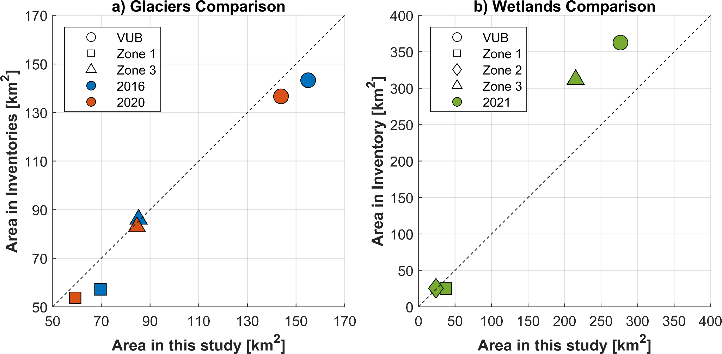
Fig. S7. Area comparison between classified maps and official inventories. Glacier areas (a) are during JAS and INAIGEM dry-season inventories (2016, 2020). Wetland areas (b) correspond to AMJ in 2021, and the National Bofedales Inventory, filtered above 3800 m a.s.l.
For wetland areas, we compared our classified wetland extent from AMJ 2021, which we subsequently filtered to elevations above 3,800 m a.s.l., to follow the elevation threshold of the methodology of the National Bofedales Inventory (NBI) for the same year (INAIGEM, 2023a). This elevation threshold allowed better alignment with the NBI approach, which focuses on high-elevation wetlands (bofedales). A wetland comparison (Fig. S7b) reveals area differences. In VUB and zone 3, our classification mapped 23.7% (-86.1 km²) and 31.0% (-96.8 km²) less wetland area, respectively, than reported in the inventory. Meanwhile, in zone 1, we find an overestimation of 48.6% (+12.2 km²), and in zone 2, the values were closer (-6.2%, -1.6 km²). This likely reflects differences in wetlands mapping approaches, as well as potential misclassifications within the national inventory. Visual inspection of satellite imagery revealed that several mapped bofedales overlapped with barren land, lakes, and glacier-covered areas (Fig. S8). On average, our classification mapped 3.3% less wetland area than the national inventory. In contrast, our results provide new dimensions (seasonality, class separation, such as lakes vs. wetlands) that are not present in the national maps. This suggests our method better distinguishes certain cover types.
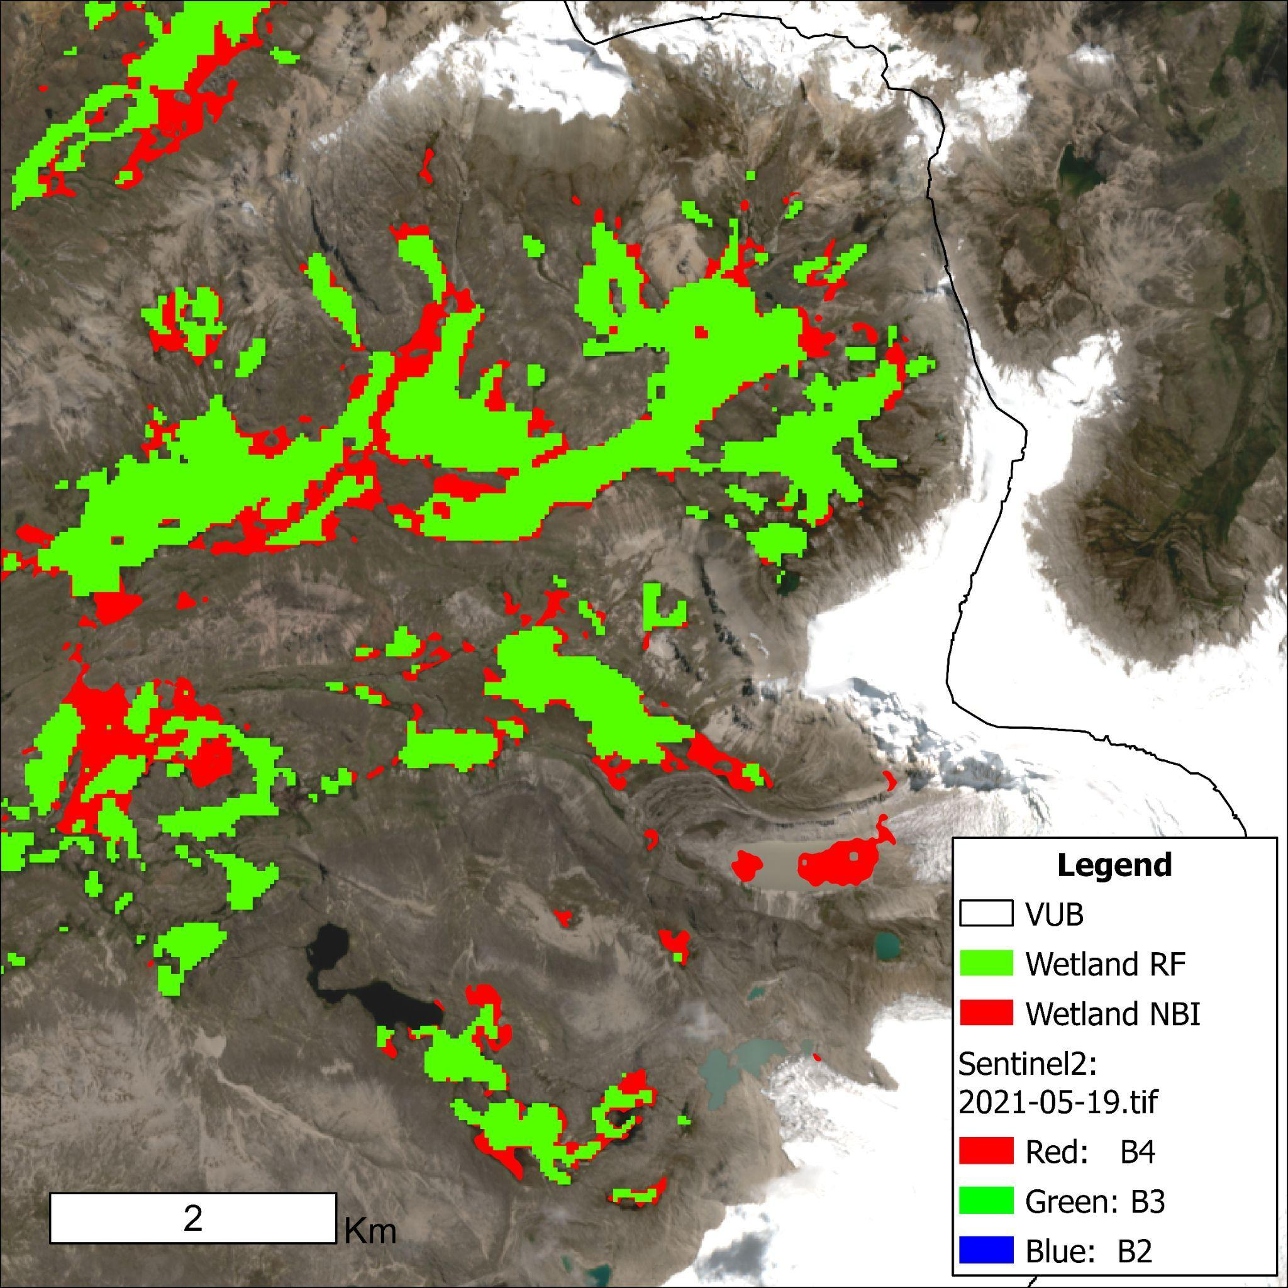
Fig. S8. Wetland classification comparison. In green are the classified wetlands, and in red are the NBI wetlands. The background image is a Sentinel-2 true colour composite from May 19, 2021 (Image ID: 20210519T145729_20210519T150626_T19LBE), centred at -13.89 lat. -70.84 long.

A.6. Snow and Ice distinction from Albedo Retrieval, and Snow Line Elevation (SLE) estimation
To provide more detailed information on the mapped cryosphere results from the Random Forest classification, we distinguished snow/ice areas using the Albedo Retrieval approach (Liang, 2001; Naegeli et al., 2019) in combination with the Otsu method (Gaddam et al., 2022; Otsu, 1979). The Random Forest classification initially presents snow and ice as a combined class due to their similar spectral responses in Landsat bands, limiting their separation with this method alone. Since snow generally has higher albedo than exposed ice, we further separated these classes using the Albedo Retrieval approach. This step was performed after the initial Random Forest classification to restrict calculations to the mapped snow/ice class, reducing unnecessary processing over non-cryospheric surfaces. The Albedo Retrieval method performs a narrow-to-broadband conversion based on the surface reflectance bands of a satellite image into a broadband albedo ($α_{short}$) using the following equation proposed by Liang (2001):
$α_{short}={0.356α}_{1}+{0.130α}_{3}+ {0.373α}_{4}+ {0.085α}_{5}+ {0.072α}_{7}-0.0018$ (1)
Where: $α_{short}$is the albedo broadband output, $α_{1}$ is the Blue, $α_{3}$ is the Red, $α_{4}$ is the NIR, $α_{5}$ is the SWIR1, $α_{7}$ is the SWIR2 surface reflectance band. We applied this equation to the median mosaic image of each season of the same Landsat same image collection constrained to the snow/ice classification result from the Random Forest and the glacier outlines from 2010 (ANA, 2014) to ensure that the classification of Ice occurs only within the glacial zone. Results were limited by maintaining realistic albedo values between 0.05 and 1. To differentiate between snow and ice, we used a threshold on albedo (Naegeli et al., 2019), which classifies albedo > 0.55 as "certainly snow" and albedo < 0.25 as "certainly ice". As described by the authors, this method left an uncertainty range for albedo values between 0.25 and 0.55. To address this uncertainty, we applied the Otsu method, which determines an optimal threshold by calculating a bimodal histogram of pixel values within the 0.25-0.55 range. Finally, we updated the seasonal land cover classification results with the snow and ice independent categories.
Snow Line Elevation (SLE) was derived from the seasonal snow maps using the method described by Meier (1975). For each seasonal classification, the total area of snow pixels within the VUB was calculated. This snow area was then compared to the hypsometric distribution using the 30 m SRTM V3 DEM (Farr et al., 2007) to determine the elevation above which the available terrain area matched the mapped snow-covered area. This approach assumes that snow accumulates at higher elevations before extending downslope. Meier method has demonstrated reliable performance for SLE determination in the Peruvian Andes, producing more stable estimates than the Krajčí et al. (2014) method under catchment conditions with limited proportional snow cover (Fyffe et al., 2025). We compared both the Meier and Krajčí methods using our seasonal snow maps and grouped the SLE per season (Fig. S9). SLE results with Krajčí showed inconsistencies across seasons and zones, with limited results in zones with low snow cover, such as zone 2 (Fig. S9c), and high SLE values in zone 1 (Fig. S9b). These inconsistencies likely result from the limited seasonal snow cover in parts of the VUB, as well as the strong influence of local hypsometry when snow pixels accounted for only a small fraction of the zone. Therefore, the Meier method was chosen as the primary approach because it provided more consistent seasonal snowline elevation estimates across the VUB and individual zones.
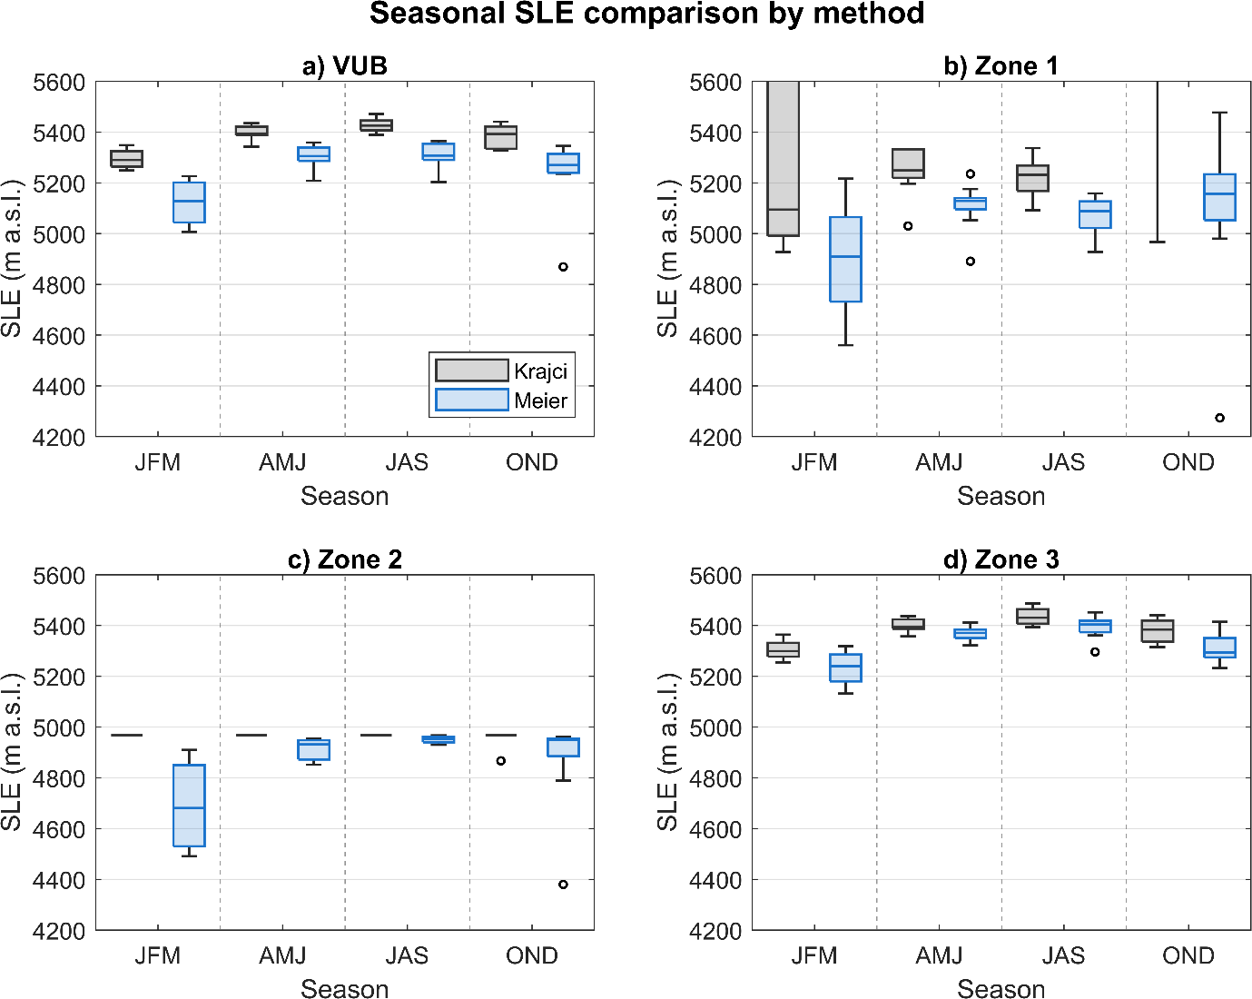
Fig. S9. Seasonal Snow Line Elevation (SLE) comparison between the Meier and Krajčí methods. SLE was estimated using the Meier (1975) (blue boxes) and the Krajčí et al. (2014) (grey boxes) methods. Panels show seasonal SLE distributions for (a) VUB, and (b-d) its three zones. SLE values are reported in m a.s.l.

A.7. Method performance and limitations
We mapped 33 seasonal land cover classes over 10 years using Landsat imagery, Random Forests, and albedo retrieval to distinguish snow and ice. The land cover classification achieved an overall accuracy of 0.74 (section A.5), consistent with similar studies (e.g. Pizarro et al., 2022; Vega Isuhuaylas et al., 2018), and exhibits minor differences relative to glacier and wetlands inventories, improving area detections (section A.5). The distinction between agriculture and pasture was constrained by the spectral information available in Landsat imagery, a limitation that could be addressed by larger sensors with broader spectral bands. Misclassification errors were also identified in water pixels confused with shadows at higher elevations, and in challenges distinguishing shrub and forest from wetlands above 4,200 m a.s.l.
Regarding the temporal scale of our study, the three-month seasonal composites enhance class separability and reveal land-cover seasonality; however, they cannot resolve monthly variability. Implementing multidecadal seasonal mapping at smaller spatial scales would enable the detection of such changes and improve understanding of potential ecosystem colonisation in response to glacier retreat and across elevations (Ficetola et al., 2021; Tovar et al., 2013). Finally, although seasonal patterns of wetland phases are consistent with independent water-table observations for bofedales in zone 4 (Ross et al., 2023), the phase classification requires further comparison with in situ hydrological data from various wetlands, as well as a refinement of the thresholds used to define the timing of drying and rewetting for each phase type.

B. CLIMATE
Climate data for 2013-2022 were obtained from simulations of the Weather Research and Forecasting (WRF) model version 3.8.1, with precipitation and temperature data bias-corrected using weather station observations. The dataset from 2013 to 2022 is an extension of the 1980-2018 data published in Fyffe et al. (2021) and Potter et al. (2023), using the same ERA-5 forcing and bias correction approach for temperature and precipitation, based on station data from 1980-2018. The WRF climate data were spatially available at a 4km resolution over the VUB and then extracted the grid points per zone for regional statistics. Daily maximum, minimum, and average temperature from WRF were aggregated to seasonal averages, while daily precipitation was aggregated to seasonal totals from 2013 to 2022. Seasonal climate information for the VUB and per zone is provided in the Data Availability section.
A representation of the monthly climographs per zone is presented in Fig. S10 and climate seasonality is summarised in Figure 5e-h in the main text. Zone 1 experiences high precipitation (total annual 1,035 mm), influenced by its proximity to the Amazon rainforest (Northwest VUB). Zone 3 (1,035 mm), while larger in area, is also affected by its northern proximity to the Amazon from the northeast. In contrast, zone 2 has drier conditions (835 mm) due to its mid-high elevation within the VUB. During the dry period, zone 3 receives more rainfall (193 mm) than zone 1 (144 mm). Maximum temperature increased steadily across seasons, with the lowest values in VUB found in zone 3 (11 °C to 12.4 °C) and the highest in zone 2 (15.4 °C to 17.1 °C). Average and minimum temperatures followed seasonal patterns across zones, with lower temperatures in the dry season than in the wet season; zone 1 had the warmest conditions and zone 3 the coldest. Only zone 3 registered minimum temperatures below 0 °C on average, during the dry season.
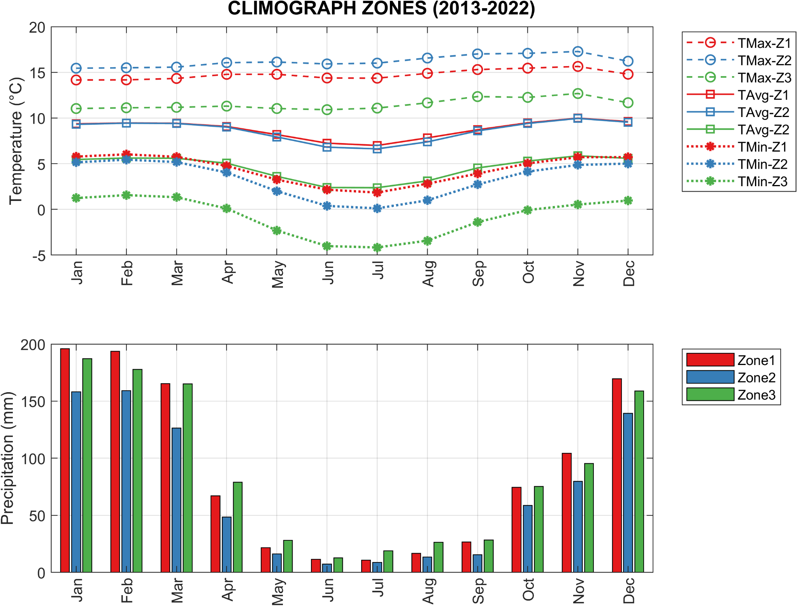
Fig. S10. Monthly climograph information for temperature and precipitation across the three different zones of analysis based on the WRF data from 2013 to 2022.

C. SEASONAL LAND COVER BETWEEN 2013 AND 2022
The full time series of the values of each land cover together with the mean and median values grouped per season between 2013 and 2022 is provided in the Data Availability section.
Table S8. Average seasonal values from 2013 to 2022.
Zone | Season | Snow | Ice | Water | Wetland | Agriculture/Pasture | Barren | Shrub | Forest | NoData
VUB | JFM | 310.7 | 23.1 | 326.5 | 801.9 | 4193.8 | 2301 | 1321 | 991.6 | 778.3
VUB | AMJ | 97.1 | 61.0 | 204.9 | 392.1 | 6127.7 | 1830.6 | 970.9 | 906.9 | 456.7
VUB | JAS | 97.4 | 63.0 | 206.0 | 319.5 | 6244.9 | 2240.6 | 842.8 | 981.0 | 52.8
VUB | OND | 227.6 | 31.5 | 208.1 | 449.9 | 5639.6 | 2108.4 | 817.1 | 804.0 | 761.6
Zone 1 | JFM | 157.0 | 7.2 | 112.9 | 183.8 | 854.0 | 881.3 | 555.6 | 574.6 | 430.1
Zone 1 | AMJ | 43.3 | 18.8 | 49.9 | 103.7 | 1462.9 | 516.9 | 434.0 | 725.9 | 401.2
Zone 1 | JAS | 50.4 | 20.8 | 57.3 | 100.0 | 1621.7 | 540.1 | 467.3 | 872.3 | 26.7
Zone 1 | OND | 132.1 | 7.4 | 56.1 | 184.2 | 1249.7 | 488.4 | 376.1 | 667.3 | 595.1
Zone 2 | JFM | 20.7 | - | 51.9 | 121.9 | 801.9 | 293.0 | 453.8 | 273.2 | 269.1
Zone 2 | AMJ | 0.0 | - | 26.3 | 49.8 | 1412.4 | 255.0 | 372.8 | 134.8 | 34.4
Zone 2 | JAS | 0.0 | - | 24.6 | 38.6 | 1442.4 | 411.1 | 279.8 | 83.6 | 5.4
Zone 2 | OND | 15.9 | - | 27.1 | 42.5 | 1283.0 | 437.0 | 306.7 | 93.5 | 79.9
Zone 3 | JFM | 133.0 | 15.9 | 161.7 | 496.3 | 2537.9 | 1126.6 | 311.6 | 143.8 | 79.1
Zone 3 | AMJ | 53.8 | 42.2 | 128.7 | 238.7 | 3252.4 | 1058.6 | 164.1 | 46.2 | 21.1
Zone 3 | JAS | 46.9 | 42.2 | 124.1 | 180.9 | 3180.8 | 1289.4 | 95.6 | 25.2 | 20.7
Zone 3 | OND | 79.6 | 24.1 | 124.9 | 223.3 | 3106.8 | 1183.0 | 134.3 | 43.2 | 86.6
Zone 4 | JFM | 21.6 | 3.0 | 2.4 | 22.4 | 28.0 | 50.4 | - | - | 4.9
Zone 4 | AMJ | 15.4 | 7.3 | 1.3 | 16.7 | 41.1 | 48.6 | - | - | 2.1
Zone 4 | JAS | 13.7 | 8.4 | 1.2 | 14.7 | 43.8 | 49.6 | - | - | 1.5
Zone 4 | OND | 17.6 | 5.1 | 1.3 | 17.1 | 39.9 | 43.6 | - | - | 8.2
Figure S11 presents the land cover classification results for a glacierised area of the northeast of zone 3, across the four seasons of 2022. Snow cover visibly expands during the wet seasons (JFM and OND), while Wetland areas contract during the dry period (AMJ and JAS). Barren and ice areas also show seasonal variations, especially during the wet seasons. Around glacier margins, water pixels vary across seasons, likely due to classification uncertainty or cloud/shadow artefacts not resolved by masking, which reflect into the NoData areas. Land cover classification products are available in Data Availability section.
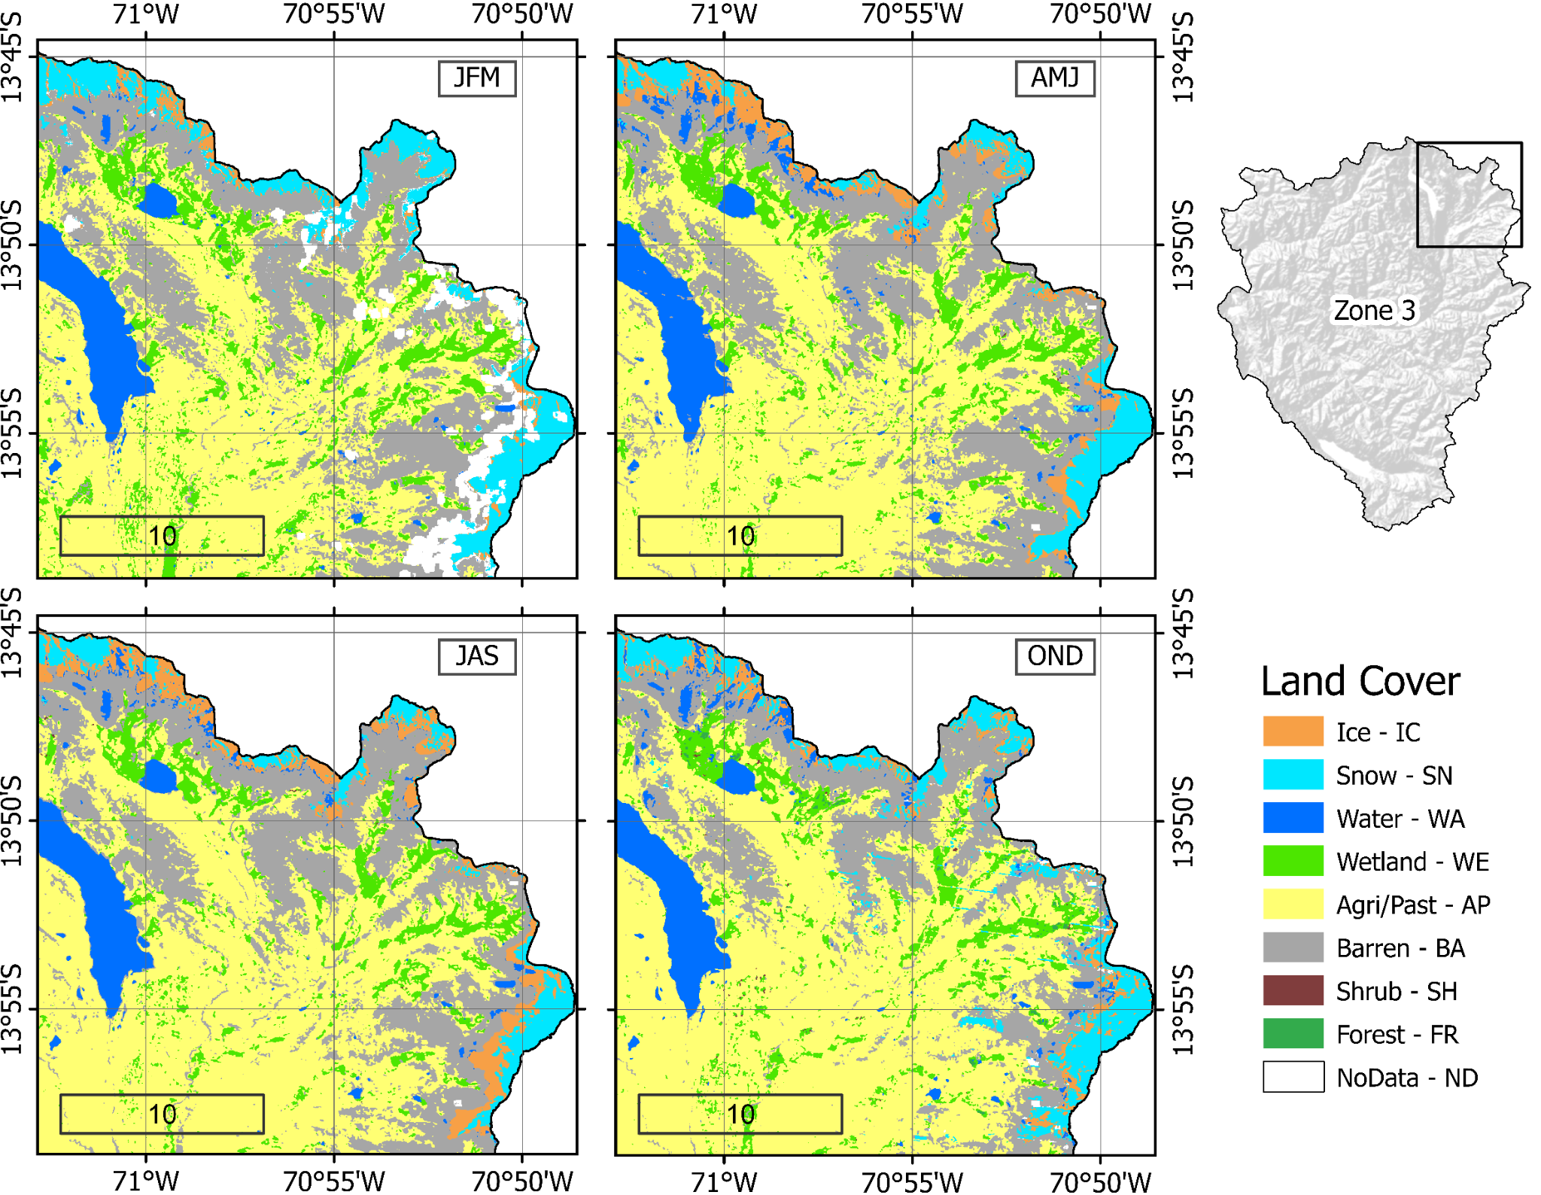
Fig. S11. Seasonal land cover maps for a glacierised subset of the North-East zone 3 region (South-East VUB), showing classification results for the four seasons (JFM, AMJ, JAS, OND) in 2022.
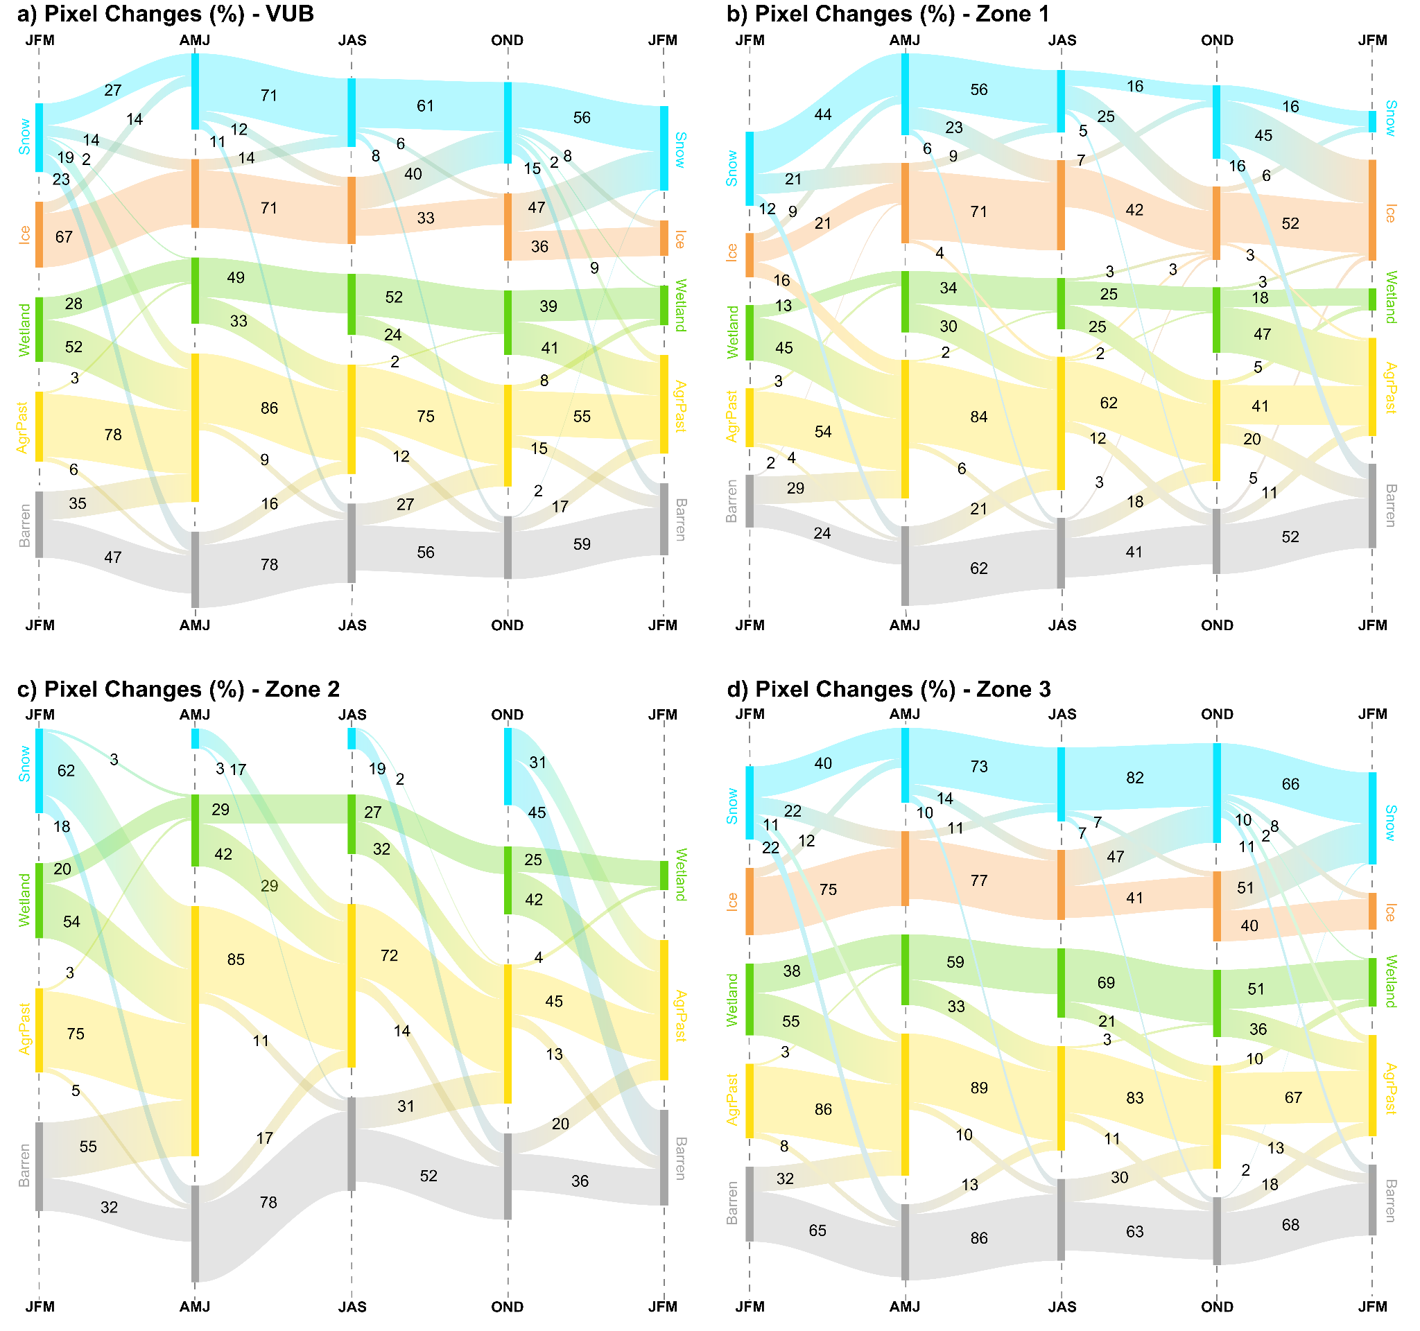
Fig. S12. Seasonal Sankey diagram of land cover pixel transitions in (a) VUB, and (c-d) zones 1 to 3. Labelled values represent the percentage of pixels that transition out from each class between one season and the next, based on the average over 2013-2022. Only dominant classes are shown; connectors below 2% and transitions to Water, Shrub, Forest and NoData classes were removed for clarity, so displayed values may not sum to 100%. The height of each bar is fixed and does not reflect absolute area. Complete pixel transition matrices are provided in Data Availability.

D. WETLANDS - LAND COVER SEASONAL EXCHANGES
We transposed the land cover pixel change transitions (%) into area (km²) with the focus on wetlands to quantify: i) the wetlands area that transforms into other land cover and ii) other land covers' area that transforms into wetlands at the inter-seasonal scale (Table S9). We use the average area value of each first season from Table S8, and we then quantified the ratio of the area using the pixel transition percentage from section C. We limited this analysis to transitions with snow, agriculture/pasture and barren as these represent the 3 more related areas that exchange pixels with wetlands based on the pixel transition results.
Table S9. Seasonal wetland in and out of land cover classes.
ZONE | LandCover_i | Wetland to LandCover_i (km²) |  |  |  | LandCover_i to Wetland (km²)
ZONE | LandCover_i | JFM-  AMJ | AMJ-  JAS | JAS-  OND | OND-  JFM | JFM-  AMJ | AMJ-  JAS | JAS-  OND | OND-  JFM
VUB | Snow | 0.16 | 0.12 | 3.48 | 2.47 | 5.16 | 0.07 | 0.06 | 3.76
VUB | Agriculture/  Pasture | 416.3 | 128.7 | 75.36 | 184.7 | 114.1 | 62.50 | 134.3 | 429.2
VUB | Barren | 20.29 | 7.69 | 5.14 | 17.32 | 21.86 | 6.22 | 14.56 | 32.05
Zone 1 | Snow | 0 | 0 | 0.71 | 1.12 | 4.08 | 0 | 0.27 | 0
Zone 1 | Agriculture/  Pasture | 99.63 | 43.18 | 31.95 | 76.85 | 21.43 | 8.92 | 21.57 | 54.86
Zone 1 | Barren | 6.27 | 2.79 | 2.33 | 3.79 | 7.49 | 1.40 | 4.16 | 6.54
Zone 2 | Snow | 0 | 0 | 0.27 | 0.26 | 0.54 | 0 | 0 | 0
Zone 2 | Agriculture/  Pasture | 66.08 | 20.72 | 12.34 | 17.74 | 20.13 | 8.62 | 19.18 | 56.33
Zone 2 | Barren | 4.16 | 1.34 | 0.90 | 0.88 | 2.49 | 0.69 | 3.17 | 5.86
Zone 3 | Snow | 0 | 0.10 | 0.90 | 0.85 | 1.54 | 0.02 | 0.05 | 1.39
Zone 3 | Agriculture/  Pasture | 271.2 | 77.66 | 37.33 | 81.43 | 67.51 | 27.65 | 82.38 | 310.1
Zone 3 | Barren | 8.88 | 3.65 | 1.30 | 6.30 | 8.11 | 1.38 | 3.22 | 15.50
Zone 4 | Snow | 0 | 0.02 | 0.18 | 0.02 | 0.15 | 0.01 | 0.02 | 0.01
Zone 4 | Agriculture/  Pasture | 7.09 | 3.11 | 1.30 | 2.86 | 2.04 | 1.30 | 4.11 | 9.54
Zone 4 | Barren | 0.25 | 0.29 | 0.12 | 0.71 | 0.65 | 0.07 | 0.32 | 0.66

E. SNOW AND WETLANDS TEMPORAL FREQUENCY
Table S10. Snow and wetland spatial statistics per zone and frequency class.
Zone | Frequency Class | Snow (pixels) | Snow (%) | Snow Median Elevation (m a.s.l.) | Wetland (pixels) | Wetland (%) | Wetland Median Elevation  (m a.s.l.) | Wetland-Glacier  Mean Distance (km)
VUB | Rare | 184321 | 59 | 4,888 | 952296 | 68 | 3,584 | 16.3
VUB | Occasional | 35113 | 11 | 5,257 | 203866 | 15 | 3,906 | 16.2
VUB | Frequent | 31880 | 10 | 5,224 | 110764 | 8 | 4,343 | 12.6
VUB | Highly Persistent | 61857 | 20 | 5,411 | 123960 | 9 | 4,692 | 5.9
Zone 1 | Rare | 122414 | 70 | 4,703 | 497460 | 84 | 3,309 | 12.5
Zone 1 | Occasional | 14956 | 8.5 | 5,027 | 66866 | 11 | 3,396 | 11.9
Zone 1 | Frequent | 18797 | 11 | 5,083 | 21293 | 4 | 4,245 | 9.1
Zone 1 | Highly Persistent | 19536 | 11 | 5,206 | 4247 | 1 | 4,307 | 5.6
Zone 2 | Rare | 262 | 100 | 4,312 | 161743 | 77 | 3,553 | 32.0
Zone 2 | Occasional | - | - | - | 35718 | 17 | 3,518 | 30.9
Zone 2 | Frequent | - | - | - | 11114 | 5 | 3,668 | 31.0
Zone 2 | Highly Persistent | - | - | - | 1895 | 1 | 4,377 | 35.4
Zone 3 | Rare | 61645 | 45 | 5,242 | 293093 | 50 | 4,414 | 14.1
Zone 3 | Occasional | 20157 | 15 | 5,321 | 101282 | 17 | 4,379 | 13.9
Zone 3 | Frequent | 13083 | 9.5 | 5,360 | 78357 | 13 | 4,546 | 11.0
Zone 3 | Highly Persistent | 42321 | 31 | 5,454 | 117818 | 20 | 4,714 | 5.5
Zone 4 | Rare | 9887 | 33 | 5,290 | 8169 | 28 | 4,882 | 3.4
Zone 4 | Occasional | 3203 | 11 | 5,357 | 3372 | 11 | 4,887 | 3.2
Zone 4 | Frequent | 3135 | 11 | 5,383 | 3854 | 13 | 4,887 | 3.1
Zone 4 | Highly Persistent | 13487 | 45 | 5,492 | 14068 | 48 | 4,896 | 2.7

Table S11. Snow pixel frequency count over all wetlands.
Zone | Frequency Class | Snow pixel over wetlands | Ratio to total snow (%)
VUB | Rare | 7550 | 0.54
VUB | Occasional | 0 | 0.00
VUB | Frequent | 0 | 0.00
VUB | Persistent | 0 | 0.00
Zone 1 | Rare | 7217 | 1.22
Zone 1 | Occasional | 0 | 0.00
Zone 1 | Frequent | 0 | 0.00
Zone 1 | Persistent | 0 | 0.00
Zone 2 | Rare | 97 | 0.05
Zone 2 | Occasional | 0 | 0.00
Zone 2 | Frequent | 0 | 0.00
Zone 2 | Persistent | 0 | 0.00
Zone 3 | Rare | 236 | 0.04
Zone 3 | Occasional | 0 | 0.00
Zone 3 | Frequent | 0 | 0.00
Zone 3 | Persistent | 0 | 0.00
Zone 4 | Rare | 93 | 0.32
Zone 4 | Occasional | 0 | 0.00
Zone 4 | Frequent | 0 | 0.00
Zone 4 | Persistent | 0 | 0.00

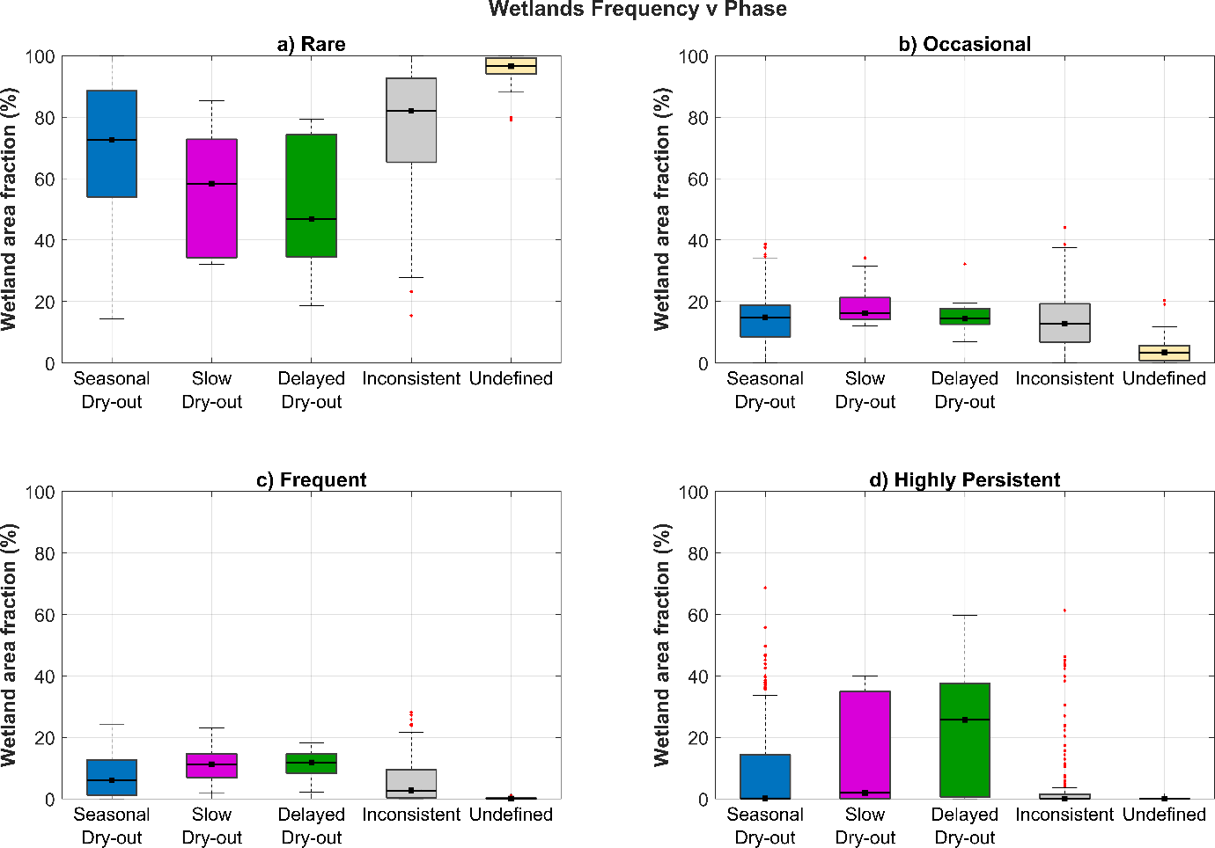Fig. S13. Wetlands seasonal phase area (%) grouped by their frequency class (a-d).
Table S12. Elevation statistics for sub-basins grouped by wetland seasonal phase. Elevation values represent the median elevation of each sub-basin. The p-value reports the Wilcoxon rank-sum test comparing each wetland phase against all remaining phases.
Wetland Phase | Sub-basins (n) | Min Elev. (m a.s.l.) | Max Elev. (m a.s.l.) | Med Elev. (m a.s.l.) | p-value
Seasonal Dry-out | 366 | 2,822 | 5,461 | 4,130 | 0.000013
Slow Dry-out | 16 | 3,649 | 5,248 | 4,212 | 0.029213
Delayed Dry-out | 13 | 3,535 | 5,276 | 4,453 | 0.007942
Inconsistent | 183 | 3,092 | 5,379 | 4,090 | 0.327870
Undefined | 37 | 1,734 | 3,077 | 2,567 | 0.000000

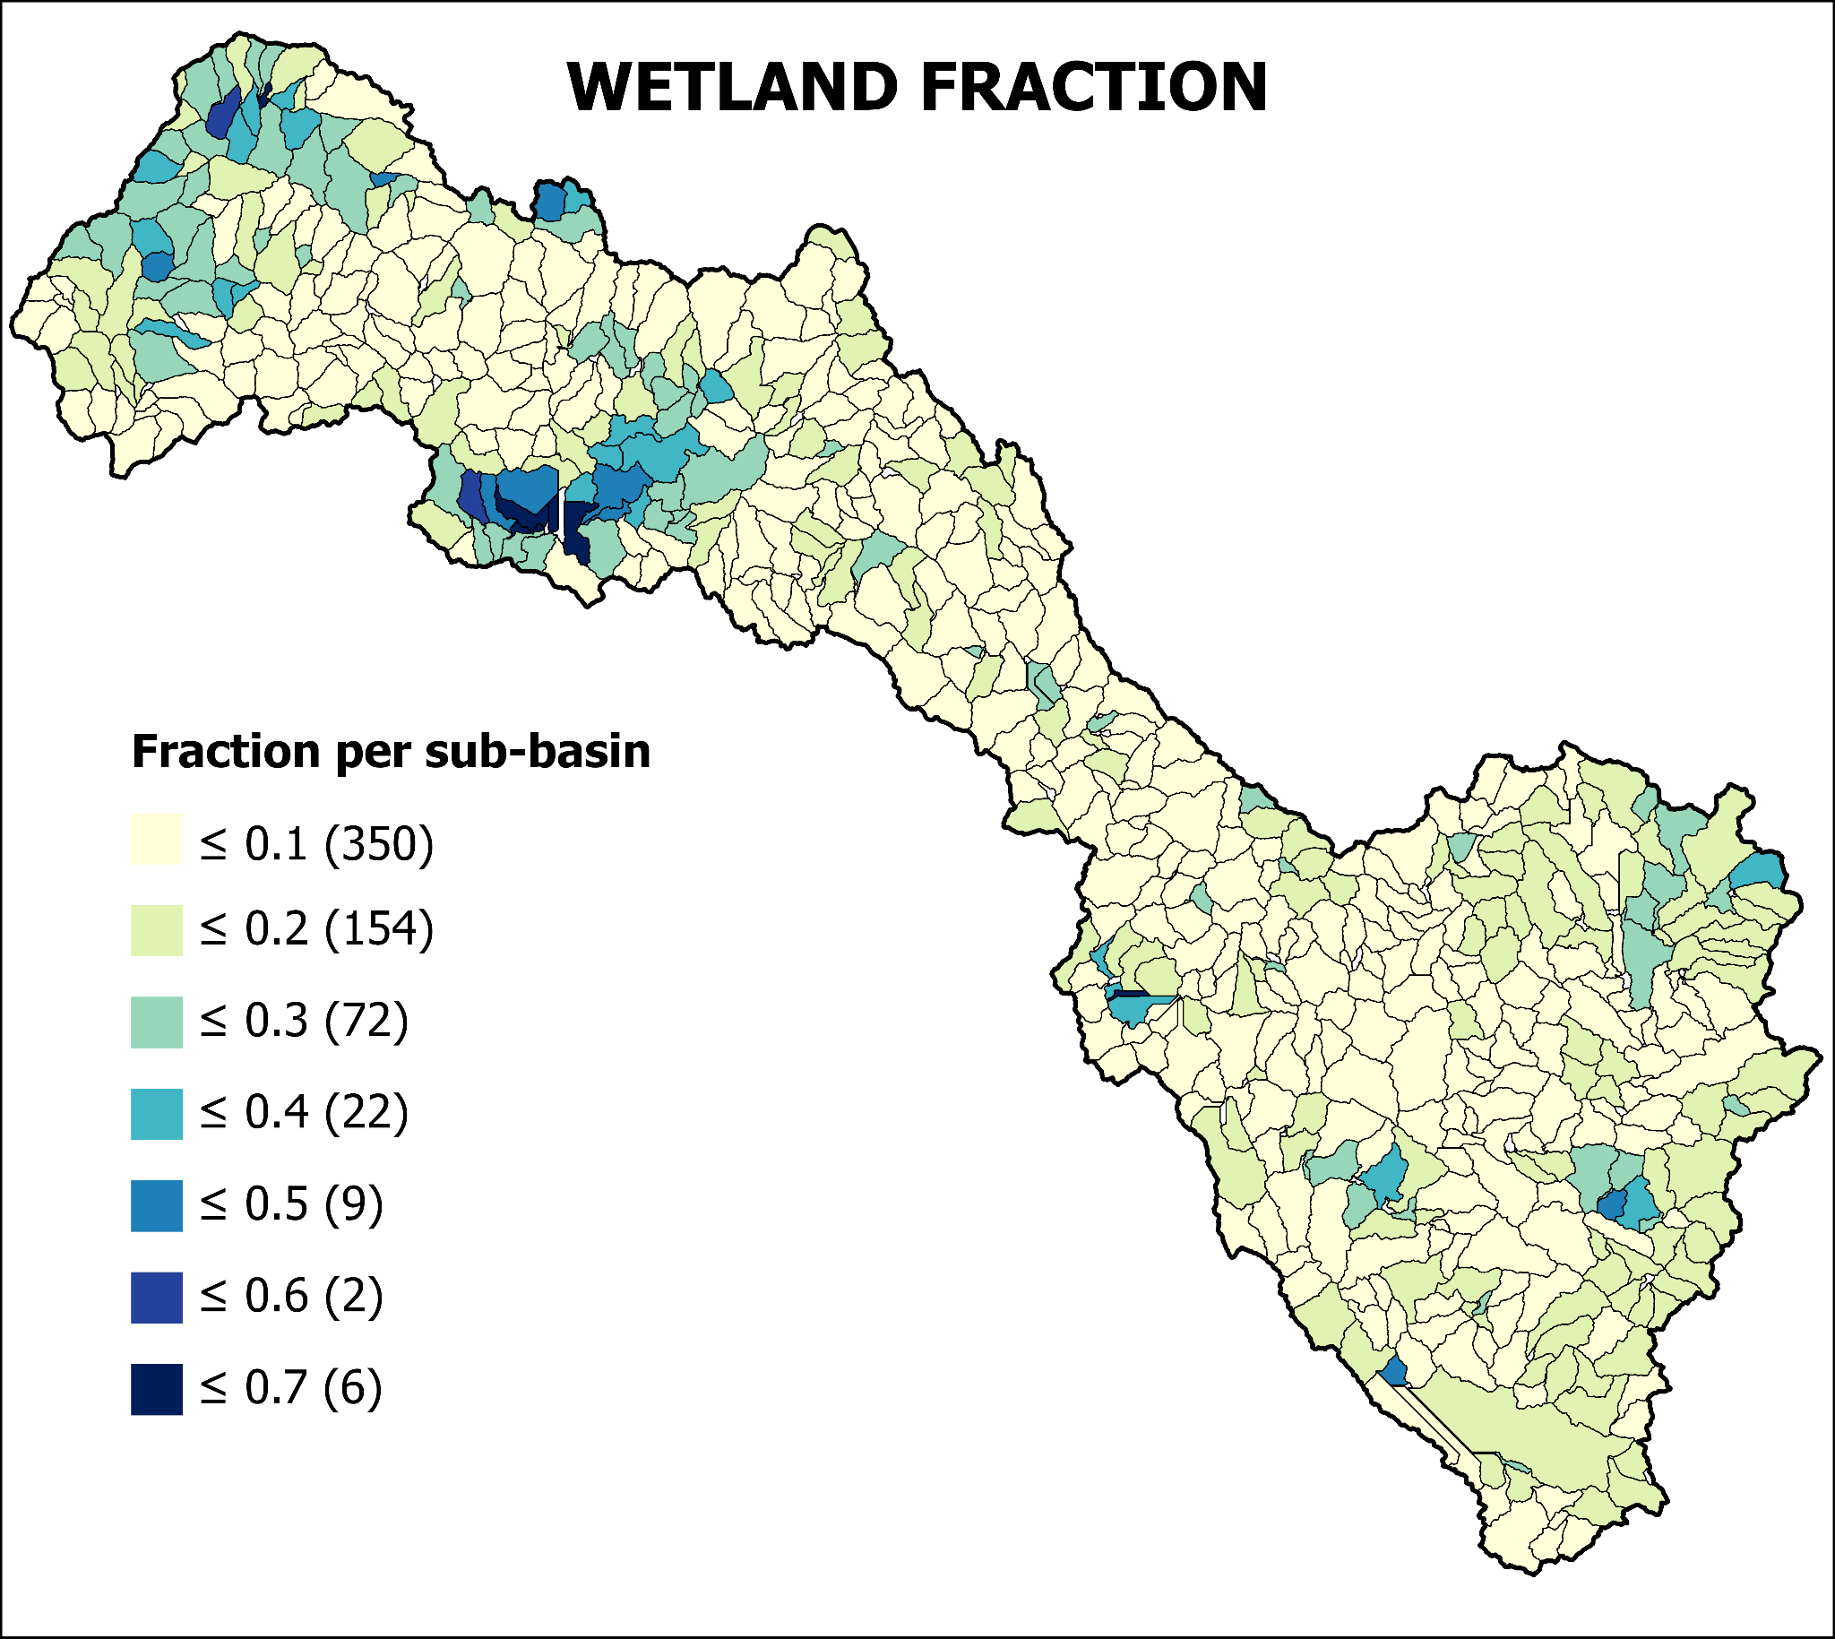
Fig. S14. Wetland fraction by sub-basin. Wetland fractions were calculated as the proportion of each sub-basin area. Only wetlands detected in more than two of the 33 seasons were considered (Fig. 7 in the main text). Values in parentheses indicate the number of sub-basins within each fraction class.

F. LAND COVER VARIABILITY AND CLIMATE ASSOCIATIONS
Spearman’s rank correlation coefficient was used to assess associations between i) land cover, SLE, and seasonal climate variability, and ii) between land covers. Correlations were calculated for the VUB and its three zones, based on inter-seasonal variability, defined as the change between two consecutive seasons (i.e. JFM-AMJ, AMJ-JAS, JAS-OND, OND-JFM). These correlations are interpreted as exploratory evidence of covariation rather than as drivers for inter-seasonal changes in land cover. The complete results of the correlation analysis are provided in the Data Availability section.
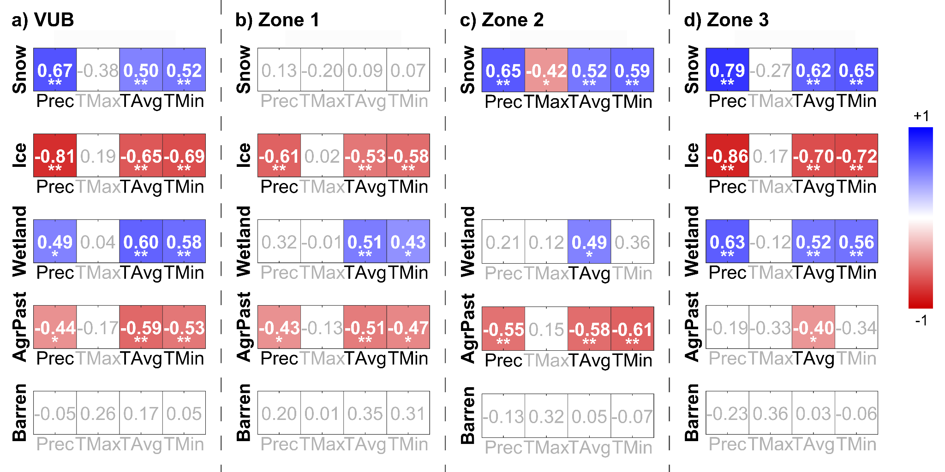
Fig. S15. Land cover and climate correlation in different zones. Groups represent the analysis of inter-seasonal changes, i.e. changes between JFM-AMJ, AMJ-JAS, JAS-OND, OND-JFM. Significant correlations are indicated with asterisks (p < 0.05 = *, p < 0.01 = **); non-significant values (p > 0.05) are shown in gray. The complete results of correlation analysis are in the Data Availability section.
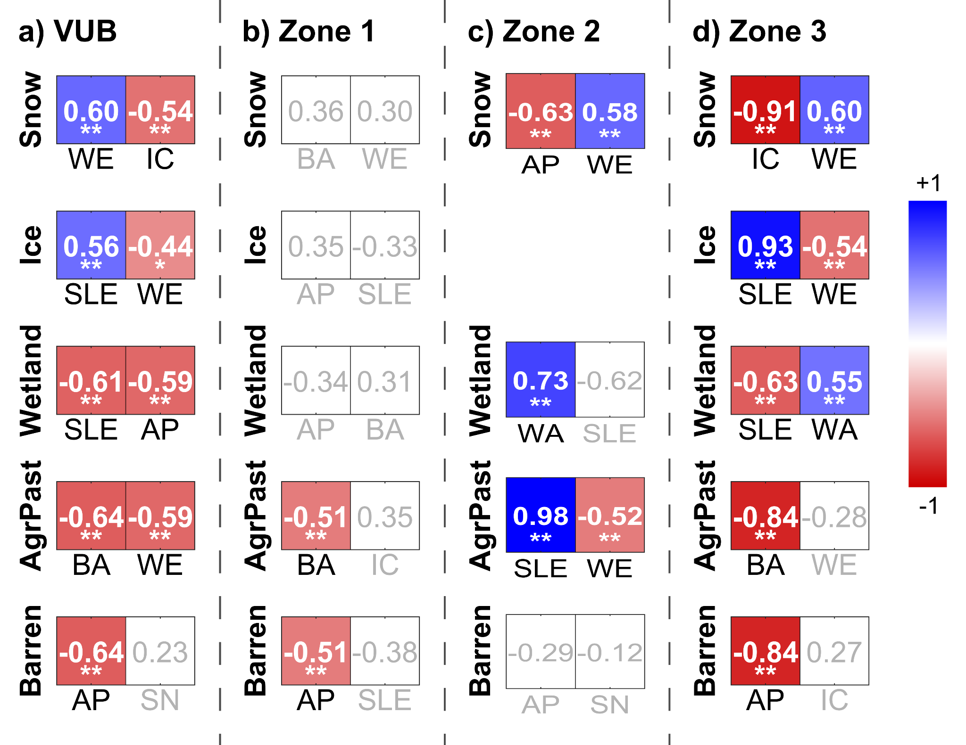
Fig. S16. The top 2 highest correlations between land cover classes at inter-seasonal scales. Groups represent the analysis of inter-seasonal changes. Abbreviations for land cover are: AP Agriculture/Pasture, BA Barren, IC Ice, SLE Snow Line Elevation, SN Snow, WE Wetland, WA Water. Significant correlations are indicated with asterisks (p < 0.05 = *, p < 0.01 = **); non-significant values (p > 0.05) are shown in gray. Repeated or unlinked classes were filtered. The complete results of correlation analysis are in the Data Availability section.
In ten years, land cover responded to climate variability, with snow and wetlands showing positive correlations with wetter and relatively warmer conditions at the inter-seasonal scale. Seasonal variability of snow and wetlands is controlled by positive relationships with precipitation and temperatures. These positive correlations with temperature reflect climate seasonality, in which wetter seasons are also relatively warmer, rather than a direct effect of higher temperatures enhancing snow accumulation and wetland expansion.
Wetland areas varied mainly in relation to other land covers, increasing during wet seasons (JFM and OND) with more snow cover and contracting when exposed ice and agriculture/pasture expanded in the dry seasons (AMJ and JAS). These patterns were supported by stronger correlations between land cover classes than between land cover and climate, so wetlands coincided with shifts in snow, water, and agriculture/pasture (Fig. S16).

G. LAND COVER VARIABILITY IN HIGH-ELEVATIONS: ZONE 4 CASE
To deepen our understanding of cryosphere-ecosystem interactions, we analysed land cover dynamics in zone 4, a glacierised headwater catchment in the Cordillera Vilcanota. Zone 4 is a subset area of the VUB located within zone 3. Zone 4 extends to 132.7 km² and is located between 4,732-5,761 m a.s.l. Among the land cover classes identified are: snow, ice, water, wetlands, pastures (with no agriculture parcels identified locally), and barren lands. Seasonal patterns of land covers in zone 4 (Fig. S17) present main differences regarding wetlands and minimum temperature. This case study provides a finer-scale perspective on the links between climate and land cover at high elevations.
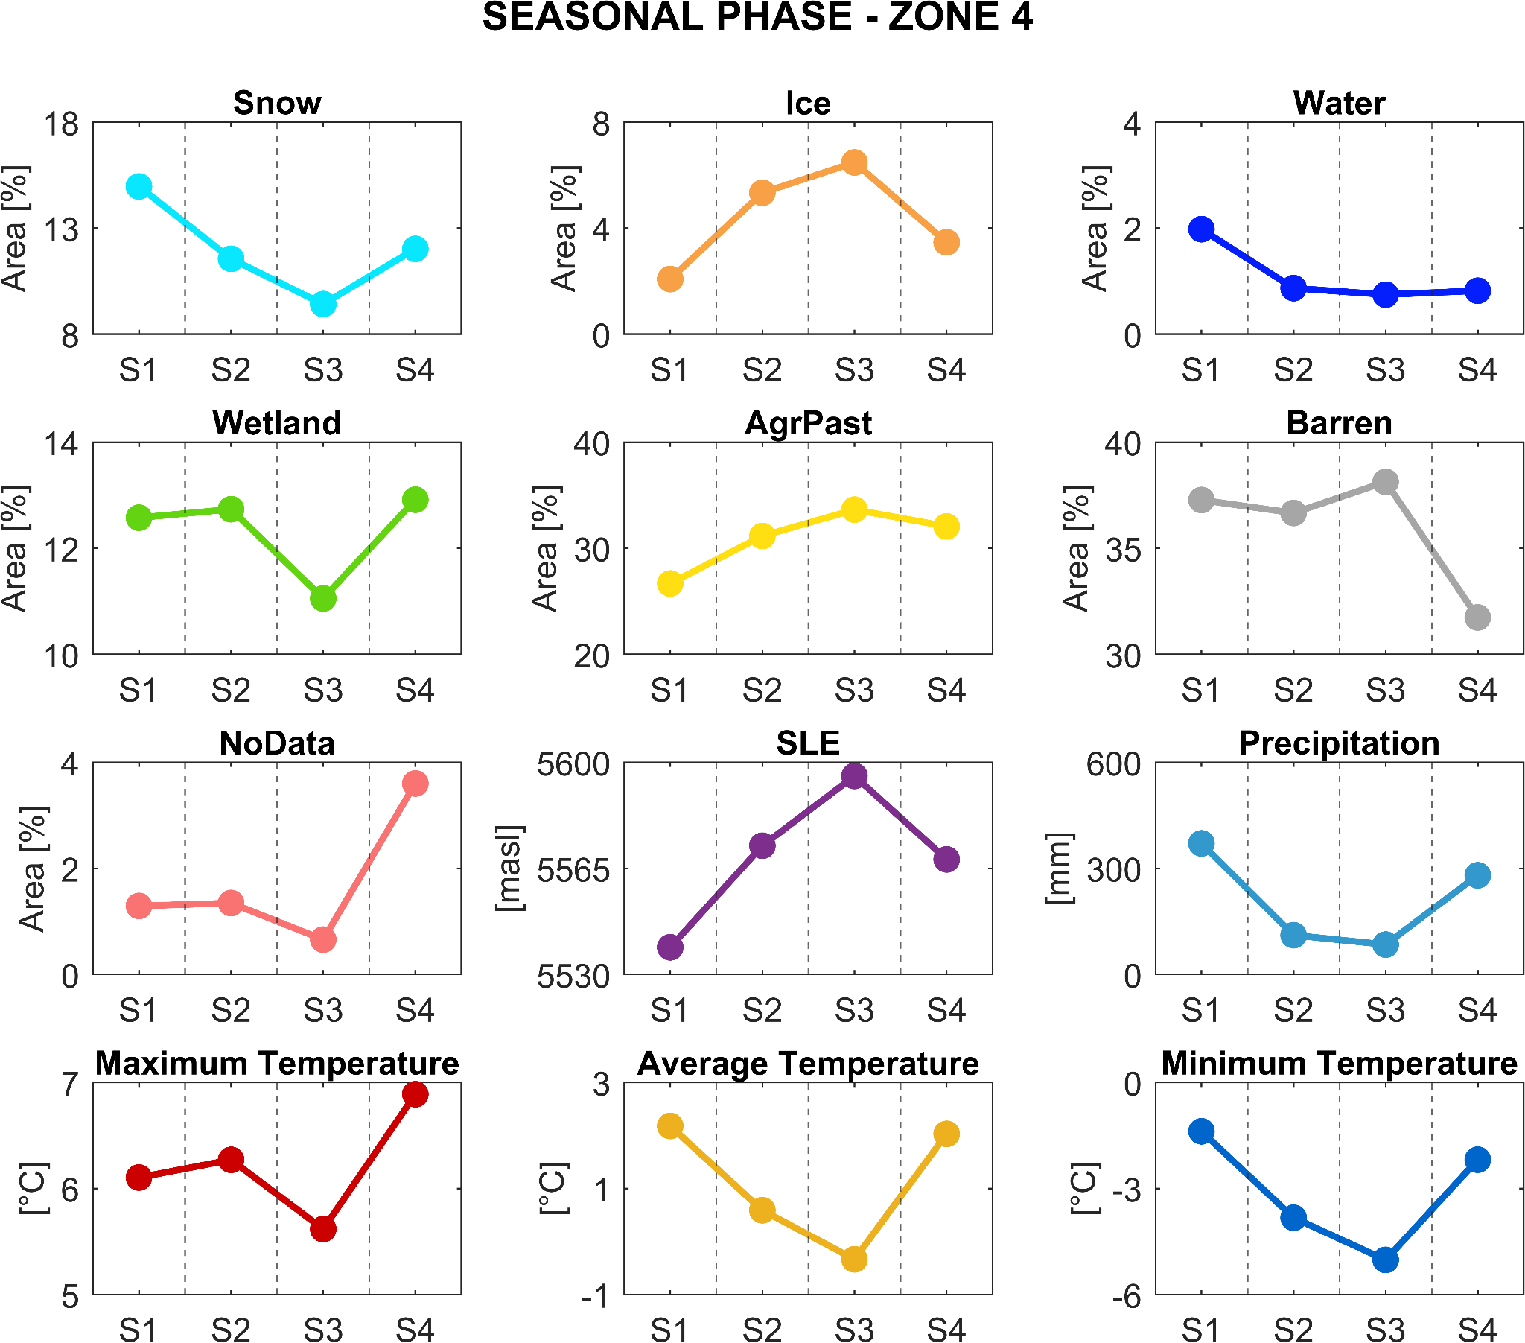
Fig. S17. Seasonal pattern of land cover classes, Snow Line Elevation (SLE), and climate variables in Zone 4. Each subplot shows the median value per season. Land cover values were transformed to area ratios and are expressed as a percentage of the total Zone 4 area (132.7 km2).
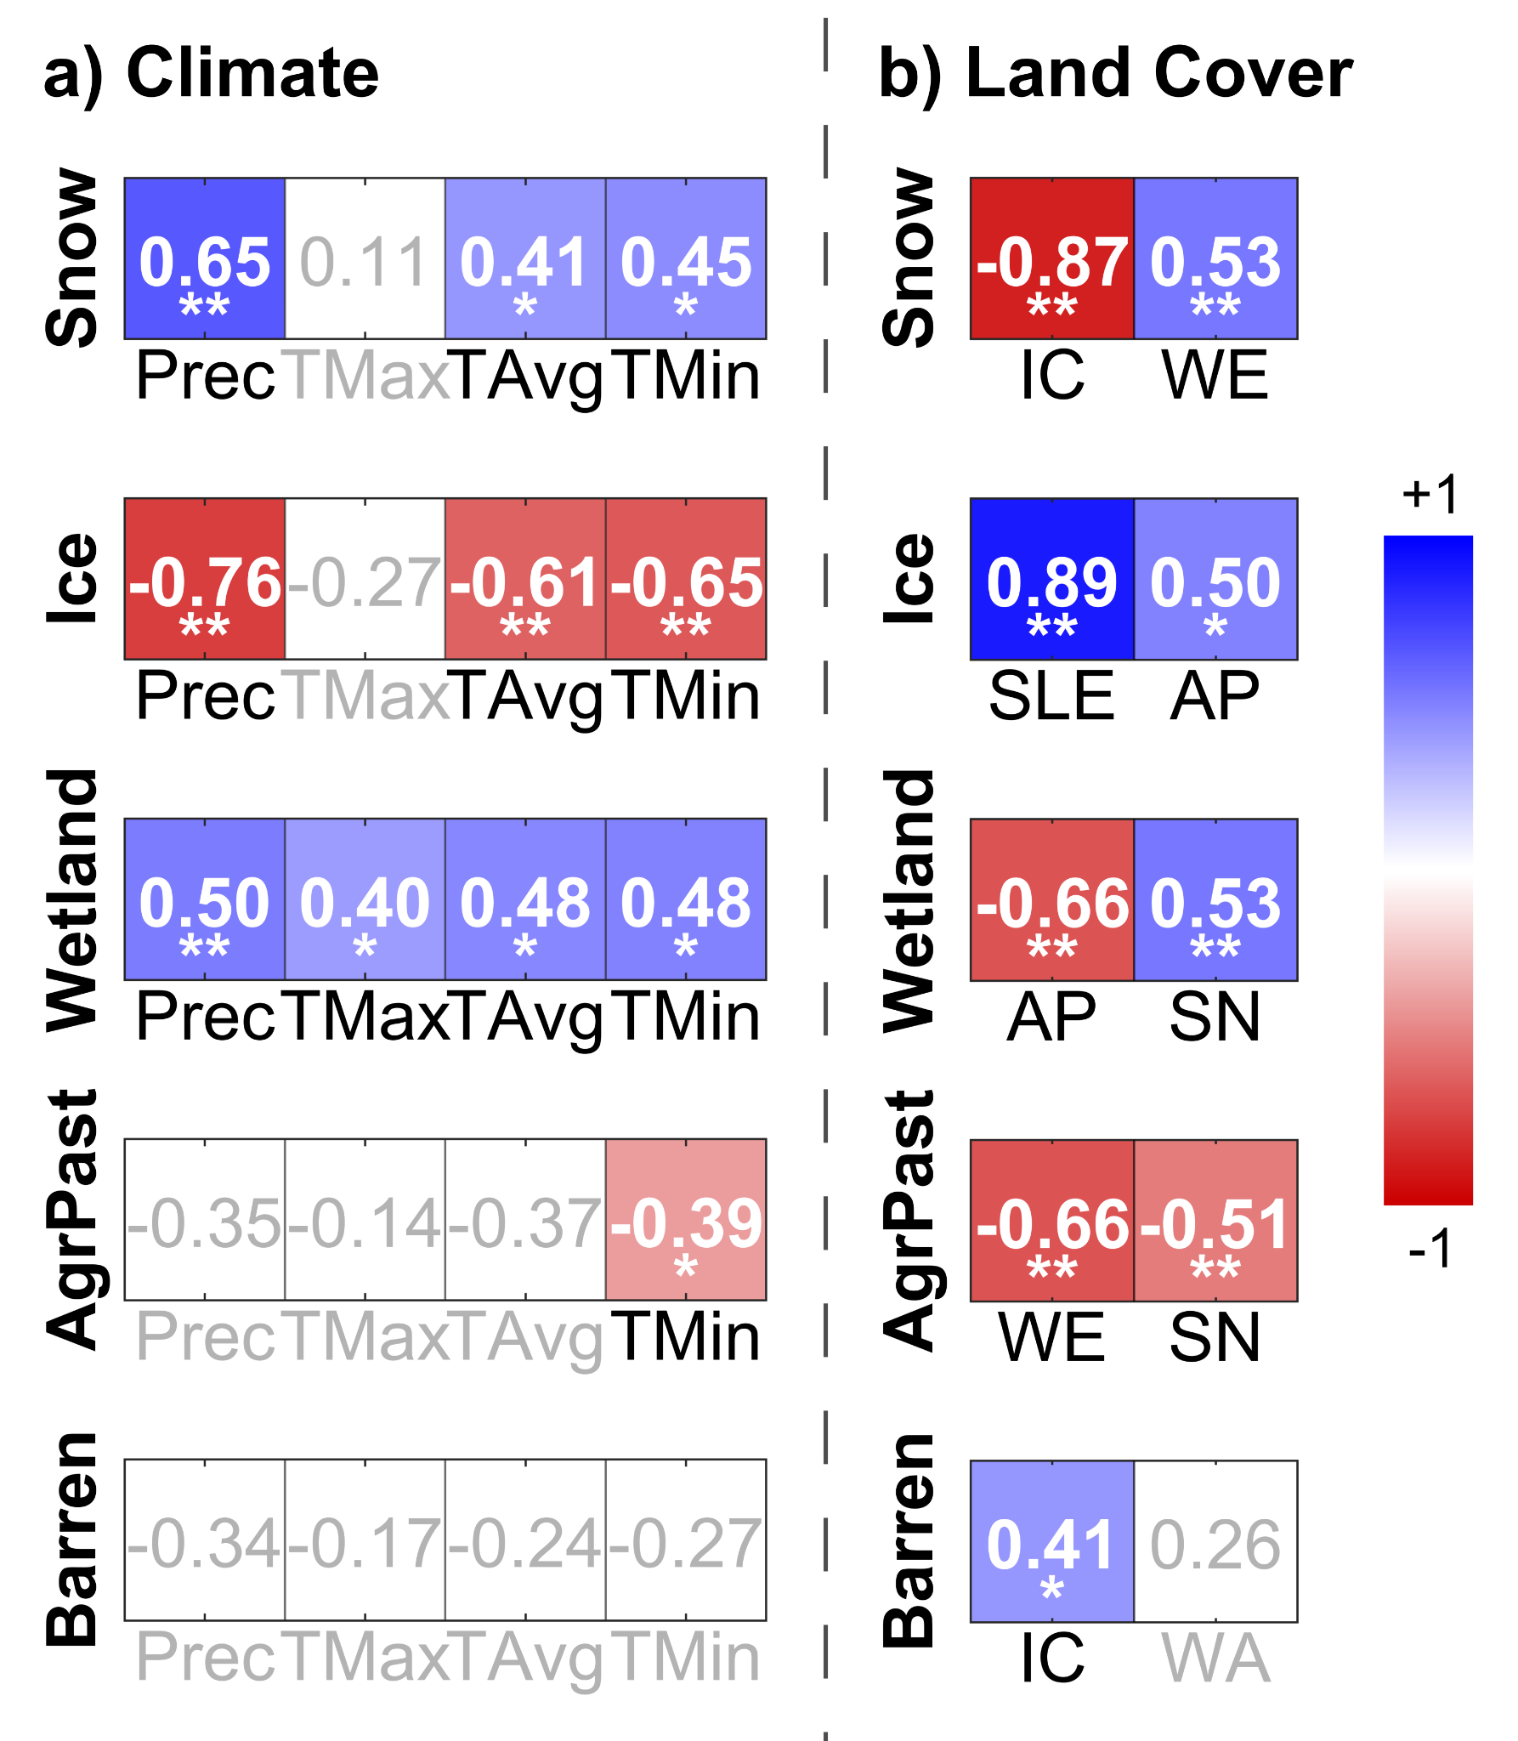
Fig. S18. Main correlation coefficient for land cover in Zone 4. Correlations between land cover classes against (a) climate variables, and (b) between land cover classes sorted by the first 2 variables. Groups represent the analysis of inter-seasonal changes. Abbreviations for land cover are: AP Agriculture/Pasture, BA Barren, IC Ice, SLE Snow Line Elevation, SN Snow, WE Wetland, WA Water. Significant correlations are indicated with asterisks (p < 0.05 = *, p < 0.01 = **); non-significant values (p > 0.05) are shown in gray. The complete results of correlation analysis are in the Data Availability section.

Reference
Alem, A., & Kumar, S. (2022). Deep Learning Models Performance Evaluations for Remote Sensed Image Classification. IEEE Access, 10, 111784–111793. https://doi.org/10.1109/ACCESS.2022.3215264
Amani, M., Salehi, B., Mahdavi, S., & Brisco, B. (2018). Spectral analysis of wetlands using multi-source optical satellite imagery. ISPRS Journal of Photogrammetry and Remote Sensing, 144, 119–136. https://doi.org/10.1016/j.isprsjprs.2018.07.005
ANA. (2014). Inventario nacional de glaciares y lagunas. https://hdl.handle.net/20.500.12543/199
Andreatta, D., Gianelle, D., Scotton, M., & Dalponte, M. (2022). Estimating grassland vegetation cover with remote sensing: A comparison between Landsat-8, Sentinel-2 and PlanetScope imagery. Ecological Indicators, 141. https://doi.org/10.1016/j.ecolind.2022.109102
Breiman, L. (2001). Random Forests (Vol. 45).
Dozier, J. (1989). Spectral Signature of Alpine Snow Cover from the Landsat Thematic Mapper (Vol. 28).
Farr, T. G., Rosen, P. A., Caro, E., Crippen, R., Duren, R., Hensley, S., Kobrick, M., Paller, M., Rodriguez, E., Roth, L., Seal, D., Shaffer, S., Shimada, J., Umland, J., Werner, M., Oskin, M., Burbank, D., & Alsdorf, D. E. (2007). The shuttle radar topography mission. Reviews of Geophysics, 45(2). https://doi.org/10.1029/2005RG000183
Ficetola, G. F., Marta, S., Guerrieri, A., Gobbi, M., Ambrosini, R., Fontaneto, D., Zerboni, A., Poulenard, J., Caccianiga, M., & Thuiller, W. (2021). Dynamics of Ecological Communities Following Current Retreat of Glaciers. Annual Review of Ecology, Evolution, and Systematics, 52(1), 405–426. https://doi.org/10.1146/annurev-ecolsys-010521-040017
Foga, S., Scaramuzza, P. L., Guo, S., Zhu, Z., Dilley, R. D., Beckmann, T., Schmidt, G. L., Dwyer, J. L., Joseph Hughes, M., & Laue, B. (2017). Cloud detection algorithm comparison and validation for operational Landsat data products. Remote Sensing of Environment, 194, 379–390. https://doi.org/10.1016/j.rse.2017.03.026
Fyffe, C. L., Potter, E., Fugger, S., Orr, A., Fatichi, S., Loarte, E., Medina, K., Hellström, R., Bernat, M., Aubry-Wake, C., Gurgiser, W., Perry, L. B., Suarez, W., Quincey, D. J., & Pellicciotti, F. (2021). The Energy and Mass Balance of Peruvian Glaciers. Journal of Geophysical Research: Atmospheres, 126(23). https://doi.org/10.1029/2021JD034911
Fyffe, C. L., Potter, E., Miles, E., Shaw, T. E., McCarthy, M., Orr, A., Loarte, E., Medina, K., Fatichi, S., Hellström, R., Baraer, M., Mateo, E., Cochachin, A., Westoby, M., & Pellicciotti, F. (2025). Thin and ephemeral snow shapes melt and runoff dynamics in the Peruvian Andes. Communications Earth and Environment, 6(1). https://doi.org/10.1038/s43247-025-02379-x
Gaddam, V. K., Boddapati, R., Kumar, T., Kulkarni, A. V., & Bjornsson, H. (2022). Application of “OTSU”—an image segmentation method for differentiation of snow and ice regions of glaciers and assessment of mass budget in Chandra basin, Western Himalaya using Remote Sensing and GIS techniques. Environmental Monitoring and Assessment, 194(5). https://doi.org/10.1007/s10661-022-09945-2
Gislason, P. O., Benediktsson, J. A., & Sveinsson, J. R. (2006). Random forests for land cover classification. Pattern Recognition Letters, 27(4), 294–300. https://doi.org/10.1016/j.patrec.2005.08.011
Hardisky, M. A., Daiber, F. C., Roman, C. T., & Klemas, V. (1984). Remote Sensing of Biomass and Annual Net Aerial Primary Productivity of a Salt Marsh. In REMOTE SENSING OF ENVIRONMENT (Vol. 16).
Hribljan, J. A., Suarez, E., Bourgeau-Chavez, L., Endres, S., Lilleskov, E. A., Chimbolema, S., Wayson, C., Serocki, E., & Chimner, R. A. (2017). Multidate, multisensor remote sensing reveals high density of carbon-rich mountain peatlands in the páramo of Ecuador. Global Change Biology, 23(12), 5412–5425. https://doi.org/10.1111/gcb.13807
Huete, A. R. (1988). A Soil-Adjusted Vegetation Index (SAVI) 295. In REMOTE SENSING OF ENVIRONMENT (Vol. 25).
INAIGEM. (2018). Inventario Nacional de Glaciares Las Cordilleras Glaciares del Perú 2018 (Instituto Nacional de Investigación en Glaciares y Ecosistemas de Montaña Biblioteca y Publicaciones, Ed.; Primera edición). https://hdl.handle.net/20.500.12748/57
INAIGEM. (2023a). Inventario Nacional de Bofedales del Perú 2023. https://repositorio.inaigem.gob.pe/handle/16072021/466
INAIGEM. (2023b). Inventario Nacional de Glaciares y Lagunas de Origen Glaciar 2023. https://repositorio.inaigem.gob.pe/items/7029db53-5118-4e93-8b2a-71e6e26db5f6
Jiang, Z., Huete, A. R., Didan, K., & Miura, T. (2008). Development of a two-band enhanced vegetation index without a blue band. Remote Sensing of Environment, 112(10), 3833–3845. https://doi.org/10.1016/j.rse.2008.06.006
Krajčí, P., Holko, L., Perdigão, R. A. P., & Parajka, J. (2014). Estimation of regional snowline elevation (RSLE) from MODIS images for seasonally snow covered mountain basins. Journal of Hydrology, 519(PB), 1769–1778. https://doi.org/10.1016/j.jhydrol.2014.08.064
Lee, J. K., Acharya, T. D., & Lee, D. H. (2018). Exploring land cover classification accuracy of Landsat 8 image using spectral index layer stacking in hilly region of South Korea. Sensors and Materials, 30(12), 2927–2941. https://doi.org/10.18494/SAM.2018.1934
Liang, S. (2001). Narrowband to broadband conversions of land surface albedo I: Algorithms. Remote Sensing of Environment, 76(2), 213–238. https://doi.org/https://doi.org/10.1016/S0034-4257(00)00205-4.
Maldonado Fonkén, M. S. (2014). An introduction to the bofedales of the Peruvian High Andes (Vol. 15, Issue 15). http://www.mires-and-peat.net/,ISSN1819-754X
Marín Del Valle, T., & Jiang, P. (2022). Comparison of common classification strategies for large-scale vegetation mapping over the Google Earth Engine platform. International Journal of Applied Earth Observation and Geoinformation, 115. https://doi.org/10.1016/j.jag.2022.103092
McFeeters, S. K. (1996). The use of the Normalized Difference Water Index (NDWI) in the delineation of open water features. International Journal of Remote Sensing, 17(7), 1425–1432. https://doi.org/10.1080/01431169608948714
Meier, M. F. (1975). Application of remote-sensing techniques to the study of seasonal snow cover. Journal of Glaciology, 15(73), 251–265. https://doi.org/10.3189/S0022143000034419
MINAM. (2018). Mapa Nacional de Ecosistemas del Perú. https://sinia.minam.gob.pe/mapas/mapa-nacional-ecosistemas-peru
Naegeli, K., Huss, M., & Hoelzle, M. (2019). Change detection of bare-ice albedo in the Swiss Alps. Cryosphere, 13(1), 397–412. https://doi.org/10.5194/tc-13-397-2019
Otsu, N. (1979). A Threshold Selection Method from Gray-Level Histograms. IEEE Transactions on Systems, Man, and Cybernetics, SMC-9, no. 1, 62–66. https://doi.org/10.1109/TSMC.1979.4310076
Phinzi, K., Ngetar, N. S., Pham, Q. B., Chakilu, G. G., & Szabó, S. (2023). Understanding the role of training sample size in the uncertainty of high-resolution LULC mapping using random forest. Earth Science Informatics, 16(4), 3667–3677. https://doi.org/10.1007/s12145-023-01117-1
Pizarro, S. E., Pricope, N. G., Vargas-Machuca, D., Huanca, O., & Ñaupari, J. (2022). Mapping Land Cover Types for Highland Andean Ecosystems in Peru Using Google Earth Engine. Remote Sensing, 14(7). https://doi.org/10.3390/rs14071562
Potter, E. R., Fyffe, C. L., Orr, A., Quincey, D. J., Ross, A. N., Rangecroft, S., Medina, K., Burns, H., Llacza, A., Jacome, G., Hellström, R., Castro, J., Cochachin, A., Montoya, N., Loarte, E., & Pellicciotti, F. (2023). A future of extreme precipitation and droughts in the Peruvian Andes. Npj Climate and Atmospheric Science, 6(1). https://doi.org/10.1038/s41612-023-00409-z
Ramezan CA, Warner TA, Maxwell AE, Price BS. Effects of Training Set Size on Supervised Machine-Learning Land-Cover Classification of Large-Area High-Resolution Remotely Sensed Data. Remote Sensing. 2021; 13(3):368. https://doi.org/10.3390/rs13030368
Rodriguez-Galiano, V. F., Ghimire, B., Rogan, J., Chica-Olmo, M., & Rigol-Sanchez, J. P. (2012). An assessment of the effectiveness of a random forest classifier for land-cover classification. ISPRS Journal of Photogrammetry and Remote Sensing, 67(1), 93–104. https://doi.org/10.1016/j.isprsjprs.2011.11.002
Ross, A. C., Mendoza, M. M., Drenkhan, F., Montoya, N., Baiker, J. R., Mackay, J. D., Hannah, D. M., & Buytaert, W. (2023). Seasonal water storage and release dynamics of bofedal wetlands in the Central Andes. Hydrological Processes, 37(8). https://doi.org/10.1002/hyp.14940
Rouse, J. W. (1973). Monitoring the Vernal Advancement and Retrogradation of Natural Vegetation. NASA/GSFCT Type II Report (Greenbelt, MD: NASA).
Sales, M. H. R., De Bruin, S., Souza, C., & Herold, M. (2022). Land Use and Land Cover Area Estimates from Class Membership Probability of a Random Forest Classification. IEEE Transactions on Geoscience and Remote Sensing, 60. https://doi.org/10.1109/TGRS.2021.3080083
Shelestov, A., Lavreniuk, M., Kussul, N., Novikov, A., & Skakun, S. (2017). Exploring Google earth engine platform for big data processing: Classification of multi-temporal satellite imagery for crop mapping. Frontiers in Earth Science, 5, 1–10. https://doi.org/10.3389/feart.2017.00017
Singh, M. P., Gayathri, V., & Chaudhuri, D. (2022). A Simple Data Preprocessing and Postprocessing Techniques for SVM Classifier of Remote Sensing Multispectral Image Classification. IEEE Journal of Selected Topics in Applied Earth Observations and Remote Sensing, 15, 7248–7262. https://doi.org/10.1109/JSTARS.2022.3201273
Tovar, C., Seijmonsbergen, A. C., & Duivenvoorden, J. F. (2013). Monitoring land use and land cover change in mountain regions: An example in the Jalca grasslands of the Peruvian Andes. Landscape and Urban Planning, 112(1), 40–49. https://doi.org/10.1016/j.landurbplan.2012.12.003
Tsai, Y. H., Stow, D., Chen, H. L., Lewison, R., An, L., & Shi, L. (2018). Mapping Vegetation and Land Use Types in Fanjingshan National Nature Reserve Using Google Earth Engine. Remote Sensing, 10(6). https://doi.org/10.3390/rs10060927
Vega Isuhuaylas, L. A., Hirata, Y., Santos, L. C. V., & Torobeo, N. S. (2018). Natural forest mapping in the Andes (Peru): A comparison of the performance of machine-learning algorithms. Remote Sensing, 10(5). https://doi.org/10.3390/rs10050782

