Appendix 1. Additional tests used in the study. The results are reported in
Table 2
- Communication Questionnaire (SCQ) (Rutter et al., 2003): Parents filled out a Social Communication Questionnaire that is a widely used screening tool for identifying symptoms of ASD. A score of 15 or higher suggests that the individual may be on the autism spectrum and should receive a full diagnostic evaluation. We are aware that these cutoffs are guidelines and not diagnostic. However, we find the SCQ scores nevertheless informative since they provide an indication of autism severity.
- Socioeconomic status (SES) was determined based on the highest educational attainment of a primary caregiver, rated on a 5-point scale ranging from 1 (no education beyond primary school) to 5 (university-level education) (Hauser & Warren, 1997).
- Test For Receptive Grammar 2 (TROG): this test assesses children’s receptive morphosyntactic skills (Fox-Boyer, 2006 in German; Lecocq, 1996 in French).
- The Peabody Picture Vocabulary Test (PPVT): this test assesses children’s receptive vocabulary (Dunn et al., 1993 in French; Lenhard et al., 2015 in German).
- Non-verbal IQ was assessed via Ravens-2 (Raven et al., 2018).
References:
Dunn, L. M., Dunn, L. M., & Thériault-Whalen, C. M. (1993). Échelle de vocabulaire en images Peabody: EVIP. PSYCAN.
Fox-Boyer, A. V. (2006). TROG-D: Test zur Überprüfung des Grammatikverständnisses. Schulz-Kirchner Verlag.
Hauser, R. M., & Warren, J. R. (1997). Socioeconomic Indexes for Occupations: A Review, Update, and Critique. Sociological Methodology, 27(1), 177–298. https://doi.org/10.1111/1467-9531.271028.
Lecocq, P. (1996). Test de compréhension grammaticale. Éditions du Centre de Psychologie Appliquée.
Lenhard, A., Lenhard, W., Segerer, A., & Suggate, S. (2015). Peabody Picture Vocabulary Test – PPVT 4: Deutschsprachige Adaption. Pearson Assessment.
Raven, J., Rust, J., Chan, F., & Zhou, X. (2018). Raven’s 2 Progressive Matrices, Clinical Edition (Raven’s 2). Pearson.
Rutter, M., Bailey, A., Berument, S. K., & Lord, C. (2003). Social Communication Questionnaire: Manual. Western Psychological Services.

Appendix 2. Elicitation of passive and active voice: Examples
Figure 1. Example of images eliciting the comprehension of passive voice

Examples (1) and (2) show a target item in passive voice in German and French, respectively.
(1) Context:
[Hier sind ein Hund und eine Maus]
[Here are a dog and a mouse]

Target:
Die Maus wird von dem Hund ge-waschen
the. nom mouse get. prs. 3sg by the.dat dog pst. ptcp-wash
‘The mouse is being washed by the dog.’

End of the task:
Zeig es mir!
Show me!

(2) Context:
[Voici un chien et une souris]
[Here is a dog and a mouse]

Target:
La souris est lav-ée par le chien
the mouse be.prs.3sg wash-pst.ptcp by the dog
‘The mouse is being washed by the dog.’

End of the task:
Montre-moi!
Show me!

Figure 2. Example of images eliciting the comprehension of active voice

Examples (3) and (4) show a target item in active voice in German and French, respectively.
(3) Context:
[Hier sind ein Elefant und ein Tiger]
[Here is an elephant and a tiger]
Target:

Der Tiger schieb-t den Elefanten
the. nom tiger push-3.sg.prs the. acc elephant
‘The tiger is pushing the elephant.’

End of the task:
Zeig es mir!
Show me!

(4) Context:

[Voici un éléphant et un tigre]
[Here is an elephant and a tiger]

Target:

Le tigre pousse l'éléphant
the tiger push. 3.sg.prs the elephant
‘The tiger is pushing the elephant.’

End of the task:
Montre-moi!
Show me!

Appendix 3. The results of model 2 (comprehension of active vs. passive voice)
Formula: model_activepassive <- activespassives %>%
glmer(formula = accuracy ~ group * Condition + (1 | ID) + (1 | item), family = "binomial", control=glmerControl(optimizer="bobyqa", optCtrl=list(maxfun=1000000)))

Active voice vs. passive voice: outcome of the generalized binominal linear mixed-effect model
AIC | BIC | logLik | deviance | df.resid
1504.3 | 1538.1 | -746.1 | 1492.3 | 2061

Scaled residuals:
Min | 1Q | Median | 3Q | Max
-7.0908 | 0.1038 | 0.2249 | 0.3607 | 1.8535
Random effects:
Groups | Name | Variance | Std.Dev.
ID | (Intercept) | 2.0515 | 1.432
item | (Intercept) | 0.3709 | 0.609

Number of obs: 2067, groups: ID, 181; item, 12
Model fit indices: marginal R² = .14; conditional R² = .50.
 | Estimate | Std. Error | z value | Pr(>|z|)
(Intercept) | 2.3425 | 0.2396 | 9.776 | < 2e-16 ***
Group | -1.2027 | 0.2848 | -4.223 | 2.41e-05 ***
Condition | 1.5986 | 0.3899 | 4.100 | 4.13e-05 ***
Group:Condition | 0.8391 | 0.3083 | 2.722 | 0.0065 **

Appendix 4. The results of Tukey’s adjustment for model 2
Formula: model.emmmode <- emmeans(model_activepassive, list(pairwise ~ group:Condition), adjust = "tukey")
Active voice vs. passive voice: Tukey multiple comparison test (Group: Condition)
 | estimate | SE | df | z.ratio | p.value
ASD Active - TD Active | -0.783 | 0.347 | Inf | -2.256 | 0.1084
ASD Active - ASD Passive | 2.018 | 0.426 | Inf | 4.739 | <.0001
ASD Active - TD Passive | 0.396 | 0.482 | Inf | 0.821 | 0.8446
TD Active - ASD Passive | 2.801 | 0.483 | Inf | 5.795 | <.0001
TD Active - TD Passive | 1.179 | 0.413 | Inf | 2.858 | 0.0221
ASD Passive - TD Passive | -1.622 | 0.299 | Inf | -5.430 | <.0001

Model Coefficients (Standardized)
Parameter | Std. Coef. | 95% CI
(Intercept) | 2.34 | [1.87, 2.81]
Group | -1.20 | [-1.76, -0.64]
Condition | 1.60 | [0.83, 2.36]
Group:Condition | 0.84 | [0.23, 1.44]

Note. Coefficients are standardized; response is unstandardized (log-odds).
Comprehension of active and passive voice by typically developing (TD) children and autistic children showing the average performance and the 95% confidence intervals on logit scale (estimated marginal means)
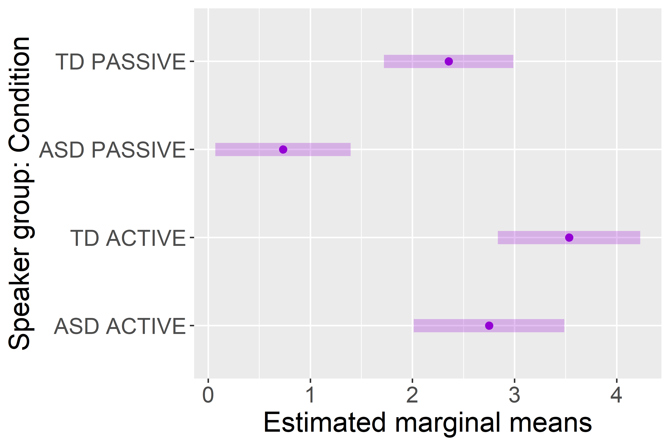

Appendix 5. The results of model 3 (comprehension of passive voice)
Formula: model_test9_mod <- passives %>%
glmer(formula = accuracy ~ group * (scale(age) + scale(nwr_score) * scale(EXP_cum_entropy)) + (1 | ID) + (1 | item), family = "binomial", control=glmerControl(optimizer="bobyqa", optCtrl=list(maxfun=1000000)))
Comprehension of passive voice: outcome of the generalized binominal linear mixed-effect model
AIC | BIC | logLik | deviance | df.resid
887.2 | 946.5 | -431.6 | 863.2 | 1023

Scaled residuals:
Min | 1Q | Median | 3Q | Max
-3.5950 | 0.1195 | 0.2187 | 0.3698 | 2.2087
Random effects:
Groups | Name | Variance | Std.Dev.
ID | (Intercept) | 2.2289 | 1.4929
item | (Intercept) | 0.1489 | 0.3859

Number of obs: 1035, groups: ID, 181; item, 6
 | Estimate | Std. Error | z value | Pr(>|z|)
(Intercept) | 1.84016 | 0.25134 | 7.321 | 2.45e-13 ***
Group | -1.44921 | 0.34973 | -4.144 | 3.42e-05 ***
Age | 0.73340 | 0.17616 | 4.163 | 3.14e-05 ***
NWR | 0.59935 | 0.16558 | 3.620 | 0.000295 ***
EXP_cum_entropy | -0.01776 | 0.17590 | -0.101 | 0.919571
NWR: EXP_cum_entropy | 0.09447 | 0.15257 | 0.619 | 0.535796
Group: Age | 0.04134 | 0.34385 | 0.120 | 0.904302
Group: NWR | 0.73578 | 0.32477 | 2.266 | 0.023481 *
Group: EXP_cum_entropy | -0.04311 | 0.35152 | -0.123 | 0.902398
Group: NWR: EXP_cum_entropy | -0.43248 | 0.30635 | -1.412 | 0.158040

Model fit indices: marginal R² = .25; conditional R² = .56

Appendix 6. Analysis of error types in passive voice comprehension
Figure 1. Mean error type for passive voice across participants and group (TD children or autistic children)
