Supplemental Materials

The prevalence and consequences of women’s algorithmic underrepresentation in cross-national political Google searches

Tobias Rohrbach, Mykola Makhortykh, Maryna Sydorova

All replication materials (R code scripts, datasets, and instructions) are available at
https://doi.org/10.7910/DVN/VLIGJB

Content

A: Information about pre-registrations 1
B: Additional information about data collection 2
B1. Search terms and countries for studies 1 and 2 2
B2. Overview of samples studies 3-4 4
B3. Experimental stimulus materials 5
B3.1 Stimuli for Study 3 5
B3.2 Stimuli for Study 4 6
C: Additional information and analyses 8
C1. Study 1 8
C2. Study 2 12
C3. Study 3 17
C3.1 Full results 17
C3.2 19
C4. Study 4 19

A: Information about pre-registrations
We pre-registered each study prior to data collection but after the analysis of the former study. Therefore, study 1 informed the data collection of study 2 while insights from study 3 guided the protocol for study 4. For our audits, the pre-registrations were submitted on [INSERT AFTER REVIEW] via the standard template. We pre-registered the first experimental study by publishing a more detailed pre-analysis plan (PAP) on [INSERT AFTER REVIEW]. Given the similarity to the previous study, we only provide a short study proposal as the pre-registration of study 4. See Table A1 below for an overview of the data collections and associated pre-registration documents. The Table also documents deviations from the pre-registrations.
We submitted the whole project for ethical review to the Ethics Committee of the Faculty of Business, Economics and Social Sciences of the University of Bern. The was cleared with the serial number 272023.

Table A1. Overview of data collections and pre-registration materials
Study | Date of data collection | Deviations
1: Audit Google images 1 | 04. August 2023 | Link: https://aspredicted.org/ma2d6.pdf  - Item 3: we did not use the ratio of women to men candidates as measure but their absolute number as well as the share of women. It became clear from peer feedback from conference and departmental presentations that the operationalization for the ratio measure was not generally intuitive without detailed explanation. In contrast, the absolute number of women and the share of women are common and very accessible measures that require only minimal explanation. Moreover, the interpretation of the share of women in search output—as a measure of algorithmic representation—is directly comparable to women’s descriptive representation.  - Item 7: Due to problems with the VPN service, we ended up with 56 countries (instead of 70).
2: Internal replication of audit | 18-19. March 2024 | Link: https://aspredicted.org/u5y4x.pdf  - Item 3: we did not use the ratio of women to men candidates as measure but their absolute number as well as the share of women. (see explanation above).  - Item 7: The final configuration of the data generating process underlying the audit was: 11 locations [Australia, Brazil, Canada, Germany, India, Israel, Japan, Saudi Arabia, South Africa, Switzerland, United States] × 20 agents per location × 20 search queries × 50 images. This yielded approximately 220’000 non-unique image search outputs.
3: Survey experiment of gender-biased vs. gender-equal output | 25-26. August 2023 | Link: https://osf.io/epjky/files/mhe2b  - Section 1: we have not conducted or reported the analyses regarding the agency and communality trait/issue measures that were pre-registered (also due to low internal consistency of the scales and because they are not part of the core interest of this manuscript). Similarly, we do not report the direct effects of the treatment on external efficacy and perceived viability. We report the results for these hypotheses in section C3.2.  - Measures: Following feedback from experts in the field of search engine audits, we also included “search engine use” as an additional covariate to our models (see section C3.2 for additional tables without this covariate).
4: Survey experiment of gender and race bias | 9-10. September 2023 | Link: https://osf.io/epjky/files/wx8fn  - Sample size: We initially expected funding for a population-based sample, which did not eventuate. We thus had to adjust the sample size.  - Measures: We changed the wording for the specific viability measure. Originally, we introduced names as candidates running for the U.S. House. We later changed this framing to Primary elections for more external realism.  Moreover, the study proposal (which served as a proxy for pre-registration) did not include a hypothesis for participants’ external efficacy beliefs (see H4b in the manuscript). This variable was originally left out because of limited survey space; as recruitment plans changed, the variable was added back to enable continuous/parallel analysis to study 3.

B: Additional information about data collection

B1. Search terms and countries for studies 1 and 2

Table B1. Overview of queries used for the algorithmic audits (studies 1 and 2)
 |  | Search terms
country | language | Lower chamber | Upper chamber
Argentina ¹ | Spanish | cámara de diputados persona | senado persona
Australia ^{1, 2} | English | house or representatives person | senate person
Austria ¹ | German | nationalrat person | bundesrat person
Azerbaijan ¹ | Azerbaijani | milli məclis şəxs | ---
Australia ^{1, 2} | English | house or representatives person | senate person
Belgium ¹ | Dutch | kamer van volksvertegenwoordigers persoon | senaat persoon
Brazil ^{1, 2} | Portuguese | câmara dos deputados pessoa | senado federal pessoa
Bulgaria ¹ | Bulgarian | народно събрание персона | ---
Canada ^{1, 2} | English | house of commons person | senate person
Chile ¹ | Spanish | cámara de diputados persona | senado persona
Colombia ¹ | Spanish | cámara de representantes persona | senado persona
Costa Rica ¹ | Spanish | asamblea legislativa | ---
Croatia ¹ | Croatia | hrvatski sabor osoba | ---
Czechia ¹ | Czech | poslanecká sněmovna osoba | senát osoba
Estonia ¹ | Estonian | riigikogu isik | ---
Finland ¹ | Finnish | eduskunta henkilö | ---
France ¹ | French | assemblée nationale personne | sénat personne
Georgia ¹ | Georgian | პარლამენტი პირი | ---
Germany ¹ | German | bundestag person | bundesrat person
Greece ¹ | Greek | κοινοβούλιο άτομο | ---
Hungary ¹ | Hungarian | országgyűlés személy | ---
Iceland ¹ | Icelandic | alþingi manneskju | ---
India ^{1, 2} | Hindi | लोक सभा व्यक्ति | राज्य सभा व्यक्ति
Indonesia ¹ | Indonesian | dewan perwakilan rakyat orang | dewan perwakilan daerah orang
Ireland ¹ | English | dáil person | seanad person
Israel ^{1, 2} | Hebrew | אדם הַכְּנֶסֶת | ---
Italy ¹ | Italian | camera dei deputati persona | senato persona
Japan ^{1, 2} | Japanese | 衆議院 人 | 参議院 人
Kazakhstan ¹ | Kazakh | мәжілісі адам | cенаты адам
Lebannon ¹ | Arabic | شخص مجلس النواب | ---
Luxembourg ¹ | Luxembourgish | d'chamber persoun | ---
Malaysia ¹ | Malay | dewan rakyat orang | dewan negara orang
Malta ¹ | Maltese | kamra tad-deputati persuna | ---
Mexico ¹ | Spanish | cámara de los diputados persona | senado persona
Moldova ¹ | Romanian | parlamentul persoana | ---
Netherlands ¹ | Dutch | tweede kamer persoon | eerste kamer persoon
New Zealand ¹ | English | house of representatives person | ---
Nth Macedonia ¹ | Macedonian | cобрание персона | ---
Norway ¹ | Norwegian | stortinget person | ---
Panama ¹ | Spanish | asamblea nacional persona | ---
Poland ¹ | Polish | sejm osoba | senat osoba
Portugal ¹ | Portuguese | parlamento pessoa | ---
Russia ¹ | Russian | государственная дума персона | совет федерации персона
Saudi Arabia ^{1, 2} | Arabic | مجلس الشورى السعودي شخص | ---
Serbia ¹ | Serbian | народна скупштина особа | ---
Slovenia ¹ | Slovenian | državni zbor oseba | državni svet oseba
South Africa ^{1, 2} | English | national assembly person | council of provinces person
South Korea ¹ | Korean | 대한민국 국회 사 | ---
Spain ¹ | Spanish | congreso de los diputados persona | senado persona
Sweden ¹ | Swedish | riksdag person | ---
Switzerland ^{1, 2} | German | nationalrat person | ständerat person
Thailand ¹ | Thai | สภาผู้แทนราษฎร บุคคล | วุฒิสภา บุคคล
Turkey ¹ | Turkish | meclis kişi | ---
Ukraine ¹ | Ukrainian | верховна рада особа | ---
United Arab Emirates ¹ | Arabic | المجلس الوطني الإتحادي شخص | ---
United Kingdom ¹ | English | house of commons person | house of lords person
United States ^{1, 2} | English | house of representatives person | senate person
Uruguay ¹ | Spanish | cámara de representantes persona | cámara de senadores persona
Vietnam ¹ | Vietnamese | quốc hội người | ---
Notes. ¹ Country included in study 1.^{, 2} Country included in study 2; The translations for the word “person” are borrowed from Vlasceanu & Amodio (2022). The terms for the legislative chambers were copied from the Wikipedia page dedicated to the political system of each country (if applicable, the subpage on the legislative branch of government).

B2. Overview of samples studies 3-4
For Study 3, we estimated that to obtain a power of 90% to detect a small to moderate effect size (Cohen’s d) of 0.25 in a paired sample comparison, a total sample of 138 participants (n= 69 per cell) would be needed (assuming α= 0.05). Aside from raising the desired power from 80% to 90%, this calculation is identical to the study by Vlasceanu and Amodio (2022) on which the present research is based. We then roughly doubled the sample size, as some of our tests hypothesize between-subject effects. In this case, we estimated that a sample size of 300 participants (n= 150 per cell) yields the power of 82% (69%) to detect an effect size of d= 0.3 (d= 0.25).
We based study 4 we initially based our sample size planning on a simulation-based power analysis, which suggested that a minimal sample size of 250 participants per experimental cell (total N = 1000) achieves a power > .90 for effect sizes larger than 0.25. For practical reasons, we had to adjust the prospective sample to 200 participants per experimental cell. With this sample size we have 85% chance to detect effect sizes larger than 0.3. Given the rather large effect sizes from the preceding studies, we consider this adequate power.

Table B2. Overview of sample characteristics
 | Study 3 |  |  | Study 4
Country | UK | USA |  | USA
N | 303 | 304 |  | 787
% women | 50.1 | 48.8 |  | 48.3
Mean age | 39.0 | 40.2 |  | 43.2
% conservative/republican party | 16.2 | 27.3 |  | 27.0
% labour/democratic party | 52.8 | 61.8 |  | 62.2
% independent/other | 31.0 | 10.9 |  | 10.8
Mean ideology (1 liberal to 10 conservative) | 4.3 | 4.2 |  | 4.5
Median response time (min) | 4.1 | 4.5 |  | 5.6
Average pay/h* (in £) | 15.1 | 13.1 |  | 10.9
Notes. All samples recruited through Prolific. *Calculated based on 1£ for survey participation. Payment in all cases exceeded requirements by prolific.com and fell in the category of “good” reward. Differences in average pay arise due to carrying response time between samples.

B3. Experimental stimulus materials

B3.1 Stimuli for Study 3
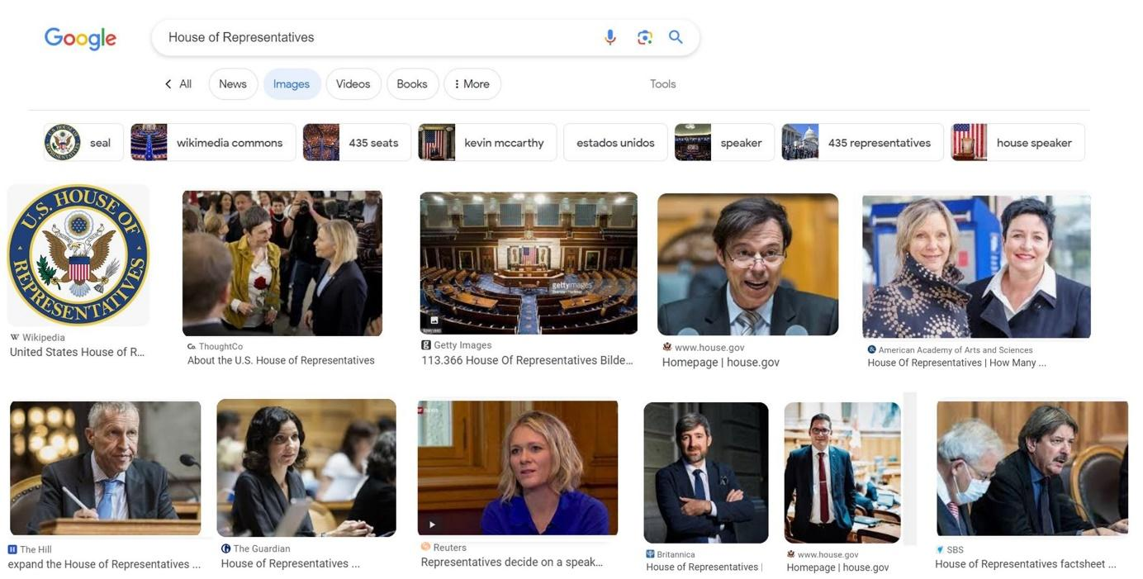
Figure B3.1.1 Gender-balanced Google search output for the US sample

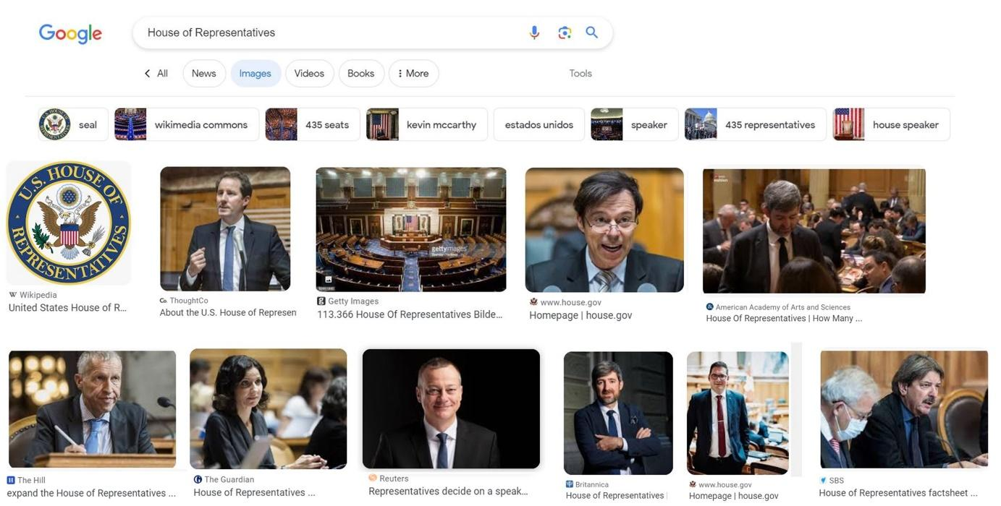
Figure B3.1.2 Gender-biased Google search output for the US sample

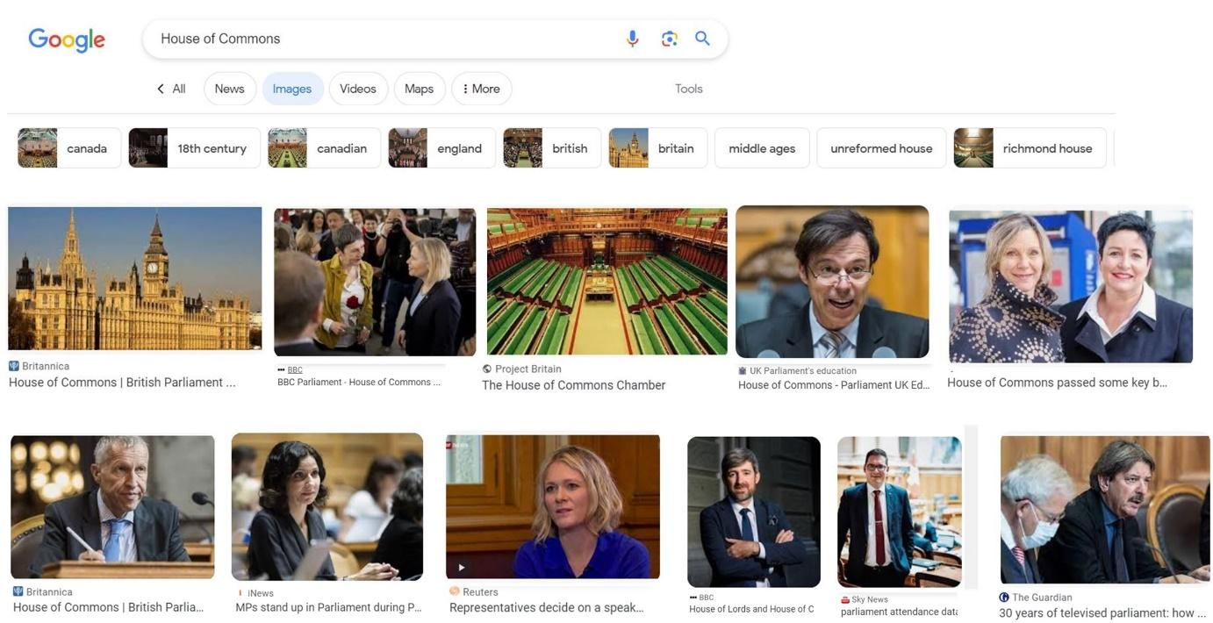
Figure B3.1.3 Gender-balanced Google search output for the UK sample

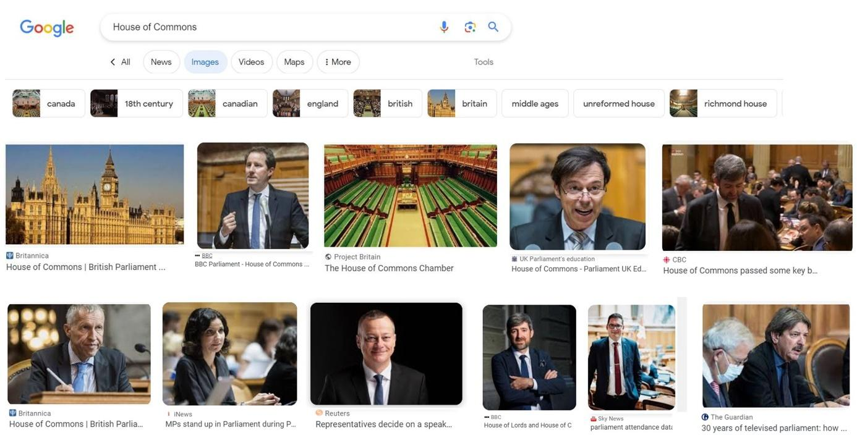
Figure B3.1.2 Gender-biased Google search output for the UK sample

B3.2 Stimuli for Study 4

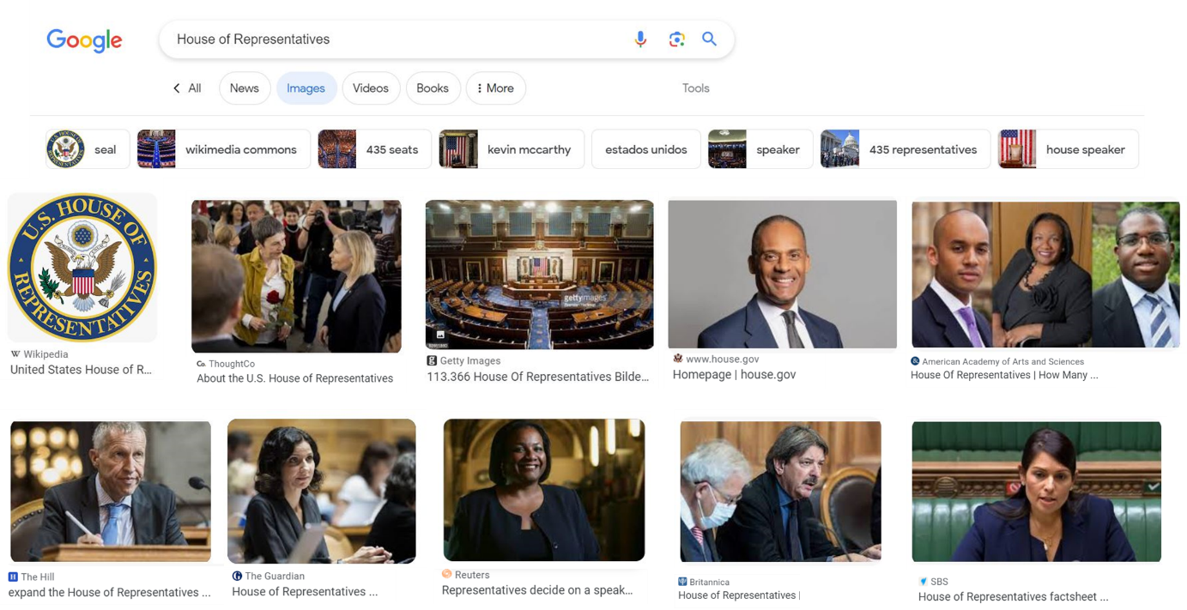
Figure B3.2.1 “No bias” condition with gender- and race-balanced Google search output

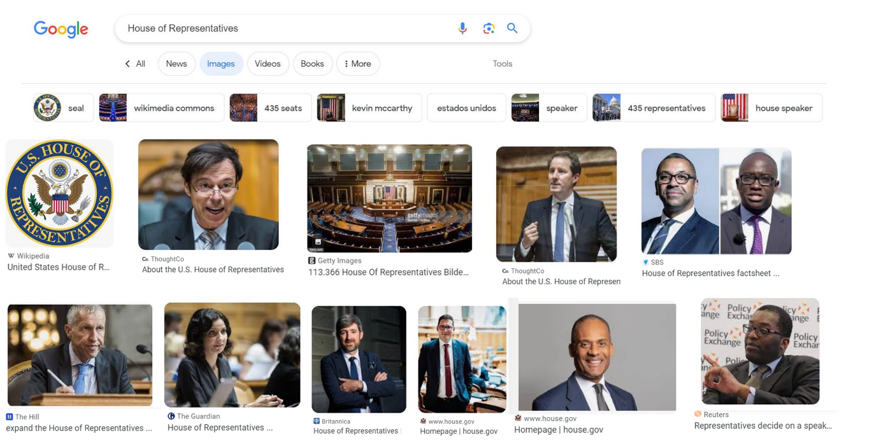
Figure B3.2.2 “Gender bias” condition with gender- biased but race-balanced Google search output

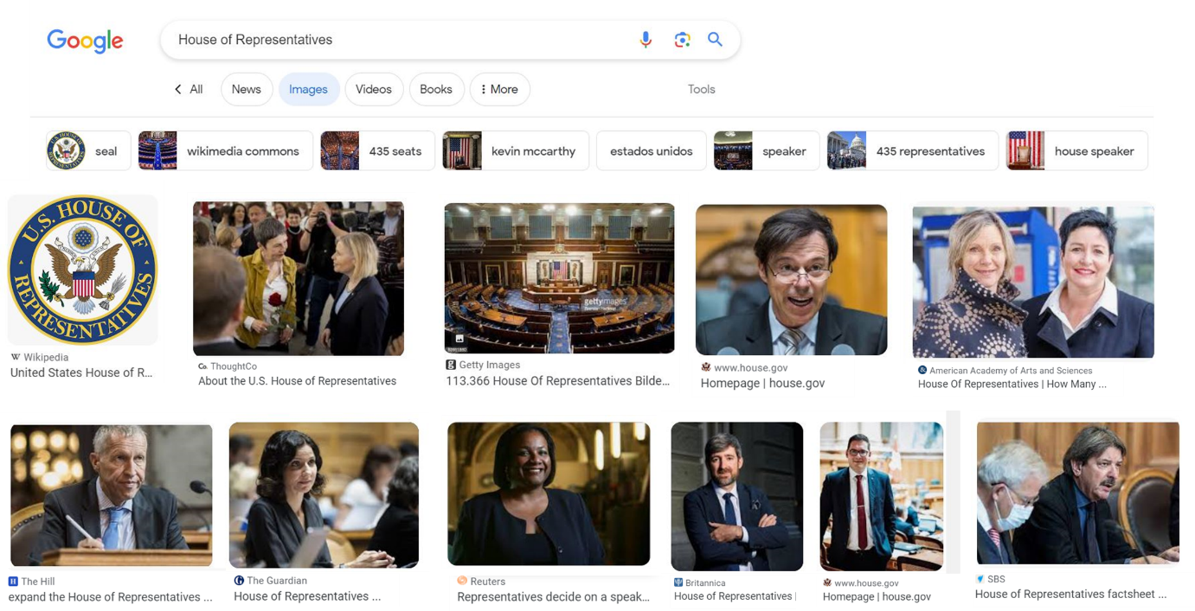
Figure B3.2.3 “Race bias” condition with race- biased but gender-balanced Google search output

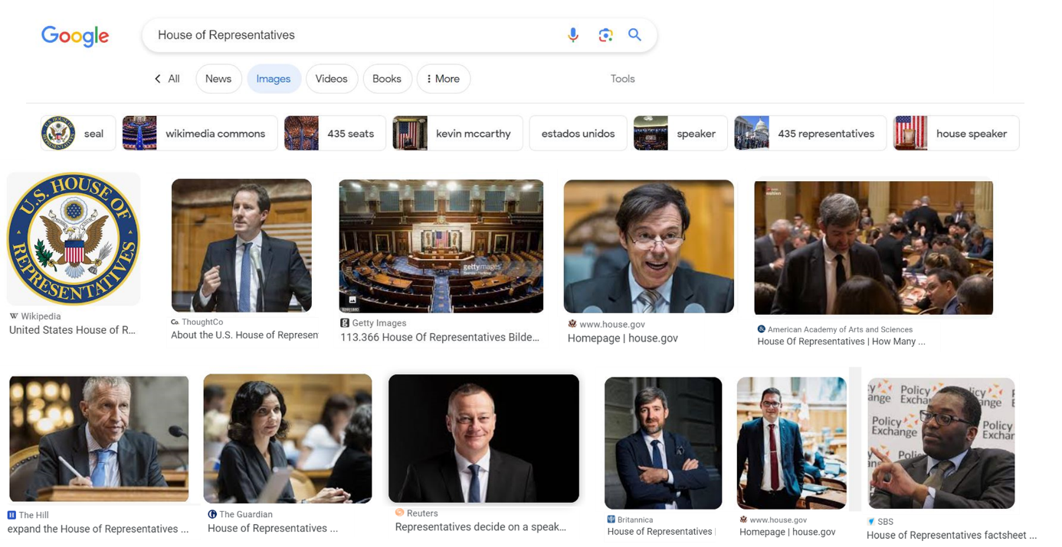
Figure B3.2.4 Intersectional “Double bias” condition with gender- and race-biased Google search output

C: Additional information and analyses

C1. Study 1
In the manuscript we estimate women’s algorithmic representation as the fixed effect intercept from mixed effects models without including any statistical controls (see Table 1 in manuscript). Similarly, we test the association between women’s algorithmic and descriptive representations as simple bivariate correlations. Table C1 provides the results for all three measures of algorithmic representation from models including additional query- or country-level predictors, including women’s descriptive representation. These additional models offer three insights. First, the finding of women’s algorithmic underrepresentation is robust to alternative model specifications. Second, the models confirm the bivariate association: Even after controlling for other factors, a percentage point increase in women’s descriptive representation results in an increase in their algorithmic representation by 0.19 percentage points (b = 0.19, CI[0.04:0.34], p = 0.016). Note that this positive association also holds for the measure of having at least one woman present in an image but not for predicting the total number of depicted women. Third, we find no compelling evidence for alternative explanations of women’s algorithmic representation. One exception is the query language. For 17 queries, we repeated the queries in a minority language (e.g., in Spanish in the US, French in Canada, Bengali in India, Dutch in Belgium etc.). The results indicate that women’s algorithmic underrepresentation tends to be stronger if minority languages are used for a political information search.
Table C1.1a Full results of generalized linear mixed effects models predicting women’s algorithmic representation in study 1 (as reported in Table 1 in the manuscript)
 | Share women |  |  | Presence women |  |  | Presence men |  |  | Number women |  |  | Number men
 | b | CI | p | OR | CI | p | OR | CI | P | b | CI | p | b | CI | p
Fixed | Lower chamber
Intercept | 0.29 | 0.27 – 0.32 | <0.001 | 0.79 | 0.67 – 0.92 | 0.003 | 1.64 | 1.39 – 1.93 | <0.001 | 2.94 | 2.47 – 3.41 | <0.001 | 7.06 | 5.81 – 8.23 | <0.001
Random
N_{imag} / k_{coun} | 2846 | 57 |  | 4243 | 57 |  | 4243 | 57 |  | 4243 | 57 |  | 4243 | 57
σ² / τ₀₀ /ICC | 0.08 | 0.01 _{country} | 0.08 | 3.29 | 0.30 _{country} | 0.08 | 3.29 | 0.34 _{country} | 0.09 | 40.33 | 2.75 _{country} | 0.06 | 222.75 | 20.29 _{country} | 0.08
R² cond | 0.076 |  |  | 0.084 |  |  | 0.093 |  |  | 0.064 |  |  | 0.083
Fixed | Upper chamber
Intercept | 0.28 | 0.26 – 0.31 | <0.001 | 0.78 | 0.63 – 0.96 | 0.020 | 1.98 | 1.65 – 2.38 | <0.001 | 2.29 | 1.80 – 2.78 | <0.001 | 5.28 | 4.11 – 6.45 | <0.001
Random
N_{imag} / k_{coun} | 1582 | 29 |  | 2120 | 29 |  | 2120 | 29 |  | 2120 | 29 |  | 2120 | 29
σ² / τ₀₀ /ICC | 0.11 | 0.00 _{country} | 0.02 | 3.29 | 0.28 _{country} | 0.08 | 3.29 | 0.19 _{country} | 0.06 | 30.36 | 1.38 _{country} | 0.04 | 160.15 | 8.08 _{country} | 0.05
R² cond | 0.02 |  |  | 0.08 |  |  | 0.05 |  |  | 0.04 |  |  | 0.065
Table C1.1b Full results of generalized linear mixed effects models predicting women’s algorithmic representation in study 2 (as reported in Table 1 in the manuscript)
 | Share women |  |  | Presence women |  |  | Presence men |  |  | Number women |  |  | Number men
 | b | CI | p | OR | CI | p | OR | CI | P | b | CI | p | b | CI | p
Fixed | Lower chamber
Intercept | 0.23 | 0.18 – 0.27 | <0.001 | 0.68 | 0.55 – 0.85 | 0.001 | 2.59 | 1.90 – 3.54 | <0.001 | 3.11 | 2.19 – 4.04 | <0.001 | 8.15 | 5.68 – 10.62 | <0.001
Random
N_{images} / σ² | 70331 | 0.08 |  | 92213 | 3.29 |  | 92213 | 3.29 |  | 92213 | 63.71 |  | 92213 | 269.29
τ_{00 agent / country / region} | 0.00 | 0.01 | 0.00 | 0.00 | 0.14 | 0.01 | 0.00 | 0.28 | 0.02 | 0.00 | 2.42 | 0.03 | 0.00 | 17.18 | 0.23
Fixed | Upper chamber
Intercept | 0.27 | 0.22 – 0.32 | <0.001 | 0.62 | 0.48 – 0.82 | 0.001 | 2.23 | 1.47 – 3.37 | <0.001 | 1.18 | 0.81 – 1.54 | <0.001 | 3.05 | 2.14 – 3.95 | <0.001
Random
N_{images} / σ² | 45223 | 0.10 |  | 59885 | 3.29 |  | 59885 | 3.31 |  | 59885 | 10.1 |  | 59885 | 66.49
τ_{00 agent / country / region} | 0.00 | 0.00 | 0.00 | 0.00 | 0.02 | 0.16 | 0.00 | 0.05 | 0.37 | 0.00 | 0.03 | 0.29 | 0.00 | 0.13 | 1.80
Notes. In addition to the country level (k = 11), all models are clustered around the location (k = 11) and the individual virtual agent (k = 220).

Table C1.2 Overview of results for models with additional predictors
 | Share of women |  |  | Number of women |  |  | Presence of woman
Predictors | Estimates | CI | p | Estimates | CI | p | Odds Ratios | CI | p
(Intercept) | 7.06 | -17.57 – 31.69 | 0.574 | 3.01 | -2.73 – 8.75 | 0.304 | 1.05 | 0.17 – 6.46 | 0.955
Women’s descriptive representation | 0.21 | 0.05 – 0.36 | 0.009 | 0.03 | -0.00 – 0.06 | 0.062 | 1.01 | 1.00 – 1.02 | 0.008
Upper chamber | -0.51 | -2.38 – 1.36 | 0.594 | -0.75 | -1.07 – -0.43 | <0.001 | 0.98 | 0.88 – 1.09 | 0.728
Query in main language  (reference: minority language) | 4.18 | 1.51 – 6.85 | 0.002 | 0.59 | 0.13 – 1.05 | 0.012 | 1.09 | 0.94 – 1.27 | 0.260
Gender quota  (reference: no quota) | -0.44 | -3.71 – 2.84 | 0.794 | 0.60 | -0.23 – 1.42 | 0.155 | 1.23 | 0.95 – 1.59 | 0.120
Global Gender Gap Index (global rank) | 21.65 | -14.86 – 58.16 | 0.245 | -1.65 | -9.86 – 6.55 | 0.693 | 0.34 | 0.03 – 4.69 | 0.424
Random Effects
σ² | 954.19 |  |  | 37.90 |  |  | 3.29
τ₀₀ | 26.11 _{country} |  |  | 1.91 _{country} |  |  | 0.21 _{country}
 | 0.00 _{region} |  |  | 0.47 _{region} |  |  | 0.00 _{region}
ICC |  |  |  | 0.06
N | 58 _{country} |  |  | 58 _{country} |  |  | 58 _{country}
 | 9 _{region} |  |  | 9 _{region} |  |  | 9 _{region}
Observations | 5497 |  |  | 8036 |  |  | 8036
Marginal R² / Conditional R² | 0.017 / NA |  |  | 0.007 / 0.066 |  |  | 0.009 / NA

Table C1.3 Alternative operationalization of algorithmic representation as gender ratio
 | Lower chamber |  |  |  | Upper chamber
Predictors | Estimates | CI | p |  | Estimates | CI | p
Fixed
Intercept | -0.41 | -0.46- -0.36 | <0.001 |  | -0.43 | -0.48- -0.38 | <0.001
Random
N_{imag} / k_{country} | 2846 / 57 |  |  |  | 1582 / 29
σ² / τ₀₀ /ICC | 0.34 / 0.03_{country} / 0.08 |  |  |  | 0.42 / 0.01_{country} / 0.02
R² cond | 0.076 |  |  |  | 0.020
Note: The dependent variable, gender ratio, is operationalized as: $\frac{{number}_{women}- {number}_{men}}{{number}_{women}+ {number}_{men}}$

C2. Study 2
Study 2 implemented additional rounds of data collection by having 20 virtual agents conducting the same query and in 11 different locations. With 20 agents per location, it resulted in 220 agents overall. This resulted in roughly 10,000 images per query that depicted persons. The goal of these methodological modifications was to provide an estimate of women’s algorithmic representation that is robust against the random noise underlying search engine behavior. In the following, we visually explore the variation introduced by these additional data generating processes.
Figure C2.1 depicts the distribution of women’s algorithmic by country and chamber, pooling the averages across different locations and virtual agents. For most countries, the variation only spans several percentage points (e.g., Japan, India). Note that in some cases the distribution of women’s algorithmic representations does not include the actual female descriptive representation (red tick). For example, every single iteration of the data collection for Japanese and Brazilian queries overrepresents women’s algorithmic representation relative to their actual presence in these legislative bodies. For a few countries, including the English-speaking countries, we find more variation (indicated by wider distributions).
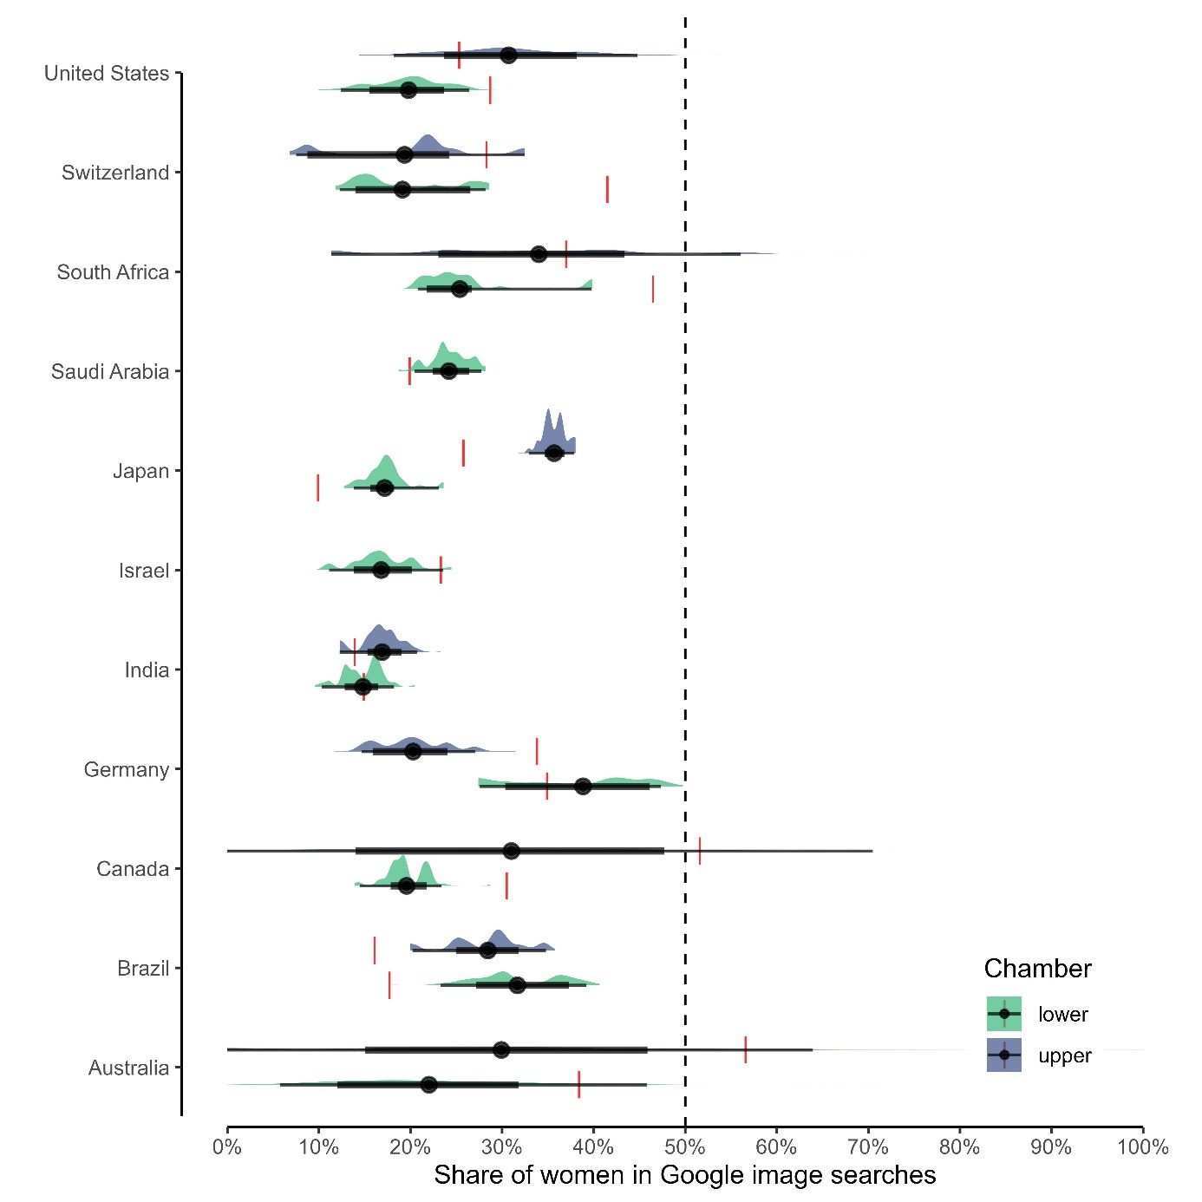

Figure C2.1 Distribution of women’s algorithmic representation by country and parliamentary chamber in study 2. Red ticks indicate women’s actual descriptive representation in the corresponding parliamentary chamber.

Figure C2.2 further breaks down the variation in data collection iterations by showing women’s average algorithmic representation (across first 50 images) for each agent and in each location (y-axis) for six example countries. The illustration shows that agents in the same location tend to yield similar results, which is indicated by the tendency of colors to cluster among themselves (see also Table C2.1 below for location-based averages). The figure also visually underscores the variation in women’s algorithmic representation for queries of the US senate, which ranges from roughly 10% up to parity, centering just above women’s actual descriptive representation.

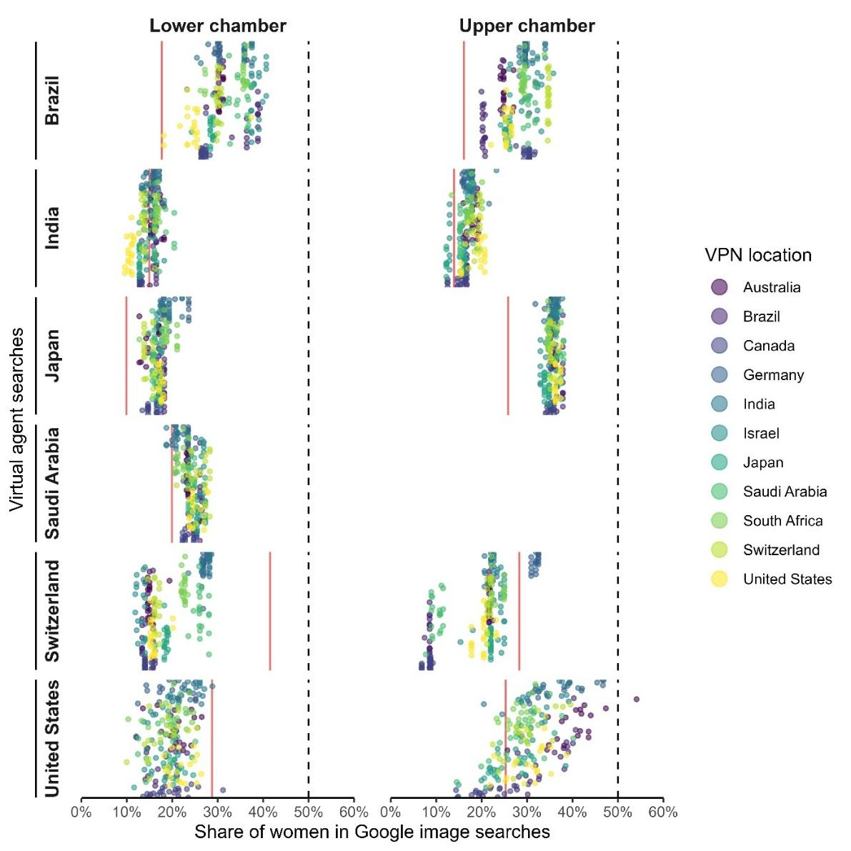
Figure C2.2 Detailed overview of women’s algorithmic representation by country and parliamentary chamber in study 2. Red lines indicate women’s actual descriptive representation in the corresponding parliamentary chamber.

Table C2.1 Geographical variation in algorithmic representation based on virtual location of data collection
Virtual location of data collection | Women’s algorithmic representation (%)
Australia | Lower chamber | Upper chamber
Australia | 20.9 | 29.1
Brazil | 23.0 | 21.5
Canada | 20.6 | 20.0
Germany | 24.7 | 28.9
India | 22.3 | 27.0
Israel | 22.4 | 24.2
Japan | 22.0 | 23.7
Saudi Arabia | 23.0 | 22.6
South Africa | 24.4 | 26.1
Switzerland | 22.2 | 25.4
United States | 22.3 | 26.9
Across locations | 22.5 (18.2-26.9) | 24.9 (19.6-28.1)
Notes. The averages are based on the first 50 images in 20 queries by 20 virtual agents per location

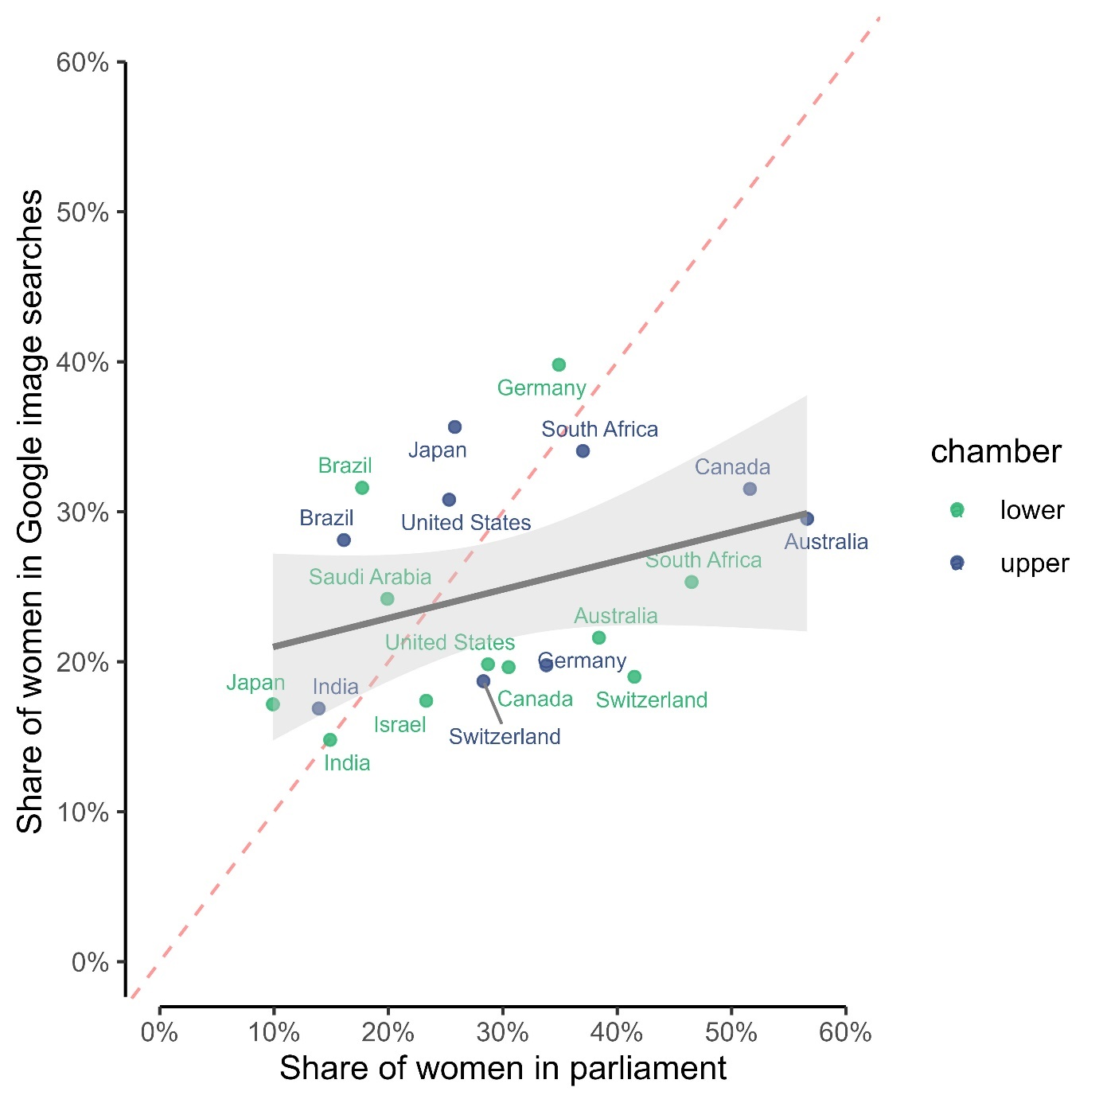

Figure C2.3 Overview of women’s algorithmic vs. descriptive representation.

Table C2.2 Overview of results for models with additional predictors
 | Share of women |  |  | Number of women |  |  | Presence of woman
Predictors | Estimates | CI | p | Estimates | CI | p | Odds Ratios | CI | p
(Intercept) | 24.91 | -28.84 – 78.66 | 0.364 | 1.09 | -9.66 – 11.85 | 0.842 | 4.05 | 1.98 – 8.27 | <0.001
Women’s descriptive representation | 0.50 | 0.46 – 0.53 | <0.001 | 0.00 | -0.01 – 0.01 | 0.636 | 1.04 | 1.04 – 1.04 | <0.001
Upper chamber | 2.75 | 2.36 – 3.14 | <0.001 | -1.60 | -1.67 – -1.53 | <0.001 | 0.94 | 0.92 – 0.96 | <0.001
Global Gender Gap Index | -24.56 | -95.75 – 46.63 | 0.499 | 2.80 | -11.44 – 17.05 | 0.700 | 0.02 | 0.01 – 0.05 | <0.001
Gender quota  (reference: no quota) | 5.38 | -4.42 – 15.18 | 0.282 | -0.50 | -2.46 – 1.46 | 0.618 | 1.15 | 0.77 – 1.72 | 0.491
Search from home location | 1.76 | 1.15 – 2.37 | <0.001 | 0.05 | -0.07 – 0.16 | 0.405 | 1.03 | 1.00 – 1.07 | 0.080
Random Effects
σ² | 922.11 |  |  | 43.10 |  |  | 3.29
τ₀₀ | 0.00 _{agent_id} |  |  | 0.00 _{agent_id} |  |  | 0.00 _{agent_id}
 | 33.72 _{country} |  |  | 1.35 _{country} |  |  | 0.10 _{country}
 | 2.19 _{region} |  |  | 0.02 _{region} |  |  | 0.01 _{region}
N | 11 _{region} |  |  | 11 _{region} |  |  | 11 _{region}
 | 11 _{country} |  |  | 11 _{country} |  |  | 11 _{country}
 | 220 _{agent_id} |  |  | 220 _{agent_id} |  |  | 220 _{agent_id}
Observations | 115554 |  |  | 152098 |  |  | 152098
Marginal R² / Conditional R² | 0.015 / NA |  |  | 0.017 / NA |  |  | 0.021 / NA

C3. Study 3

C3.1 Full results
Table C3.1.1 Full results for reported effects predicting estimations of women’s descriptive representation (perceptual bias H3; study 3)
 | Estimated representation
 |  | US Sample |  |  | UK Sample
Predictors | Estimates | CI | p | Estimates | CI | p
(Intercept) | 28.11 | 21.55 – 34.68 | <0.001 | 33.02 | 26.47 – 39.57 | <0.001
Gender-biased condition | -10.36 | -12.78 – -7.93 | <0.001 | -11.64 | -13.93 – -9.34 | <0.001
Time (pretreatment) | -3.22 | -4.21 – -2.24 | <0.001 | -3.89 | -4.68 – -3.10 | <0.001
Female participant | -1.81 | -4.14 – 0.52 | 0.128 | -2.83 | -5.10 – -0.57 | 0.014
Non-binary participant | 1.60 | -6.92 – 10.11 | 0.713 | -3.13 | -16.84 – 10.59 | 0.655
Conservative  Ideology | 0.93 | 0.24 – 1.62 | 0.008 | 0.51 | -0.19 – 1.22 | 0.152
Age | -0.02 | -0.12 – 0.07 | 0.598 | 0.03 | -0.06 – 0.12 | 0.459
Search engine use | 0.03 | -0.02 – 0.08 | 0.224 | -0.00 | -0.06 – 0.05 | 0.859
Liberal party vote | 0.16 | -3.60 – 3.92 | 0.935 | -4.11 | -7.75 – -0.46 | 0.027
Independent party vote | 1.70 | -2.68 – 6.07 | 0.447 | -1.83 | -5.53 – 1.86 | 0.331
Gender-biased condition × Time (pretreatment) | 10.99 | 9.59 – 12.38 | <0.001 | 11.58 | 10.46 – 12.70 | <0.001
Random Effects
σ² | 38.06 |  |  | 24.35
τ₀₀ | 93.65 _{ResponseId} |  |  | 87.29 _{ResponseId}
ICC | 0.71 |  |  | 0.78
N | 303 _{ResponseId} |  |  | 299 _{ResponseId}
Observations | 1212 |  |  | 1196
Marginal R² / Conditional R² | 0.138 / 0.751 |  |  | 0.185 / 0.822

Table C3.1.2 Full results for the simple mediation models as reported in the manuscript (study 3)
 | Mediator model |  |  | Outcome models
 | Estimated representation  (perceptual bias) |  |  | Women’s electability |  |  | Participants’ external efficacy
Predictors | Estimates | CI | p | Estimates | CI | p | Estimates | CI | p
(Intercept) | 2.58 | -2.64 – 7.81 | 0.332 | -0.08 | -0.87 – 0.71 | 0.845 | 2.04 | 1.58 – 2.50 | <0.001
Gender-biased condition | -11.14 | -12.94 – -9.33 | <0.001 | -0.07 | -0.38 – 0.23 | 0.644 | 0.26 | 0.08 – 0.43 | 0.005
Age | 0.00 | -0.07 – 0.07 | 0.951 | 0.01 | -0.00 – 0.02 | 0.121 | 0.01 | 0.00 – 0.01 | 0.007
Female participant | -2.36 | -4.19 – -0.54 | 0.011 | -0.43 | -0.71 – -0.16 | 0.002 | -0.15 | -0.31 – 0.01 | 0.072
Conservative ideology | 0.62 | 0.08 – 1.16 | 0.026 | -0.07 | -0.15 – 0.01 | 0.106 | -0.02 | -0.07 – 0.03 | 0.490
Liberal party vote | -2.20 | -5.12 – 0.72 | 0.140 | -0.11 | -0.55 – 0.33 | 0.632 | -0.10 | -0.36 – 0.16 | 0.435
Independent party vote | 0.35 | -2.75 – 3.45 | 0.824 | -0.20 | -0.67 – 0.27 | 0.399 | -0.58 | -0.85 – -0.30 | <0.001
Search engine use | 0.01 | -0.04 – 0.05 | 0.803 | 0.00 | -0.00 – 0.01 | 0.182 | 0.00 | -0.00 – 0.01 | 0.279
UK sample | -5.78 | -7.65 – -3.91 | <0.001 | 0.01 | -0.28 – 0.30 | 0.959 | -0.03 | -0.20 – 0.14 | 0.699
Estimated representation  (perceptual bias) |  |  |  | 0.02 | 0.00 – 0.03 | 0.014 | 0.02 | 0.01 – 0.02 | <0.001
ADE |  |  |  | -0.07 | -0.37– 0.22 | 0.639 | 0.25 | 0.07–0.43 | 0.005
ACME |  |  |  | -0.17 | -0.34– -0.03 | 0.015 | -0.19 | -0.28– -0.11 | <0.001
Observations | 593 |  |  | 593 |  |  | 593
R² / R² adjusted | 0.265 / 0.255 |  |  | 0.044 / 0.030 |  |  | 0.101 / 0.087

C3.2 Tests of pre-registered hypotheses not reported in manuscript

As documented in section A, the main manuscript did not include results for three pre-registered hypotheses. These hypotheses were not reported in the manuscript, as the authors chose to focus more specifically on the role of representation; adding additional indicators of masculinized views of politics—see H3b*, H3c*—would have gone beyond the scope of a single manuscript. The motivation behind these hypotheses was to test whether our treatments not only slant political perceptions (i.e. estimated descriptive representations; see H3 in manuscript) but also influence specific evaluations of (gendered) leadership traits preferred in political leaders (H3b*) as well as issue priorities (H3c*). Moreover, we did not report the expected direct effects of our treatments on viability and external efficacy beliefs (see H3d*) to avoid confusion between direct and indirect pathways. We measured perceived viability as a global candidate evaluation consisting of the electability question from the manuscript and two additional items rating candidates’ perceived qualification and likelihood of winning the elections (note: the three items were then averaged to form a single scale). The omitted hypotheses are:
- H3b*: Gender-biased (compared to gender-balanced) Google search output will result in higher (lower) desirability of agentic (communal) personality traits
- H3c*: Gender-biased (compared to gender-balanced) Google search output will result in higher (lower) importance of masculine (feminine) political issues
- H3d*: Gender-biased (compared to gender-balanced) Google search output will decrease the perceived viability of women and participants’ external efficacy
Below, we test these hypotheses by fitting separate OLS regression models for each of the six outcomes (see Tables C3.2.1-C3.2.3). Note that the models include the same controls (participant gender, ideology, age, search engine use, and party affiliation). The results show null findings for hypotheses H3b* and H3c*, suggesting that exposure to algorithmic underrepresentation of women does not affect the perceived desirability of traits in political leaders nor the perceived importance of political issues. In contrast, we find that US and UK participants significantly perceive women candidates to be less viable after seeing them being underrepresented in Google image search output. Similarly, gender-biased output results in lower self-reported external efficacy in both samples, lending overall rather consistent evidence to the idea of a direct link of algorithmic exposure and viability/efficacy assessments (H3d*).
Table C3.2.1a Full results for reported effects predicting the desirability of communal traits (H3b*)
 | Communal traits
 |  | US Sample |  |  | UK Sample
Predictors | b | se | p | b | CI | p
(Intercept) | 0.22 | 0.07 | 0.002 | 0.34 | 0.06 | <0.001
Gender-biased condition | -0.02 | 0.02 | 0.357 | -0.02 | 0.02 | 0.449
Female participant | 0.02 | 0.02 | 0.393 | -0.04 | 0.02 | 0.043
Non-binary participant | -0.08 | 0.09 | 0.406 | -0.03 | 0.13 | 0.835
Conservative Id. | 0.01 | 0.01 | 0.325 | 0.01 | 0.01 | 0.214
Age | 0.00 | 0.00 | <0.001 | 0.00 | 0.00 | 0.014
Search engine use | 0.00 | 0.00 | 0.078 | -0.00 | 0.00 | 0.339
Liberal party vote | -0.01 | 0.04 | 0.824 | -0.06 | 0.03 | 0.060
Ind. party vote | -0.08 | 0.05 | 0.087 | -0.09 | 0.03 | 0.009
Observations | 303 |  |  | 299
R² / R²_{adj.} | 0.102 / 0.078 |  |  | 0.087 / 0.062

Table C3.2.1b Full results for reported effects predicting the desirability of agentic traits (H3b*)
 | Agentic traits
 |  | US Sample |  |  | UK Sample
Predictors | b | se | p | b | CI | p
(Intercept) | 0.52 | 0.06 | <0.001 | 0.68 | 0.06 | <0.001
Gender-biased condition | -0.02 | 0.02 | 0.475 | 0.00 | 0.02 | 0.818
Female participant | 0.04 | 0.02 | 0.042 | -0.01 | 0.02 | 0.680
Non-binary participant | 0.02 | 0.08 | 0.783 | -0.06 | 0.12 | 0.589
Conservative Id. | 0.00 | 0.01 | 0.604 | -0.01 | 0.01 | 0.247
Age | 0.00 | 0.00 | 0.048 | 0.00 | 0.00 | 0.243
Search engine use | 0.00 | 0.00 | 0.194 | -0.00 | 0.00 | 0.260
Liberal party vote | 0.02 | 0.03 | 0.658 | -0.07 | 0.03 | 0.022
Ind. party vote | -0.07 | 0.04 | 0.094 | -0.09 | 0.03 | 0.005
Observations | 303 |  |  | 299
R² / R²_{adj.} | 0.057 / 0.034 |  |  | 0.038 / 0.014
Table C3.2.2a Full results predicting the importance of feminine issues (H3c*)
 | Feminine issues
 |  | US Sample |  |  | UK Sample
Predictors | b | se | p | b | CI | p
(Intercept) | 0.65 | 0.10 | <0.001 | 0.83 | 0.09 | <0.001
Gender-biased condition | -0.03 | 0.03 | 0.437 | -0.05 | 0.03 | 0.116
Female participant | -0.02 | 0.03 | 0.591 | -0.02 | 0.03 | 0.617
Non-binary participant | 0.04 | 0.12 | 0.742 | 0.17 | 0.19 | 0.366
Conservative Id. | 0.02 | 0.01 | 0.115 | -0.02 | 0.01 | 0.030
Age | 0.00 | 0.00 | 0.770 | 0.00 | 0.00 | 0.025
Search engine use | 0.00 | 0.00 | 0.898 | -0.00 | 0.00 | 0.750
Liberal party vote | 0.03 | 0.06 | 0.611 | 0.00 | 0.05 | 0.957
Ind. party vote | -0.04 | 0.06 | 0.580 | -0.06 | 0.05 | 0.212
Observations | 303 |  |  | 299
R² / R²_{adj.} | 0.019 / -0.008 |  |  | 0.052 / 0.026

Table C3.2.2b Full results predicting the importance of masculine issues (H3c*)
 | Masculine issues
 |  | US Sample |  |  | UK Sample
Predictors | b | se | p | b | CI | p
(Intercept) | 0.71 | 0.07 | <0.001 | 0.65 | 0.08 | <0.001
Gender-biased condition | -0.01 | 0.02 | 0.744 | -0.03 | 0.03 | 0.297
Female participant | 0.00 | 0.02 | 0.864 | 0.01 | 0.03 | 0.842
Non-binary participant | -0.06 | 0.09 | 0.506 | -0.03 | 0.16 | 0.845
Conservative Id. | 0.01 | 0.01 | 0.439 | 0.01 | 0.01 | 0.210
Age | 0.00 | 0.00 | 0.154 | 0.00 | 0.00 | 0.007
Search engine use | 0.00 | 0.00 | 0.373 | -0.00 | 0.00 | 0.330
Liberal party vote | 0.00 | 0.04 | 0.934 | 0.02 | 0.04 | 0.661
Ind. party vote | 0.01 | 0.04 | 0.823 | -0.04 | 0.04 | 0.314
Observations | 303 |  |  | 299
R² / R²_{adj.} | 0.021 / -0.006 |  |  | 0.051 / 0.025
Table C3.2.3a Full results for reported effects predicting perceived viability (H3d*)
 | Perceived viability
 |  | US Sample |  |  | UK Sample
Predictors | b | se | p | b | CI | p
(Intercept) | -0.10 | 0.32 | 0.759 | 0.18 | 0.34 | 0.584
Gender-biased condition | 0.03 | 0.11 | 0.788 | -0.19 | 0.11 | 0.098
Female participant | -0.01 | 0.12 | 0.954 | -0.28 | 0.12 | 0.016
Non-binary participant | 0.13 | 0.42 | 0.757 | 0.84 | 0.71 | 0.236
Conservative Id. | -0.07 | 0.03 | 0.041 | -0.04 | 0.04 | 0.245
Age | 0.01 | 0.00 | 0.049 | 0.01 | 0.00 | 0.054
Search engine use | 0.00 | 0.00 | 0.614 | 0.01 | 0.00 | 0.050
Liberal party vote | -0.01 | 0.19 | 0.971 | -0.26 | 0.19 | 0.168
Ind. party vote | -0.21 | 0.22 | 0.325 | -0.33 | 0.19 | 0.081
Observations | 303 |  |  | 299
R² / R²_{adj.} | 0.045 / 0.020 |  |  | 0.060 / 0.034

Table C3.2.3b Full results for reported effects predicting external efficacy (H3d*)
 | External efficacy
 |  | US Sample |  |  | UK Sample
Predictors | b | se | p | b | CI | p
(Intercept) | 1.38 | 0.35 | <0.001 | 2.79 | 2.79 | 0.31
Gender-biased condition | 0.12 | 0.12 | 0.345 | -0.42 | 0.10 | 0.11
Female participant | -0.03 | 0.12 | 0.804 | -0.35 | -0.35 | 0.11
Conservative Id. | -0.34 | 0.45 | 0.453 | -0.00 | -0.14 | 0.65
Age | 0.02 | 0.04 | 0.676 | -0.00 | -0.00 | 0.03
Search engine use | 0.01 | 0.00 | 0.005 | -0.00 | -0.00 | 0.00
Liberal party vote | 0.01 | 0.00 | 0.035 | -0.54 | -0.00 | 0.00
Ind. party vote | 0.16 | 0.20 | 0.417 | 0.100 | -0.54 | 0.17
Observations | 303 |  |  | 299
R² / R²_{adj.} | 0.085 / 0.060 |  |  | 0.110 / 0.085

Table C3.2.4 Full results for reported effects predicting estimations of women’s descriptive representation (perceptual bias H3; study 3—but without the non-preregistered covariate search engine use)
 | Estimated representation
 |  | US Sample |  |  | UK Sample
Predictors | Estimates | CI | p | Estimates | CI | p
(Intercept) | 28.74 | 22.25 – 35.23 | <0.001 | 32.87 | 26.54 – 39.19 | <0.001
Gender-biased condition | -10.46 | -12.88 – -8.04 | <0.001 | -11.65 | -13.94 – -9.37 | <0.001
Time (pretreatment) | -3.22 | -4.21 – -2.24 | <0.001 | -3.89 | -4.68 – -3.10 | <0.001
Female participant | -1.95 | -4.27 – 0.37 | 0.100 | -2.82 | -5.08 – -0.56 | 0.014
Non-binary participant | 1.19 | -7.31 – 9.69 | 0.784 | -3.06 | -16.74 – 10.61 | 0.660
Conservative  Ideology | 0.92 | 0.23 – 1.61 | 0.009 | 0.51 | -0.19 – 1.21 | 0.153
Age | -0.02 | -0.11 – 0.08 | 0.733 | 0.03 | -0.05 – 0.12 | 0.445
Liberal party vote | 0.26 | -3.50 – 4.02 | 0.891 | -4.10 | -7.73 – -0.46 | 0.027
Independent party vote | 1.56 | -2.81 – 5.93 | 0.484 | -1.81 | -5.49 – 1.87 | 0.334
Gender-biased condition × Time (pretreatment) | 10.99 | 9.59 – 12.38 | <0.001 | 11.58 | 10.46 – 12.70 | <0.001
Random Effects
σ² | 38.60 |  |  | 24.38
τ₀₀ | 92.66 _{ResponseId} |  |  | 87.29 _{ResponseId}
ICC | 0.71 |  |  | 0.78
N | 297 _{ResponseId} |  |  | 297 _{ResponseId}
Observations | 1212 |  |  | 1196
Marginal R² / Conditional R² | 0.135 / 0.750 |  |  | 0.185 / 0.822

C4. Study 4

Table C4.1. Full results for reported effects predicting estimations of women’s descriptive representation (perceptual bias H3; study 4)
 | Estimated representation:  Women politicians |  |  | Estimated representation:  Non-white politicians |  |  | Estimated representation:  Non-white women politicians
Predictors | Estimates | CI | p | Estimates | CI | p | Estimates | CI | p
(Intercept) | 26.75 | 21.46 – 32.04 | <0.001 | 29.72 | 23.54 – 35.90 | <0.001 | 8.03 | 2.42 – 13.64 | 0.005
Condition: Gender bias | -11.53 | -14.08 – -8.98 | <0.001 | -1.80 | -4.78 – 1.18 | 0.236 | -5.38 | -8.09 – -2.67 | <0.001
Condition: Race bias | -0.84 | -3.38 – 1.70 | 0.517 | -7.65 | -10.62 – -4.68 | <0.001 | -5.28 | -7.98 – -2.59 | <0.001
Condition: Double bias | -9.49 | -12.03 – -6.94 | <0.001 | -9.49 | -12.47 – -6.52 | <0.001 | -6.99 | -9.70 – -4.29 | <0.001
Female participant | -2.02 | -3.90 – -0.13 | 0.036 | -0.50 | -2.70 – 1.70 | 0.655 | 0.19 | -1.81 – 2.19 | 0.853
Non-binary participant | -2.94 | -9.14 – 3.25 | 0.351 | 3.44 | -3.79 – 10.68 | 0.350 | 6.00 | -0.57 – 12.58 | 0.074
Democratic party vote | 2.53 | -0.42 – 5.48 | 0.093 | -3.49 | -6.93 – -0.04 | 0.047 | -0.21 | -3.34 – 2.93 | 0.897
Independent party vote | 1.08 | -2.41 – 4.56 | 0.545 | -3.25 | -7.32 – 0.82 | 0.117 | -3.38 | -7.08 – 0.32 | 0.073
Conservative ideology | 0.87 | 0.39 – 1.35 | <0.001 | 0.70 | 0.14 – 1.26 | 0.015 | 1.40 | 0.89 – 1.91 | <0.001
Age | 0.03 | -0.04 – 0.10 | 0.367 | -0.05 | -0.12 – 0.03 | 0.249 | 0.01 | -0.06 – 0.08 | 0.875
Search engine Use | 0.04 | 0.01 – 0.08 | 0.026 | 0.11 | 0.06 – 0.15 | <0.001 | 0.18 | 0.14 – 0.22 | <0.001
Observations | 778 |  |  | 778 |  |  | 778
R² / R² adjusted | 0.173 / 0.163 |  |  | 0.131 / 0.120 |  |  | 0.196 / 0.185

Table C4.2.1 Full results for the simple mediation models for gender bias as reported in the manuscript (study 4; full sample)
 | Mediator model |  |  | Outcome models
 | Estimated representation  (perceptual bias) |  |  | Women’s general  electability |  |  | Women’s specific  electablity |  |  | Participants’  external efficacy
Predictors | Estimates | CI | p | Estimates | CI | p | Estimates | CI | p | Estimates | CI | p
(Intercept) | 26.33 | 21.20 – 31.46 | <0.001 | 1.37 | 1.01 – 1.73 | <0.001 | -0.21 | -0.37 – -0.04 | 0.015 | 1.12 | 0.68 – 1.57 | <0.001
Gender-biased condition | -10.08 | -11.89 – -8.28 | <0.001 | 0.04 | -0.09 – 0.17 | 0.549 | -0.01 | -0.07 – 0.05 | 0.690 | -0.01 | -0.17 – 0.14 | 0.856
Age | 0.03 | -0.04 – 0.09 | 0.398 | 0.01 | 0.01 – 0.01 | <0.001 | 0.00 | -0.00 – 0.00 | 0.067 | 0.01 | 0.01 – 0.02 | <0.001
Female participant | -1.95 | -3.83 – -0.07 | 0.042 | -0.36 | -0.48 – -0.23 | <0.001 | -0.10 | -0.16 – -0.04 | 0.001 | -0.33 | -0.48 – -0.17 | <0.001
Non-binary participant | -2.85 | -9.05 – 3.34 | 0.367 | -0.11 | -0.52 – 0.30 | 0.594 | -0.12 | -0.31 – 0.07 | 0.208 | -0.32 | -0.82 – 0.19 | 0.215
Conservative ideology | 0.87 | 0.39 – 1.35 | <0.001 | 0.09 | 0.06 – 0.12 | <0.001 | 0.01 | -0.01 – 0.02 | 0.315 | 0.05 | 0.01 – 0.09 | 0.009
Liberal party vote | 2.56 | -0.39 – 5.51 | 0.089 | 0.04 | -0.16 – 0.23 | 0.719 | -0.07 | -0.16 – 0.02 | 0.131 | 0.52 | 0.28 – 0.76 | <0.001
Independent party vote | 1.10 | -2.38 – 4.58 | 0.535 | 0.05 | -0.18 – 0.29 | 0.641 | -0.03 | -0.14 – 0.08 | 0.589 | -0.25 | -0.53 – 0.04 | 0.088
Search engine use | 0.04 | 0.01 – 0.08 | 0.025 | 0.00 | -0.00 – 0.00 | 0.158 | -0.00 | -0.00 – 0.00 | 0.839 | 0.00 | 0.00 – 0.01 | 0.009
Estimated representation  (perceptual bias) |  |  |  | 0.02 | 0.00 | <0.001 | 0.00 | 0.00 | 0.001 | 0.01 | 0.00 | 0.002
ADE |  |  |  | 0.03 [-0.09:0.16] |  | 0.556 | -0.01 [-0.07:0.05] |  | 0.736 | -0.01 [-0.17:0.13] |  | 0.838
ACME |  |  |  | -0.15 [-0.22:-0.11] |  | <0.001 | -0.04 [-0.06:-0.02] |  | <0.001 | -0.09 [-0.15:-0.04] |  | 0.004
Observations | 778 |  |  | 778 |  |  | 778 |  |  | 778
R² / R² adjusted | 0.170 / 0.162 |  |  | 0.214 / 0.205 |  |  | 0.115 / 0.105 |  |  | 0.065 / 0.054

Table C4.2.2 Full results for the simple mediation models for race bias as reported in the manuscript (study 4; full sample)
 | Mediator model |  |  | Outcome models
 | Estimated representation  (perceptual bias) |  |  | Women’s general  electability |  |  | Women’s specific  electablity |  |  | Participants’  external efficacy
Predictors | Estimates | CI | p | Estimates | CI | p | Estimates | CI | p | Estimates | CI | p
(Intercept) | 29.02 | 22.99 – 35.05 | <0.001 | 1.38 | 0.99 – 1.76 | <0.001 | -0.61 | -0.81 – -0.41 | <0.001 | 1.09 | 0.65 – 1.54 | <0.001
Race-biased condition | -7.68 | -9.78 – -5.58 | <0.001 | -0.07 | -0.20 – 0.06 | 0.320 | -0.01 | -0.08 – 0.06 | 0.773 | 0.16 | 0.01 – 0.31 | 0.042
Age | -0.05 | -0.13 – 0.03 | 0.213 | 0.01 | 0.00 – 0.01 | 0.001 | 0.00 | 0.00 – 0.01 | 0.023 | 0.01 | 0.01 – 0.02 | <0.001
Female participant | -0.58 | -2.77 – 1.62 | 0.606 | -0.16 | -0.29 – -0.03 | 0.019 | -0.08 | -0.15 – -0.01 | 0.021 | -0.34 | -0.50 – -0.19 | <0.001
Non-binary participant | 3.40 | -3.84 – 10.64 | 0.357 | 0.04 | -0.40 – 0.48 | 0.862 | -0.02 | -0.24 – 0.21 | 0.880 | -0.36 | -0.87 – 0.14 | 0.158
Conservative ideology | 0.70 | 0.14 – 1.26 | 0.014 | 0.11 | 0.08 – 0.14 | <0.001 | 0.03 | 0.01 – 0.05 | 0.001 | 0.06 | 0.02 – 0.10 | 0.005
Liberal party vote | -3.55 | -7.00 – -0.10 | 0.043 | -0.15 | -0.35 – 0.06 | 0.172 | -0.07 | -0.18 – 0.04 | 0.216 | 0.56 | 0.31 – 0.80 | <0.001
Independent party vote | -3.39 | -7.45 – 0.68 | 0.102 | -0.03 | -0.28 – 0.21 | 0.796 | 0.01 | -0.12 – 0.14 | 0.884 | -0.23 | -0.52 – 0.05 | 0.108
Search engine use | 0.11 | 0.06 – 0.15 | <0.001 | 0.00 | -0.00 – 0.00 | 0.310 | 0.00 | -0.00 – 0.00 | 0.077 | 0.00 | 0.00 – 0.01 | 0.014
Estimated representation  (perceptual bias) |  |  |  | 0.02 | 0.00 | <0.001 | 0.01 | 0.00 | <0.001 | 0.01 | 0.00 | 0.022
ADE |  |  |  | -0.06 [-0.21:0.06] |  | 0.300 | -0.009 [-0.07:0.06] |  | 0.790 | 0.15 [-0.002:0.31] |  | 0.060
ACME |  |  |  | -0.11 [-0.17:-0.07] |  | <0.001 | -0.05 [-0.08:-0.03] |  | <0.001 | -0.04 [-0.09:0.00] |  | 0.044
Observations | 778 |  |  | 778 |  |  | 778 |  |  | 778
R² / R² adjusted | 0.128 / 0.119 |  |  | 0.241 / 0.232 |  |  | 0.142 / 0.132 |  |  | 0.111 / 0.100

Table C4.2.3 Full results for the simple mediation models for intersectional bias as reported in the manuscript (study 4; full sample)
 | Mediator model |  |  | Outcome models
 | Estimated representation  (perceptual bias) |  |  | Women’s general  electability |  |  | Women’s specific  electablity |  |  | Participants’  external efficacy
Predictors | Estimates | CI | p | Estimates | CI | p | Estimates | CI | p | Estimates | CI | p
(Intercept) | 8.09 | 2.48 – 13.70 | 0.005 | 1.16 | 0.75 – 1.58 | <0.001 | -0.55 | -0.78 – -0.32 | <0.001 | 1.28 | 0.84 – 1.71 | <0.001
Race-biased condition | -5.89 | -8.09 – -3.68 | <0.001 | -0.01 | -0.17 – 0.16 | 0.951 | -0.02 | -0.11 – 0.07 | 0.640 | 0.01 | -0.16 – 0.18 | 0.904
Age | 0.01 | -0.06 – 0.08 | 0.869 | 0.01 | 0.01 – 0.02 | <0.001 | 0.00 | 0.00 – 0.01 | 0.001 | 0.01 | 0.01 – 0.02 | <0.001
Female participant | 0.11 | -1.88 – 2.11 | 0.912 | -0.28 | -0.42 – -0.13 | <0.001 | -0.15 | -0.23 – -0.06 | 0.001 | -0.35 | -0.50 – -0.20 | <0.001
Non-binary participant | 5.92 | -0.66 – 12.49 | 0.078 | -0.13 | -0.61 – 0.35 | 0.594 | -0.13 | -0.41 – 0.14 | 0.336 | -0.40 | -0.91 – 0.10 | 0.117
Conservative ideology | 1.40 | 0.89 – 1.91 | <0.001 | 0.11 | 0.08 – 0.15 | <0.001 | 0.02 | -0.00 – 0.04 | 0.115 | 0.05 | 0.01 – 0.09 | 0.020
Liberal party vote | -0.25 | -3.38 – 2.88 | 0.875 | -0.18 | -0.41 – 0.05 | 0.123 | -0.13 | -0.26 – -0.01 | 0.041 | 0.54 | 0.30 – 0.78 | <0.001
Independent party vote | -3.45 | -7.14 – 0.25 | 0.067 | 0.06 | -0.21 – 0.34 | 0.638 | 0.02 | -0.13 – 0.17 | 0.775 | -0.21 | -0.49 – 0.07 | 0.149
Search engine use | 0.18 | 0.14 – 0.22 | <0.001 | 0.00 | -0.00 – 0.00 | 0.375 | 0.00 | -0.00 – 0.00 | 0.901 | 0.00 | -0.00 – 0.01 | 0.079
Estimated representation  (perceptual bias) |  |  |  | 0.01 | 0.00 | <0.001 | 0.01 | 0.00 | <0.001 | 0.01 | 0.00 | 0.001
ADE |  |  |  | -0.005 [-0.19:0.16] |  | 0.940 | -0.02 [-0.12:0.07] |  | 0.620 | 0.01[-0.17:0.18] |  | 0.886
ACME |  |  |  | -0.05 [-0.13:-0.04] |  | <0.001 | -0.03 [-0.06:-0.01] |  | <0.001 | -0.05 [-0.10:-0.02] |  | 0.002
Observations | 778 |  |  | 778 |  |  | 778 |  |  | 778
R² / R² adjusted | 0.194 / 0.185 |  |  | 0.235 / 0.226 |  |  | 0.142 / 0.132 |  |  | 0.115 / 0.105

