Supplementary material
Supplementary material SM1. Participants’ characteristics
Table SM1A. Description of the bilingual variables of the participants
 | Autistic children  N = 90 | Neurotypical children  N= 168
Language status N, (%)
(Number of languages encountered: 1 | 2 | 3)
Monolingual | 21 (23%) | 48 (29%)
Bilingual | 46 (51%) | 79 (47%)
Trilingual | 23 (26%) | 41 (24%)
Exposure to Additional Languages (EtAL)
Mean (SD) | 22.0 (22.9) | 21.7 (23.6)
Median [Min, Max] | 12.5 [0, 85.0] | 12.5 [0, 92.0]
Current exposure to S1 (%)
Mean (SD) | 78.0 (22.9) | 78.3 (23.7)
Median [Min, Max] | 87.0 [15.0, 100] | 87.5 [8.00, 100]
Current exposure to L2 (%)
Mean (SD) | 25.3 (20.1) | 27.1 (22.2)
Median [Min, Max] | 23.0 [0, 80.0] | 23.5 [0, 92.0]
Current exposure to L3(%)
Mean (SD) | 10.2 (12.4) | 9.63 (9.05)
Median [Min, Max] | 5.00 [0, 45.0] | 6.00 [0, 32.0]
Cumulative exposure to S1 (%)
Mean (SD) | 71.4 (28.1) | 74.0 (26.7)
Median [Min, Max] | 72.1 [0, 100] | 78.5 [5.82, 100]
Cumulative exposure to L2 (%)
Mean (SD) | 31.7 (24.1) | 31.3 (23.4)
Median [Min, Max] | 34.3 [0, 77.9] | 32.1 [0, 93.4]
Cumulative exposure to L3 (%)
Mean (SD) | 16.5 (16.7) | 14.8 (14.8)
Median [Min, Max] | 13.9 [0, 48.0] | 7.88 [0, 50.0]
Parent rated proficiency in S1 (%)
Mean (SD) | 78.2 (19.4) | 91.3 (12.7)
Median [Min, Max] | 83.3 [33.3, 100] | 100 [33.3, 100]
Parent rated proficiency in L2 (%)
Mean (SD) | 52.7 (27.2) | 61.2 (27.0)
Median [Min, Max] | 50.0 [0, 100] | 66.7 [0, 100]
Parent rated proficiency in L3 (%)
Mean (SD) | 44.8 (24.4) | 40.1 (22.7)
Median [Min, Max] | 41.7 [0, 83.3] | 50.0 [0, 83.3]
Age of First Exposure to S1 (months)
Mean (SD) | 8.93 (19.2) | 4.63 (12.2)
Median [Min, Max] | 0 [0, 95.0] | 0 [0, 60.0]
N (%) of children who acquired S1 at birth | 59 (66%) | 119 (71%)
N (%) of children who acquired S1 before age 3 | 26 (29%) | 42 (25%)
N (%) of children who acquired S1 after age 3 | 5 (6%) | 7 (4%)
Age of First Exposure to L2 (months)
Mean (SD) | 18.4 (29.6) | 13.4 (25.9)
Median [Min, Max] | 0 [0, 130] | 0 [0, 97.0]
Age of First Exposure to L3 (months)
Mean (SD) | 27.4 (31.3) | 22.9 (34.4)
Median [Min, Max] | 36.0 [0, 104] | 1.00 [0, 126]
Place of First Exposure to S1
Home | 75 (83.3%) | 131 (78.0%)
School | 11 (12.2%) | 29 (17.3%)
Other | 4 (4.4%) | 8 (4.8%)
Place of First Exposure to L2
Home | 46 (51.1%) | 77 (45.8%)
School | 20 (22.2%) | 32 (19.0%)
Other | 3 (3.3%) | 11 (6.5%)
Place of First Exposure to L3
Home | 11 (12.2%) | 23 (13.7%)
School | 12 (13.3%) | 14 (8.3%)
Other | 0 (0%) | 4 (2.4%)
Richness of S1 exposure
Mean (SD) | 78.2 (19.4) | 91.3 (12.7)
Median [Min, Max] | 83.3 [33.3, 100] | 100 [33.3, 100]
Richness of L2 exposure
Mean (SD) | 52.7 (27.2) | 61.2 (27.0)
Median [Min, Max] | 50.0 [0, 100] | 66.7 [0, 100]
Richness of L3 exposure
Mean (SD) | 44.8 (24.4) | 40.1 (22.7)
Median [Min, Max] | 41.7 [0, 83.3] | 50.0 [0, 83.3]
Current use of S1
Mean (SD) | 82.0 (22.8) | 80.1 (24.2)
Median [Min, Max] | 91.5 [15.0, 100] | 91.5 [7.00, 100]
Current use of L2
Mean (SD) | 20.8 (21.7) | 25.2 (23.4)
Median [Min, Max] | 13.0 [0, 83.0] | 17.5 [0, 93.0]
Current use of L3
Mean (SD) | 8.04 (12.2) | 7.73 (9.37)
Median [Min, Max] | 4.00 [0, 47.0] | 3.00 [0, 31.0]

Figures SM1B. Variety of the second and third languages participants were exposed to. Numbers indicate how many families reported that their child was exposed to these languages, in addition to the testing language.
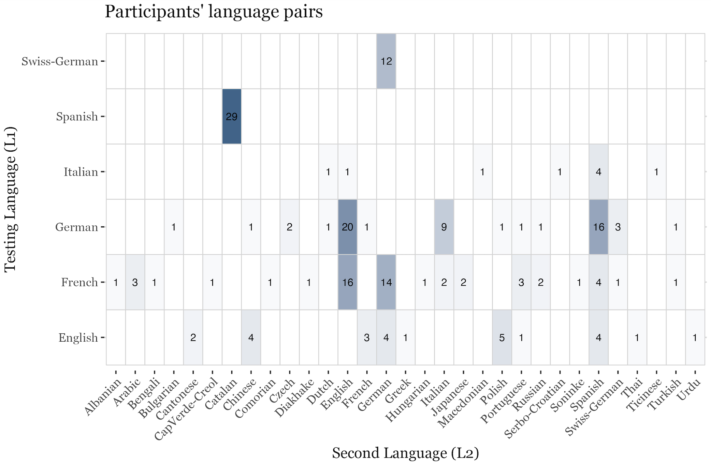
Testing Language
(strongest language, S1)
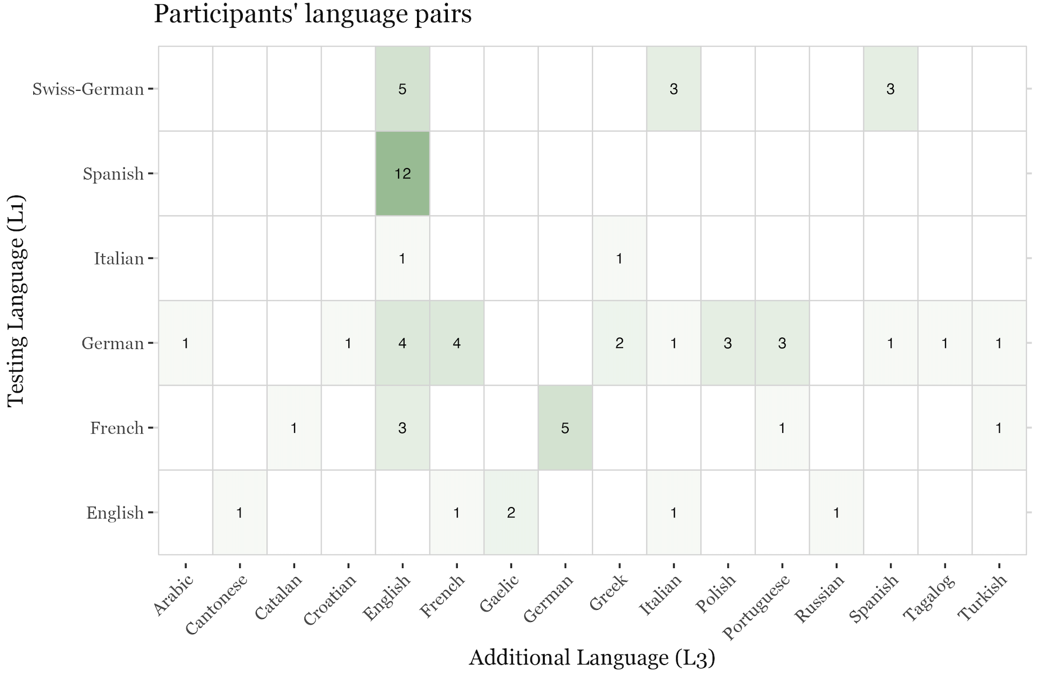
Testing Language
(strongest language, S1)

Figure SM1C. Proficiency combination in S1 and L2 in both groups. Parents indicated, on a Likert-scale, how well their child spoke, understood, read or wrote each language (see Methods). To simplify, proficiency is classified as ‘good’ if the rated parental proficiency of the language > 70%, ‘Middle’ if comprised between 40% and 70%, ‘low’ if below 40%.
Proficiency in S1 and L2 in Autistic and Neurotypical Children
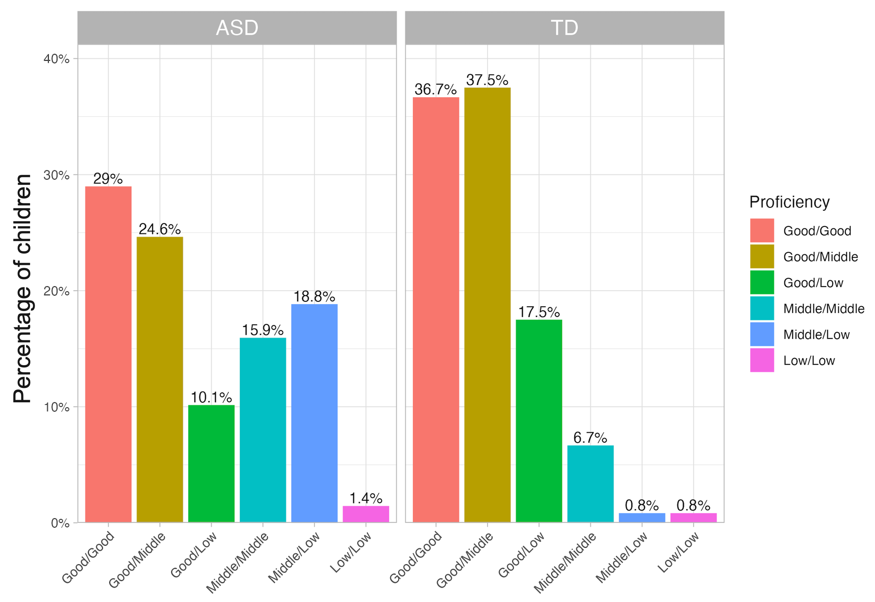
Proficiency combination (S1-L2)

SM1D. Social Communication Questionnaire (SCQ) scores
SM1D, Figure 1. Distribution of the autism severity (SCQ scores) across autistic and neurotypical children
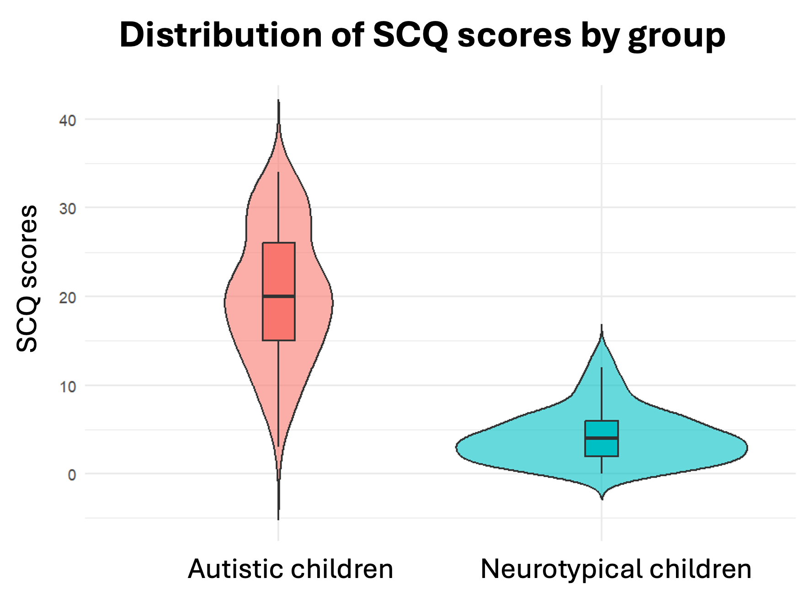

S1D, Table 1. Zero-order correlations on the macrostructure dimensions and the SCQ scores
 | IST-use | Story Structure | Story Complexity | SCQ scores
IST-use | - | 0.59*** | 0.19** | -0.14*
Story Structure | 0.59*** | - | 0.58*** | -0.28***
Story Complexity | 0.19** | 0.58*** | - | -0.19**
SCQ | -0.14* | -0.28*** | -0.19** | -
Note. SCQ = Social Communication Questionnaire

Supplementary material SM2. Language adaptations of the PPVT and TROG
To assess receptive morphosyntax in the children’s strongest language S1, the respective versions of the Test for Reception of Grammar (TROG) have been proposed:
- In English: Bishop, D. V. (2003). Test for Reception of Grammar, version 2. London: Pearson assessment. Addison-Wesley Professional.
- In French: Lecocq, P. (1996). L’É.CO.S.SE: Une épreuve de compréhension syntaxico-sémantique. Presses universitaires du Septentrion.
- In German: Fox-Boyer, A. V. (2006). TROG-D: Test zur Überprüfung des Grammatikverständnisses. Schulz-Kirchner Verlag GmbH.
- In Italian: Suraniti, S., Neri, V., & Ferri, R. (2009). TROG-2: Contributo alla validazione italiana (Giunti O.S.).
- In Spanish: Mendoza, E., Carballo, G., Muñoz, J., & Fresneda, M. D. (2005). Test de comprensión de estructuras gramaticales (CEG). TEA.
To assess receptive vocabulary in the children’s L1, the respective versions of the Peabody Picture Vocabulary Test (PPVT-4) have been proposed:
- In English: Dunn, L. M., & Dunn, D. M. (2007). PPVT-4: Peabody picture vocabulary test. Pearson Assessments.
- In French: Dunn, L. M., Dunn, L. M., & Thériault-Whalen, C. M. (1993). Echelle de vocabulaire en images Peabody: EVIP. PSYCAN.
- In German: Lenhard, A., Lenhard, W., Segerer, R., & Suggate, S. (2015). Peabody picture vocabulary test-4. Deutsche Fassung. (Pearson Assessment).
- In Italian: Stella, G., Pizzoli, C., & Tressoldi, P. (2000). Il Peabody Test—Test di vocabolario ricettivo. Omega Edizione, Torino.
- In Spanish: Dunn, L. M., Dunn, L. M., & Arribas Aguila, D. (2006). PPVT-III Peabody test de vocabulario en imágenes. TEA Ediciones.

Supplementary material SM3. Full specifications of the statistical models
To investigate the impact of Exposure to Additional Languages (EtAL) on narrative macrostructure (RQ1), and the influence of WM, ToM, and MA on performance (RQ2), analyses were conducted in R (version 2024.04.2+764; R Core Team, 2020) for each macrostructure dimension separately (i.e., story structure, story complexity, IST-use). Both RQ1 and RQ2 were examined with the same model for each dimension.
A base model was fitted for each dimension, including a 3-way interaction (between group [sum coded: ASD, NT], age [scaled], and EtAL [scaled] for story structure and story complexity), or 4-way interaction for IST-use. Covariates were added in each model to account for their impact on performance (i.e., language skills, non-verbal IQ [scaled], and sex [sum coded: female; male]).
For each model, prior checks on the variance inflation factor (VIF) indicated no concerning levels of multicollinearity among the predictors (VIF <3). Covariates ToM, WM, and MA (all scaled) were added stepwise and only retained in the final model if they improved model fit. The model with the lowest Akaike Information Criterion (AIC) was considered to provide the best balance between model fit and complexity and was selected as the final model. Participants with missing values on a given covariate were automatically excluded from the corresponding model, but remained included in all other analyses; no imputation was applied.
Story structure. Binomial GLMMs were fitted the lme4 package (Bates et al., 2015) to model the presence/absence [1/0] of each of the 17 story elements independently. Random intercepts were included for participants and items to account for individual and item-level variability.
Formula: performance story structure ~ EtAL * Group * Age
+ language skills + Non-verbal IQ + Sex + ToMI + WM + MA
+ (1|participant) + (1|item)
Story complexity. GLMs followed the same structure as story structure.
Formula: performance story structure ~ EtAL * Group * Age
+ language skills + Non-verbal IQ + Sex + ToMI + WM + MA
+ (1|participant) + (1|item)
IST-use: Negative binomial GLMMs (glmmTMB package; Brooks et al., 2017) included a 4-way interaction (EtAL, age, group, condition [sum coded: +0.5 ToM-unrelated IST, -0.5 ToM-related IST]). Random intercepts for participants were included.
Formula: performance IST-use ~ EtAL * Age * Group * Condition
+ Language skills + Non-verbal IQ + Sex + ToMI + WM + MA
+ (1 | participant)

Tables SM4. Output of the GLMM for story structure
In the following tables, the intercept represents the model’s baseline estimate of story structure when all predictors are set to zero (i.e., at their reference level or mean, if scaled). Regression coefficients (β) indicate the direction and size of the association between predictors and story structure: positive values reflect a positive relationship, and negative values reflect a negative relationship. The standard error (Std. Err) reflects the variability of the coefficient estimate, and the Z value indicates the test statistic used to evaluate whether the coefficient differs significantly from zero. Results with p < .05 are considered statistically significant and are highlighted in bold to ease identification.
- Table SM4A. Final model for story structure
 | Performance
 | β | Std. Err | Z value | p value
(Intercept) | -0.716 | 0.362 | -1.979 | .048
Group | -0.098 | 0.139 | -0.700 | .484
EtAL | 0.003 | 0.051 | 0.064 | .949
Age | 0.191 | 0.067 | 2.850 | .004
Language skills | 0.059 | 0.052 | 1.142 | .253
Non-verbal IQ | 0.022 | 0.050 | 0.431 | .666
Sex assigned at birth | 0.340 | 0.098 | 3.474 | .001
ToMI-score | 0.091 | 0.066 | 1.381 | .167
WM | 0.065 | 0.064 | 1.012 | .311
MA-score | 0.116 | 0.059 | 1.983 | .047
Group : EtAL | -0.200 | 0.102 | -1.966 | .049
Group : Age | -0.041 | 0.102 | -0.401 | .688
EtAL : Age | 0.027 | 0.056 | 0.477 | .634
Group : EtAL : Age | -0.060 | 0.113 | -0.534 | .594

- Table SM4B. Simple effects investigation in the group of neurotypical children
 | Performance
 | β | Std. Err | Z value | p value
(Intercept) | -0.611 | 0.393 | -1.554 | .120
EtAL | 0.110 | 0.056 | 1.971 | .049
Age | 0.279 | 0.072 | 3.854 | < .001
Language skills | 0.045 | 0.062 | 0.722 | .470
Non-verbal IQ | 0.045 | 0.059 | 0.765 | .444
Sex assigned at birth | 0.298 | 0.105 | 2.828 | .005
ToMI-score | 0.048 | 0.107 | 0.455 | .649
WM | 0.003 | 0.080 | 0.036 | .971
MA-score | 0.077 | 0.068 | 1.140 | .254
EtAL: Age | 0.051 | 0.052 | 0.977 | .329

- Table SM4C. Simple effects investigation in the group of autistic children
 | Performance
 | β | Std. Err | Z value | p value
(Intercept) | -0.599 | 0.353 | -1.699 | .089
EtAL | -0.065 | 0.092 | -0.709 | .478
Age | 0.065 | 0.124 | 0.527 | .598
Language skills | 0.057 | 0.096 | 0.592 | .554
Non-verbal IQ | -0.011 | 0.092 | -0.114 | .909
Sex assigned at birth | 0.599 | 0.242 | 2.478 | .013
ToMI-score | 0.116 | 0.090 | 1.287 | .198
WM | 0.127 | 0.110 | 1.153 | .249
MA-score | 0.214 | 0.117 | 1.819 | .069
EtAL: Age | 0.012 | 0.110 | 0.105 | .917

Table SM5. Output of the GLM for story complexity
 | Performance
 | β | Std. Err | t  value | p value
(Intercept) | 3.468 | 0.093 | 37.477 | <.001
Group | -0.233 | 0.244 | -0.956 | .340
EtAL | -0.017 | 0.088 | -0.191 | .849
Age | 0.101 | 0.118 | 0.856 | .393
Language skills | 0.077 | 0.092 | 0.836 | .404
Non-verbal IQ | -0.074 | 0.089 | -0.828 | .408
Sex assigned at birth | 0.084 | 0.174 | 0.479 | .632
ToMI-score | 0.017 | 0.115 | 0.150 | .881
WM | 0.108 | 0.112 | 0.968 | .334
Group : EtAL | 0.080 | 0.100 | 0.797 | .426
Group : Age | -0.199 | 0.176 | -1.133 | .258
EtAL:Age | 0.009 | 0.177 | 0.049 | .961
Group : EtAL: Age | 0.045 | 0.097 | 0.466 | .642

Tables SM6. Output of the GLMM for IST-use
- Table SM6A. Final model for IST-use
 | Performance
 | β | Std. Err | Z value | p value
(Intercept) | 0.288 | 0.056 | 5.174 | < .001
EtAL | -0.096 | 0.053 | -1.809 | .070
Age | 0.123 | 0.069 | 1.799 | .072
Group | 0.088 | 0.142 | 0.619 | .536
Condition (ToM-related/ToM-unrelated ISTs) | 0.104 | 0.094 | 1.111 | .266
Language skills | -0.032 | 0.050 | -0.645 | .519
Non-verbal IQ | 0.062 | 0.048 | 1.276 | .202
Sex assigned at birth | 0.453 | 0.092 | 4.925 | < .001
ToMI | 0.124 | 0.066 | 1.880 | .060
WM | 0.004 | 0.064 | 0.065 | .948
MA-score | 0.063 | 0.059 | 1.064 | .287
EtAL : Age | -0.115 | 0.059 | -1.953 | .051
EtAL : Group | 0.026 | 0.106 | 0.240 | .810
Age : Group | -0.137 | 0.105 | -1.306 | .191
EtAL : Condition | 0.228 | 0.098 | 2.334 | .020
Age : Condition | 0.358 | 0.096 | 3.723 | < .001
Group : Condition | -0.314 | 0.188 | -1.673 | .094
EtAL : Age : Group | -0.396 | 0.118 | -3.349 | .001
EtAL: Age : Condition | -0.061 | 0.109 | -0.556 | .578
EtAL : Group : Condition | 0.248 | 0.195 | 1.270 | .204
Age : Group : Condition | 0.380 | 0.192 | 1.978 | .048
EtAL : Age : Group : Condition | 0.193 | 0.218 | 0.884 | .376

- Table SM6B. IST-use model in autistic children only
 | Performance
 | β | Std. Err | Z value | p value
(Intercept) | 0.430 | 0.136 | 3.167 | .002
EtAL | -0.059 | 0.092 | -0.645 | .519
Age | -0.005 | 0.126 | -0.037 | .970
Condition | -0.055 | 0.164 | -0.337 | .736
Language skills | 0.005 | 0.091 | 0.059 | .953
Non-verbal IQ | 0.046 | 0.089 | 0.518 | .604
Sex assigned at birth | 0.694 | 0.198 | 3.498 | < .001
ToMI | 0.124 | 0.086 | 1.444 | .149
WM | -0.002 | 0.109 | -0.018 | .986
MA | 0.145 | 0.114 | 1.278 | .201
EtAL : Age | -0.307 | 0.111 | -2.762 | .006
EtAL :Condition | 0.344 | 0.168 | 2.049 | .040
Age : Condition | 0.559 | 0.172 | 3.240 | .001
EtAL : Age: Condition | 0.056 | 0.202 | 0.276 | .782
- Table SM6C. IST-use model in neurotypical children only
 | Performance
 | β | Std. Err | Z value | p value
(Intercept) | 0.269 | 0.082 | 3.289 | .001
EtAL | -0.106 | 0.059 | -1.787 | .074
Age | 0.212 | 0.071 | 2.990 | .003
Condition | 0.261 | 0.097 | 2.696 | .007
Language skills | -0.057 | 0.060 | -0.953 | .341
Non-verbal IQ | 0.075 | 0.058 | 1.298 | .194
Sex assigned at birth | 0.394 | 0.103 | 3.832 | < .001
ToMI | 0.132 | 0.109 | 1.217 | .224
WM | -0.008 | 0.081 | -0.100 | .920
MA | 0.028 | 0.069 | 0.404 | .686
EtAL : Age | 0.078 | 0.053 | 1.469 | .142
EtAL :Condition | 0.103 | 0.105 | 0.980 | .327
Age : Condition | 0.167 | 0.095 | 1.757 | .079
EtAL : Age: Condition | -0.155 | 0.095 | -1.627 | .104

- Table SM6D. Model for ToM-related ISTs in all children
 | Performance
 | β | Std. Err | Z value | p value
(Intercept) | 0.152 | 0.087 | 1.749 | .080
EtAL | -0.209 | 0.081 | -2.568 | .010
Age | -0.014 | 0.102 | -0.132 | .895
Group | 0.162 | 0.210 | 0.775 | .439
Language skills | -0.065 | 0.077 | -0.844 | .399
Non-verbal IQ | 0.108 | 0.074 | 1.460 | .144
Sex assigned at birth | 0.388 | 0.142 | 2.733 | .006
ToMI | 0.108 | 0.098 | 1.109 | .267
WM | -0.063 | 0.095 | -0.664 | .507
MA | 0.083 | 0.086 | 0.962 | .336
EtAL: Age | -0.083 | 0.090 | -0.924 | .356
EtAL : Group | -0.082 | 0.163 | -0.504 | .614
Age : Group | -0.315 | 0.153 | -2.053 | .040
EtAL : Age: Group | -0.492 | 0.180 | -2.728 | .006
- Table SM6E. Model for ToM-unrelated ISTs in all children
 | Performance
 | β | Std. Err | Z value | p value
(Intercept) | 0.369 | 0.076 | 4.838 | < .001
EtAL | 0.025 | 0.067 | 0.373 | .709
Age | 0.265 | 0.089 | 2.989 | .003
Group | 0.000 | 0.185 | 0.000 | 1.000
Language skills | -0.004 | 0.063 | -0.058 | .954
Non-verbal IQ | 0.015 | 0.061 | 0.244 | .807
Sex assigned at birth | 0.511 | 0.115 | 4.450 | <.001
ToMI | 0.134 | 0.085 | 1.569 | .117
WM | 0.072 | 0.085 | 0.854 | .393
MA | 0.043 | 0.079 | 0.539 | .590
EtAL: Age | -0.145 | 0.074 | -1.964 | .050
EtAL : Group | 0.152 | 0.133 | 1.143 | .253
Age : Group | 0.048 | 0.139 | 0.344 | .731
EtAL : Age: Group | -0.282 | 0.147 | -1.915 | .056

- Table SM6F. Model for ToM-related ISTs in autistic children only
 | Performance
 | β | Std. Err | Z value | p value
(Intercept) | 0.222 | 0.227 | 0.975 | .330
EtAL | -0.227 | 0.149 | -1.523 | .128
Age | -0.191 | 0.195 | -0.977 | .329
Language skills | 0.085 | 0.145 | 0.584 | .559
Non-verbal IQ | 0.077 | 0.138 | 0.558 | .577
Sex assigned at birth | 0.400 | 0.335 | 1.192 | .233
ToMI | 0.097 | 0.136 | 0.711 | .477
WM | -0.027 | 0.165 | -0.162 | .872
MA | 0.007 | 0.168 | 0.043 | .966
EtAL: Age | -0.320 | 0.179 | -1.785 | .0743
- Table SM6G. Model for ToM-unrelated ISTs in autistic children only
 | Performance
 | β | Std. Err | Z value | p value
(Intercept) | 0.458 | 0.161 | 2.837 | .005
EtAL | 0.132 | 0.111 | 1.193 | .233
Age | 0.206 | 0.164 | 1.253 | .210
Language skills | -0.070 | 0.113 | -0.623 | .534
Non-verbal IQ | -0.015 | 0.116 | -0.130 | .897
Sex assigned at birth | 0.964 | 0.227 | 4.252 | < .001
ToMI | 0.123 | 0.109 | 1.126 | .260
WM | 0.032 | 0.142 | 0.228 | .819
MA | 0.352 | 0.178 | 1.975 | .048
EtAL: Age | -0.248 | 0.136 | -1.830 | .067

Supplementary Material SM7. Investigation of the impact of cumulative Exposure to Additional Languages (cum_EtAL) on narrative macrostructure in autistic and neurotypical children
SM7-1. Purpose

The main manuscript examines whether current exposure to additional languages (EtAL over the past 12 months) relates to the expression of narrative macrostructure in autistic and neurotypical school-aged children. To provide a complementary temporal perspective, we conducted a parallel set of analyses using cumulative exposure to additional languages (cum_EtAL), reflecting proportional exposure across the child’s lifetime (i.e., exposure since birth).
SM7-2. Bilingualism operationalization

The procedure used to compute cum_EtAL was analogous to that used for current EtAL. Cumulative exposure to S1, L2, and L3 was derived from caregivers’ estimates of the child’s language exposure across different developmental periods (e.g., infancy, preschool, primary school), as collected through the Q-BEx questionnaire (De Cat et al., 2022).
For each child, cumulative exposure represented the weighted proportional exposure to additional languages across the child’s lifetime. It thus corresponded to the percentage of time the child had been exposed to any language other than their S1 since birth (e.g., 0% for a monolingual child; 50% for a child exposed equally to S1 and L2 throughout their life).
Although descriptively similar in some cases at the group level, cum_EtAL and current EtAL diverge at the individual level. The two measures showed a strong but not perfect correlation (r = .81), reflecting both shared variance and changes in children’s language environments over development (see Table SM1A).
Importantly, cumulative exposure could not be reliably computed for N=15 children due to inconsistent caregiver reports (i.e., caregivers indicated no lifetime exposure to an additional language while reporting non-zero exposure over the past 12 months). These cases were excluded from the analyses.
SM7-3. Statistical approach

All analyses reported in the main manuscript were repeated using cum_EtAL in place of current EtAL. This included:
- the full model specification for each of the three narrative outcomes (story structure, story complexity, IST);
- the same covariates and interaction terms as in the primary analyses;
- identical model-selection procedures (stepwise comparison based on AIC);
- identical procedures for handling missing values and random effects structure.
Thus, SM7 provides a directly parallel analytic pipeline, differing only in the operationalisation of bilingual experience (cumulative EtAL instead of current EtAL). Please see Supplementary Material SM3 for models specifications.
SM7-4. Results

Story structure. The final model was the model with maximal structure (similar to current EtAL; see Supplementary Material SM3).

- Table SM7-4A. Final model and output for story structure with cum_EtAL
 | Performance
 | β | Std. Err | Z value | p value
(Intercept) | -0.700 | 0.360 | -1.948 | .051
Group | -0.112 | 0.144 | -0.775 | .439
Cum__EtAL | 0.013 | 0.051 | 0.251 | .802
Age | 0.171 | 0.070 | 2.440 | .015
Language skills | 0.055 | 0.053 | 1.036 | .300
Non-verbal IQ | 0.000 | 0.052 | -0.002 | .999
Sex assigned at birth | 0.356 | 0.101 | 3.526 | < .001
ToMI-score | 0.081 | 0.068 | 1.195 | .232
WM | 0.092 | 0.067 | 1.388 | .165
MA-score | 0.121 | 0.059 | 2.058 | .040
Group : cum_EtAL | -0.175 | 0.101 | -1.726 | .084
Group : Age | -0.063 | 0.105 | -0.596 | .551
Cum_EtAL : Age | 0.057 | 0.053 | 1.075 | .282
Group : cum_EtAL : Age | -0.044 | 0.108 | -0.405 | .685
Significant, positive, predictors of performance in story structure are: Age, Sex assigned at birth, and metalinguistic awareness.
Story complexity. The final model for story complexity was similar than with current EtAL; the model with maximal structure, without Metalinguistic Awareness (see SM3 for model specifications).
- Table SM7-4B. Final model and output for story complexity with cum_EtAL
 | Performance
 | β | Std. Err | t  value | p value
(Intercept) | 3.464 | 0.094 | 36.767 | <.001
Group | -0.209 | 0.248 | -.843 | 0.400
Cum_EtAL | -0.017 | 0.088 | -.191 | 0.849
Age | 0.111 | 0.114 | .975 | 0.330
Language skills | 0.081 | 0.090 | .898 | 0.370
Non-verbal IQ | -0.093 | 0.091 | -1.018 | 0.310
Sex assigned at birth | 0.127 | 0.178 | .716 | 0.475
ToMI-score | 0.009 | 0.117 | .078 | 0.938
WM | 0.166 | 0.114 | 1.448 | 0.149
Group : cum_EtAL | -0.217 | 0.174 | -1.246 | 0.214
Group : Age | 0.054 | 0.177 | .305 | 0.760
Cum_EtAL:Age | 0.140 | 0.091 | 1.541 | 0.125
Group : cum_EtAL: Age | 0.149 | 0.184 | .811 | 0.418
There is no significant predictor of story complexity identified.

Internal State terms. The final model for IST was similar than with current EtAL (see Supplementary Material SM3 for model specifications).
- Table SM7-4C. Final model for IST with cum_EtAL
 | Performance
 | β | Std. Err | Z value | p value
(Intercept) | 0.322 | 0.057 | 5.667 | <.001
Cum_EtAL | -0.089 | 0.052 | -1.727 | .084
Age | 0.115 | 0.071 | 1.624 | .104
Group | 0.147 | 0.145 | 1.012 | .311
Condition (ToM-related/ToM-unrelated ISTs) | 0.088 | 0.094 | 0.939 | .348
Language skills | -0.037 | 0.052 | -0.722 | .470
Non-verbal IQ | 0.047 | 0.050 | 0.937 | .349
Sex assigned at birth | 0.460 | 0.096 | 4.792 | <.001
ToMI | 0.141 | 0.068 | 2.080 | .038
WM | -0.009 | 0.066 | -0.132 | .895
MA-score | 0.067 | 0.060 | 1.121 | .262
Cum_EtAL : Age | -0.051 | 0.054 | -0.935 | .350
Cum_EtAL : Group | 0.009 | 0.103 | 0.092 | .927
Age : Group | -0.161 | 0.107 | -1.514 | .130
Cum_EtAL : Condition | 0.168 | 0.093 | 1.796 | .072
Age : Condition | 0.340 | 0.096 | 3.532 | <.001
Group : Condition | -0.329 | 0.188 | -1.752 | .080
Cum_EtAL : Age : Group | -0.257 | 0.110 | -2.338 | .019
Cum_EtAL: Age : Condition | -0.011 | 0.099 | -0.108 | .914
Cum_EtAL : Group : Condition | 0.110 | 0.187 | 0.590 | .555
Age : Group : Condition | 0.331 | 0.192 | 1.722 | .085
Cum_EtAL : Age : Group : Condition | 0.181 | 0.197 | 0.918 | .358
Significant predictors of IST are: sex assigned at birth (girls overperforming boys) and ToM. Significant interactions are (a) Age and condition, and (b) Age, cumulative EtAL and Group.

- Table SM7-4D. Investigation of the significant Age : Condition interaction - Model for ToM-related ISTs in all children
 | Performance
 | β | Std. Err | Z value | p value
(Intercept) | 0.195 | 0.088 | 2.217 | .027
Cum_EtAL | -0.175 | 0.075 | -2.320 | .020
Age | -0.013 | 0.106 | -0.126 | .900
Group | 0.248 | 0.211 | 1.176 | .240
Language skills | -0.084 | 0.079 | -1.061 | .289
Non-verbal IQ | 0.112 | 0.076 | 1.482 | .138
Sex assigned at birth | 0.385 | 0.147 | 2.615 | .009
ToMI | 0.149 | 0.100 | 1.490 | .136
WM | -0.083 | 0.098 | -0.851 | .395
MA | 0.092 | 0.087 | 1.057 | .291
Cum_EtAL: Age | -0.045 | 0.080 | -0.559 | .576
Cum_EtAL : Group | -0.011 | 0.150 | -0.071 | .943
Age : Group | -0.313 | 0.154 | -2.027 | .043
Cum_EtAL : Age: Group | -0.363 | 0.162 | -2.248 | .025
Age is not a significant predictor or ToM-related ISTs.

- Table SM7-4E. Investigation of the significant Age : Condition interaction - Model for ToM-unrelated ISTs in all children
 | Performance
 | β | Std. Err | Z value | p value
(Intercept) | 0.387 | 0.079 | 4.905 | .000
Cum_EtAL | 0.007 | 0.069 | 0.105 | .916
Age | 0.246 | 0.092 | 2.669 | .008
Group | 0.030 | 0.191 | 0.159 | .873
Language skills | 0.004 | 0.066 | 0.067 | .946
Non-verbal IQ | -0.017 | 0.063 | -0.276 | .783
Sex assigned at birth | 0.525 | 0.121 | 4.359 | .000
ToMI | 0.127 | 0.088 | 1.438 | .150
WM | 0.067 | 0.087 | 0.767 | .443
MA | 0.046 | 0.081 | 0.573 | .566
Cum_EtAL: Age | -0.052 | 0.071 | -0.734 | .463
Cum_EtAL : Group | 0.050 | 0.137 | 0.362 | .717
Age : Group | -0.005 | 0.143 | -0.032 | .975
Cum_EtAL : Age: Group | -0.128 | 0.143 | -0.895 | .371
Age is a significant predictor for ToM-unrelated ISTs, while it was not the case for ToM-related ISTs: this is where the Age : Condition significant interaction stems from.

- Table SM7-4F. Investigation of the significant Cum_EtAL : Age : Group interaction – Model in neurotypical children only
 | Performance
 | β | Std. Err | Z value | p value
(Intercept) | 0.288 | 0.082 | 3.503 | .000
Cum_EtAL | -0.098 | 0.059 | -1.670 | .095
Age | 0.232 | 0.073 | 3.168 | .002
Condition | 0.253 | 0.099 | 2.565 | .010
Language skills | -0.056 | 0.062 | -0.898 | .369
Non-verbal IQ | 0.069 | 0.059 | 1.175 | .240
Sex assigned at birth | 0.396 | 0.107 | 3.697 | .000
ToMI | 0.129 | 0.111 | 1.168 | .243
WM | -0.032 | 0.082 | -0.387 | .699
MA | 0.015 | 0.068 | 0.226 | .821
Cum_EtAL : Age | 0.075 | 0.054 | 1.392 | .164
Cum_EtAL : Condition | 0.112 | 0.104 | 1.076 | .282
Age : Condition | 0.173 | 0.096 | 1.796 | .073
Cum_EtAL : Age : Condition | -0.101 | 0.099 | -1.016 | .310
In neurotypical children, the interaction between cumulative EtAL and Age is not significant.
- Table SM7-4G. Investigation of the significant Cum_EtAL : Age : Group interaction – Model in autistic children only
 | Performance
 | β | Std. Err | Z value | p value
(Intercept) | 0.496 | 0.138 | 3.603 | .000
Cum_EtAL | -0.060 | 0.089 | -0.681 | .496
Age | -0.054 | 0.134 | -0.399 | .690
Condition | -0.084 | 0.164 | -0.512 | .609
Language skills | -0.032 | 0.097 | -0.328 | .743
Non-verbal IQ | 0.027 | 0.093 | 0.288 | .774
Sex assigned at birth | 0.717 | 0.208 | 3.451 | .001
ToMI | 0.159 | 0.090 | 1.762 | .078
WM | 0.000 | 0.117 | 0.003 | .998
MA | 0.201 | 0.120 | 1.680 | .093
Cum_EtAL : Age | -0.190 | 0.103 | -1.850 | .064
Cum_EtAL : Condition | 0.215 | 0.158 | 1.359 | .174
Age : Condition | 0.524 | 0.173 | 3.032 | .002
Cum_EtAL : Age : Condition | 0.081 | 0.175 | 0.465 | .642
In autistic children, the interaction between cumulative EtAL and Age approaches significance level.

SM7-5. Findings and interpretation
Across all three narrative outcomes, the analyses using cumulative EtAL (cum_EtAL) produced a pattern that was broadly consistent with the primary analyses based on current exposure (EtAL), presented in the manuscript.
In both sets of models, metalinguistic awareness emerged as a positive predictor of story structure for both groups, no effects of bilingual exposure (current or cumulative) were found for story complexity, and bilingualism was not associated with detrimental outcomes for autistic children. The interaction patterns observed for IST (e.g., Age × Condition; Age × Group × Condition) were likewise replicated with cumulative EtAL.
The main divergence concerned story structure in neurotypical children, where the positive association found with current EtAL did not re-emerge when cumulative EtAL was used. This difference indicates that current and cumulative exposure capture distinct temporal dimensions of children’s bilingual experience, with current exposure potentially relating more closely to how macrostructural elements are expressed at school age, whereas cumulative exposure reflects earlier developmental input. Given that macrostructural schemas are typically acquired early but their expression can be shaped by ongoing discourse practices, it is plausible that recent exposure, but not lifetime exposure, relates to the observed variation in story-structure performance. This interpretation is consistent with the conceptual distinction outlined in the main manuscript (i.e., expression vs. acquisition).
Overall, the analyses conducted with cumulative EtAL support the robustness of the primary findings presented in the manuscript. Both current and cumulative measures provide complementary perspectives. Importantly, the cumulative-exposure analyses fully reinforce the main conclusion of the manuscript: Exposure to additional languages is not associated with detrimental narrative outcomes in autistic children.

