Supplemental Material - Appendix

Appendix S1. Bilingual characteristics of the sample
- Table A. Variety of Languages participants were exposed to.
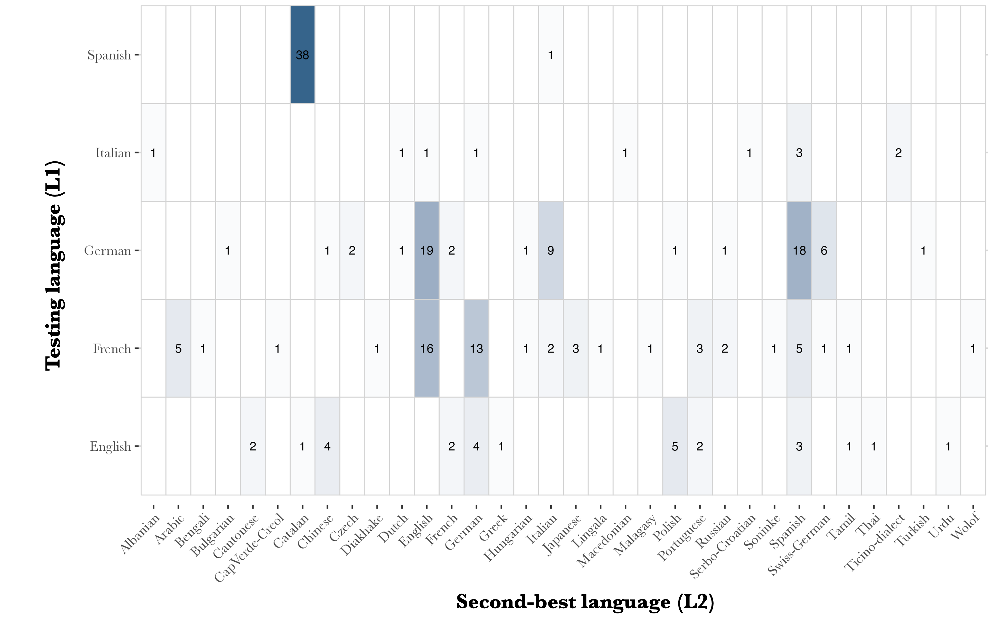
Numbers represent number of participants.
- Table B. Description of bilingual-related characteristics of the sample.
 | Autistic children (N=90) |  |  |  |  |  |  |  |  |  | Neurotypical children (N=180)
 | L1 |  |  | L2 |  |  | L3 |  |  |  | L1 |  |  |  | L2 |  |  |  | L3
Age of First Exposition  Mean (SD) [range]
  8.17 (18.1)
  0 [0, 95]
  14.2 (25.9)
  0 [0, 120]
  26.1 (26)
  24.5 [0, 84]
  5.25 (12.9)
  0 [0, 60]
  10.1 (22.3)
  0 [0, 97]
  25.8 (37.2)
  1.00 [0, 126]
Place of First Exposition
Home | 73 (81.1%) | 49 (54.4%) |  |  | 8 (8.9%) |  |  |  | 138 (76.7%) |  |  |  | 87 (48.3%) |  |  |  | 19 (10.6%)
Other | 5 (5.6%) | 5 (5.6%) |  |  | 1 (1.1%) |  |  |  | 9 (5.0%) |  |  |  | 12 (6.7%) |  |  |  | 4 (2.2%)
School | 12 (13.3%) | 17 (18.9%) |  |  | 13 (14.4%) |  |  |  | 33 (18.3%) |  |  |  | 29 (16.1%) |  |  |  | 17 (9.4%)
Relative exposure since birth (%)
  72.2 (29.0)
  81 [0, 100]
  31.4 (24.9)
  30.1 [0, 92.6]
  12.3 (14.0)
  6.6 [0, 45]
  72.0 (27.8)
  76.2 [4.19, 100]
  34.8 (23.9)
  35.9 [0, 95.8]
  14.7 (14.7)
  9.44[0, 50]
Relative use in the last year (%)
  82.1 (22.2)
  91 [15, 100]
  21.2 (21.5)
  14 [0, 83]
  4.55 (10.0)
  1.50 [0, 47]
  78.4 (25.4)
  91.0 [6, 100]
  27.8 (24.3)
  23 [0, 94]
  8.05 (9.94)
  3 [0, 40]
Note. In the group of autistic children, N = 71 caregivers reported the presence of a second Language (L2), and N = 22 the presence of a third Language (L3). In the group of neurotypical children, N = 128 caregivers reported the presence of a L2 and N = 40 of a L3.

- Appendix S1C. L2 proficiency calculation
To index participant’s L2 proficiency for RQ2 and RQ3, we selected the parents’ estimate of their child’s proficiency in their second-best language L2. Specifically, parents indicated on a 4-point Likert-scale the level of proficiency of their child in speaking, understanding, writing and reading any language to which the child was exposed. Scores on these subindices were averaged per language. The result was a percentage indicating the proficiency in that language, from 0% (no proficiency in that language) to 100% (excellent proficiency). Hence, the percentage corresponding to the second-best language other than the language of testing (L1) indicated L2 proficiency. For participants whose parents reported no L2 (i.e., ‘true’ monolinguals), L2 proficiency was set to 0.

Appendix S2. Examples of GJT items in the different languages
 | GM | gM  Analyzed knowledge | Gm  Cognitive control | gm
 | Grammatically correct,  Semantically appropriate | Grammatically incorrect, Semantically appropriate | Grammatically correct,  Semantically  odd | grammatically incorrect, Semantically  odd
ENGLISH | Mark goes to the swimming pool with a friend. | Tonight there are clouds and stars in sky the. | The broom wakes up every morning. | The rain climb tonight in the sandbox.
FRENCH | Marc va à la piscine avec un ami. | La nuit il y a nuages des dans le ciel. | Le balai se réveille tous les matins. | La pluie grimpons ce soir dans le caillou.
GERMAN | Mark geht mit einem Freund ins Schwimmbad. | Es gibt in Nacht der Wolken am Himmel. | Der Besen wacht jeden Morgen auf. | Der Regen klettern heute Nacht in den Stein.
ITALIAN | Marco va al mare con un amico. | Di notte sono stelle ci in cielo. | La scopa si sveglia la mattina. | La pioggia si arrampicare sul sasso
SPANISH | Marcos va a la piscina con amigos. | Esta noche hay nubes en cielo el. | La escoba se levanta cada día. | La lluvia subir ayer en el castillo.

Appendix S3. References of the different language versions of the Peabody Picture Vocabulary Test (PPVT-4).
To assess receptive vocabulary in the children’s L1, the respective versions of the Peabody Picture Vocabulary Test (PPVT-4) have been proposed:
- In English: Dunn, L. M., & Dunn, D. M. (2007). PPVT-4: Peabody picture vocabulary test. Pearson Assessments.
- In French: Dunn, L. M., Dunn, L. M., & Thériault-Whalen, C. M. (1993). Echelle de vocabulaire en images Peabody: EVIP. PSYCAN.
- In German: Lenhard, A., Lenhard, W., Segerer, R., & Suggate, S. (2015). Peabody picture vocabulary test-4. Deutsche Fassung. (Pearson Assessment).
- In Italian: Stella, G., Pizzoli, C., & Tressoldi, P. (2000). Il Peabody Test—Test di vocabolario ricettivo. Omega Edizione, Torino.
- In Spanish: Dunn, L. M., Dunn, L. M., & Arribas Aguila, D. (2006). PPVT-III Peabody test de vocabulario en imágenes. TEA Ediciones.

Appendix S4. Detailed models specifications
Generalized mixed-effects models with a logit-link function were fitted independantly for each research question, using the glmer function from the lme4 package (Bates et al., 2015) in R (version 2024.04.2+764; R Core Team, 2020). A separate model was created for each RQ, with performance at the item level (0 or 1) as the dependent variable.
Two planned sentence-type contrasts were entered as contrast-coded predictors:
[a] Gm vs. GM sentences, indexing the cognitive control dimension, and
[b] gM vs. GM sentences, indexing the analyzed knowledge dimension.
For RQ1, we included the main effects and full three-way interactions between diagnostic group (ASD/NT, sum-coded), bilingual status (monolingual/bilingual, sum-coded) and sentence type. For RQ2 and RQ3, we models included the main effects and full three-way interactions between diagnostic group (ASD/NT, sum-coded), L2 proficiency (scaled proficiency in the L2) and sentence type.
All models included the following covariates as fixed effects: age (scaled), language of testing (sum-coded), non-verbal IQ (scaled), and receptive vocabulary (z-score), given their known influence on GJT performance (Bialystok, 1986; Tremblay, 2005; Wolfer et al., 2024).
Participants and items were included as random intercepts. All continuous predictors were scaled, and model diagnostics confirmed no problematic multicollinearity (VIF ≤ 5). Significant interactions were resolved hierarchically.

Cited references
Bates, D., Mächler, M., Bolker, B., & Walker, S. (2015). Fitting linear mixed-effects models using lme4. Journal of Statistical Software, 67(1), 1–48. https://doi.org/10.18637/jss.v067.i01
Bialystok, E. (1986). Factors in the growth of linguistic awareness. Child Development, 498–510.
R Core Team. (2020). R Core Team (2020). A language and environment for statistical computing. (Vienna, Austria).
Tremblay, A. (2005). Theoretical and methodological perspectives on the use of grammaticality judgment tasks in linguistic theory. Sec. Lang. Stud., 24.
Wolfer, P., Baumeister, F., Rudelli, N., Corrigan, G., Naigles, L. R., & Durrleman, S. (2024). Exploring metalinguistic awareness in school-aged autistic children: Insights from grammatical judgment. Journal of Autism and Developmental Disorders. https://doi.org/10.1007/s10803-024-06569-y

Appendix S5. Post-hoc investigations of interactions for RQ1

Table A. Output of the GLMM for RQ1 in NT children only
 | Est. | Std. Error | z value | p
(Intercept) | 2.249 | 0.160 | 14.062 | < .001
Bilingual status | -0.027 | 0.203 | -0.135 | .893
Gm vs. GM [a] | -0.372 | 0.190 | -1.958 | .050
gM vs. GM [b] | -1.357 | 0.187 | -7.266 | < .001
Sentence type [omnibus] | 0.156 | 0.229 | 0.681 | .496
Age | 0.927 | 0.089 | 10.367 | < .001
Non-verbal IQ | 0.229 | 0.099 | 2.313 | .021
Receptive Vocabulary in L1 (PPVT) | 0.238 | 0.081 | 2.933 | .003
Language_English | -2.370 | 0.819 | -2.894 | .004
Language_French | 3.008 | 0.881 | 3.412 | .001
Language_German | 0.546 | 0.786 | 0.695 | .487
Language_Italian | -1.073 | 1.103 | -0.972 | .331
Bilingual status:Gm vs. GM [a] | -0.302 | 0.166 | -1.823 | .068
Bilingual status:gM vs. GM [b] | 0.549 | 0.163 | 3.359 | .001
Bilingual status:Sentence type [omnibus] | -0.286 | 0.193 | -1.481 | .139

Table B. Output of the GLMM for RQ1 in autistic children only
 | Est. | Std. Error | z value | p
(Intercept) | 1.533 | 0.183 | 8.364 | < .001
Bilingual status | 0.663 | 0.264 | 2.509 | .012
Gm vs. GM [a] | -0.725 | 0.172 | -4.220 | < .001
gM vs. GM [b] | -0.870 | 0.171 | -5.086 | < .001
Sentence type [omnibus] | -0.046 | 0.210 | -0.220 | .826
Age | 0.686 | 0.122 | 5.637 | < .001
Non-verbal IQ | 0.077 | 0.118 | 0.654 | .513
Receptive Vocabulary in L1 (PPVT) | 0.400 | 0.078 | 5.150 | < .001
Language_English | -4.517 | 1.528 | -2.956 | .003
Language_French | 2.045 | 1.000 | 2.044 | .041
Language_German | 4.343 | 1.292 | 3.362 | .001
Language_Italian | 0.063 | 2.153 | 0.029 | .977
Bilingual status:Gm vs. GM [a] | 0.533 | 0.187 | 2.854 | .004
Bilingual status:gM vs. GM [b] | -0.532 | 0.187 | -2.837 | .005
Bilingual status:Sentence type [omnibus] | 0.299 | 0.228 | 1.312 | .190

Table C. Output of the GLMM for RQ1 in autistic children only, in Gm sentences specifically
 | Est. | Std. Error | z value | p
(Intercept) | 1.250 | 0.414 | 3.015 | .003
Bilingual status | 1.755 | 0.638 | 2.753 | .006
Age | 1.409 | 0.322 | 4.384 | < .001
Non-verbal IQ | 0.670 | 0.309 | 2.166 | .030
Receptive Vocabulary in L1 (PPVT) | 0.433 | 0.190 | 2.280 | .023
Language_English | -6.593 | 3.756 | -1.755 | .079
Language_French | 4.067 | 2.413 | 1.685 | .092
Language_German | 5.160 | 3.136 | 1.645 | .100
Language_Italian | 0.258 | 4.831 | 0.053 | .957

Table D. Output of the GLMM for RQ1 in autistic children only, in GM sentences specifically
 | Est. | Std. Error | z value | p
(Intercept) | 2.826 | 0.320 | 8.842 | < .001
Bilingual status | 1.195 | 0.491 | 2.435 | .015
Age | 0.579 | 0.226 | 2.565 | .010
Non-verbal IQ | 0.080 | 0.196 | 0.407 | .684
Receptive Vocabulary in L1 (PPVT) | 0.478 | 0.129 | 3.695 | < .001
Language_English | -2.320 | 2.454 | -0.945 | .345
Language_French | 4.687 | 1.743 | 2.689 | .007
Language_German | 2.887 | 2.481 | 1.164 | .244
Language_Italian | -3.505 | 2.878 | -1.218 | .223

Table E. Output of the GLMM for RQ1 in bilingual children (ASD and NT)
 | Est. | Std. Error | z value | p
(Intercept) | 1.990 | 0.141 | 14.110 | < .001
Group | -0.277 | 0.202 | -1.373 | .170
Gm vs. GM [a] | -0.485 | 0.172 | -2.827 | .005
gM vs. GM [b] | -1.095 | 0.171 | -6.407 | < .001
Sentence type [omnibus] | 0.025 | 0.210 | 0.120 | .904
Age | 0.824 | 0.085 | 9.732 | < .001
Non-verbal IQ | 0.203 | 0.093 | 2.180 | .029
Receptive Vocabulary in L1 (PPVT) | 0.341 | 0.069 | 4.967 | < .001
Language_English | -2.221 | 0.947 | -2.346 | .019
Language_French | 2.329 | 0.749 | 3.111 | .002
Language_German | 1.894 | 0.799 | 2.371 | .018
Language_Italian | -0.836 | 1.301 | -0.642 | .521
Group:Gm vs. GM [a] | 0.075 | 0.134 | 0.560 | .576
Group:gM vs. GM [b] | -0.108 | 0.134 | -0.808 | .419
Group:Sentence type [omnibus] | 0.118 | 0.162 | 0.730 | .466

Table F. Output of the GLMM for RQ1 in monolingual children (both ASD and NT)
 | Est. | Std. Error | z value | p
(Intercept) | 0.891 | 0.264 | 3.370 | .001
Group | -1.231 | 0.352 | -3.497 | < .001
Gm vs. GM [a] | -0.614 | 0.191 | -3.219 | .001
gM vs. GM [b] | -1.139 | 0.185 | -6.175 | < .001
Sentence type [omnibus] | 0.069 | 0.228 | 0.301 | .764
Age | 0.910 | 0.151 | 6.037 | < .001
Non-verbal IQ | 0.129 | 0.139 | 0.930 | .352
Receptive Vocabulary in L1 (PPVT) | 0.257 | 0.100 | 2.564 | .010
Language_French | 1.480 | 0.378 | 3.916 | < .001
Language_German | 0.973 | 0.357 | 2.724 | .006
Language_Italian | 0.465 | 0.437 | 1.064 | .287
Group:Gm vs. GM [a] | -0.768 | 0.211 | -3.644 | < .001
Group:gM vs. GM [b] | 0.983 | 0.210 | 4.677 | < .001
Group:Sentence type [omnibus] | -0.428 | 0.252 | -1.697 | .090

Table G. Output of the GLMM for RQ1 in monolinguals for Gm sentences
 | Est. | Std. Error | z value | p
(Intercept) | 2.433 | 0.822 | 2.961 | .003
Group | -3.126 | 1.039 | -3.010 | .003
Age | 1.695 | 0.474 | 3.574 | < .001
Non-verbal IQ | 0.832 | 0.431 | 1.927 | .054
Receptive Vocabulary in L1 (PPVT) | 0.501 | 0.289 | 1.732 | .083
Language_French | 0.285 | 1.067 | 0.267 | .789
Language_German | -1.223 | 1.097 | -1.115 | .265
Language_Italian | -1.798 | 1.246 | -1.442 | .149
To address convergence issues, the random-effect structure for this model was simplified to only include random intercepts for participants (1|participant).

Table H. Output of the GLMM for RQ1 in monolinguals for GM sentences
 | Est. | Std. Error | z value | p
(Intercept) | 2.939 | 0.480 | 6.120 | < .001
Group | -0.727 | 0.573 | -1.268 | .205
Age | 0.142 | 0.244 | 0.582 | .560
Non-verbal IQ | 0.323 | 0.250 | 1.292 | .196
Receptive Vocabulary in L1 (PPVT) | -0.004 | 0.159 | -0.025 | .980
Language_French | 0.276 | 0.600 | 0.459 | .646
Language_German | 0.563 | 0.669 | 0.842 | .400
Language_Italian | -0.228 | 0.669 | -0.341 | .733
To address convergence issues, the random-effect structure for this model was simplified to only include random intercepts for participants (1|participant).

Appendix S6. Post-hoc investigations of interactions for RQ2/RQ3

Table A. Output of the GLMM for RQ2/RQ3, in NT children only
 | Est. | Std. Error | z value | p
(Intercept) | 2.231 | 0.154 | 14.521 | < .001
L2 proficiency | 0.064 | 0.099 | 0.651 | .515
Gm vs. GM [a] | -0.424 | 0.187 | -2.269 | .023
gM vs. GM [b] | -1.254 | 0.184 | -6.817 | < .001
Sentence type [omnibus] | 0.101 | 0.227 | 0.445 | .656
Age | 0.917 | 0.090 | 10.229 | < .001
Non-verbal IQ | 0.223 | 0.099 | 2.259 | .024
Receptive Vocabulary in L1 (PPVT) | 0.243 | 0.081 | 3.004 | .003
Language_English | -2.227 | 0.834 | -2.670 | .008
Language_French | 2.973 | 0.876 | 3.393 | .001
Language_German | 0.623 | 0.788 | 0.791 | .429
Language_Italian | -0.873 | 1.109 | -0.787 | .431
L2 proficiency: Gm vs. GM [a] | -0.154 | 0.074 | -2.079 | .038
L2 proficiency: gM vs. GM [b] | 0.201 | 0.073 | 2.743 | .006
L2 proficiency: Sentence type [omnibus] | -0.098 | 0.089 | -1.098 | .272

Table B. Output of the GLMM for RQ2/RQ3, in NT children only, in gM sentences
 | Est. | Std. Error | z value | p
(Intercept) | 1.192 | 0.368 | 3.236 | .001
L2 proficiency | 0.308 | 0.162 | 1.894 | .058
Age | 1.213 | 0.160 | 7.598 | < .001
Non-verbal IQ | 0.075 | 0.168 | 0.444 | .657
Receptive Vocabulary in L1 (PPVT) | 0.378 | 0.138 | 2.731 | .006
Language_English | -4.884 | 1.439 | -3.394 | .001
Language_French | 4.986 | 1.516 | 3.289 | .001
Language_German | 1.855 | 1.358 | 1.366 | .172
Language_Italian | -0.394 | 1.979 | -0.199 | .842

Table C. Output of the GLMM for RQ2/RQ3, in NT children only, in GM sentences
 | Est. | Std. Error | z value | p
(Intercept) | 3.663 | 0.350 | 10.480 | < .001
L2 proficiency | -0.018 | 0.177 | -0.103 | .918
Age | 0.343 | 0.159 | 2.157 | .031
Non-verbal IQ | 0.559 | 0.189 | 2.965 | .003
Receptive Vocabulary in L1 (PPVT) | -0.043 | 0.146 | -0.292 | .770
Language_English | 0.247 | 1.707 | 0.144 | .885
Language_French | 2.632 | 1.964 | 1.340 | .180
Language_German | -3.165 | 1.434 | -2.207 | .027
Language_Italian | -2.870 | 1.727 | -1.662 | .096

Table D. Output of the GLMM for RQ2/RQ3, in autistic children only
 | Est. | Std. Error | z value | p
(Intercept) | 1.736 | 0.184 | 9.436 | < .001
L2 proficiency | 0.331 | 0.144 | 2.301 | .021
Gm vs. GM [a] | -0.590 | 0.166 | -3.563 | < .001
gM vs. GM [b] | -1.003 | 0.165 | -6.068 | < .001
Sentence type [omnibus] | 0.031 | 0.202 | 0.154 | .878
Age | 0.628 | 0.122 | 5.133 | .000
Non-verbal IQ | 0.065 | 0.120 | 0.544 | .587
Receptive Vocabulary in L1 (PPVT) | 0.370 | 0.077 | 4.806 | < .001
Language_English | -4.705 | 1.516 | -3.104 | .002
Language_French | 2.035 | 1.003 | 2.030 | .042
Language_German | 4.334 | 1.295 | 3.348 | .001
Language_Italian | 0.855 | 2.179 | 0.392 | .695
L2 proficiency: Gm vs. GM [a] | 0.087 | 0.094 | 0.924 | .356
L2 proficiency: gM vs. GM [b] | -0.091 | 0.093 | -0.970 | .332
L2 proficiency: Sentence type [omnibus] | 0.039 | 0.113 | 0.342 | .733

Appendix S7. Supplementary exploratory descriptive analyses (monolinguals, Gm sentences)

We conducted exploratory descriptive analyses to examine whether the difference between monolingual autistic and monolingual NT children on sentences requiring greater cognitive control (Gm sentences) varied with age, non-verbal IQ, or autistic traits (SCQ). These analyses were intended for illustrative purposes only and were not used for inference; all conclusions rely on the GLMER models reported in the manuscript.

- Age (Fig. S7.1) – Visual inspection showed that accuracy on sentences requiring cognitive control increased with age in both groups, reflecting general developmental gains in performance. The group difference was evident across the full age range, though slightly narrower at older ages, consistent with the idea that developmental progress may reduce group disparities over time.
Fig S7.1.
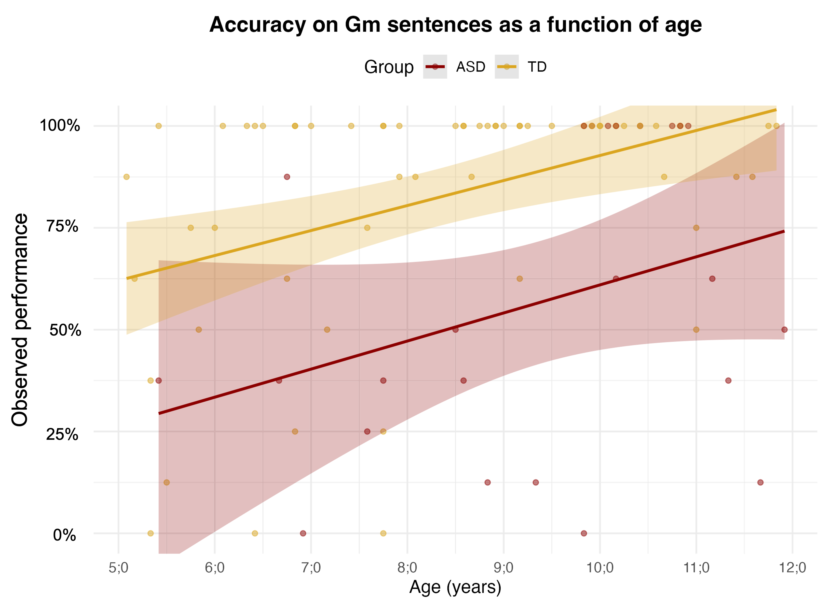

- Non-verbal IQ (Fig. S7.2) – Accuracy tended to be higher at greater non-verbal IQ levels in both groups, with the autistic group showing a steeper trend. This pattern aligns with the GLMER finding that non-verbal reasoning contributes to metalinguistic performance, suggesting that stronger reasoning skills may support performance, particularly in autistic children.
Fig S7.2.
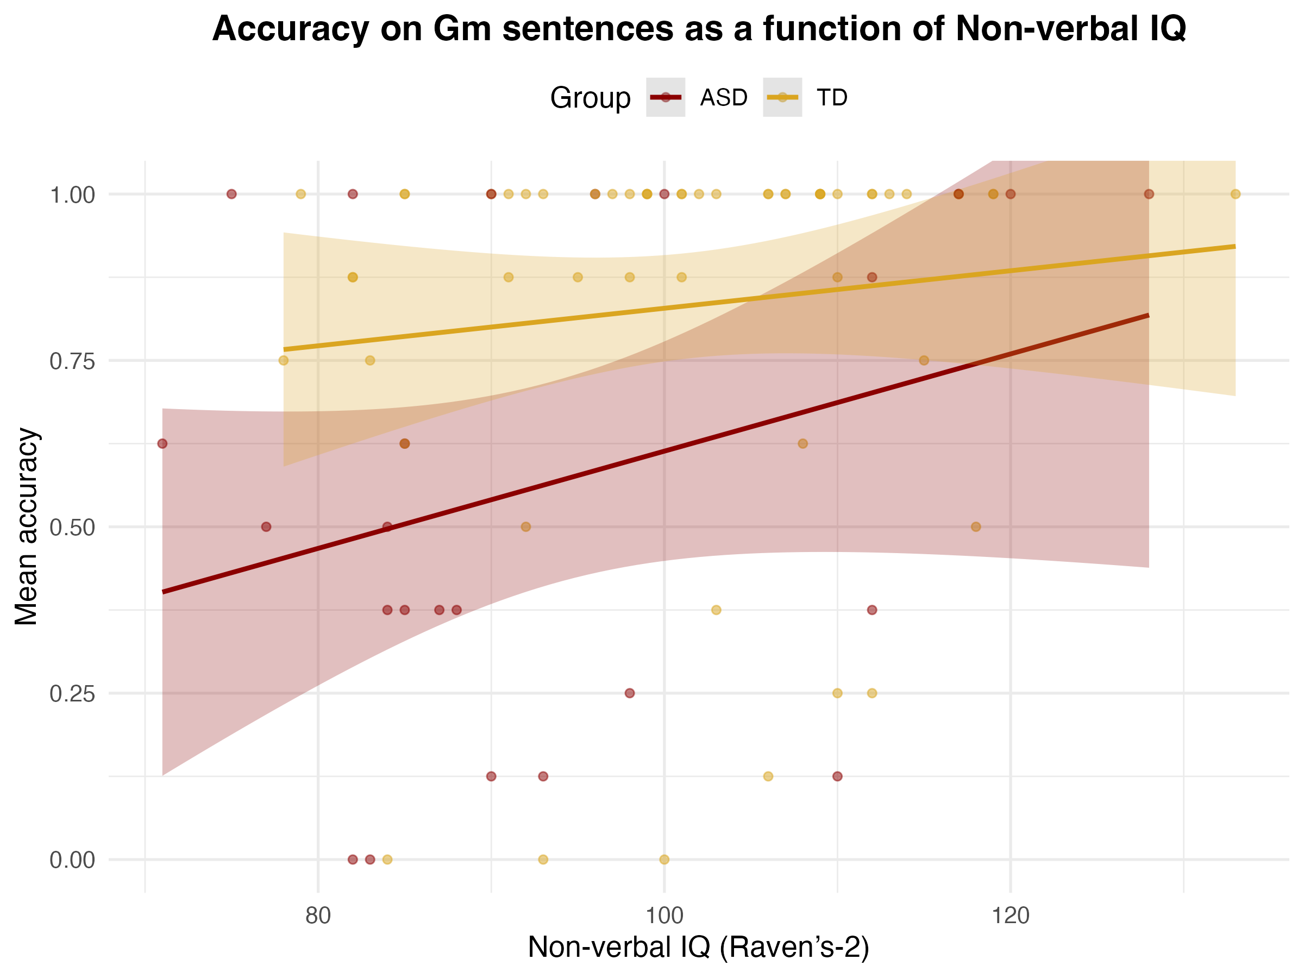

- SCQ total score (Figure S7.3) – Within the autistic group, a negative trend was observed, suggesting that children with higher SCQ scores tended to show lower accuracy on control-demanding sentences. However, the number of available data points was limited, and confidence intervals were large, indicating that this association should be interpreted with caution.
This exploratory pattern may suggest that greater expression of autistic traits is associated with increased difficulty in tasks requiring cognitive control. Future research using clinician-administered measures, such as the ADOS-2 or ADI-R, and larger samples could more precisely assess how specific symptom domains relate to metalinguistic performance.
Fig. S7.3.
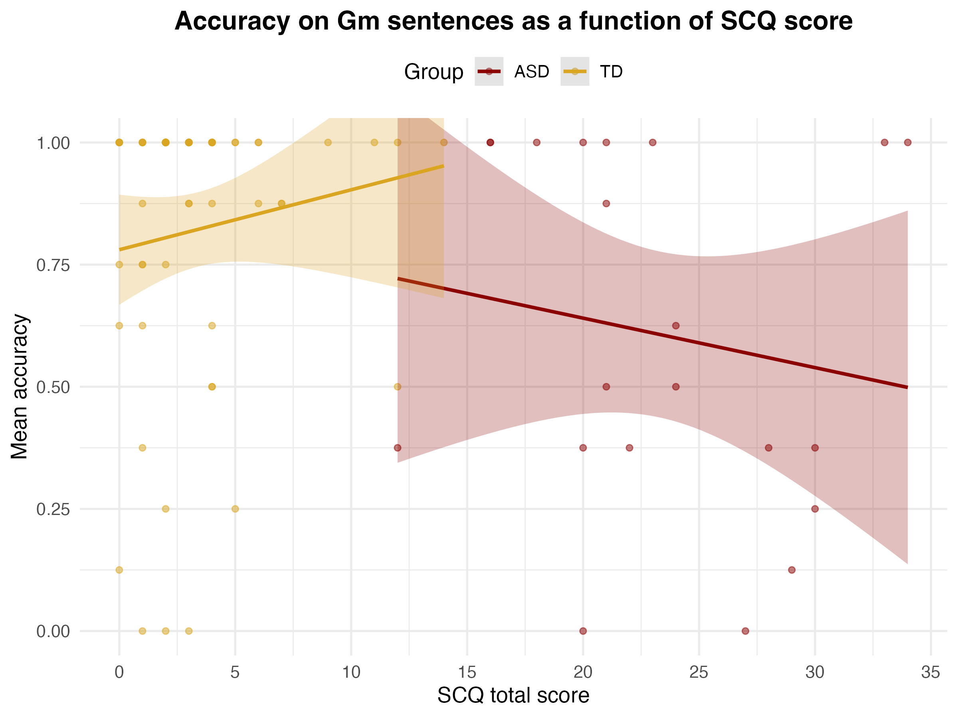

Taken together, these exploratory visualizations suggest that the group difference observed in the GLMER model is robust across a range of ages and cognitive levels, and not driven by a specific subgroup of younger or lower-IQ participants.

