Supporting Information
Mechanoregulatory effects of cell-scale microwells on epithelial cell phenotype
Ruiwen He#, Wang Sik Lee#, Phattadon Yajan, Aaron Lee, Mauro Sousa de Almeida, Sandeep Keshavan, Jozef Adamcik, Céline Loussert-Fonta, Dimitri Vanhecke, Barbara Rothen-Rutishauser*, Alke Petri-Fink*
R. He^{1#}, W. S. Lee^{1,2#}, P. Yajan^{1,2}, A. Lee^{1,2,3}, M. Sousa de Almeida^{1,2}, S. Keshavan¹, J. Adamcik^{1,2}, C. Loussert-Fonta¹, D. Vanhecke^{1,2}, B. Rothen-Rutishauser*^{1,2}, A. Petri-Fink*^{1,2,4}
¹Adolphe Merkle Institute, University of Fribourg, Chemin des Verdiers 4, 1700 Fribourg, Switzerland.
W. S. Lee^{1,2#}, P. Yajan^{1,2}, A. Lee^{1,2,3}, M. Sousa de Almeida^{1,2}, S. Keshavan¹, J. Adamcik^{1,2}, D. Vanhecke^{1,2}, B. Rothen-Rutishauser*^{1,2}, A. Petri-Fink*^{1,2,4}
²National Center of Competence in Research Bio-Inspired Materials, University of Fribourg, Chemin des Verdiers 4, 1700 Fribourg, Switzerland
A. Lee^{1,2,3}
³Department of Bioengineering, Imperial College London, South Kensington SW7 2BP, London, United Kingdom
A. Petri-Fink*^{1,2,4}
⁴Department of Chemistry, University of Fribourg, Chemin du Musée 9, 1700 Fribourg, Switzerland.
#These first two authors contributed equally.
*Corresponding author: Prof. Alke Petri-Fink; E-mail: alke.fink@unifr.ch
Prof. Barbara Rothen-Rutishauser; E-mail: barbara.rothen@unifr.ch

Funding: This work was supported by the Swiss National Science Foundation through the National Center of Competence in Research Bio-Inspired Materials (Grant no. 205603). Additionally, this study was supported by the Swiss National Science Foundation (Grant no. 184635 and 192056).

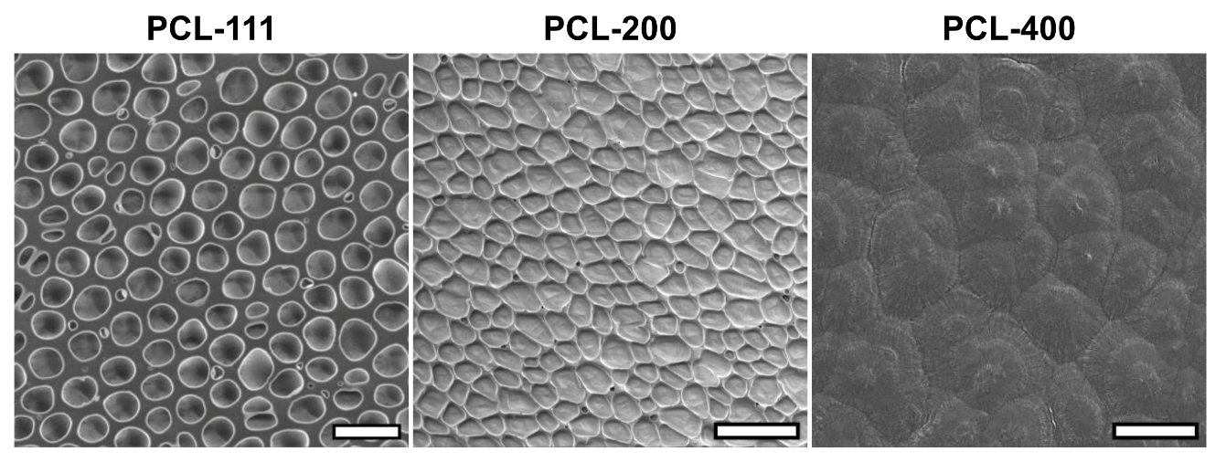
Figure S1. Representative scanning electron microscopy images of PCL substrates prepared by solvent-casting. PCL-111 exhibits well-defined circular pores (scale bar: 20 μm), PCL-200 shows elongated interconnected pores (scale bar: 100 μm), and PCL-400 displays minimal surface topology (scale bar: 20 μm). The distinct morphologies result from differences in solvent evaporation kinetics during fabrication.

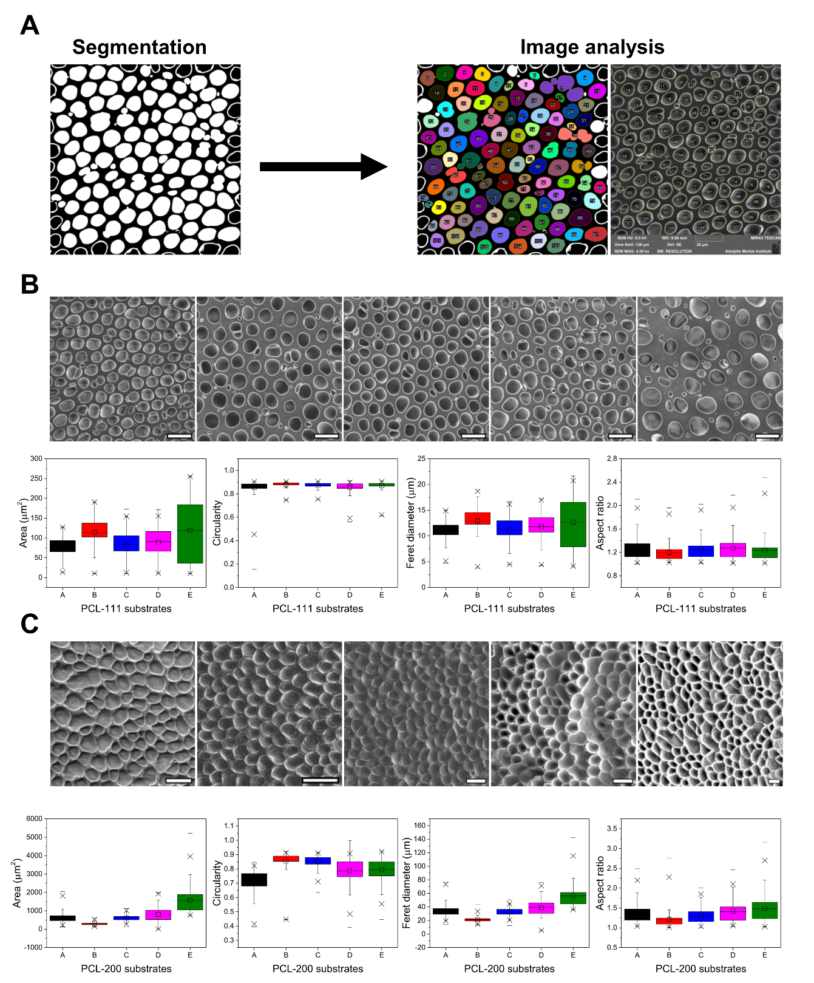
Figure S2. Morphological analysis across five independent preparations (A-E). (A) Segmentation-based image analysis workflow. SEM images were processed using Ilastik for pixel classification, and morphometric parameters were quantified in FIJI. Wells with areas > 10 μm² were selected to exclude noise, and incorrectly segmented regions were manually excluded. (B) PCL-111 substrates exhibit excellent batch-to-batch reproducibility (n = 157-183 wells per preparation). (C) PCL-200 substrates show consistent shape characteristics but variable well dimensions (n = 106-140 wells per preparation). PCL-111 features wells smaller than, while PCL-200 features wells larger than, A549 cell dimensions (10.59-14.93 μm). Box plots display mean (central line), interquartile range (box), and full data range (whiskers).

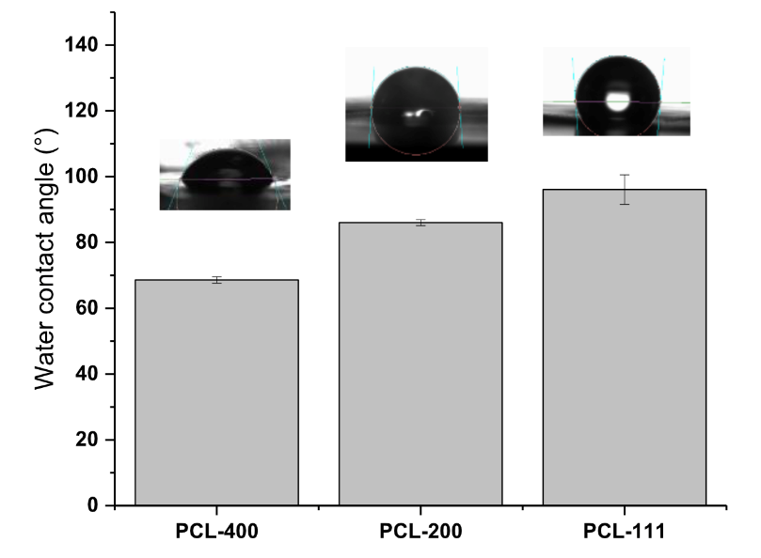
Figure S3. Contact angle measurements of PCL substrates before cell culture media pre-treatment (n=3). All substrates exhibited water contact angles > 45° (PCL-400: 68.60 ± 0.98°; PCL-200: 86.03 ± 0.87°; PCL-111: 96.07 ± 4.50°), confirming hydrophobic surfaces. Representative droplet images are shown above each bar.

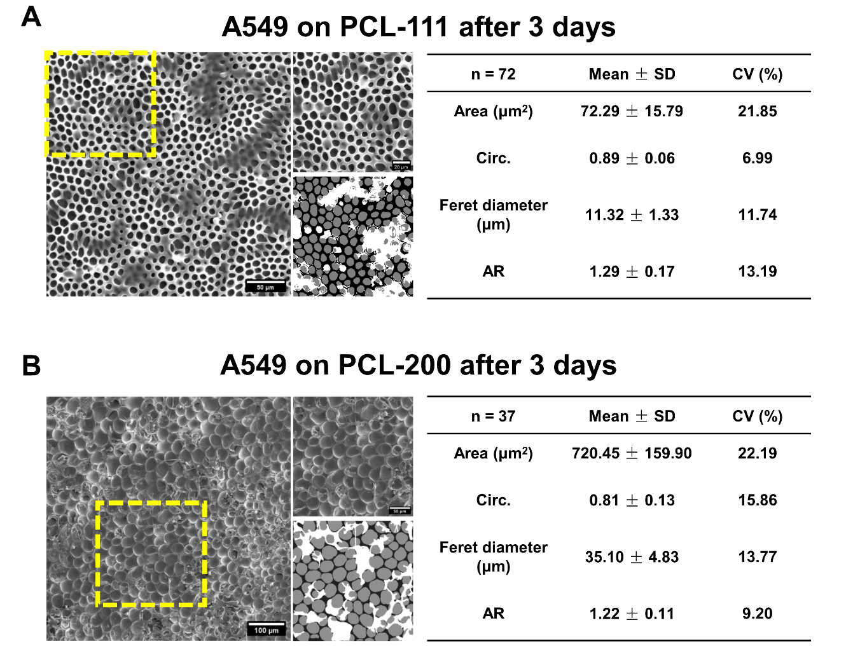
Figure S4. SEM images and morphological characterization of A549 cells cultured on (A) PCL-111 and (B) PCL-200 substrates for 3 days. Image segmentation was performed to distinguish PCL substrates, microwells, and cell-covered areas. After segmentation, microwell regions were analyzed selectively in FIJI. Regions overlapping with cells and incorrectly segmented areas were manually excluded from analysis. Parameters measured include area, circularity, Feret diameter, and aspect ratio (n=72 for PCL-111, n=37 for PCL-200).

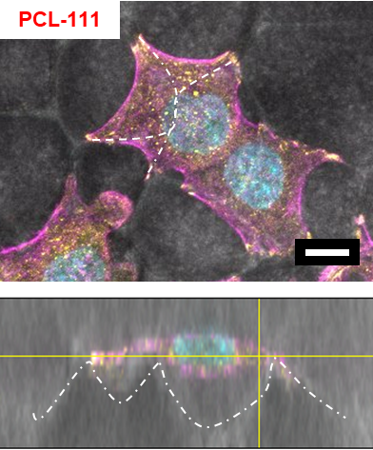
Figure S5. Representative fluorescence microscopy images of nuclei (cyan), F-actin (magenta), and paxillin (yellow) in A549 on PCL-111 substrate after three days of culture. Scale bar: 10 μm.

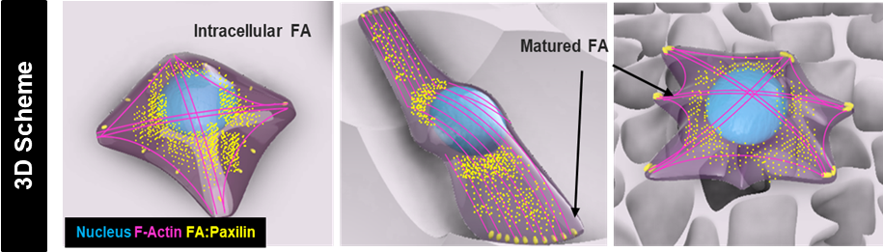
Figure S6. Focal adhesion maturation depends on substrate geometry. Schematic showing focal adhesion (FA, yellow/paxillin) organization on flat vs. topographical surfaces. Flat substrates enable distributed intracellular FAs (left), cell elongation promotes FA maturation at extremities (middle), while microwell topography restricts FAs to discrete contact points (right, arrows), requiring bridging behavior. Nuclear: cyan; F-actin: magenta.

Table S1. Morphological parameters and reproducibility metrics of PCL substrates
 | Area (μm²) | CV (%) | Circularity | CV (%) | Feret diameter  (μm) | CV (%) | Aspect ratio | CV * (%)
PCL-111 | 96.68 ± 18.66 | 19.30 | 0.86 ± 0.01 | 1.33 | 11.94 ± 0.85 | 7.11 | 1.24 ± 0.03 | 2.31
PCL-200 | 780.75 ± 477.33 | 61.14 | 0.80 ± 0.06 | 7.05 | 36.73 ± 12.74 | 34.68 | 1.36 ± 0.10 | 7.63
Data are presented as mean ± standard deviation calculated from 5 independent preparations (A-E). *CV: coefficient of variation.

Table S2. PCL solution formulations used for solvent casting
 | PCL (mg) | DCM (mL) | Ethanol (mL)
PCL-400 | 2000 | 5 | 0.66
PCL-200 | 2000 | 10 | 0.66
PCL-111 | 2000 | 18 | 0.66

