Supplementary information:
Sulfide silver autometallography to differentiate the ultrastructural localization of iron-carbohydrate complexes inside macrophages
Anne-Marinette Cao¹, Jules Duruz¹, Mauro Sousa de Almeida¹, Dimitri Vanhecke¹, Amy E. Alston², Reinaldo Digigow², Beat Flühmann², Alke Fink^{1,3*}, and Barbara Rothen-Rutishauser¹*
¹Adolphe Merkle Institute, University of Fribourg, Chemin des Verdiers 4, 1700 Fribourg, Switzerland
²Vifor Pharma Group, Vifor Pharma Management Ltd
³Department of Chemistry, University of Fribourg, Chemin du Musée 9, Fribourg,
Switzerland

*Corresponding Authors
*Alke Petri-Fink email: alke.fink@unifr.ch and *Barbara Rothen-Rutishauser email: barbara.rothen@unifr.ch

Supplementary figures

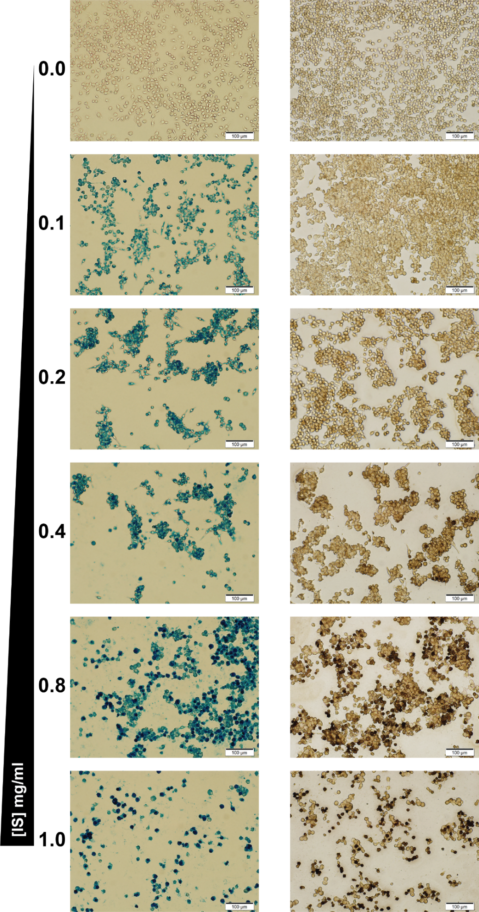
Fig. S1. Macrophages treated with increasing doses of IS and imaged by Prussian blue (left) and ssAMG (right)
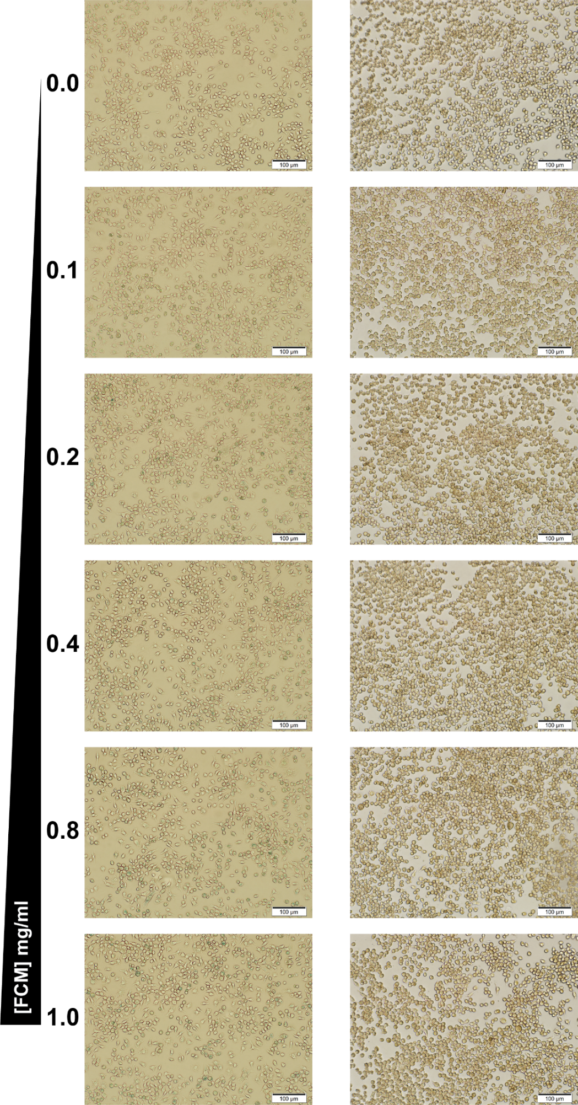
Fig. S2. Macrophages treated with increasing doses of FCM and imaged by Prussian blue (left) and ssAMG (right)
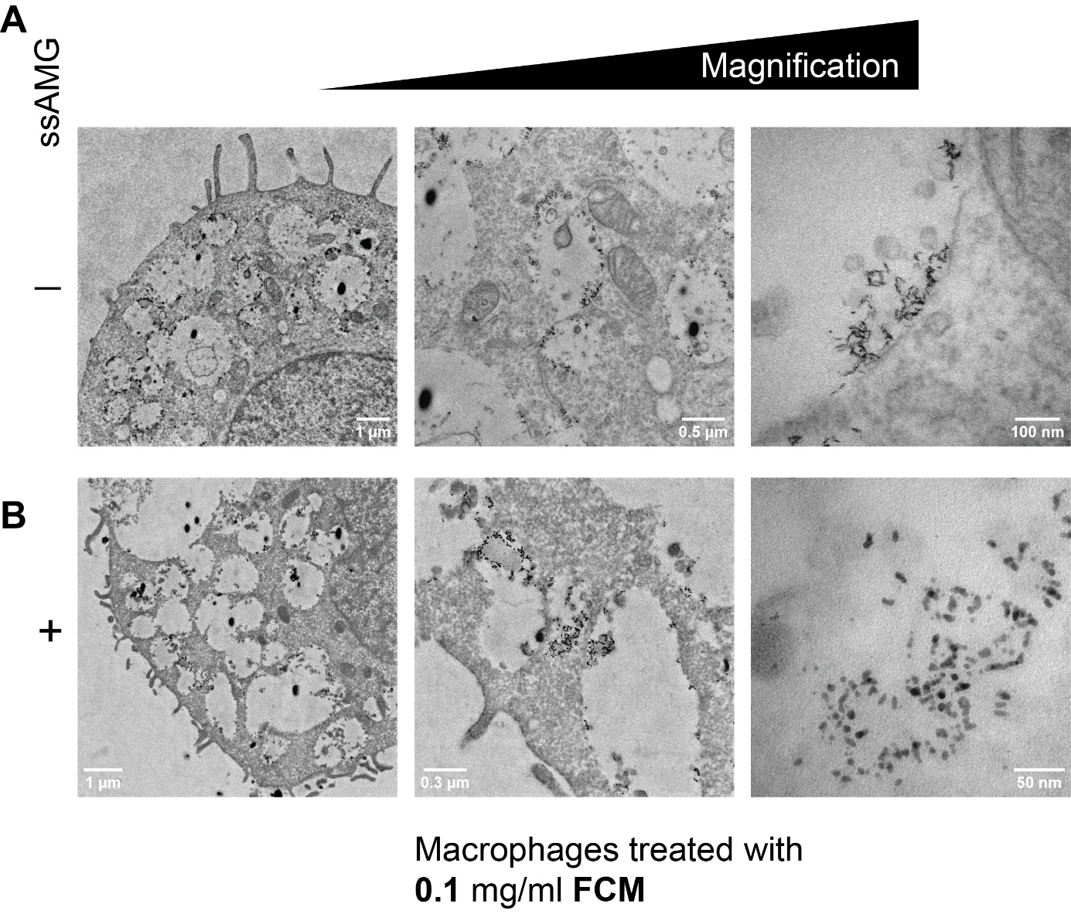
Fig. S3. Representative TEM images of macrophages treated with 0.1 mg/ml FCM

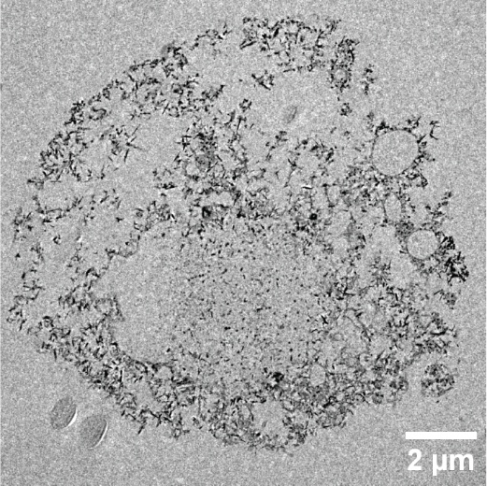

Fig. S4. Representative TEM image of macrophages treated with 1 mg/ml IS

