Supplementary table 1. SAM analogs.
SAM analog | Formula | MW | CAS number | Structure | Source
SAM | C15H22N6O5S | 398.44 | 17176-17-9 | 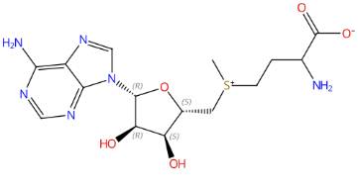 | Sigma A2408
SAH | C14H22N6O5S | 384.41 | 979-92-0 | 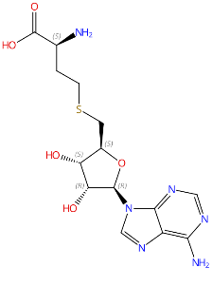 | Sigma A9384
SAO  (Sinefungin) | C15H23N7O5 | 381.39 | 58944-73-3 | 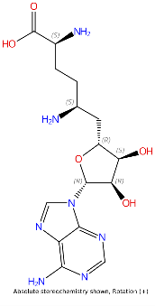 | Sigma S8559
MTA | C11H15N5O3S | 297.33 | 2457-80-9 | 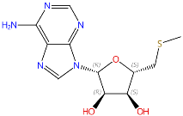 | Sigma D5011
dcSAH | C13H20N6O3S | 340.4 | 53186-57-5 | 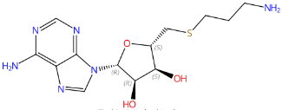 | Sigma 43713
dcSAM | C14H23N6O3S | 355.43 | 22365-13-5 | 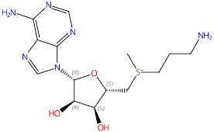 | David J. Feith  (University of Virginia)
SAC | C13H18N6O5S | 370.38 | 35899-53-7 | 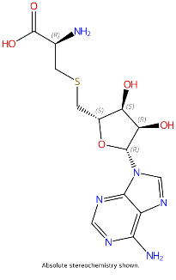 | Sigma A7772
NECA | C12H16N6O4 | 308.29 | 35920-39-9 | 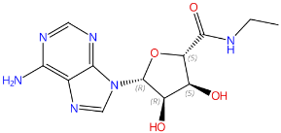 | Sigma E2387
IMP | C10H13N4O8P | 348.21 | 131-99-7 | 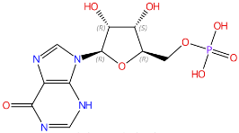 | Sigma I2879
GMP | C10H14N5O8P | 348.21 | 5550-12-9 | 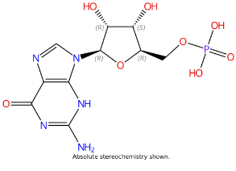 | Sigma G8377
dADP | C10H15N5O9P2 | 411.20 | 2793-06-8 | 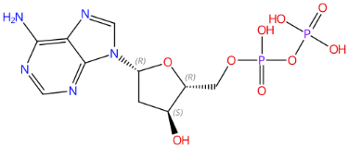 | Sigma D6375
EFA | C6H11N5O3 | 237 | 17019-46-4 | 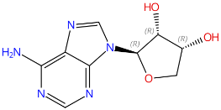 | Howard B. Cottam  (University of California San Diego)
SAE | C16H24N6O5S | 412.47 | 524-70-9 | 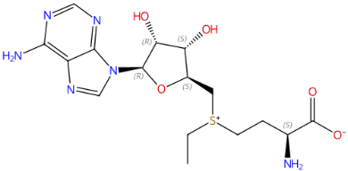 | Zhaohui Sunny Zhou  (Northeastern University)
AdoPropan | C17H26N6O5S | 426.49 | 53830-48-1 | 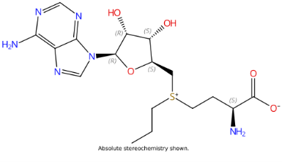 | Elmar Weinhold  (RWTH Aachen University)
AdoBut-2-yn | C18H24N6O5S | 436.48 | 875155-65-0 | 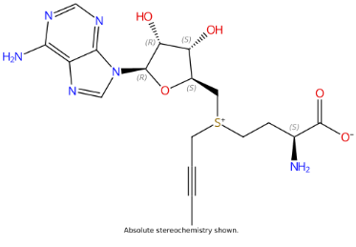 | Elmar Weinhold  (RWTH Aachen University)
AdoBenz | C21H26N6O5S | 474.53 | 912477-38-4 | 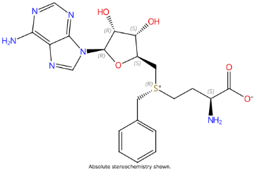 | Elmar Weinhold  (RWTH Aachen University)
AdoAzidoBenz | C21H25N9O5S | 515.54 | 2093487-15-9 | 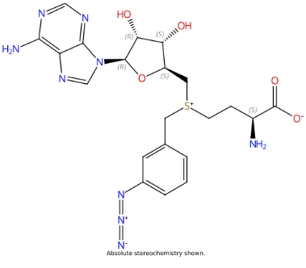 | Elmar Weinhold  (RWTH Aachen University)
AdoEnYn | C19H25N6O5S | 449.5 | 1245499-34-6 | 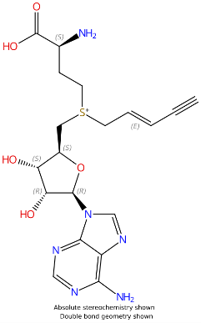 | Elmar Weinhold  (RWTH Aachen University)
MT-DADMe-ImmA | C13H19N5OS | 293.4 | 653592-04-2 | 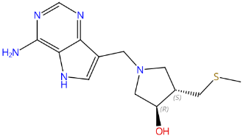 | Vern L. Schramm  (Albert Einstein College of Medicine)
GENZ-642346  (MDL-73811) | C15H23N7O3 | 349.4 | 123642-27-3 | 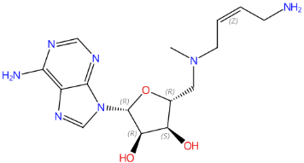 | Robert H. Barker  (Genzyme)
GENZ-644131 | C16H25N7O3 | 363.4 | 1092979-24-2 | 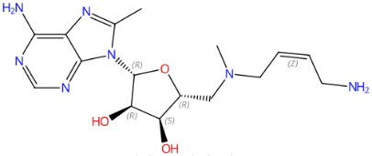 | Margaret A. Phillips  (University of Texas Southwestern)
SRI-19176 | C12H17N5O3S | 311.4 | 1106914-55-9 | 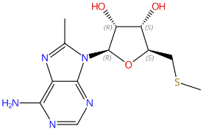 | John A. Secrist III  (Southern Research Institute)
SRI-19782 | C10H11Cl2N5O3 | 320.1 | 75059-21-1 | 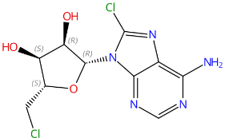 | John A. Secrist III  (Southern Research Institute)
SRI-19783 | C11H15ClN6O3 | 314.7 | 121059-94-7 | 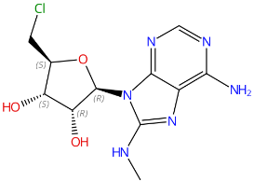 | John A. Secrist III  (Southern Research Institute)
SRI-19786 | C12H18N6O3 | 294.3 | 1092978-84-1 | 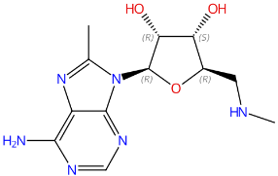 | John A. Secrist III  (Southern Research Institute)
SRI-19793 | C17H20N6O3 | 356.4 | 1106913-44-3 | 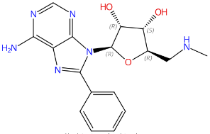 | John A. Secrist III  (Southern Research Institute)
SRI-19800 | C11H16N6O4 | 296.3 | 1106913-30-7 | 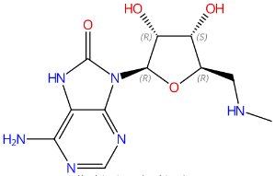 | John A. Secrist III  (Southern Research Institute)
SRI-20664 | C11H16N6O3 | 280.3 | 47058-90-2 | 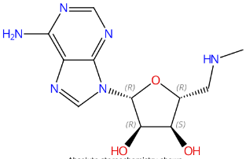 | John A. Secrist III  (Southern Research Institute)
SRI-21064 | C16H27N7O4 | 381.4 | 1106913-82-9 | 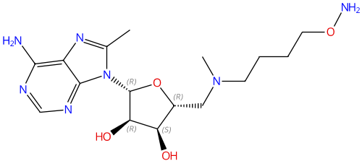 | John A. Secrist III  (Southern Research Institute)
SRI-21261 | C12H18N6O3 | 294.3 | 78694-79-8 | 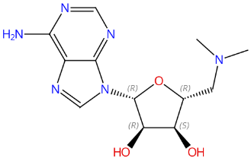 | John A. Secrist III  (Southern Research Institute)
SRI-21371 | C15H25N7O5 | 383.4 | 1106913-79-4 | 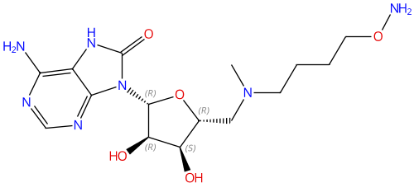 | John A. Secrist III  (Southern Research Institute)
SRI-21374 | C21H29N7O4 | 443.5 | 1106913-76-1 | 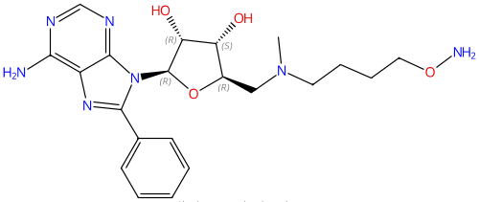 | John A. Secrist III  (Southern Research Institute)
SRI-21412 | C12H18N5O3S | 347.8 | 15648-76-7 | 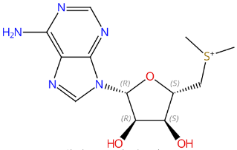 | John A. Secrist III  (Southern Research Institute)
SRI-21443 | C13H20N6O3 | 308.3 | 1106914-51-5 | 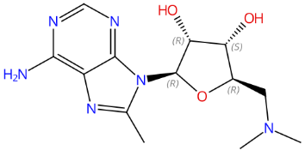 | John A. Secrist III  (Southern Research Institute)
SRI-21446 | C13H20N5O3S | 361.9 | 1106914-61-7 | 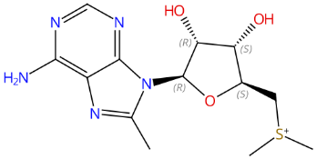 | John A. Secrist III  (Southern Research Institute)
CJ-078 |  | 380.4 |  | 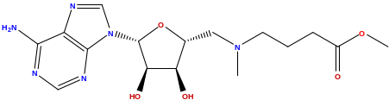 | Adam Nelson  (University of Leeds)
CJ-229 | C18H29N7O4 | 407.5 | 1129995-78-3 | 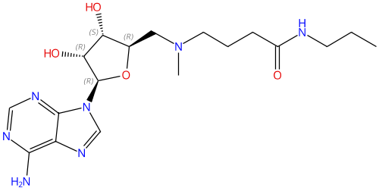 | Adam Nelson  (University of Leeds)
CJ-250  (AzaSAM) | C15H23N7O5 | 381.4 | 111770-79-7 | 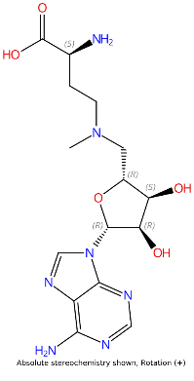 | Adam Nelson  (University of Leeds)  &  Christian G. Bochet  (University of Fribourg)
CJ-274 | C19H32N7O4 | 549.4 | 1129995-80-7 | 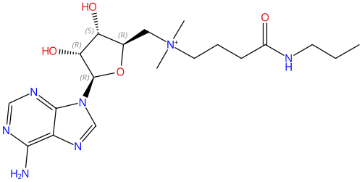 | Adam Nelson  (University of Leeds)
CJ-276 | C18H30N8O4 | 422.5 | 1129995-76-1 | 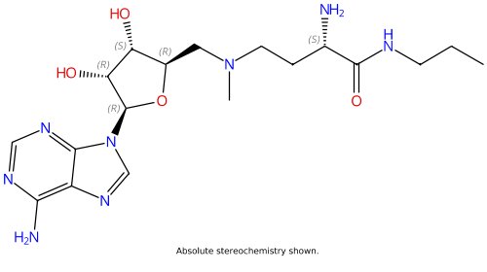 | Adam Nelson  (University of Leeds)

Supplementary figure S1. Metabolites in plasma of I278T mice fed methionine-adjusted diets. Metabolites were quantified using liquid chromatography-tandem mass spectrometry (LC-MS/MS): total homocysteine (tHcy; A), total cysteine (tCys; B), methionine (Met; C), S-adenosylmethionine (SAM; D), S-adenosylhomocysteine (SAH; E), SAM/SAH ratio (F), betaine (G), glycine (H), serine (I) and cystathionine (J). Data are presented as mean±SEM. Asterisk (*) refers to a significant change compared to WT mice on standard mouse chow.

Supplementary figure S2. Clustering of the studied SAM analogs based on the obtained structure-activity relationship data. The impact of the evaluated SAM analogs on CBS WT activity was plotted against their impact on native CBS WT proteolytic half-life. This analysis underscores the intricate relationship between the CBS structural/conformational properties and its enzymatic activity. Specifically, the green cluster includes SAM analogs, which showed no binding and thus did not affect CBS activity or resistance to proteolysis, thus likely maintained CBS in its resting trans-basal filamentous conformation (e.g. NECA). Blue cluster consists of SAM analogs, which bind CBS and likely promote formation of cis-basal filamentous assembly characterized by slight increase in activity and partially decreased proteolytic half-life (e.g. SAH, SAO and AzaSAM). Lastly, the red cluster exclusively consists of sulfonium-containing SAM analogs, which bind CBS, induce full activation and further reduce proteolytic half-life indicating substantial conformational changes likely associated with CBS subunit rearrangement and stacking by forming allo-activated stacked filamentous assembly (e.g. SAM, AdoBenz, dcSAM).
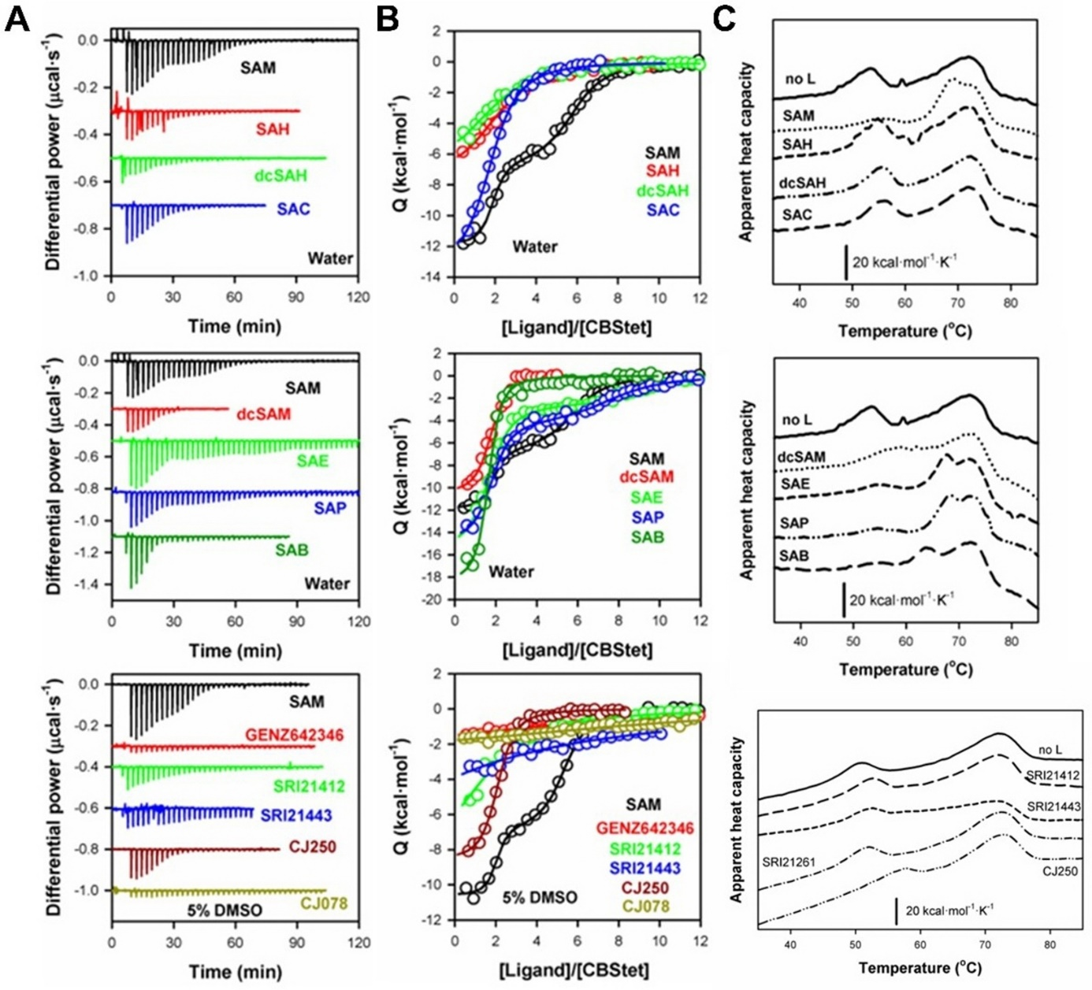

Supplementary figure S3. Microcalorimetric analyses of CBS in the presence of SAM analogs. A – Representative raw calorimetric titrations of CBS WT (3-5 µM in subunit) with the selected SAM analogs (30–50 injections of 0.75–1.2 μl 250–350 μM SAM analog solution spaced 150 s apart). B – Binding isotherms corresponding to the raw titrations shown in panel A. C – Representative thermal denaturation profiles (2-4°C scan rate) of CBS WT (5 µM in subunit) in the presence of the selected SAM analogs (25-400 µM).

Supplementary figure S4. Intracellular levels of SAM and SAH after the treatment with SAM analogs. A-C – HEK293A lacking endogenous CBS, but stably overexpressing CBS I278T variant, were cultured for three days in the absence (vehicle) or presence of 500 µM SAM, SAO or AzaSAM. Levels of SAM (A) and SAH (B) were determined by LC-MS/MS, while the SAM/SAH ratios (C) were calculated to evaluate impact of treatment on cellular methylations. Asterisk (*) refers to a significant change compared to vehicle-treated controls. Data are presented as mean±SEM.
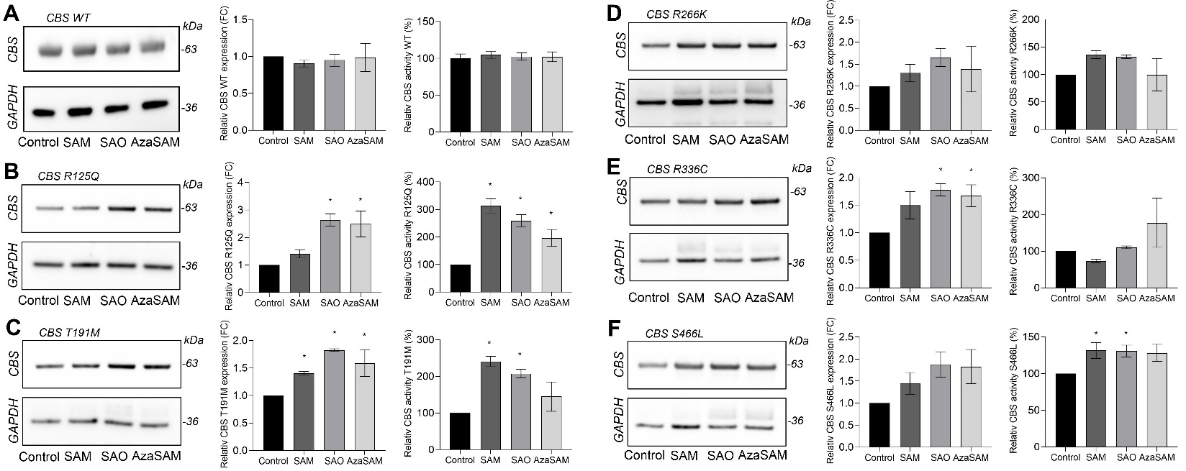

Supplementary figure S5. Impact of SAM analog treatment on expression and activity of selected pathogenic missense CBS variants. A-E – HEK293A cells lacking endogenous CBS and stably overexpressing CBS WT as a control (A) or HCU-causing CBS R125Q (B), CBS T191M (C), CBS R266K (D), CBS R336C (E) or CBS S466L (F) variants were cultured in the absence (vehicle) or presence of 500 µM SAM analog for three days in methionine-deficient media. Afterwards, cell homogenates were used to evaluate expression of CBS variants using Western blot analysis (left) followed by a densitometric quantification of CBS expression normalized to GAPDH levels (middle). In addition, CBS activity was determined in the same cell homogenates using AzMC assay (right). Asterisk (*) refers to a significant change compared to vehicle-treated controls. Data are presented as mean±SEM.

