Supporting Information
Bioinspired Stabilization of Fluorescent Au@SiO₂ Tracers for Multimodal Biological Imaging
Wang Sik Lee¹, Henry Lee¹, Patricia Taladriz-Blanco¹, Dimitri Vanhecke¹, Barbara Rothen-Rutishauser¹, and Alke Petri-Fink*¹
¹Adolphe Merkle Institute, University of Fribourg, Chemin des Verdiers 4, 1700 Fribourg, Switzerland
Corresponding author: Prof. Alke Petri-Fink (alke.fink@unifr.ch)

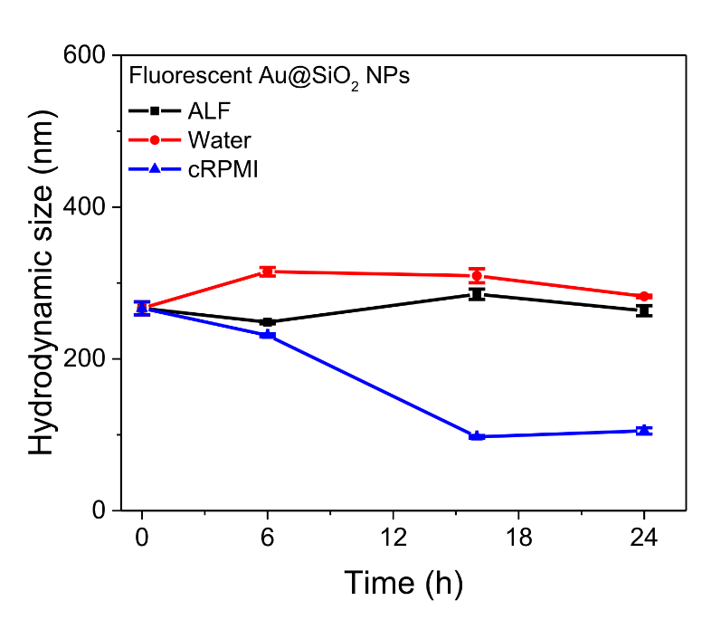

Figure S1. (a) Hydrodynamic diameters of fluorescent Au@SiO₂ NPs (20 μg/mL) measured in water, complete cell culture medium (cRPMI), and artificial lysosomal fluid (ALF) over time. After incubation, all samples were centrifuged and resuspended in fresh Milli-Q water for measurement. The Milli-Q water had a pH of 5.5–6.5, and measurements were performed at 25 °C (n = 3).

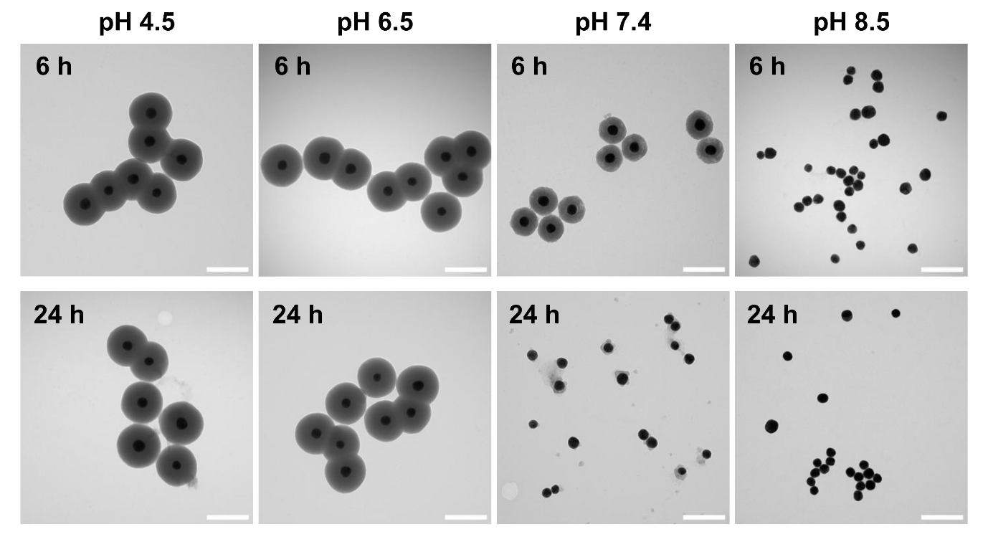
Figure S2. pH-dependent dissolution of the fluorescent Au@SiO₂ NPs. Particles (20 µg/mL) were incubated at 37°C in buffer solutions at pH 4.5 (acetate buffer), pH 6.5 (phosphate buffer), pH 7.4 (PBS), and pH 8.5 (phosphate buffer) for 6 h and 24 h. TEM images reveal that silica shells remain intact at pH 4.5 and pH 6.5 but undergo dissolution at pH 7.4, with complete shell degradation observed at pH 8.5 within 6 h. This pH-dependent instability demonstrates the vulnerability of conventional silica shells under physiologically relevant pH conditions (pH ≥ 7.4). Scale bars: 200 nm.

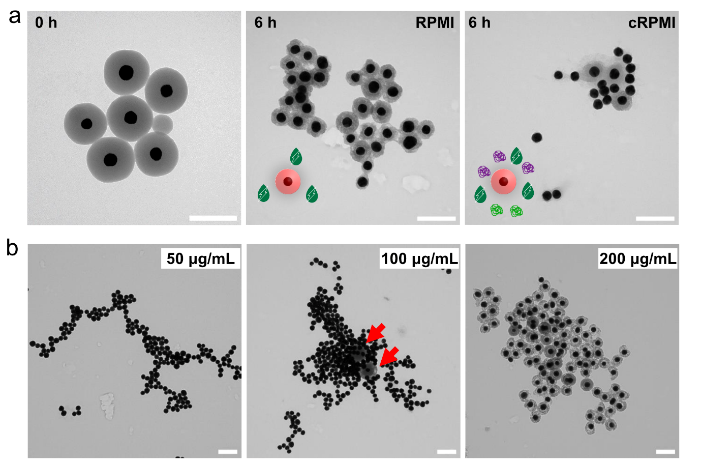
Figure S3. Dissolution mechanisms of fluorescent Au@SiO₂ NPs in biological media. (a) TEM images of fluorescent Au@SiO₂ NPs (20 μg/mL) at 0 h (left), after 6 h incubation in serum-free RPMI medium (middle), and in complete RPMI medium with 10% FBS (cRPMI, right), showing that shell degradation occurs in both serum-free and serum-containing media. Scale bars: 200 nm. (b) Concentration-dependent stability of fluorescent Au@SiO₂ NPs after 24 h in cRPMI. At low concentrations (50 μg/mL, left), complete shell dissolution occurred. At intermediate concentrations (100 μg/mL, middle), partial shells remained (red arrows). At high concentrations (200 μg/mL, right), core-shell structures were largely preserved, consistent with the silica saturation concentration principle. Scale bars: 200 nm.

Table S1. Hydrodynamic size and zeta potential of fluorescent Au@SiO₂–Cy5 NPs before and after calcination, measured in water. All samples (10× dilution from the as-synthesized suspension) were centrifuged and resuspended in fresh Milli-Q water for analysis (Milli-Q water at pH ~7.0; measurements performed at 25 °C; n = 3).
Nanoparticle designation | Hydrodynamic diameter (nm) | Zeta-potential (mV)
Fluorescent Au@SiO₂-NPs | 260.3 ± 1.0 | -49.6 ± 0.2
Fluorescent Au@SiO₂-NPs  (After Liquid phase calcination) | 277.0 ± 7.4 | -39.6 ± 0.6
Au@SiO₂ NPs  (After Solid phase calcination) | 189.3 ± 1.6 | -29.7 ± 1.0
Au@SiO₂-Cy5 NPs  (After attachment of Cy5) | 244.5 ± 5.7 | 38.6 ± 0.4

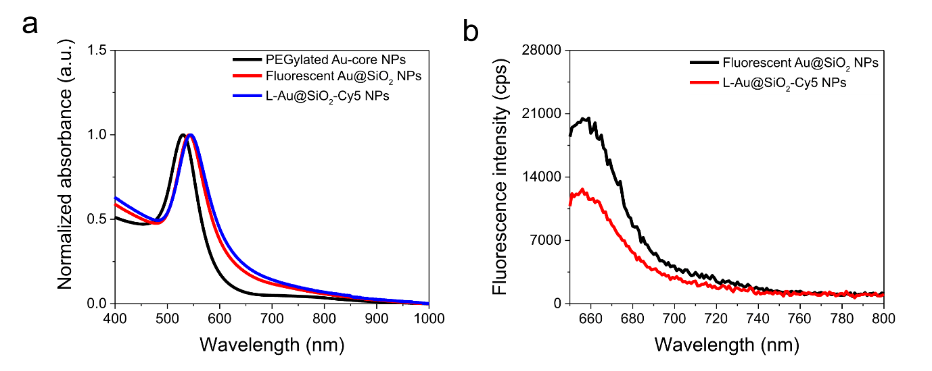
Figure S4. Optical characterization of liquid-phase calcined fluorescent Au@SiO₂ NPs (L-Au@SiO₂-Cy5 NPs). (a) UV-Vis extinction spectra of PEGylated Au-core NPs (black), as-synthesized fluorescent Au@SiO₂ NPs (red), and L-Au@SiO₂-Cy5 NPs (blue), showing preservation of the localized surface plasmon resonance peak. (b) Fluorescence emission spectra (λex = 630 nm) of as-synthesized (black) and L-Au@SiO₂-Cy5 NPs (red) at 20 μg/mL, showing moderate fluorescence reduction (~38%) after liquid-phase calcination due to partial thermal degradation of Cy5.

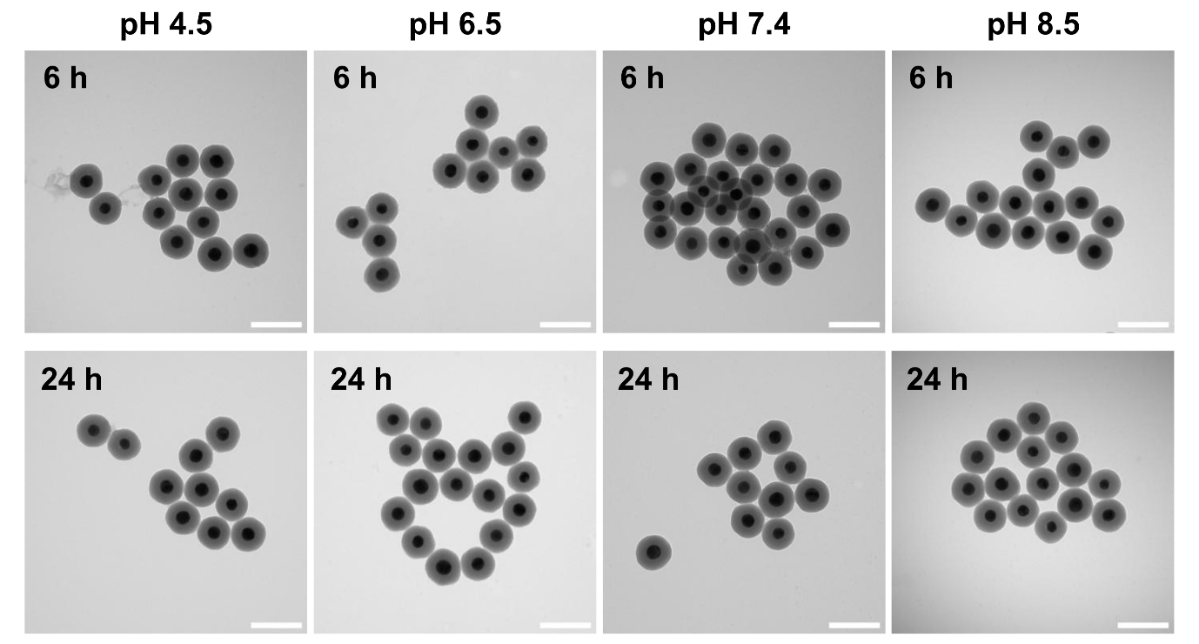
Figure S5. pH-independent stability of solid-phase calcined S-Au@SiO2-Cy5 NPs. S-Au@SiO₂-Cy5 NPs (20 µg/mL) were incubated at 37°C in buffer solutions at pH 4.5 (acetate buffer), pH 6.5 (phosphate buffer), pH 7.4 (PBS), and pH 8.5 (phosphate buffer) for 6 h and 24 h. TEM images demonstrate that silica shells remain completely intact across all pH conditions tested (pH 4.5-8.5), encompassing the physiologically relevant pH range of 7-8. This pH-independent stability confirms that solid-phase calcination produces chemically robust silica shells that resist dissolution across the full range of biological pH environments. Scale bars: 200 nm.

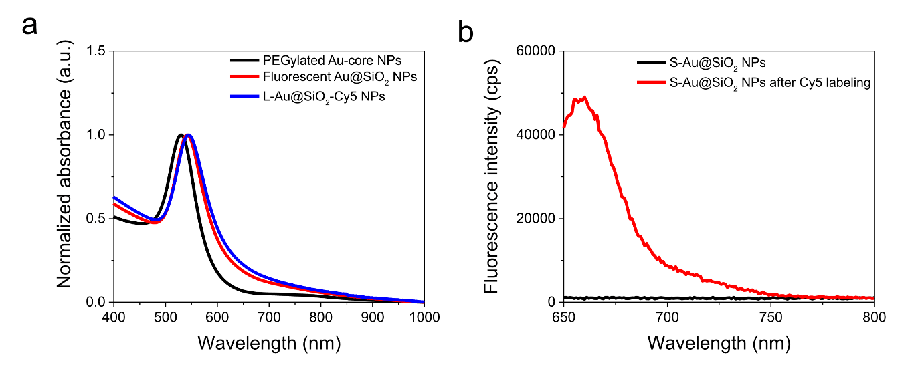
Figure S6. Optical characterization of solid-phase calcined Au@SiO₂ NPs (S-Au@SiO₂-Cy5 NPs), confirming preservation of multimodal imaging capability after post-calcination labeling. (a) UV-Vis extinction spectra of PEGylated Au-core NPs (black), solid-phase calcined Au@SiO2 NPs before dye conjugation (red), and S-Au@SiO₂-Cy5 NPs after post-calcination Cy5 labeling (blue), confirming preserved plasmonic properties. (b) Fluorescence emission spectra of solid-phase calcined Au@SiO₂ NPs before Cy5 conjugation (black, control) and S-Au@SiO₂-Cy5 NPs after post-calcination labeling (red) at 20 μg/mL, demonstrating successful fluorophore attachment.

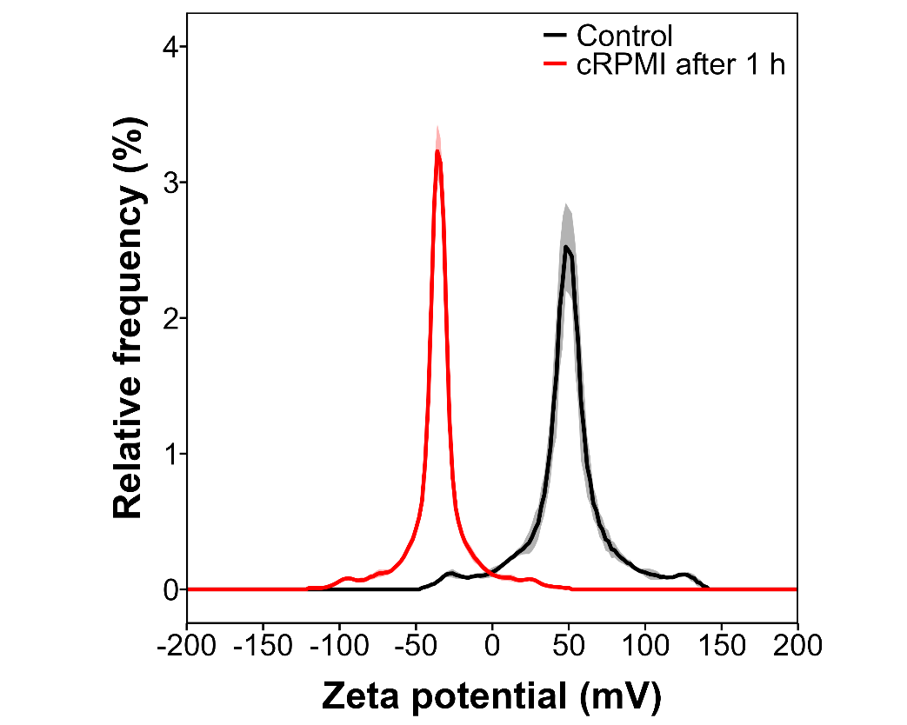
Figure S7. Zeta potential distributions of S-Au@SiO₂-Cy5 NPs before (black) and after (red) protein corona formation. Particles were incubated in complete RPMI medium (cRPMI) containing 10% fetal bovine serum for 1 h at 37°C, then centrifugally isolated (15,000 rcf, 10 min) and redispersed in fresh MilliQ water (pH 5.5-6.5) for measurement. Direct zeta potential measurement in serum-containing media is unreliable due to electrode fouling from high ionic strength^{[1]}; therefore, centrifugal isolation was employed to remove excess salts and loosely bound proteins while preserving the hard protein corona. The charge inversion from +42.1 ± 1.3 mV to -35.0 ± 0.7 mV demonstrates extensive adsorption of negatively charged serum proteins. Values represent mean ± standard deviation (n=5).

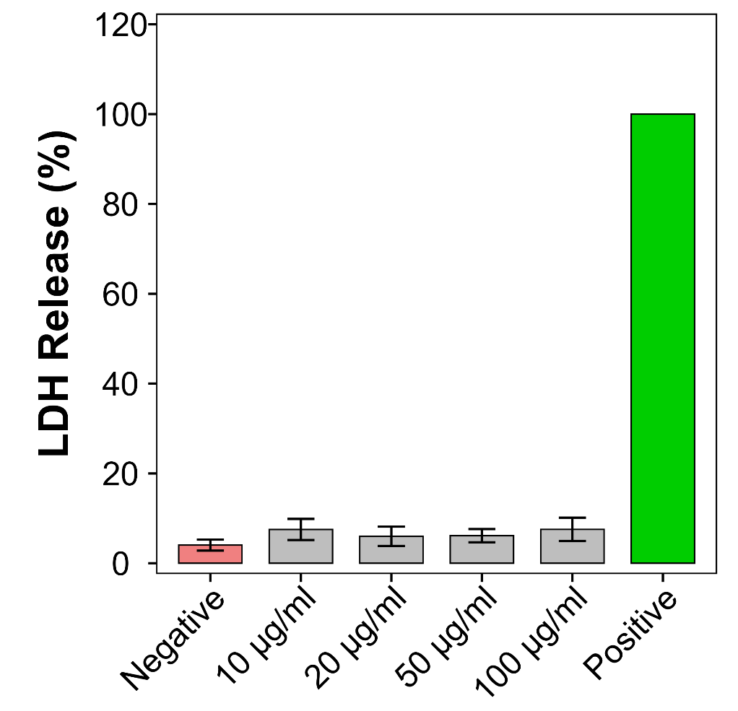
Figure S8. Lactate dehydrogenase (LDH) release assay demonstrating biocompatibility of S-Au@SiO₂-Cy5 NPs. RAW 264.7 macrophages (100,000 cells/well in 96-well plates) were treated with S-Au@SiO₂-Cy5 NPs at concentrations of 10, 20, 50, and 100 µg/mL for 24 h in complete RPMI medium. Untreated cells served as negative control (N Control), and cells treated with 0.2% Triton X-100 served as positive control (P Control, representing 100% LDH release). All S-Au@SiO₂-Cy5 NP treatments (rows B-E) showed <10% LDH release, comparable to negative controls and substantially lower than positive controls. Each condition was tested in triplicate within each experiment, with data representing 9 values pooled from 3 independent replicated experiments (n = 3 biological replicates, technical triplicates per replicate). Error bars represent standard deviation. LDH release was quantified by measuring absorbance at 490 nm using a microplate reader after 24 h incubation.

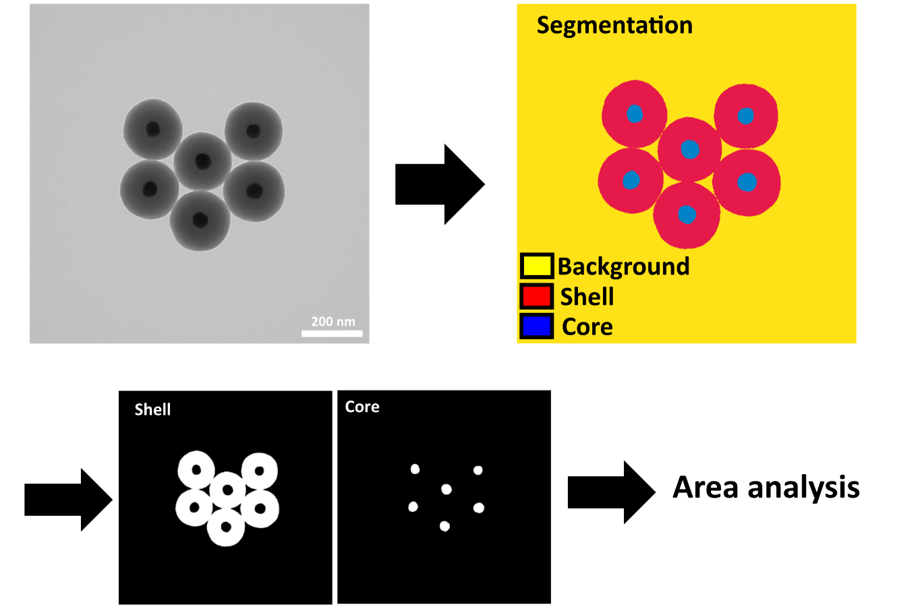
Figure S9. Segmentation-based quantification method for shell-to-core area ratio analysis. TEM images were segmented using Ilastik machine-learning software to classify pixels into three categories: background (yellow), silica shells (red), and Au cores (blue). Segmented images were processed in Fiji to separate shells and cores by contrast thresholding, enabling precise area measurements. This approach was adopted because conventional Feret diameter analysis inadequately captures irregular shell morphology changes during dissolution. Shell-to-core area ratios calculated by this method provide a quantitative assessment of structural stability over time in cRPMI.

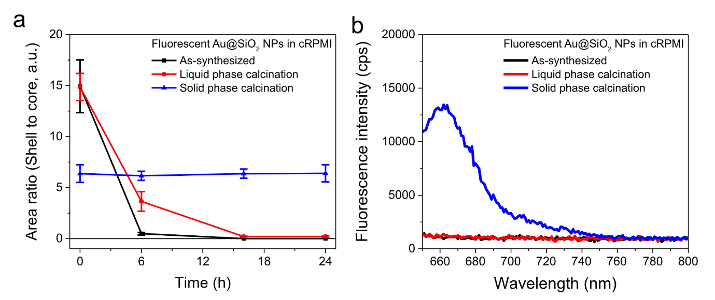
Figure S10. Quantitative stability analysis of fluorescent Au@SiO₂ NPs in complete RPMI medium. (a) Time-dependent changes in shell-to-core area ratios measured by segmentation analysis (Figure S6). Non-calcined (black) and liquid-phase calcined (red) NPs showed progressive shell loss, reaching near-zero ratios by 6-16 h, whereas solid-phase calcined NPs (blue) maintained stable ratios (~6) throughout 24 h. Error bars represent the standard deviation from three independent measurements. (b) Fluorescence emission spectra (λex = 630 nm) after 24 h incubation in cRPMI. Only solid-phase calcined NPs (blue) retained Cy5 fluorescence, while non-calcined (black) and liquid-phase calcined (red) samples showed complete fluorescence loss, consistent with structural degradation observed in panel (a). These results demonstrate that the shell-to-core area ratio is a reliable quantitative indicator of both structural and functional stability.

Table S2. Shell-to-core area ratios of the fluorescent Au@SiO₂ NPs under different calcination conditions
Fluorescent Au@SiO₂ NPs | Time (h) |  | Core-shell ratio | Variability (CV%) | Sample size
As synthesized | 0 | 14.93 ± 2.58 |  | 17.30 | 121 (12)
 | 6 | 0.48 ± 0.47 |  | 25.83 | 231 (5)
 | 16 | 0 |  | – | –
 | 24 | 0 |  | – | –
Liquid-phase calcination | 0 | 14.86 ± 1.33 |  | 8.92 | 127 (6)
 | 6 | 3.65 ± 0.96 |  | 26.46 | 123 (6)
 | 16 | 0.20 ± 0.03 |  | 16.10 | 154 (5)
 | 24 | 0.21 ± 0.08 |  | 36.53 | 134 (5)
Solid-phase calcination | 0 | 6.37 ± 0.86 |  | 13.52 | 108 (6)
 | 6 | 6.15 ± 0.45 |  | 7.26 | 103 (6)
 | 16 | 6.36 ± 0.45 |  | 7.04 | 159 (5)
 | 24 | 6.40 ± 0.83 |  | 12.98 | 88 (5)
Data presentation: Core-shell ratio values present the mean ± standard deviation. Sample size indicates the total number of analyzed Au@SiO₂ NPs (number of TEM images). CV presents the coefficient of variation.

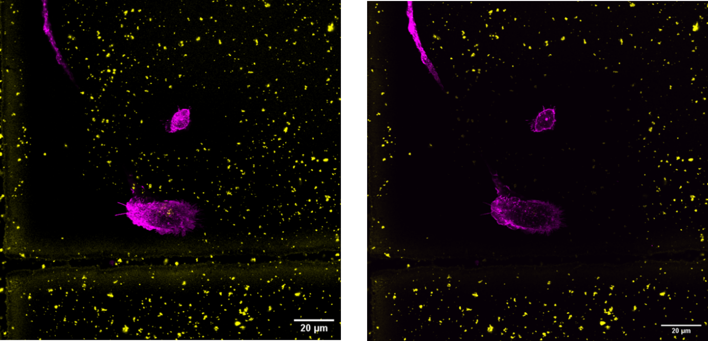
Figure S11. Progressive photobleaching of Cy5 fluorescence during sequential z-stack acquisition. Confocal LSM images of the same optical plane in human monocyte-derived macrophages (MDMs) acquired before (left) and after (right) completing the full z-stack acquisition. Fluorescence from S-Au@SiO₂-Cy5 NPs (yellow dots) shows marked intensity decrease or complete signal loss after cumulative photon exposure during sequential imaging. This progressive depletion of fluorescence in later z-planes necessitates the use of permanent structural markers (electron-dense Au cores) for reliable quantitative tracking throughout 3D volumes, as demonstrated in Figure 6. Scale bars: 20 µm.

Reference
[1] S. Bhattacharjee, J. Control. Release 2016, 235, 337.

