Comparative grain size analysis of fine-grained sediments: a case study of the Opalinus Clay, northern Switzerland
Géraldine Nicole Zimmerli^{a,}*, Alicia Fantasiaª, Stephan Wohlwend^{b,c}, Gaudenz Deplazes^{d}, and Anneleen Foubertª
ª Department of Geosciences, University of Fribourg, Chemin du Musée 6, 1700 Fribourg, Switzerland
^{b} Institute of Geological Sciences, University of Bern, Baltzerstrasse 1 + 3, 3012 Bern, Switzerland
^{c} Wohlwend Geologie, Eichrainstrasse 9, 8052 Zürich, Switzerland
^{d} National Cooperative for the Disposal of Radioactive Waste (Nagra), Hardstrasse 73, 5430 Wettingen, Switzerland
*Corresponding author: geraldine.zimmerli@unifr.ch

Supplementary Material

Appendix A
Sample name | Depth (m) | Formation | Subfacies type | Analyses performed on the samples
1 | 801.03 | Opalinus Clay | SF3 | Thin sections (TS), computed tomography (CT), laser particle size analysis (LPSA), sieving/decantation (SD), Mineralogy (M), XRF
2 | 806.13 | Opalinus Clay | SF3 | TS, CT, LPSA, SD, M, XRF
3 | 812.74 | Opalinus Clay | SF1 | TS, CT, LPSA, SD, M, XRF
4 | 818.43 | Opalinus Clay | SF1 | TS, CT, LPSA, SD, M, XRF
5 | 824.92 | Opalinus Clay | SF1 | TS, CT, LPSA, SD, M, XRF
6 | 830.94 | Opalinus Clay | SF2 | TS, CT, LPSA, SD, M, XRF
7 | 836.04 | Opalinus Clay | SF2 | TS, CT, LPSA, SD, M, XRF
8 | 841.98 | Opalinus Clay | SF6 | TS, CT, LPSA, SD, M, XRF
9 | 847.74 | Opalinus Clay | SF2 | TS, CT, LPSA, SD, M, XRF
10 | 853.03 | Opalinus Clay | SF2 | TS, CT, LPSA, SD, M, XRF
11 | 859.51 | Opalinus Clay | SF2 | TS, CT, LPSA, SD, M, XRF
12 | 867.01 | Opalinus Clay | SF1 | TS, CT, LPSA, SD, M, XRF
13 | 872.57 | Opalinus Clay | SF1 | TS, CT, LPSA, SD, M, XRF
14 | 878.98 | Opalinus Clay | SF6 | TS, CT, LPSA, SD, M, XRF
15 | 890.16 | Opalinus Clay | SF1 | TS, CT, LPSA, SD, M, XRF
16 | 895.26 | Opalinus Clay | SF1 | TS, CT, LPSA, SD, M, XRF
17 | 901.04 | Opalinus Clay | SF1 | TS, CT, LPSA, SD, M, XRF
Table A. Overview of the samples analyzed from Stadel-2 (sample name, sample depth, formation, subfacies type and analyses performed).

Appendix B
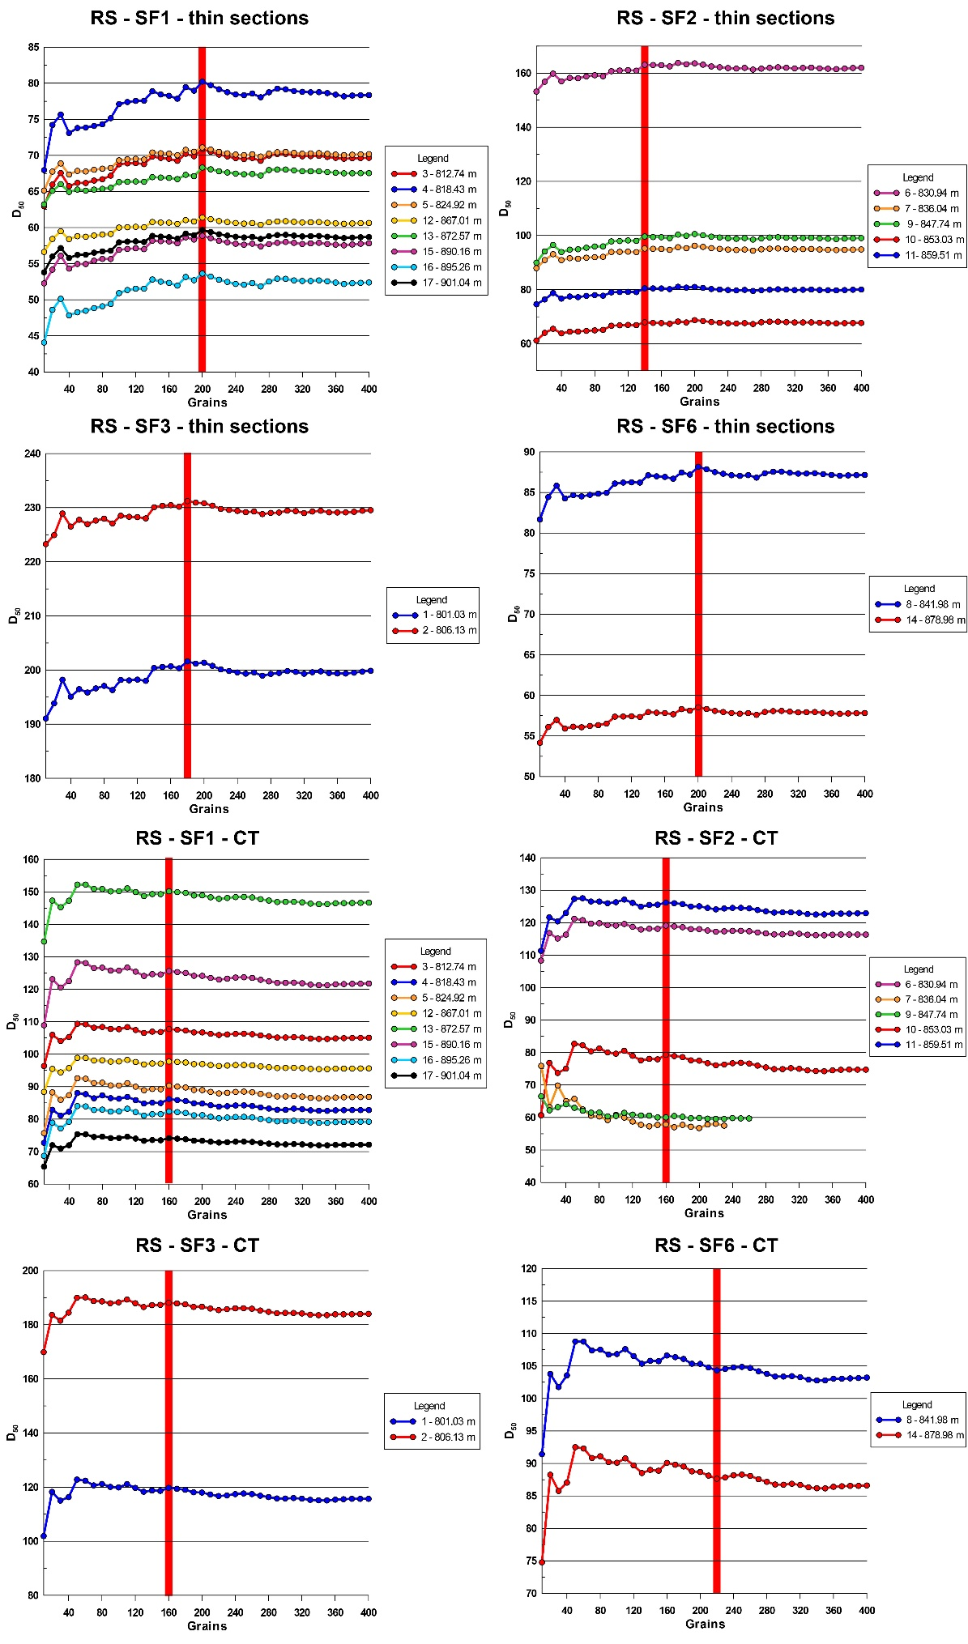
Fig. B. Identification of the Representative Sample (RS) (the minimum amount of grains necessary to be representative for grain size analyses) based on D₅₀ for both TS (SF1, SF2, SF3 and SF6) and CT scans (SF1, SF2, SF3 and SF6) is shown (similar approach see Houghton et al., 2024b). The RS is achieved within a range of 140 and 220 grains, with samples containing more than 220 grains considered representative for both TS and CT scans. Sample numbers and locations, here distinguished by depth, are provided in Figure 1.

Appendix C
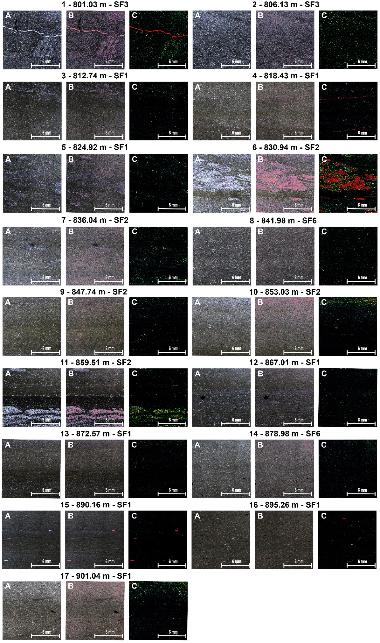
Fig. C. 17 original thin section images (A), segmented grains (highlighted in red within the original images; B), and final segmented grains color-coded based on size (C): red/orange/yellow represents larger grains and green/blue denotes smaller grains (labeling: Connected Component Analysis). The names of the samples, depth (in m), and corresponding lithology are marked above the images (sample location indicated in Fig. 1). Cracks and bioclasts that exhibited similar colors to the segmented grains were excluded from the results. The scale is indicated in all images and is 6 mm.

Appendix D
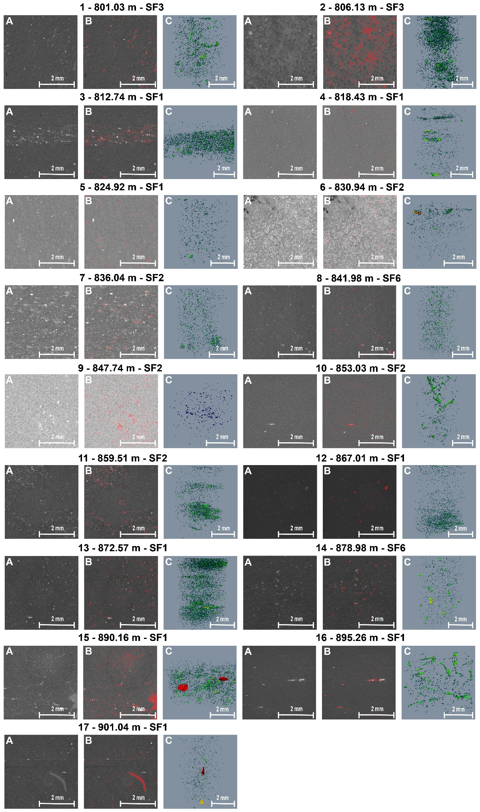
Fig. D. 17 original computed tomography slices (2D; A), segmented grains (highlighted in red within the original images; B), alongside a final 3D representation of the segmented grains, color-coded by size (C): red/orange/yellow indicates larger grains and green/blue denotes smaller grains (labeling: Connected Component Analysis). The names of the samples, depth (in m), and corresponding lithology are marked above the images (sample location indicated in Fig. 1). Larger bioclast grains, prominently visible in sample 901.04 m, were excluded from the analysis. The scale is indicated in all images and is 2 mm.

Appendix E
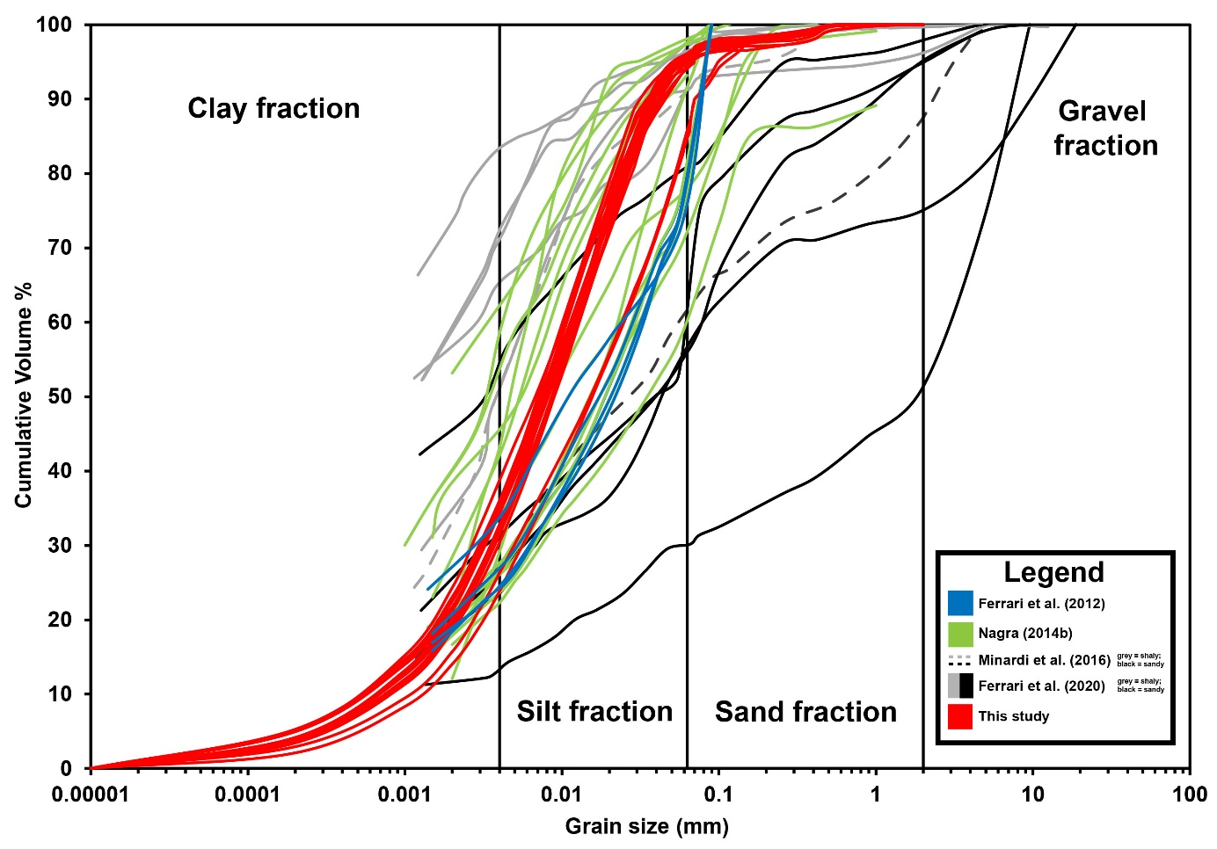
Fig. E. Compilation of quantitative OPA grain size measurements from Nagra (2014b), Minardi et al. (2016), Ferrari et al. (2012, 2020) and data from this study. See legend for colors. In this study, the shaly facies correspond to SF1, while the sandy facies encompass SF2 and SF3.

