Figure S1. Quality assessment of RNA-seq data across samples.
Summary of RNA-seq data quality for all experimental groups, including Q20 and Q30 scores, and mapping rates to the Populus deltoides reference genome. Data confirm high integrity and consistency across species and treatment conditions. The percentages of successfully mapped reads further validate the reliability of transcriptomic analyses for Populus tomentosa (PT), P. × canadensis (PC), and P. × beijingensis (PB).
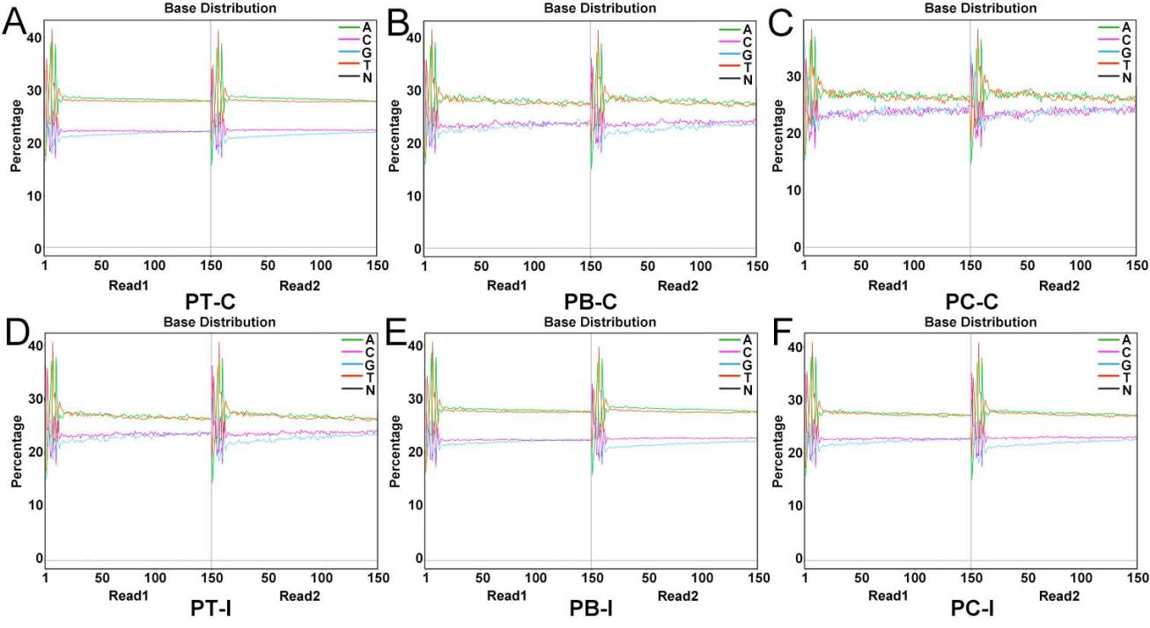

Figure S2. Transcriptomic analysis of poplar species in response to C. chrysosperma infection.

(A) Counts of upregulated and downregulated DEGs across species. (B-D) MA plots showing gene expression differences (log2 fold-change) in PT (B), PB (C), and PC (D). Red and green dots represent significantly upregulated and downregulated genes, respectively.
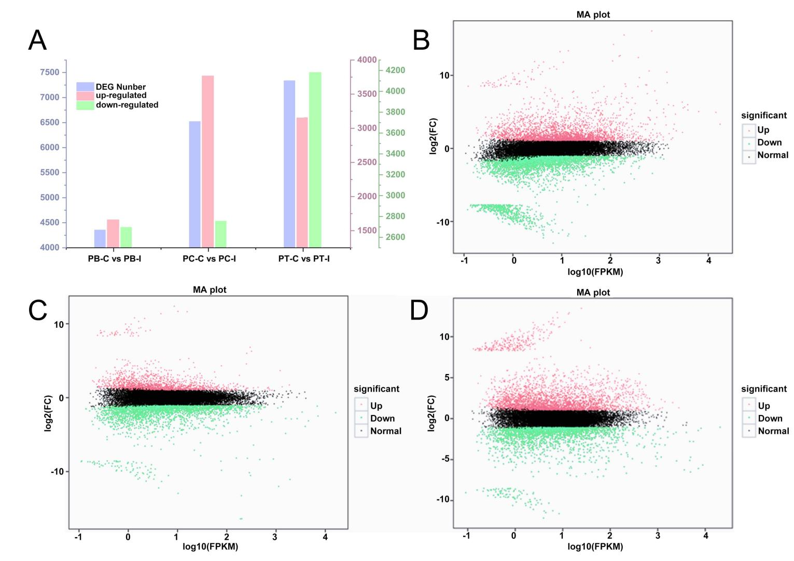
Table S1. Primer sequences.

Primers | 5’ to 3’
q-18S-F | CAACCATAAACGATGCCGA
q-18S-R | AGCCTTGCGACCATACTCC
q-PAL-F | GAGCCCTGCTGAAGCCTTTA
q-PAL-R | CCAAACGCGTGTTGTCCATT
q-HCT-F | AATTTCCAGCCTCAGAGCCC
q-HCT-R | TGCCATCACACCTTGTGTCA
q-4CL-F | ATATTGGTTCAGGCGCTGCT
q-4CL-R | GTCAGTACGCTGTTGGGTGA
q-CAD-F | TTGCGTTGCTTGCAGAGAAC
q-CAD-R | ACCGAGTCCAATCACCCCTA
q-CCR-F | TTCGGGAGTTTGATGGAGCC
q-CCR-R | AGCCTGCCTGATGCTTTCTT
q-COMT-F | TTTGAAGGCCTCGCATCCTT
q-COMT-R | AGCAGTGTTCATCGCTCCAA
q-CSE-F | GGAGTGCAGTGGTTCCATGA
q-CSE-R | TCTGAGCATTTCCAGGGCTG
q-F5,H-F | CTTTGCCCACTATGGTCCGT
q-F5,H-R | CTCCGTCCCACCAAACATCA

Table S2. Summary of RNA-Seq data and mapping statistics
This table provides comprehensive details on RNA-seq performance metrics for all experimental groups, including total read counts, mapping percentages, and base quality scores (Q20/Q30).

Sample_ID | Total Reads | Mapped Reads | Uniq Map | BaseSum | GC(%) | Q20(%) | Q30(%)
PB-C1 | 57794134 (100%) | 47382210 (81.98%) | 43609866 (75.46%) | 8641435190 | 44.14 | 97.8 | 93.38
PB-C2 | 58211952 (100%) | 47711747 (81.96%) | 43666599 (75.01%) | 8696614926 | 44.36 | 97.81 | 93.44
PB-C3 | 57540722 (100%) | 47323595 (82.24%) | 40659179 (70.66%) | 8611907244 | 45.6 | 98.07 | 94.56
PB-I1 | 54297244 (100%) | 45294902 (83.42%) | 41895861 (77.16%) | 8122059936 | 44.48 | 97.9 | 93.59
PB-I2 | 56104288 (100%) | 46940629 (83.67%) | 43444382 (77.44%) | 8388782664 | 44.59 | 97.97 | 93.74
PB-I3 | 66639924 (100%) | 54095337 (81.18%) | 50316065 (75.50%) | 9966542156 | 44.46 | 98.57 | 95.78
PC-C1 | 53073786 (100%) | 46891297 (88.35%) | 43224438 (81.44%) | 7940623122 | 44.18 | 97.87 | 93.5
PC-C2 | 57936968 (100%) | 51180400 (88.34%) | 47292960 (81.63%) | 8670972368 | 44.23 | 97.89 | 93.51
PC-C3 | 71223078 (100%) | 57299396 (80.45%) | 46590349 (65.41%) | 10623231276 | 47.22 | 96.71 | 92.56
PC-I1 | 55267912 (100%) | 49026554 (88.71%) | 45540132 (82.40%) | 8264074494 | 44.28 | 98.15 | 94.13
PC-I2 | 54071546 (100%) | 47536590 (87.91%) | 44227278 (81.79%) | 8091313268 | 44.23 | 97.76 | 93.29
PC-I3 | 54957496 (100%) | 47963098 (87.27%) | 42780663 (77.84%) | 8224783908 | 45.1 | 98.47 | 95.42
PT-C1 | 53852194 (100%) | 36714883 (68.18%) | 33980861 (63.10%) | 8051658624 | 44.37 | 97.99 | 93.78
PT-C2 | 59419332 (100%) | 39994212 (67.31%) | 36998380 (62.27%) | 8882484386 | 44.29 | 97.76 | 93.23
PT-C3 | 57139464 (100%) | 38557375 (67.48%) | 36664846 (64.17%) | 8548789026 | 43.9 | 98.39 | 95.14
PT-I1 | 69418618 (100%) | 46197092 (66.55%) | 42491967 (61.21%) | 10370007976 | 44.8 | 97.77 | 93.31
PT-I2 | 58871404 (100%) | 39309784 (66.77%) | 36306319 (61.67%) | 8794471212 | 44.96 | 98.09 | 94.06
PT-I3 | 54509462 (100%) | 36127058 (66.28%) | 30780032 (56.47%) | 8155722426 | 46.43 | 98.58 | 95.77

